Experiment No: 2

**Name: Shashank Sharma**

**Roll No – J062**

**Btech Data science**

Aim: Interfacing with Arduino uno

Objective:

* Increase the brightness of the inbuilt LED which has a delay of 10ms and fade of 10ms
* Increase the brightness of 2 External LED alternatively.
* Reading using potentiometer
* Using potentiometer to control LED brightness
* Displaying potentiometer resistance on serial monitor
* Displaying potentiometer (variable resistance) on serial plotter
* Controlling multiple LEDs using button or switch
* Controlling single LED using switch or button
* Displaying switch state or button state on serial plotter
* Reading inputs from a switch or button on serial monitor



void setup()

{

pinMode(13, OUTPUT);

}

void loop()

{

for(int i=1;i<256;i++)

{

analogWrite(13, i);

delay(10);

}

for(int i=255; i>0; i--)

{

analogWrite(13, i);

delay(10);

}

}

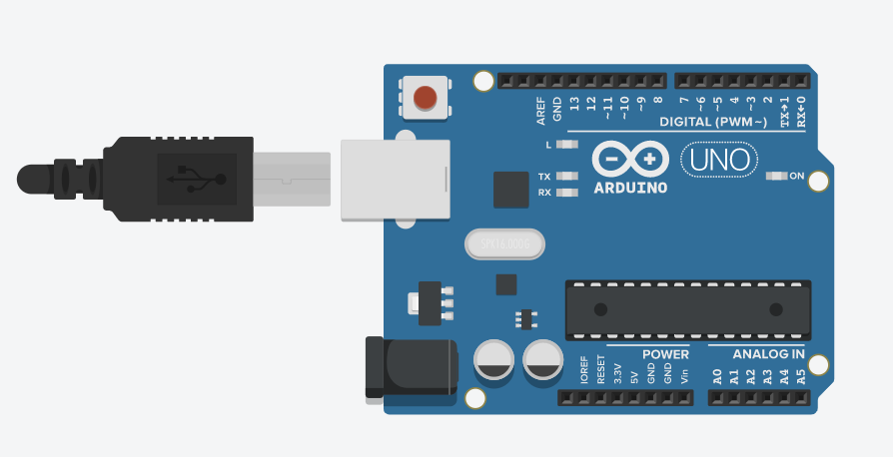

1. –

void setup()

{

pinMode(A0, OUTPUT);

pinMode(A1, OUTPUT);

}

void loop()

{

for(int i=1;i<256;i++)

{

analogWrite(A0, i);

analogWrite(A1, 255 - i);

delay(10);

}

for(int i=254; i>=0; i--)

{

analogWrite(A0, i);

analogWrite(A1, 255 - i);

delay(10);

}

}

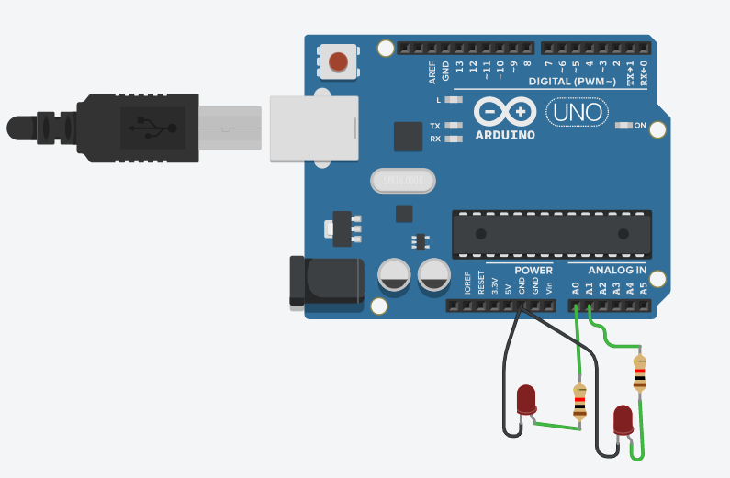

1. -

int sensorVal = 0;

void setup()

{

pinMode(A0, INPUT);

Serial.begin(9600);

}

void loop()

{

sensorVal = analogRead(A0);

Serial.println(sensorVal);

delay(100);

}

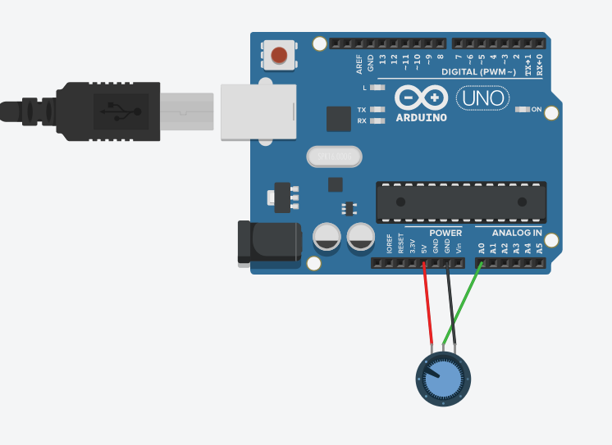

1. , 5. , 6. -

int sensorVal = 0;

void setup()

{

pinMode(A0, INPUT);

pinMode(A1, OUTPUT);

Serial.begin(9600);

}

void loop()

{

sensorVal = analogRead(A0);

analogWrite(A1,map(sensorVal, 0,1023,0,255));

Serial.println(sensorVal);

delay(100);

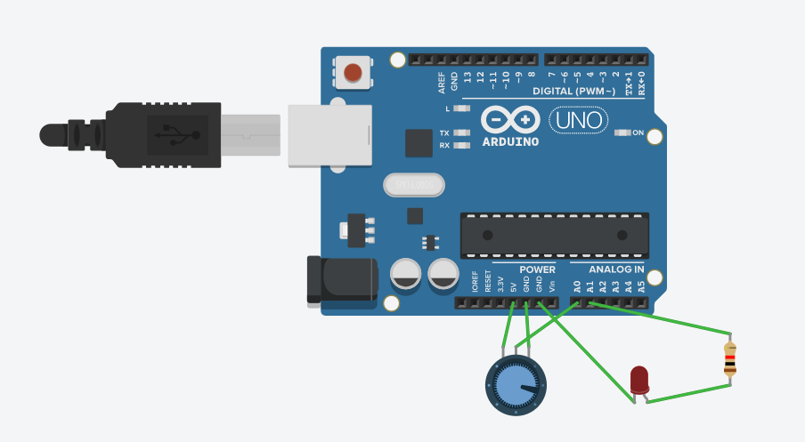

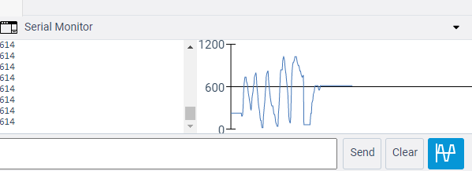

7. –

int buttonState = 0;

void setup()

{

pinMode(8, OUTPUT);

pinMode(9, OUTPUT);

pinMode(3, INPUT_PULLUP);

Serial.begin(9600);

}

void loop()

{

buttonState = digitalRead(3);

Serial.println(buttonState);

delay(100);

if (buttonState == HIGH)

{

digitalWrite(8, HIGH);

digitalWrite(9, HIGH);

}

if (buttonState == LOW)

{

digitalWrite(8, LOW);

digitalWrite(9, LOW);

}

}

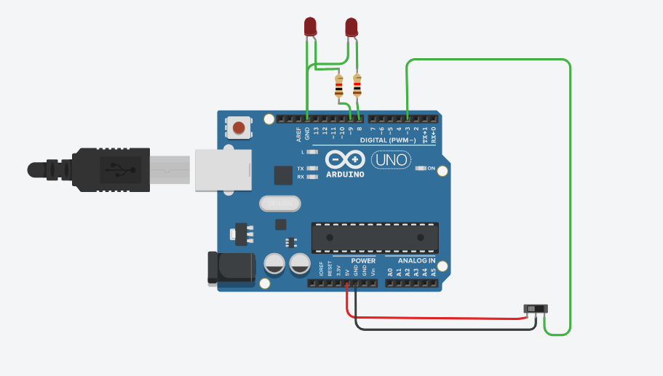

8. , 9. , 10. –

int btnstatus = 0;

void setup()

{

pinMode(3,INPUT_PULLUP);

pinMode(9,OUTPUT);

Serial.begin(9600);

}

void loop()

{

btnstatus = digitalRead(3);

if (btnstatus == HIGH )

{ digitalWrite(9,HIGH);

}

if(btnstatus == LOW )

{ digitalWrite(9,LOW);

}

}

