DATE

{PATIENT NAME}
{ADDRESS}

Dear [First Name]

All On 4 Plus® Treatment Proposal

Thank you for visiting our clinic, an All on 4 Plus® Premium Provider and global leaders in innovative implant-based oral rehabilitation and smile design.

Further to your consultation about your treatment options, I am pleased to provide you with further relevant information regarding your proposed All-On-4 Plus® dental implants treatment and associated fees.

Please refer to the attached Proposed Treatment Summary, Schedule of Fees and What To Expect documents for detailed information about the various anticipated components of your treatment, the associated fees, your surgeon and the facility. All preparatory work as well as the restorative/cosmetic components of your treatment will be provided in a collaborative manner by various relevant members of our team.

This proposal should be read in conjunction with all other information provided by your dentist and does not include all your treatment options. Please let me know should you wish to further explore any other alternatives and we can arrange for a separate consultation with the appropriate dentist within our group, or arrange a referral if necessary.

Should you require finance we have a number of options and can also provide information regarding compassionate release of Super if you suffer from dental/oral pain.

You will find our Terms on allon4plus.com.au/trading-terms and our Privacy Policy on allon4plus.com.au/privacy-policy.

The Next Step:

Once you decide to proceed with the proposed All On 4 Plus® treatment, please contact me directly to arrange a surgery date and an appointment for your work up.

A $5,000 deposit is required to secure your booking and commence the pre-operative procedures and planning. This deposit will come off your treatment costs, but it is non-refundable so please take your time to discuss this proposal with your family and dentist and consider your options before booking your surgery. The balance of all other payments according to the Schedule of Fees will be due on the day of surgery (or prior).

Sincerely,

[TREATMENT COORDINATOR NOTED ON FORM]
Treatment Co-ordinator
PROPOSED TREATMENT SUMMARY

UPPER All-On-4 Plus® Dental Implants Rehabilitation
[6. Treatment Description]

ADD-ONS: | Zygoma Surgery  Advanced Digital Smile Design Single Arch
[Any add-ons ticked]

Your Surgeon/s: | Restorative & Smile Design Consultant/s:
1 Dr Consulting Clinician Name …if 2 is YES  3 Dr Other Surgeon’s Name…if 3 is YES | [1 Consulting Clinician Last Name]  [Referring Dentist Name] …if 4 is YES

Surgical Facility:
3 Surgical Facility

STAGES/APPOINTMENTS

Appointment 1 – WORK-UP & PREPERATION for Surgery

Preliminary records (impressions and photographs) for a pre-operative diagnostic work-up and Smile Design. We will discuss shape and colour options to create the smile you desire. If you have any preferences (such as natural look vs Hollywood white) please make it known to our team. If you have any pictures from when you were younger which you would like us to match, please bring them with you (or email to us).

Appointment 2 – SURGERY at the above Surgical Facility

IMPLANT SURGERY involving removal of poor or infected tissue and any teeth (if present), reshaping of the bone to create a flat and hygienic interface, and careful placement of implants and abutments. The gum tissues will be closed with dissolvable stitches.

IMPRESSIONS & BITE REGISTRATION will be undertaken immediately after your surgery, and we will be digitally correlated to your smile design.
use templates produced by the laboratory to determine the correct position of your bite and the shapes of your new teeth.

TRY-IN of a template of your new teeth (according to your digital smile design) is performed within hours of your surgery to verify the correct position of your bite and the shapes of your new teeth so as to enable our laboratory to fine tune the aesthetics by hand.
In most cases you will be able to leave with the template/s as temporary teeth on the very same day, but this cannot be guaranteed.

Appointment 3 – FITTING of the new Immediate Final Teeth™

Insertion of FINAL implant supported replacement teeth is typically done in the next day, but in some cases it may be desirable to do so within a week once swelling subsides. The new teeth will be Acrylic with a custom-designed milled Titanium Frame. These teeth are light in weight and highly aesthetic (refer to the information below under Teeth Type, Repairs & Longevity).

SCHEDULE OF FEES Page 1 of 2

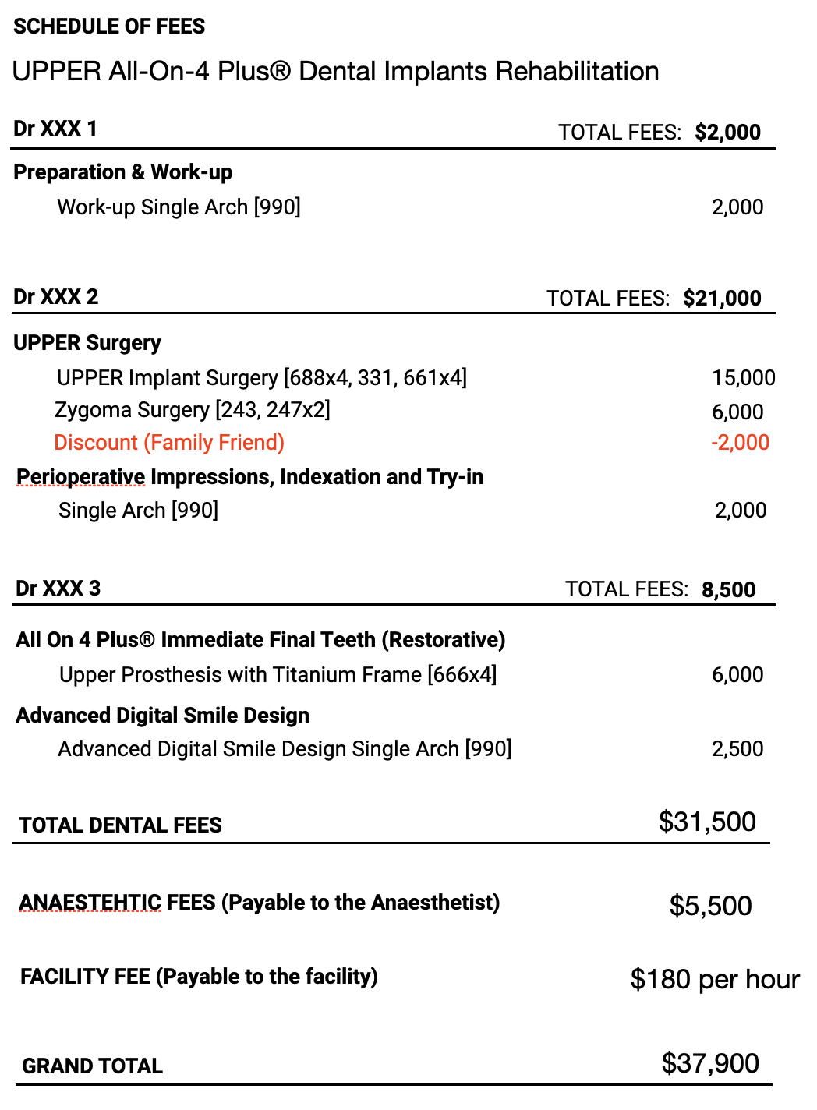
FEES TEXT BOX TITLE

Text box content Only appears of ticked.

SCHEDULE OF FEES Page 2 of 2

OTHER FEES

Anaesthetic & Facility Fees – when treatment is performed under a general anaesthetic, a specialist anaesthetist will administer the anaesthetic and will bill you separately. A substantial part of the anaesthetic fee is claimable through Medicare. There is also a facility fee payable to the facility which is not claimable through Medicare or your health fund.

Dental Treatment Not Specified – Any treatment not specified in this proposal will be subject to additional fees. A separate plan will be provided for any such treatment.

Grinding/Clenching Injections – After implant treatment the common solid feel of the new teeth may cause excessive clenching of the jaw muscles. Injection of a substance to weaken and relax the clenching muscles may be required in certain situations to reduce the forces of the bite. It costs $650 and remains effective for 4 months.

MODIFICATION

Whilst every effort is taken to provide you with a definitive plan, there may be situations during your course of treatment which require modification to that plan, preserve certain teeth, preclude the ability to fit the new teeth immediately as planned, or require the insertion of additional implants. The surgeon may exercise discretion at the time of surgery based on their judgement. Your plan may also need modification depending on your progress and healing over time. These may affect the stated timeframe and overall cost to you.

For example, bone grafting, additional implants or Zygoma implants (inserted into the cheekbones) may be required for adequate support where bone quality is poorer than expected, or for other reasons determined by your surgeon. Fees - $3,000 per implant or graft.

PAYMENT TERMS

A $5,000 non-refundable deposit is required to secure your booking and commence the pre-operative procedures and planning. The balance is payable on the day of surgery (or prior). Payment arrangements should be made in advance as you will still be under the influence of the anaesthetic when you leave this clinic. The anaesthetic fees are time-dependant and are also payable on the day of your surgery. If any component is being financed, this must be approved and available in advance.

AVAILABLE REBATES

MEDICARE for ANAESTHESIA – A Medicare rebate is available for the anaesthetist’s fees. It is typically one third of the fee up to your individual safety net, and then 80% of the balance.

PRIVATE HEALTH FUND – If you have dental cover, your proposed treatment falls largely under the ‘Major Dental’ category, and most patients receive their full annual limit (that is on average in the vicinity of $800-$2,500), regardless of the extent of procedures or item numbers. Please confirm the balance of your annual limit for ‘Major Dental’ with your health fund.

SUPER ACCESS – If you have financial difficulties and suffering from dental or related pain you may be eligible compassionate release of your super. This must be arranged in advance.

WHAT TO EXPECT Page 1 of 3

What to Expect with All-On-4 Plus® Implant Treatment?

SWELLING/BRUISING & TIME OFF WORK

Implant/jaw surgery is accompanied by a degree of swelling, bruising and/or pain. The degree of swelling and bruising does vary from patient to patient. Swelling increases gradually to its maximum on day 3 or 4, before improving. When bruising takes place this may last a little longer. Ice packs in the first 24 hours help reduce the extent of swelling and bruising.

We typically recommend 1 week off work (up to 2 weeks), and if necessary can provide a medical certificate for the required time depending on individual circumstances.

DIET DURING HEALING

Whilst your new teeth are fitted to the implant fixtures immediately after surgery, the supporting implants will still undergo healing (osseointegration) in the bone over a period of 3-4 months. During this period you are required to be on a soft diet so as not to disturb the healing process. The diet may consist of foods with the consistency of fish, pasta, stir-fry, eggs, soft chicken, etc.

Foods to avoid: Chocolate bars, apples, carrots, steak, nuts, sandwiches with crusty breads, and other foods of similar consistency, or which are tougher to bite or chew.

Patients who have poor bone quality, those with diabetes, osteoporosis or who take medication that affects healing or bone turnover should keep to a softer diet for longer (6 Months).

ARCH SIZE & NUMBER OF TEETH

The typical number of teeth in an All-On-4 restoration is twelve, but this depends on the position of the back implants which in turn depends on the jaw anatomy and/or findings at surgery. We always aim to give you the maximum number of teeth possible, but in some cases may only be able to fit a shortened arch with one less tooth on one or both side/s. If we need to reduce the arch size, we would still aim to provide molar teeth in the back to optimise function.

REVIEWS, CLEANING & MAINTENANCE

All your post-operative reviews in the first 4 months are included in this plan.

If you were referred to us by your dentist or dental specialist, then the maintenance over time may be carried out by them, otherwise you are welcome to attend this (or any of our other clinics) for ongoing maintenance. Ongoing maintenance is a separate ongoing cost.

Cleaning is simple and is crucial to long-term success. It is important to ensure that you clean your new teeth twice a day, as will be demonstrated to you by and our team. A normal toothbrush is the primary cleaning method, but there are other ways to clean the gum interface using super floss or mini brushes. This will be demonstrated at your 3 weeks review once the stitches have dissolved.

Like with natural teeth, it is also important maintain regular dental check-ups and professional cleans, which is typically every 4-6 months and costs similar to a visit for maintenance of natural teeth.
WHAT TO EXPECT Page 2 of 3

Teeth Type, Repairs & Longevity

All repairs and in-mouth adjustments to your teeth are included for a period of 2 years.

Your Immediate Final Teeth™ will be constructed using acrylic or polymethyl methacrylate (PMMA) teeth supported by a custom-milled titanium frame, using All On 4 Plus® proprietary methods to achieve optimal aesthetics and function. These teeth are fixed and can only be removed by your dentist. The physical properties of Acrylic or PMMA make them ideal for absorbing some of the impact from your bite, which is especially important during the initial healing/osseointegration of the implants, but also over time. They are also light in weight, which makes them comfortable to wear and simple (and quick) to repair or reline if necessary.

Using All On 4 Plus® proprietary systems and techniques it is uncommon to get any significant gum shrinkage after surgery, however if any shrinkage does occur, the teeth can be easily and effectively relined, which is at no additional cost within 2 years.

The longevity of the teeth will vary significantly from person to person, but on average it is reasonable to anticipate replacement (for an average person) after 5 years. Using the original titanium frame, the replacement of the Acrylic or PMMA teeth is quick and simple, costs approximately $3,000 per arch, and allow you to make changes to the aesthetics (such as teeth colour or arrangement) as your desires may change with age.

Upgrades

Due to the fixed and immobile nature of implant-supported teeth (unlike natural teeth) there is no cushioning to absorb biting pressures (which is otherwise present with natural teeth) and it is not uncommon for the biting forces to increase even without your awareness. In certain individuals (15% of cases) the improvements to the forces of the bite after treatment may be beyond the physical tolerance of the acrylic material resulting in chipping or breakages. If you happen to be in this group, there are certain things that we can do to reduce the biting or clenching power (like anti-clenching injections or mouthguard), but in most cases an upgrade to stronger Zirconia/Ceramic teeth will be required.

The upgrade cost is $9,950 per arch, and this fee is guaranteed for 5 years from the date of your treatment. This is a discounted upgrade-only rate and is only available to patients who receive their original treatment at this clinic, as part of our ongoing commitment to your long-term care. Additional fees may apply depending on individual circumstances.

Your Input and Preferences

You are able to choose the colour, shape and arrangement of your teeth, or otherwise leave it to us to determine. Despite our many thousands of amazing transformations, whether we reach your personal expectations in terms of aesthetics or how it feels is somewhat of an unknown and cannot be guaranteed. In the unlikely event that you are not satisfied with the outcome, making your desired changes to the teeth is indeed possible once the implants are integrated (after 4 months) and the fees charged would typically be at cost.

WHAT TO EXPECT Page 3 of 3

Zygoma & Grafting

In certain situation the quality or quantity of the upper jawbone may be inadequate for standard implants. This may or may not be clearly evident when planning your treatment, and may be a situation discovered by the surgeon during surgery.

Your surgeon may decide on bone grafting using an artificial or bovine bone mineral to build up bone reserves as contingency, or Zygoma Implants, which are longer fixtures that transverse the sinus and poor area of your upper jaw and anchor into the underside of the cheekbones. The surgery is more invasive, and as such the swelling is often more profound.

Treatment Alternatives & Risks

Like all surgical and cosmetic procedures your proposed treatment carries risks for complications during or after your surgery, and also in the long term. Most complications during the surgery can be managed by your surgeon at the time and may include the need to modify the plan (like using different or additional implants or preserving certain natural teeth). Some post-operative consequences can be more frequent but less significant because they are self-limiting (like bleeding or swelling) or can be easily addressed (for example chipping or breakages of the teeth). Whereas other long-term risks include complications which may be rare but more significant because they are difficult and/or costly to fix (for example rejection/failure of one or more implants or infection), or because there is a long-term consequence such as numbness. Those are some of the known risks, but there may also be unknown risks or unexpected complications.

You should also consider the possible risks of delaying treatment, such as bone loss as a result of a spread of infection or disease from your teeth or from natural atrophy if you wear dentures, which may limit your future options or prospects of success.

Whilst the chances of significant complications are extremely low when performed by a trained and experienced All On 4 Plus® Premium Provider, the consequences to you if a complication occurs may be significant (such losing your implants and having to wear a loose denture, which you might not be able to tolerate). You should always consider the risks and benefits of your proposed treatment against the risks of not doing anything or of other alternatives discussed with your dentist or other opinions.

SMOKERS

Smoking may cause severe health issues including lung and mouth cancer. It may also cause diseases of the gums surrounding the implants, impaired healing and/or a higher predisposition to implant failures. If you smoke, you will be required to refrain from smoking during the first 3 months of healing, and we strongly encourage you see your doctor and quit altogether to reduce your long-term risks.
WHAT TO EXPECT TEXT BOX TITLE

Text box content Only appears of ticked.

FINANCE

Should you require finance, please let me know and I will go over available options.

We offer the following finance options (subject to separate and individual Terms & Conditions):

3rd party finance:

This finance is offered by a third party lender and is subject to approval.

Maximum Loan Amount: up to 50% of the value of the dental treatment (excluding anaesthetic) to a maximum of $15,000.

Interest-Free Period: 12-months, check interest rate at time of enquiry

Administration fee: $390

Secured Loan:

This finance is administered internally.

Suitable for approved applicants with a residential property asset that can be used as security.

Loan Amount: up to 50% of the value of the dental treatment (excluding anaesthetic)

Interest: 0%

Special Conditions:
- Subject to charge over the property until fully repaid
- Minimum repayments $750 per month
- Maximum term – 3 years

Required Documentation:
- Rates Notice showing value of property (usually the first annual notice)
- Loan statement showing balance (if there is a loan)
- Copy of Driver’s License for ALL owners
- Copy of Passport for ALL owners
Note: If name on the passport or license does not match name on the title a statutory declaration explaining the reason and signed by the person on the title will be required.

FINANCE TEXT BOX

Text box content

Only appears of ticked.

