[Your University] [School / Faculty] [Department of Computer Science]

SVDS — VEHICLE REGISTRY AND STOLEN VEHICLE DETECTION SYSTEM

A camera-based license plate detection and vehicle registry system for the Zambia Police Service
BY
[Your Full Name]
[Course Code] FINAL YEAR COURSE PROJECT
A THESIS SUBMITTED IN PARTIAL FULFILMENT OF THE REQUIREMENT FOR THE AWARD OF A BACHELOR'S DEGREE OF COMPUTER SCIENCE
SUPERVISOR: [Supervisor Name]

DECLARATION
I, the undersigned, hereby declare that the Vehicle Registry and Reporting System / Stolen Vehicle Detection System (VRRS/SVDS) is my own work. That it has not been submitted for any degree or examination in any other university to my knowledge, and that all sources I have used or quoted have been indicated and acknowledged by complete references.
Author: [Your Full Name] Student Number: [Student Number] Signature: _________ Date: [Submission Date]
Supervisor: [Supervisor Name] Signature: _________

DEDICATION
[Write your own — the golf thesis dedicated the work to family/faith; keep this section personal to you rather than templated.]

ACKNOWLEDGEMENT
I want to express my gratitude to [Supervisor Name], my supervisor, for guidance and feedback throughout this project. [Add anyone else who supported the work — family, the Zambia Police Service contacts who informed the requirements interviews, etc.]

ABSTRACT
Vehicle theft investigation in Zambia currently relies on manual, paper-based reporting and word-of-mouth alerting between police stations — a stolen vehicle report filed at one station has no mechanism to automatically flag the vehicle if it is later sighted elsewhere. This project, SVDS (Stolen Vehicle Detection System), addresses that gap by combining a conventional vehicle-registry web application with a real-time, camera-based automatic license plate recognition (ALPR) pipeline.
The system has three cooperating parts. A FastAPI backend exposes a REST and WebSocket API over a PostgreSQL database, enforcing role-based access for three user types: Reportee (the public, filing and tracking stolen-vehicle reports), Police (viewing live detection alerts, managing the vehicle registry, and analytics), and Admin (user and system management). A React single-page application provides the interface for all three roles. A separate, decoupled camera-node process streams video from a phone-mounted camera, detects license plates with a custom-trained YOLOv8n object detector, reads the plate text with EasyOCR, and reports matches to the backend over plain HTTP — requiring no coupling to the backend's internals or technology choices.
The detection model was trained on a self-collected, Roboflow-annotated dataset of Zambian number plates (335 source images, augmented to 1,890) and evaluated at precision 0.988 and recall 0.751 (mAP50 0.801) after 100 training epochs. The full system was tested end-to-end — from a real phone camera feed, through detection and OCR, to a live WebSocket alert appearing on the police dashboard — and validated with an automated test suite (39 tests) covering authentication, role-based access control, the report lifecycle, plate-matching logic, and the analytics layer.
This work demonstrates that a real-time ALPR pipeline can be integrated into a practical, role-based law-enforcement registry system using consumer hardware (an Android phone as the camera) and open-source computer vision tooling, without recourse to commercial ALPR licensing.

1. Introduction
SDLC phase: Problem identification / feasibility study

1.1 Background
Vehicle theft is a persistent problem for law enforcement in Zambia, and the process of recovering a stolen vehicle depends heavily on chance: an officer at a checkpoint or on patrol happening to recognize a plate number from a paper report or a radio bulletin. Vehicle registry records, incident reports, and eyewitness descriptions are typically kept on paper or in disconnected station-level spreadsheets, which means a report filed at one police station is invisible to an officer working in a different part of the same city, let alone a different province.
At the same time, automatic license plate recognition (ALPR) has become inexpensive enough to build from commodity hardware. A single Android phone can stream video over Wi-Fi, and open-source object detection models (this project uses Ultralytics YOLOv8) can be trained on a modest, self-collected image set and run in real time on a consumer GPU. This closes the gap between "a report exists somewhere" and "a report is automatically checked against every vehicle a camera sees."

1.2 Problem Statement
There is no system available to the Zambia Police Service that automatically checks a vehicle's license plate — as seen by a camera in the field — against an active stolen-vehicle registry in real time. Existing practice depends on manual recognition by officers and manual cross-referencing of paper reports. This results in: (a) slow or missed detections of stolen vehicles that pass through monitored locations, (b) no centralized, real-time way for a report filed by the public to reach every officer who might encounter the vehicle, and (c) no audit trail connecting a detection event back to the report that triggered it.

1.3 Research Questions
- Can a custom-trained, lightweight object detector (YOLOv8n) combined with an open-source OCR engine achieve detection and recognition accuracy sufficient for real-time plate matching on Zambian number plates, using only a phone camera and a consumer GPU?
- Can such a detection pipeline be integrated into a role-based registry system as a fully decoupled component — communicating only over plain HTTP/WebSocket — without requiring the detection logic to be embedded in the backend itself?
- Does a real-time alert delivered over WebSocket meaningfully reduce the latency between "a stolen vehicle is sighted" and "a police officer is notified," compared to the manual process it replaces?

1.4 Aim
The aim of this project is to design, implement, and evaluate SVDS: a vehicle registry and reporting web application integrated with a real-time, camera-based license plate detection pipeline, for use by the Zambia Police Service and the public it serves.

1.5 Objectives
- Implement role-based accounts for three user types — Reportee, Police, and Admin — each with access scoped to what that role needs (vrrs-backend/app/middleware.py).
- Allow the public to file, track, and view the status of stolen-vehicle reports (under_review → missing → found).
- Give police officers a live view of detection alerts, the vehicle registry, and system analytics, with the ability to activate reports, mark vehicles recovered, and flag false positives.
- Give administrators control over user accounts, roles, and visibility into system health and the audit trail.
- Collect and annotate a dataset of Zambian license plates, and train a YOLOv8-based object detector to localize plates in a camera frame.
- Integrate an OCR stage (EasyOCR) to read the localized plate text, and validate/clean that text against the expected format.
- Build a decoupled camera-node process that connects a real video stream (an Android phone's IP Webcam feed) to the detection pipeline and reports matches to the backend over HTTP, independent of the backend's and frontend's technology stack.
- Deliver real-time alerts to connected police/admin clients over WebSocket the moment a stolen vehicle is detected.
- Evaluate the detector quantitatively (precision, recall, mAP) and the system as a whole through automated and manual/system testing.

1.6 Scope
This project covers the vehicle-registry web application (backend + frontend), the camera-node detection pipeline, and the integration between them. It does not cover: a native mobile app for the public (the public-facing interface is a responsive web app), payment/e-government integration, multi-camera fleet management beyond a single configured node, or GPS-based camera geolocation (the camera's location is currently a configured string, not read from the phone's sensors — see §9.2).

2. Literature Review
SDLC phase: Research / analysis (precedes formal requirements gathering)

2.1 Introduction
This chapter surveys existing automatic license plate recognition (ALPR) approaches and law-enforcement/vehicle-registry systems relevant to SVDS, to establish what already exists, what is transferable, and what gap this project fills — specifically, the absence of any ALPR-integrated stolen-vehicle registry built for the Zambian context.

2.2 Review of Similar Systems

2.2.1 Commercial and open ALPR platforms
- OpenALPR — an open-source ALPR library offering pre-trained models for several countries' plate formats. It is a strong general-purpose reference but ships no model trained on Zambian plates, and its default pipeline (classical image processing plus a small CNN) predates the anchor-free, single-stage detectors (e.g., YOLOv8) used in this project.
- Plate Recognizer (a commercial ALPR SaaS) — demonstrates the split this project also uses: a lightweight edge client that captures frames and a separate service that performs recognition. Its accuracy is strong across many plate formats but the service is a paid API, which is a barrier for public-sector deployment on a limited budget — reinforcing the case for a self-hosted, custom-trained alternative.
- Ultralytics YOLOv8 (the detector family used in this project) — chosen over older YOLO versions and over two-stage detectors (e.g., Faster R-CNN) for its balance of inference speed and accuracy on a single consumer GPU, and its first-class support for training on a small, custom, single-class dataset via the Ultralytics CLI/Python API.
- EasyOCR — an open-source, PyTorch-based OCR engine supporting a character allowlist, which is used here to constrain readings to the alphanumeric character set a Zambian plate can contain, reducing spurious reads from background text.

2.2.2 Vehicle registry and reporting systems
Existing vehicle registry and reporting workflows in the literature and in observed practice are predominantly record-keeping systems: they store reports, ownership records, and status, but do not themselves watch for the reported vehicle. Where ALPR is used in policing literature, it is typically deployed as fixed, purpose-built roadside camera infrastructure (e.g., number-plate recognition cameras on major routes) rather than integrated with a public-facing reporting system that a citizen can use directly. SVDS's contribution is closing that loop: a report filed by the public immediately becomes something a camera node can match against, without a separate data-entry step for police to "load" the report into a detection system.

2.2.3 Gap this project addresses
No system reviewed combines all of: (a) public self-service reporting, (b) role-based access for police/admin oversight, (c) a custom-trained detector for the specific plate format in question, and (d) real-time WebSocket delivery of detection alerts to connected officers. SVDS's architecture — a fully decoupled camera node talking to a conventional registry backend over HTTP — is deliberately chosen so the detection pipeline could later be pointed at fixed roadside cameras without changing the backend at all.

2.3 Research Methodology
Requirements and design decisions for SVDS were informed by:
- Background reading on ALPR architectures (YOLO family detectors, OCR engines) and on typical vehicle-registry data models (report lifecycle, audit logging).
- Direct inspection of the problem domain — the manual, paper-based nature of current stolen-vehicle reporting, and the fact that police, reportees, and administrators need materially different views of the same underlying data (which directly shaped the three-role design).
- Iterative build-and-test cycles, where the camera-node pipeline (frame capture → detection → OCR → cleaning → dedup → HTTP report) was refined against real footage from a phone camera rather than only against the training/validation image set.

2.4 Summary
ALPR technology and vehicle-registry web applications are both mature, well-documented domains individually. The literature and available products show little precedent for combining the two into a single system aimed at a specific national plate format and a public/police/admin role split — which is the space this project occupies.

3. Requirements Engineering
SDLC phase: Requirements

3.1 Development Methodology
SVDS was built iteratively rather than to a single upfront specification: the registry web application (backend + frontend) and the camera-node detection pipeline were developed as two work-streams that converged at one integration point — the POST /alerts/check-plate endpoint. This let the detection model's training/evaluation cycle (data collection → annotation → training → evaluation, see Chapter 5) proceed independently of the web application's CRUD/auth work, and let each be iterated and retested without blocking the other.
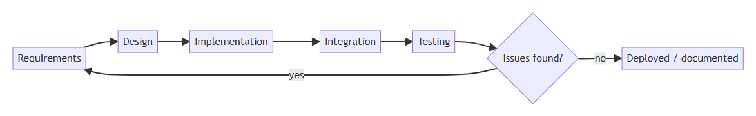

3.2 Required Resources
Layer | Technology
Backend | Python, FastAPI, SQLAlchemy (ORM), PostgreSQL, JWT (python-jose), bcrypt (passlib)
Frontend | React 18, React Router, Axios, Vite
Camera node | Python, OpenCV, Ultralytics YOLOv8, EasyOCR, PyTorch (CUDA)
Dataset/annotation | Roboflow (annotation, augmentation, dataset versioning/export)
Dev/runtime | Windows 11, NVIDIA GPU (CUDA) for training and real-time inference, Android phone running an IP Webcam app as the camera source
Development environments are isolated per component: the backend uses a Python venv with psycopg2-binary for Postgres connectivity; the camera node requires a GPU-enabled Python environment with torch/ultralytics/easyocr installed (CPU-only inference is possible but materially slower for real-time video).

3.3 Requirements Gathering Approach
Requirements were derived from: (a) the practical gap identified in Chapter 1 (no automatic cross-referencing of reports against field sightings), (b) the natural three-way split of who interacts with a stolen-vehicle report — the person who filed it, the officer investigating it, and the administrator managing accounts and system health — and (c) the technical constraints of the detection pipeline itself (a single, cheap camera source; the need to avoid coupling the detector to the backend's release cycle).

3.4 Functional Requirements

3.4.1 Reportee (public)
- Register an account and log in (POST /auth/register, /auth/login).
- File a stolen-vehicle report with owner, vehicle, and incident details (POST /reports/); a duplicate report cannot be filed against a plate that already has an active (missing-status) report.
- View and search their own filed reports (GET /reports/, scoped to their own reported_by).
- View and edit their own profile (GET/PATCH /users/me), including changing password.

3.4.2 Police
- Everything a Reportee can do, plus:
- View, search, and filter all reports system-wide, not just their own.
- Activate a report (move it from under_review to missing, making it eligible for plate matching) and mark a report found once the vehicle is recovered (PATCH /reports/{id}/activate, PATCH /reports/{id}/found).
- View live detection alerts, mark them read, and flag false positives (GET /alerts/, PATCH /alerts/{id}/read, PATCH /alerts/{id}/false-positive).
- Receive new detection alerts in real time via WebSocket without refreshing the page.
- View the live camera feed and camera-node status (online/offline, detection count, average confidence) on the Cameras page.
- View system analytics: report totals/status breakdown, recovery rate, alerts over time, detections per camera node, average recovery time.

3.4.3 Admin
- Everything a Police user can do, plus:
- Create police/employee accounts (POST /users/invite), change any user's role (PATCH /users/{id}/role), deactivate/reactivate accounts, and delete accounts.
- Delete a stolen-vehicle report, including one with existing detection history (DELETE /reports/{id} — see §8.5 for why this specifically needed a fix).
- View the system-wide audit log of significant actions (GET /system/audit).
- View system health: API response time, DB connection pool usage, disk usage, active sessions, camera node online/offline count, uptime (GET /system/health).
- View user-growth analytics (GET /analytics/user-growth).

3.4.4 Camera node (SVDS detection subsystem)
- Connect to a live MJPEG video stream from a phone-mounted camera.
- Detect license plates in each processed frame using a custom-trained object detector, at a configurable confidence threshold.
- Extract and pre-process the detected plate region for OCR (grayscale, upscale, threshold).
- Read the plate text and validate it against the expected Zambian plate character pattern before treating it as a genuine reading.
- Suppress repeated reports of the same plate within a cooldown window, tolerant of OCR noise between frames (i.e., near-identical readings should not each trigger a separate report).
- Report each accepted reading to the backend over HTTP, and log the backend's response (CLEAR/STOLEN) locally.
- Recover automatically if the video stream connection drops.

3.5 Non-Functional Requirements
- Security: passwords are never stored in plaintext (bcrypt hashing); every protected route requires a valid JWT; role checks are enforced server-side (app/middleware.py's require_role), not only hidden in the frontend UI; the camera feed proxy and WebSocket endpoint both validate a JWT before granting access, since <img> tags and WebSocket handshakes cannot send an Authorization header.
- Performance: the detection pipeline processes every 5th frame (not every frame) to keep pace with the video stream on the available GPU; database aggregate queries in the analytics/system routers use SQL-side counting/averaging rather than pulling full row sets into Python.
- Availability/resilience: the camera node reconnects automatically if the phone stream drops; the backend's WebSocket manager removes dead connections on broadcast failure rather than blocking on them.
- Decoupling: the camera node has no dependency on the backend's internals — it is a separate OS process communicating only over HTTP/JSON, so it can be redeployed, restarted, or replaced independently (see Chapter 7).
- Usability: each role sees only the navigation and actions relevant to it (the frontend's route guards mirror the backend's role checks) so users are not shown controls they cannot use.
- Maintainability: the schema is defined once in SQLAlchemy models and shared by every router; business rules that matter to more than one endpoint (e.g., confidence normalization) are factored into a single expression rather than duplicated.
- Auditability: state-changing actions taken by police/admin users are written to an audit_log table, giving a traceable record of who activated, resolved, or deleted a report, and who changed a user's role.

4. System Design
SDLC phase: Design

4.1 Proposed System
SVDS is composed of three independently-runnable processes that communicate only over network calls, never by sharing code or a process boundary:
- vrrs-backend — a FastAPI application backed by PostgreSQL, exposing REST endpoints and one WebSocket endpoint.
- vrrs-frontend — a React single-page application consumed by browsers, talking to the backend over HTTPS (Axios) and WebSocket.
- vrrs-node — a standalone Python script (plate_node.py) that pulls a phone's video stream, runs detection/OCR, and reports over plain HTTP.

4.2 System Architecture
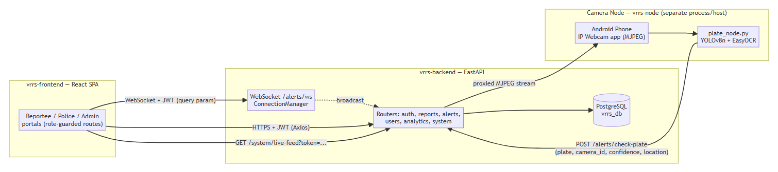
This is deliberately not a monolith: the camera node does not import anything from vrrs-backend, and could be pointed at a different backend entirely by changing one environment variable (BACKEND_URL). This decision trades a small amount of network overhead for the ability to develop, restart, and scale the detection pipeline independently of the web application — see Chapter 7 for the integration contract in detail.

4.3 Database Design (Entity-Relationship Diagram)
The schema has four tables, defined once in vrrs-backend/app/models.py and shared by every router:
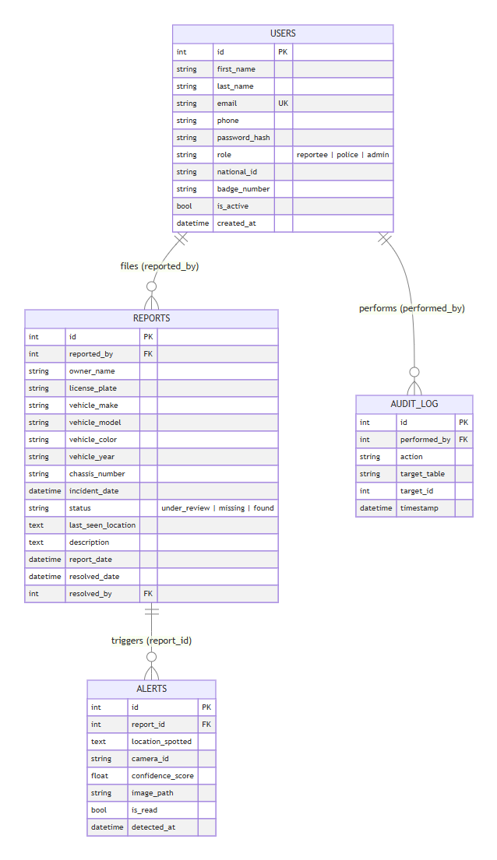
Alert.report_id carries ON DELETE CASCADE (see §8.5): deleting a report also deletes its detection history rather than being blocked by the foreign key. Report has no direct foreign key to Alert; the relationship is navigated the other way, and Alert.license_plate is a computed property that reads through to Alert.report.license_plate rather than being stored redundantly.
No formal migration tool (e.g., Alembic, though it is listed in requirements.txt) is currently wired up — the schema is created with Base.metadata.create_all() at backend startup, which creates missing tables but does not alter existing ones. This is why the cascade fix in §8.5 required a direct ALTER TABLE against the live database in addition to the model change (see §9.2 for this as a noted limitation).

4.4 API Design
Router | Prefix | Purpose | Auth
Auth | /auth | Register (reportee only), login, logout | Public
Reports | /reports | Stolen-vehicle report CRUD + lifecycle transitions | Reportee+ (scoped), Police for updates, Admin for delete
Alerts | /alerts | check-plate (public, called by the camera node), alert listing/read/false-positive, WebSocket | Public for check-plate; Police+ for the rest
Users | /users | Profile, admin user management, role changes | Self for profile; Admin for management
Analytics | /analytics | Aggregate stats for dashboards/charts | Police+ (Admin for user-growth)
System | /system | Audit log, camera-node status, live-feed proxy, health metrics | Admin/Police, token-gated for the feed proxy
/alerts/check-plate is intentionally unauthenticated (the camera node has no user identity of its own) but is not a general write endpoint — it can only ever produce a CLEAR response or create an Alert row linked to an already-missing report; it cannot create, modify, or delete a report.

4.5 Sequence Design: Authentication
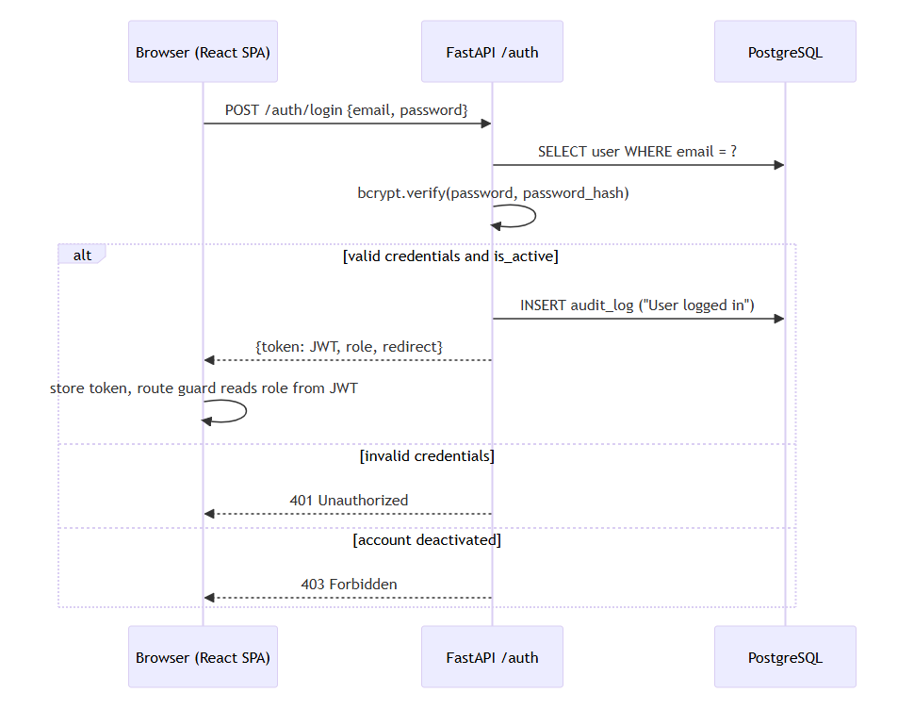
Every subsequent request attaches the JWT as a Bearer token; app/middleware.py decodes it once per request (get_current_user) and layers role checks on top (is_reportee, is_police, is_admin) rather than re-implementing auth logic per route.

4.6 Sequence Design: Detection-to-Alert (the system's core value flow)
See Chapter 5 (§5.7) for the full pipeline diagram inside the camera node, and Chapter 7 for the integration contract this sequence relies on.
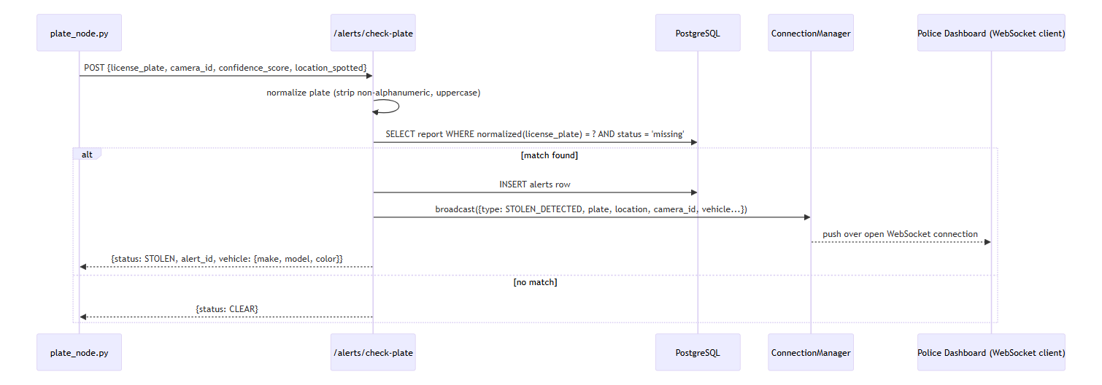

4.7 Role/Access Design
Access is enforced identically in two places: server-side (FastAPI dependencies) and client-side (React route guards), so the UI never shows a control the API would refuse.
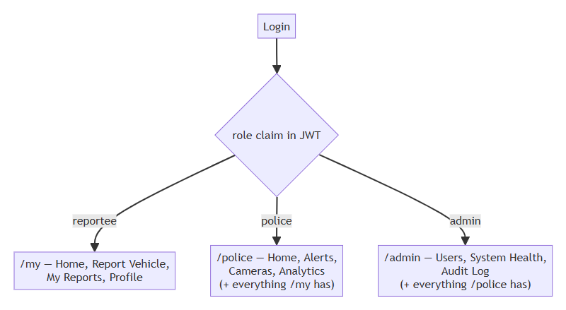
(vrrs-frontend/src/App.jsx's Guard roles={[...]} component and vrrs-backend/app/middleware.py's require_role(*roles) implement the two sides of this same rule set.)

4.8 UI Design
The frontend has 14 pages split across four areas: public (Login, Register), Reportee (ReporteeHome, ReportVehicle, MyReports, Profile), Police (PoliceHome, Alerts, Cameras, Analytics), and Admin (AdminHome, UserManagement, SystemHealth, AuditLog). A shared PortalLayout gives role-appropriate navigation, and a global AlertsContext means a new detection toast can appear on any page a police/admin user is viewing, not only the Alerts page — this was a deliberate design choice so an officer reviewing analytics is not the last to know about a live detection.

5. Object Detection & Plate Recognition Module
This chapter documents the ML sub-lifecycle that Chapters 4 (Design) and 6 (Implementation) reference but don't repeat in full: data → annotation → training → evaluation → deployment. Every figure and number in this chapter is copied directly from the actual training run in C:\Users\user\runs\detect\svds-plate-detector-final-2\ — see assets/detection-model/.

5.1 Why a custom-trained detector
Off-the-shelf ALPR models (§2.2.1) are trained on plate formats from the regions that produced them and do not reliably localize the layout and proportions of Zambian plates. Rather than adapt a general model, a single-class detector — zambia-number-plate-detection — was trained from scratch on YOLOv8n's pretrained COCO weights, fine-tuned only to localize "this region of the frame is a plate," leaving character recognition to a separate OCR stage (§5.6). Splitting localization and recognition into two stages (rather than an end-to-end plate-reading model) keeps each stage simple, independently testable, and swappable — the OCR engine could be replaced without retraining the detector.

5.2 Data Collection
335 source images of vehicles bearing Zambian plates were collected by phone camera (the same category of hardware the deployed camera node uses — see the IMG_xxxx.jpg filename pattern from the source photography under C:\Users\user\runs\detect\predict-6\, matching the phone-camera capture format used throughout this project). Collecting images with the same kind of camera the system would actually use in the field — rather than sourcing a generic plate dataset — was intentional: it means the training distribution (angle, lighting, motion blur, resolution) matches the deployment distribution.

5.3 Annotation
Images were annotated using Roboflow (project zambia-number-plate-detection, workspace nicholass-workspace-j3yig), with a single bounding-box class per plate. The dataset was exported in YOLOv8 label format (assets/dataset/data.yaml):
names:
- zambia-number-plate-detection
nc: 1
train: ../train/images
val: ../valid/images
test: ../test/images

5.4 Pre-processing and Augmentation
Roboflow's export pipeline applied (documented in assets/dataset/README.roboflow.txt):
- Auto-orientation (EXIF-orientation stripping)
- Resize to 640×640 (stretch)
- 3 augmented versions per source image: 50% chance of horizontal flip, random rotation (±15°), random brightness adjustment (±25%), and a small random Gaussian blur (0–1.8px) applied to bounding boxes
This grew the dataset from 335 source images to 1,890 images, split:
Split | Images
train | 1,476
valid | 407
test | 7

5.5 Training
Trained with the Ultralytics CLI/Python API. Actual hyperparameters, from assets/detection-model/args.yaml:
Parameter | Value
Base model | yolov8n.pt (pretrained, fine-tuned)
Epochs | 100
Batch size | 8
Image size | 640×640
Device | GPU (device: '0', NVIDIA Quadro P2000)
Optimizer | auto (Ultralytics default: SGD/AdamW selection)
Learning rate | lr0=0.01, lrf=0.01, cosine schedule off
Augmentation (in-training) | mosaic 1.0, fliplr 0.5, HSV jitter, erasing 0.4
This was one of several training runs (svds-plate-detector, -2, -3, -final, -final-2, etc. — see the runs/detect/ history); svds-plate-detector-final-2 is the run whose weights (best.pt) are the ones actually loaded by plate_node.py in production (MODEL_PATH in vrrs-node/.env).

5.6 Evaluation
Final-epoch (100/100) metrics, read directly from assets/detection-model/results.csv:
Metric | Value
Precision (B) | 0.988
Recall (B) | 0.751
mAP50 (B) | 0.801
mAP50-95 (B) | 0.686
High precision with lower recall means the detector rarely produces a false bounding box, but does sometimes miss a plate in a frame (e.g., under motion blur or extreme angle) — an acceptable trade-off for this use case, since a missed detection in one frame is very likely caught in a subsequent frame of the same vehicle passing the camera (the pipeline evaluates every 5th frame of a live stream, not a single still image), whereas a false-positive detection could file a spurious alert against an innocent vehicle.
Supporting evaluation artifacts, copied from the real training run into assets/detection-model/:
- confusion_matrix.png, confusion_matrix_normalized.png
- BoxPR_curve.png, BoxF1_curve.png, BoxP_curve.png, BoxR_curve.png
- results.png (loss/metric curves across all 100 epochs)
- val_batch0_pred.jpg, val_batch1_pred.jpg (real predicted bounding boxes on held-out validation images, alongside val_batch0_labels.jpg for ground-truth comparison)
Figure 5.1 — training/validation loss and metric curves across all 100 epochs:
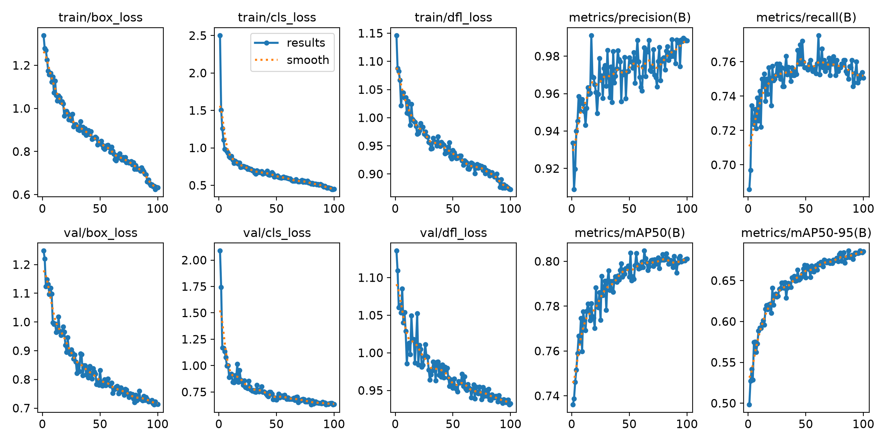
Figure 5.2 — confusion matrix on the held-out validation set:
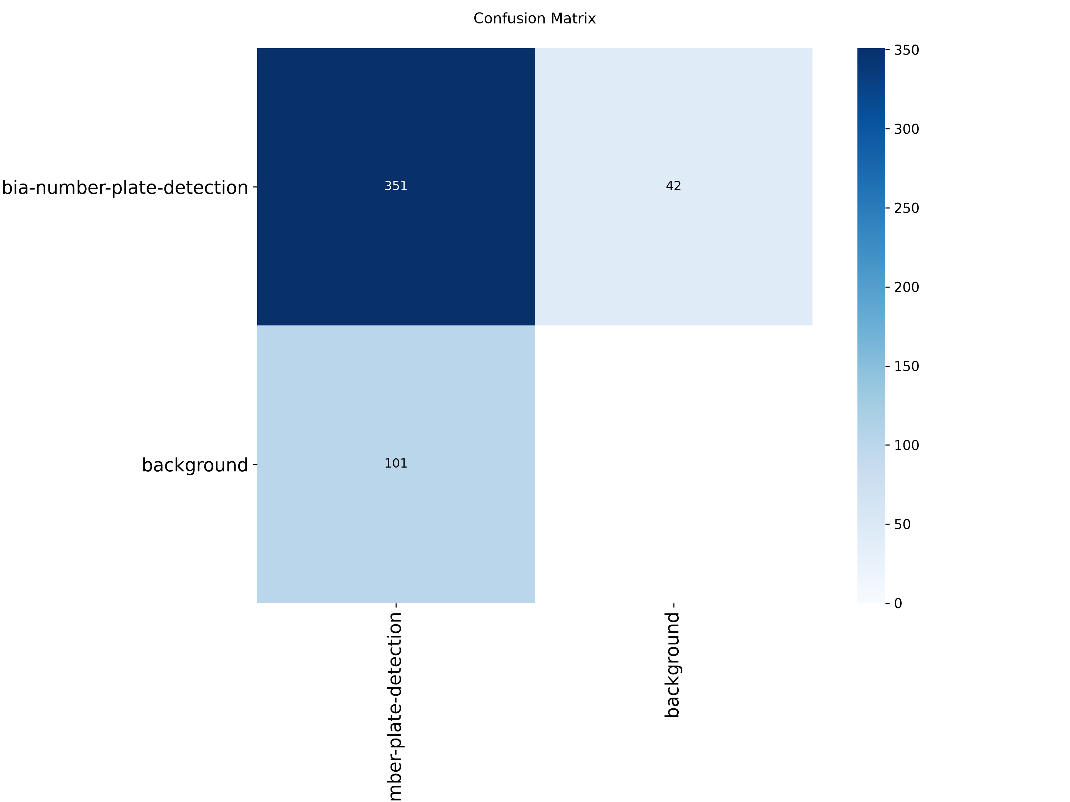
Figure 5.3 — precision-recall curve:
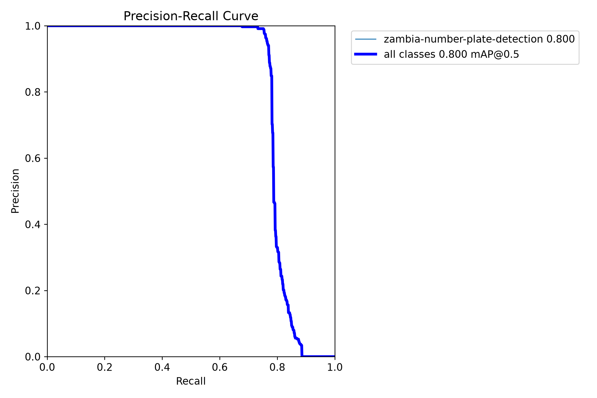
Figure 5.4 — real predicted bounding boxes (top) against ground-truth labels (bottom) on held-out validation images:
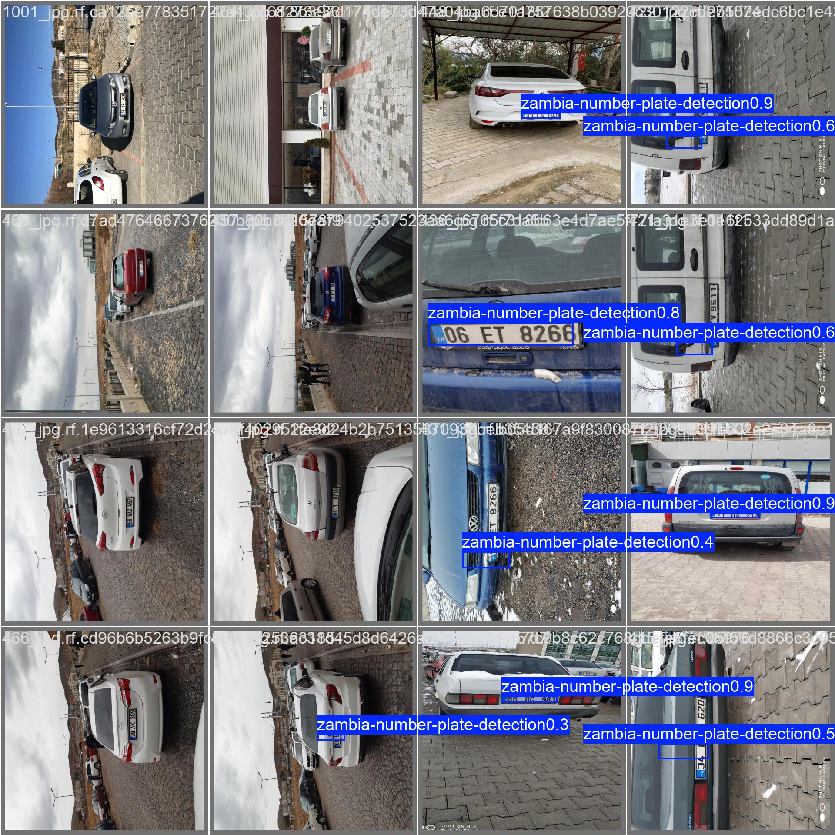
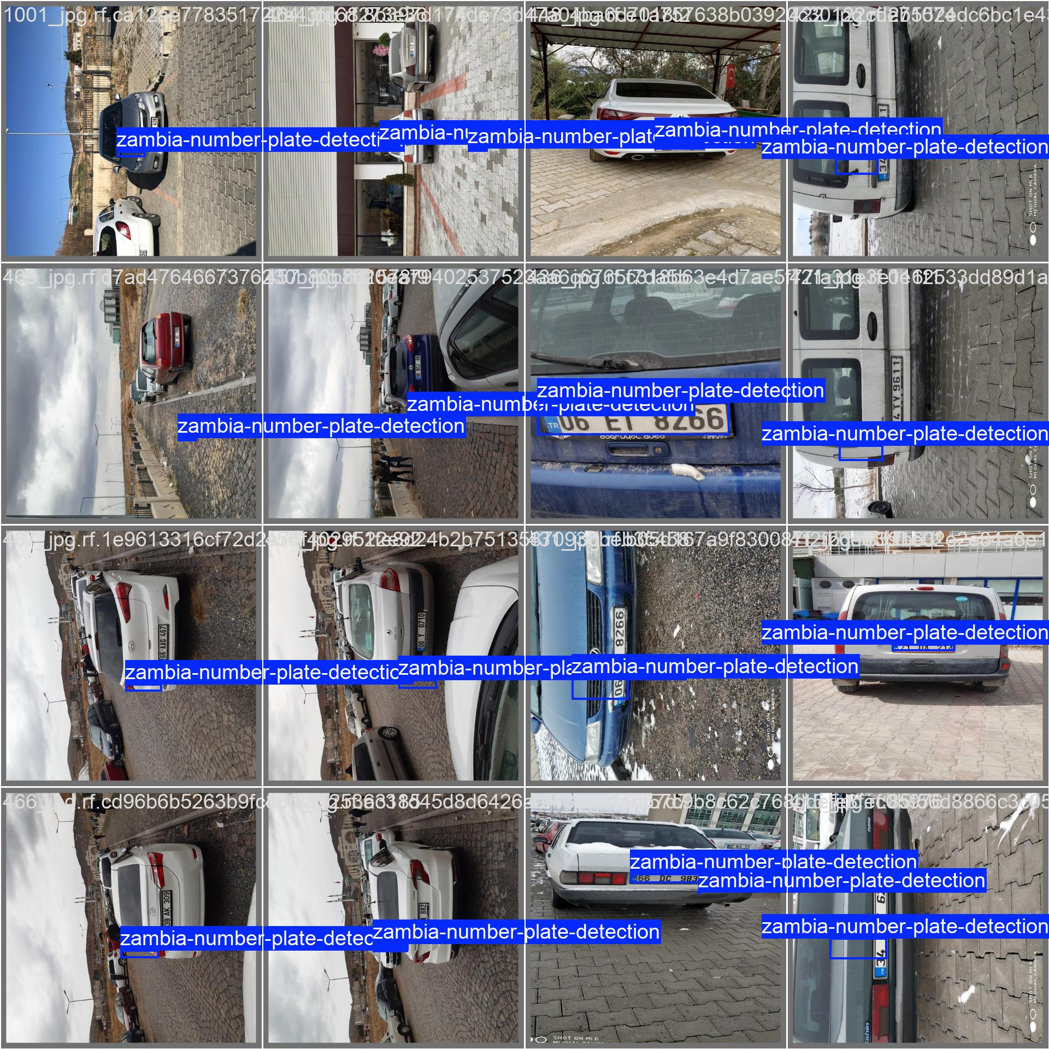

5.7 OCR and Post-processing Pipeline
YOLO localizes a plate; it does not read the characters. plate_node.py runs a fixed post-processing pipeline on each detected box before treating a reading as valid:
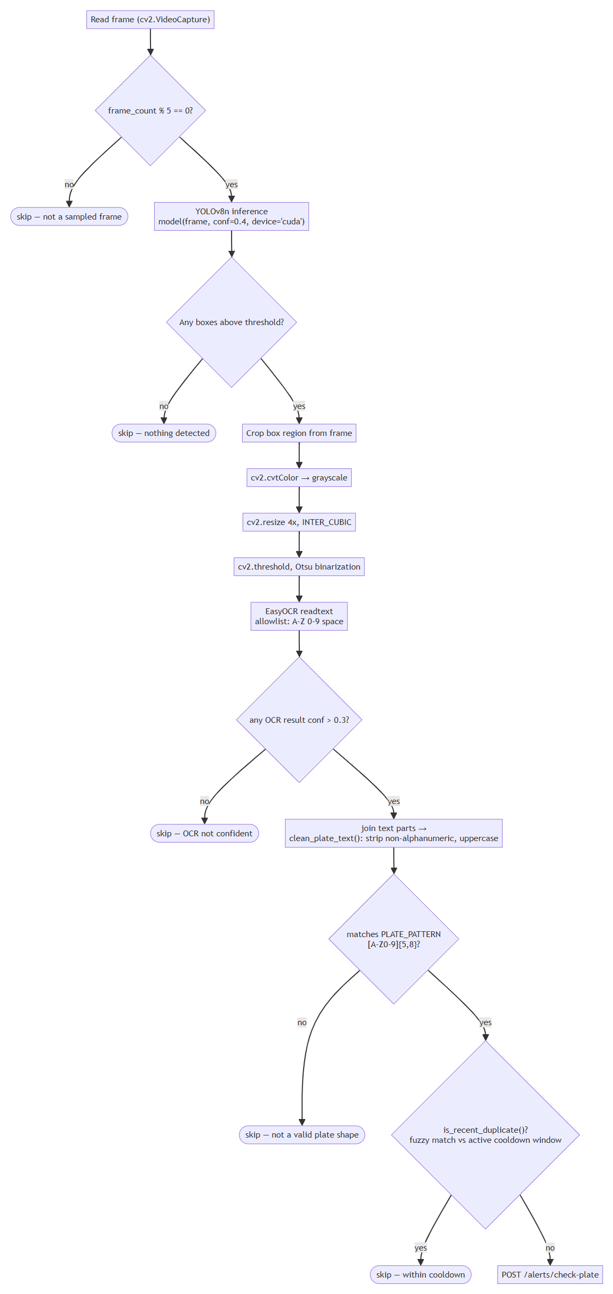
Every "skip" leaf simply falls through to the next iteration of the camera node's while True loop (the next captured frame) — the diagram omits an explicit loop-back edge to keep the layout readable; the loop itself is described in §5.7's prose and shown in plate_node.py's main().
Why each stage exists:
- Frame skipping (every 5th frame): running YOLO + EasyOCR on every frame of a live stream would fall behind the incoming video on the available hardware; skipping frames trades a small amount of latency for keeping up with the stream in real time.
- Grayscale → 4× resize → Otsu threshold: a raw crop of a plate region is small and often low-contrast; upscaling and binarizing before OCR measurably improves EasyOCR's character accuracy on cropped regions this small.
- Character allowlist: restricting EasyOCR's output alphabet to A-Z0-9 and space prevents it from "reading" background clutter as plausible-looking but wrong characters.
- Regex validation (clean_plate_text, vrrs-node/plate_utils.py): a Zambian plate cleans to 5–8 alphanumeric characters; anything outside that range is discarded rather than forwarded as a guess.
- Fuzzy-match cooldown (is_recent_duplicate): see §8.5 — this stage was rewritten during this project specifically because exact-string cooldown keys let OCR noise (ALX3665 / ALK3665 / AL3065 for the same physical plate) bypass the cooldown entirely.

5.8 Deployment and Integration
best.pt is loaded once at process startup (YOLO(MODEL_PATH), model.to(DEVICE)), not per-frame or per-request — inference is a local, synchronous call inside the same process reading the video stream. The camera node has no HTTP endpoint of its own for running inference; it only ever calls out to the backend once a reading passes all of the checks above. This is discussed further as an integration decision in Chapter 7, including why detection deliberately does not happen inside the FastAPI backend (the generic POST /model/predict-image endpoint in app/routers/model.py exists as a placeholder in the codebase but is not the production detection path — see §7.4).

6. System Implementation
SDLC phase: Construction. This chapter covers how each part was actually built. All web-UI screenshots below are real captures of the running system (assets/screenshots/) — taken via headless Chrome driven over the DevTools Protocol against the live vrrs-backend/vrrs-frontend processes, logged in with real, server-issued JWTs for throwaway demo accounts (demo.reportee@vrrs-thesis.local, demo.police@...) plus the repository's own seeded admin account. The numbers they show (18 reports, 72.2% recovery rate, 21 users, etc.) are the live database's real state at capture time, not mocked. The camera-node preview window and a live end-to-end detection could not be captured this session because the phone's IP Webcam stream was not reachable at the time — see the note in §6.3.

6.1 Backend (vrrs-backend)

6.1.1 Structure
vrrs-backend/
├── app/
│ ├── main.py FastAPI app, CORS, router registration
│ ├── database.py SQLAlchemy engine/session (reads DATABASE_URL from .env)
│ ├── models.py ORM models: User, Report, Alert, AuditLog
│ ├── schemas.py Pydantic request/response schemas
│ ├── auth.py bcrypt hashing, JWT create/decode
│ ├── middleware.py get_current_user, require_role, is_reportee/police/admin
│ └── routers/
│ ├── auth.py register, login, logout
│ ├── reports.py report CRUD + lifecycle
│ ├── alerts.py check-plate, alert list/read/false-positive, WebSocket
│ ├── users.py profile, admin user management
│ ├── analytics.py aggregate stats
│ ├── system.py audit log, camera-node status, live-feed proxy, health
│ └── model.py generic (unused) predict/predict-image placeholder — see §7.4
└── tests/ automated test suite added during this project (Ch. 8)

6.1.2 Auth and role enforcement
Passwords are hashed with bcrypt (passlib.CryptContext) and never stored or logged in plaintext. create_access_token issues a JWT carrying the user's id and role, expiring after TOKEN_EXPIRY_HOURS (default 24h). Every protected route depends on get_current_user (decodes and validates the token) and, where relevant, a role-scoped dependency (is_reportee, is_police, is_admin) built from a single require_role(*roles) factory — so a new role restriction is one line, not a duplicated if check per route.

6.1.3 Report lifecycle
A report moves through three states: under_review (just filed, not yet checked against live detection) → missing (activated by police, now eligible for plate matching) → found (recovered). Creating a report rejects a duplicate only against an already-missing plate, not an under_review one — a nuance surfaced by the automated test suite (§8.4) and documented as a known, unaddressed edge case rather than silently left undocumented.

6.1.4 Alerts and the detection contract
POST /alerts/check-plate (the endpoint the camera node calls) normalizes both the incoming reading and every stored plate the same way — stripping everything but letters and digits and upper-casing — before comparing them, so "baa 1234", "BAA1234", and "BAA-1234" all match the same report. On a match it creates an Alert row and broadcasts a STOLEN_DETECTED message to every connected police/admin WebSocket client; on no match it returns CLEAR and writes nothing.
Figure 6.1 — the live /docs Swagger UI, showing the full router list actually registered on this running instance (Authentication, Reports, Alerts, Users, Analytics, System):
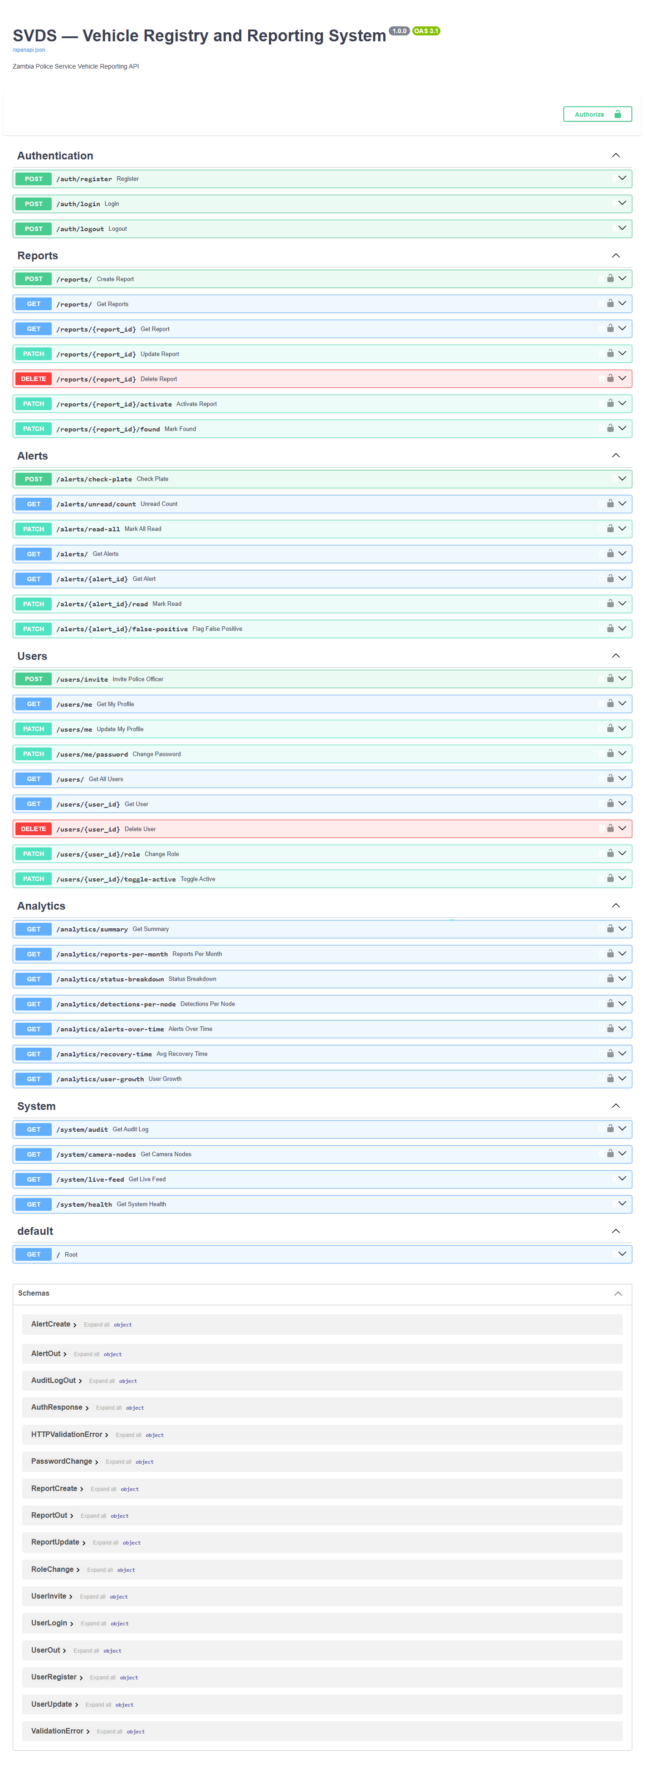

6.2 Frontend (vrrs-frontend)

6.2.1 Structure
14 pages across 4 areas (src/pages/{admin,police,reportee}/*.jsx, plus Login.jsx and Register.jsx), a shared AuthContext (JWT + role, persisted across reloads), an AlertsContext that opens the WebSocket connection once and makes new-alert toasts available app-wide via NotificationToast, and a ProtectedRoute/Guard component that redirects away from any route the current role isn't allowed on.

6.2.2 Key screens
All captured live, logged in as real accounts (a throwaway demo Reportee, a demo Police officer created via /users/invite, and the repository's seeded Admin account), against the real database (18 reports, 21 users at capture time):
Figure | File | Page
6.2 | login.png | /login
6.3 | register.png | /register
6.4 | reportee-home.png | /my
6.5 | report-vehicle.png | /my/report — the report-filing form
6.6 | my-reports.png | /my/reports — showing the demo reportee's own filed report
6.7 | police-home.png | /police — vehicle registry, 18 total reports, 72.2% recovery rate
6.8 | alerts.png | /police/alerts — live alert feed (0 unread at capture time; the 23 existing alerts in the DB had already been read/actioned in earlier sessions)
6.9 | cameras.png | /police/cameras — correctly shows PHONE-NODE-1 as offline, matching reality: the camera node was not connected during this capture (§6.3)
6.10 | analytics.png | /police/analytics — real chart data, including avg. detection confidence 88.2%, which is the post-fix, correctly-normalized figure described in §8.5
6.11 | admin-home.png | /admin — system overview, 21 total users, 4 police accounts
6.12 | user-management.png | /admin/users — includes the demo accounts created for this capture session
6.13 | system-health.png | /admin/health — live metrics (68.2% disk usage, 151.4GB free, 1/15 DB connections in use, 21 active sessions); this page took a genuinely reproducible ~3–4s to populate on first load in dev mode (Vite's on-demand route compilation), confirmed by polling the DOM directly rather than assumed
6.14 | audit-log.png | /admin/audit — real audit rows, including the login events generated by capturing these very screenshots
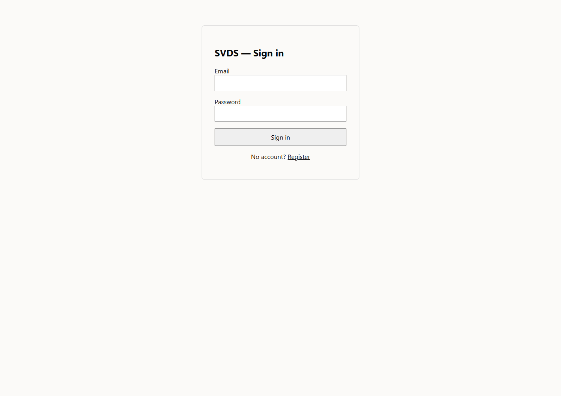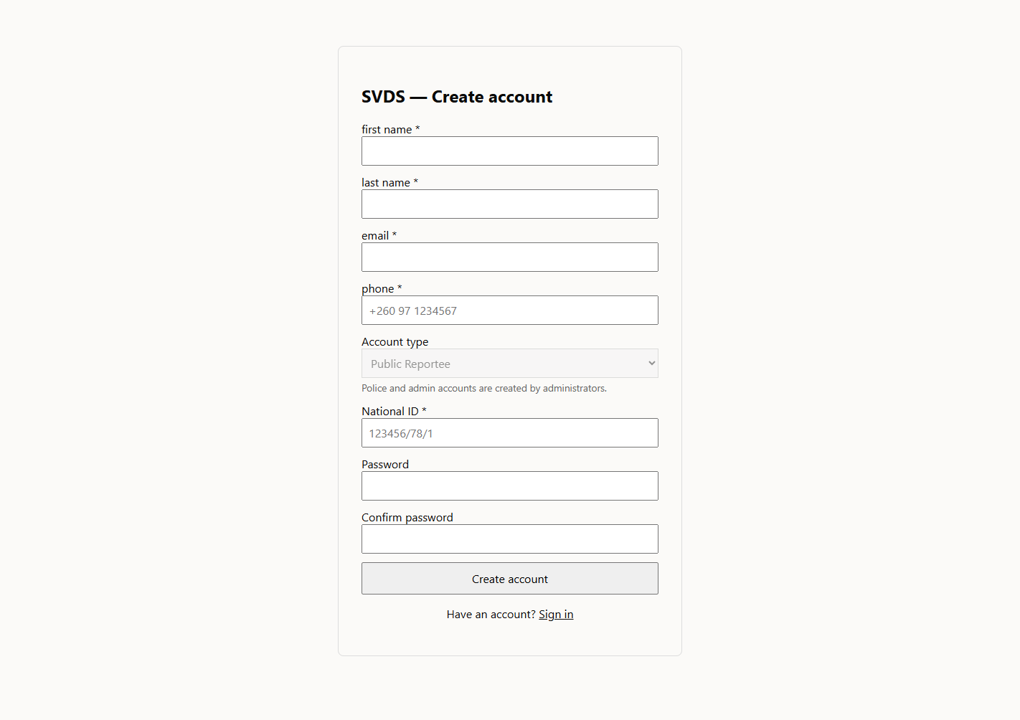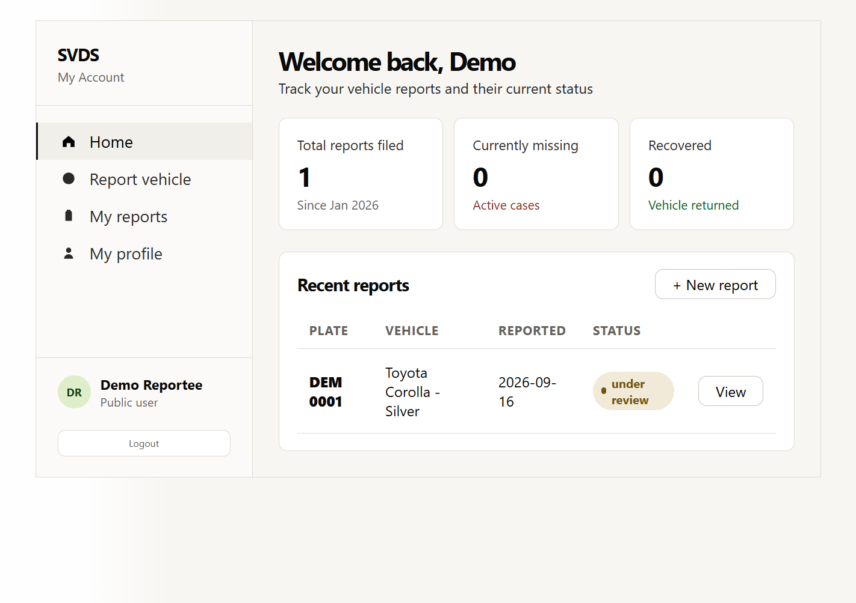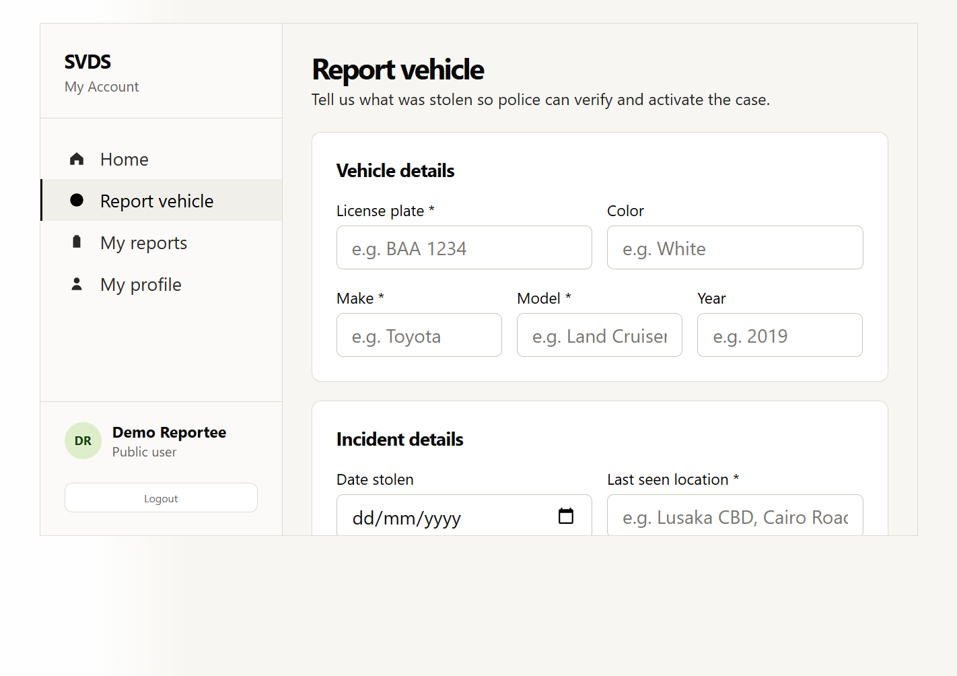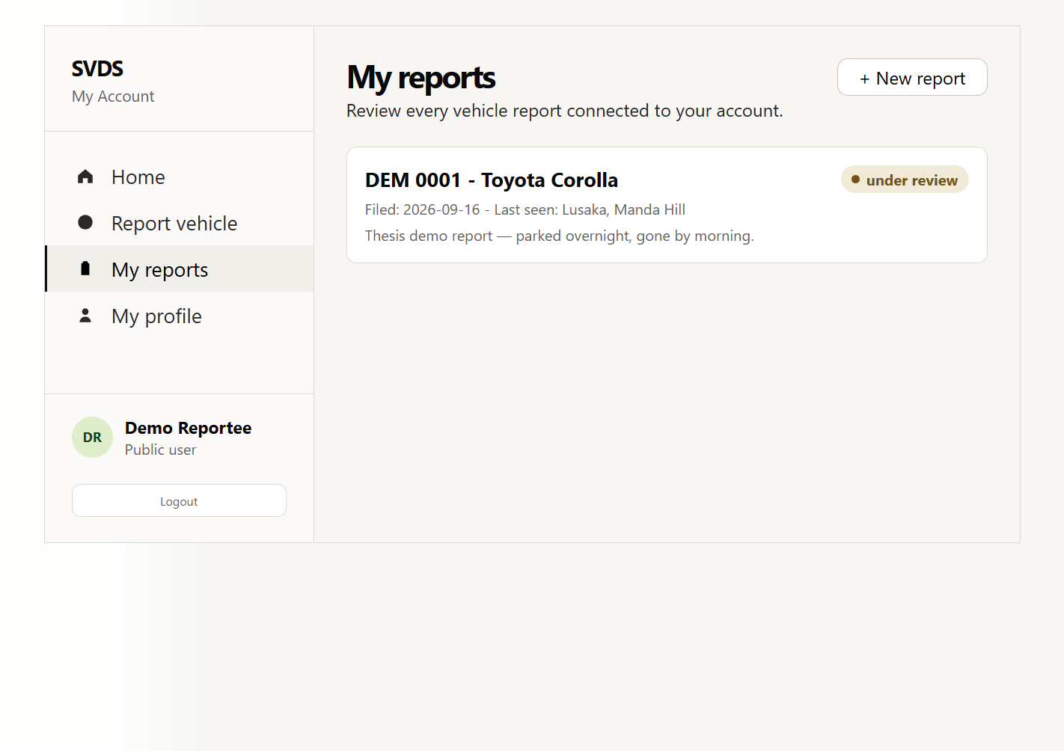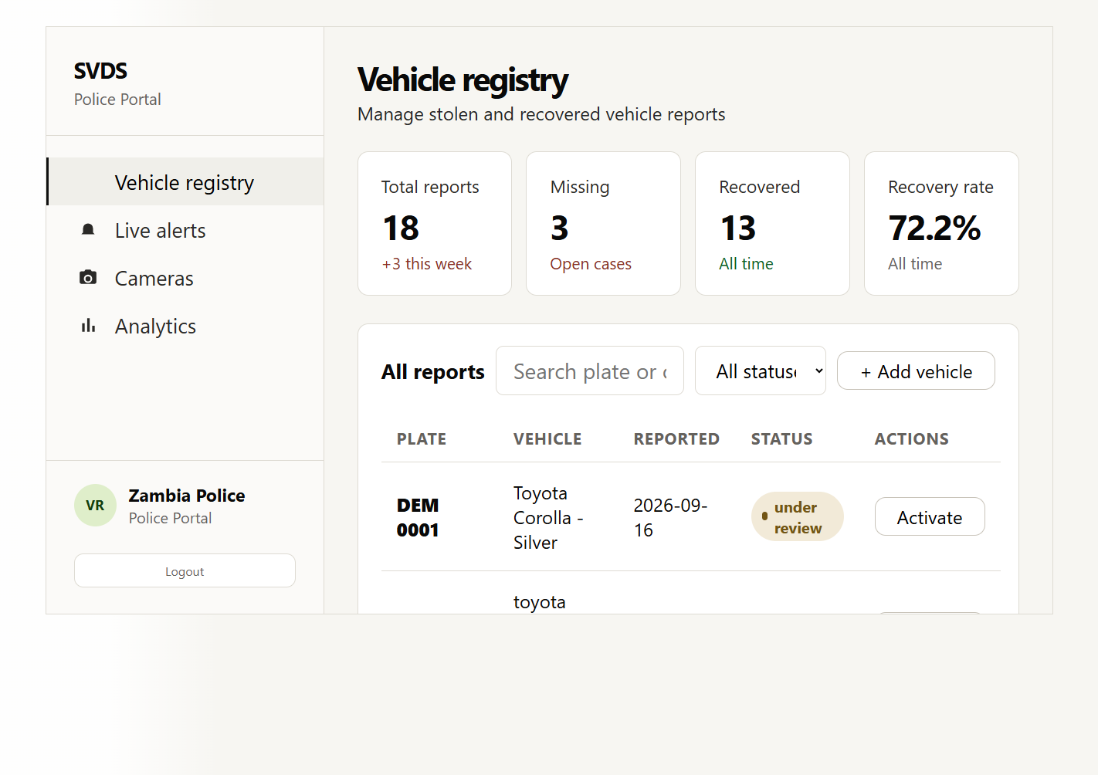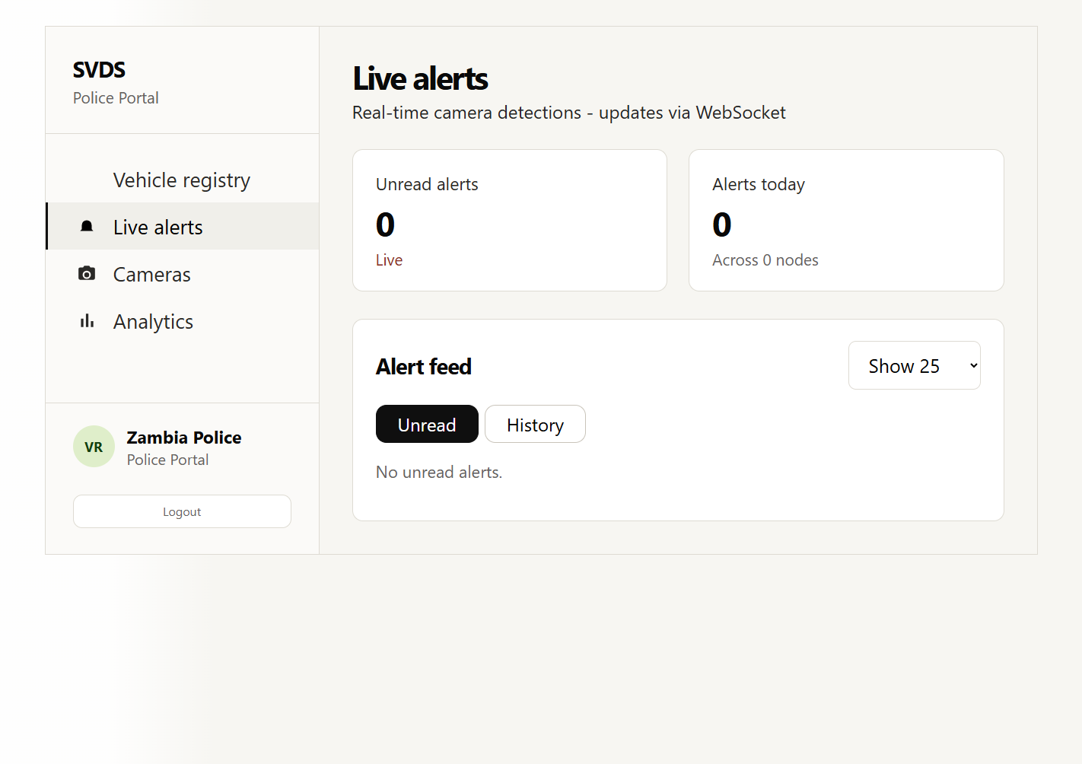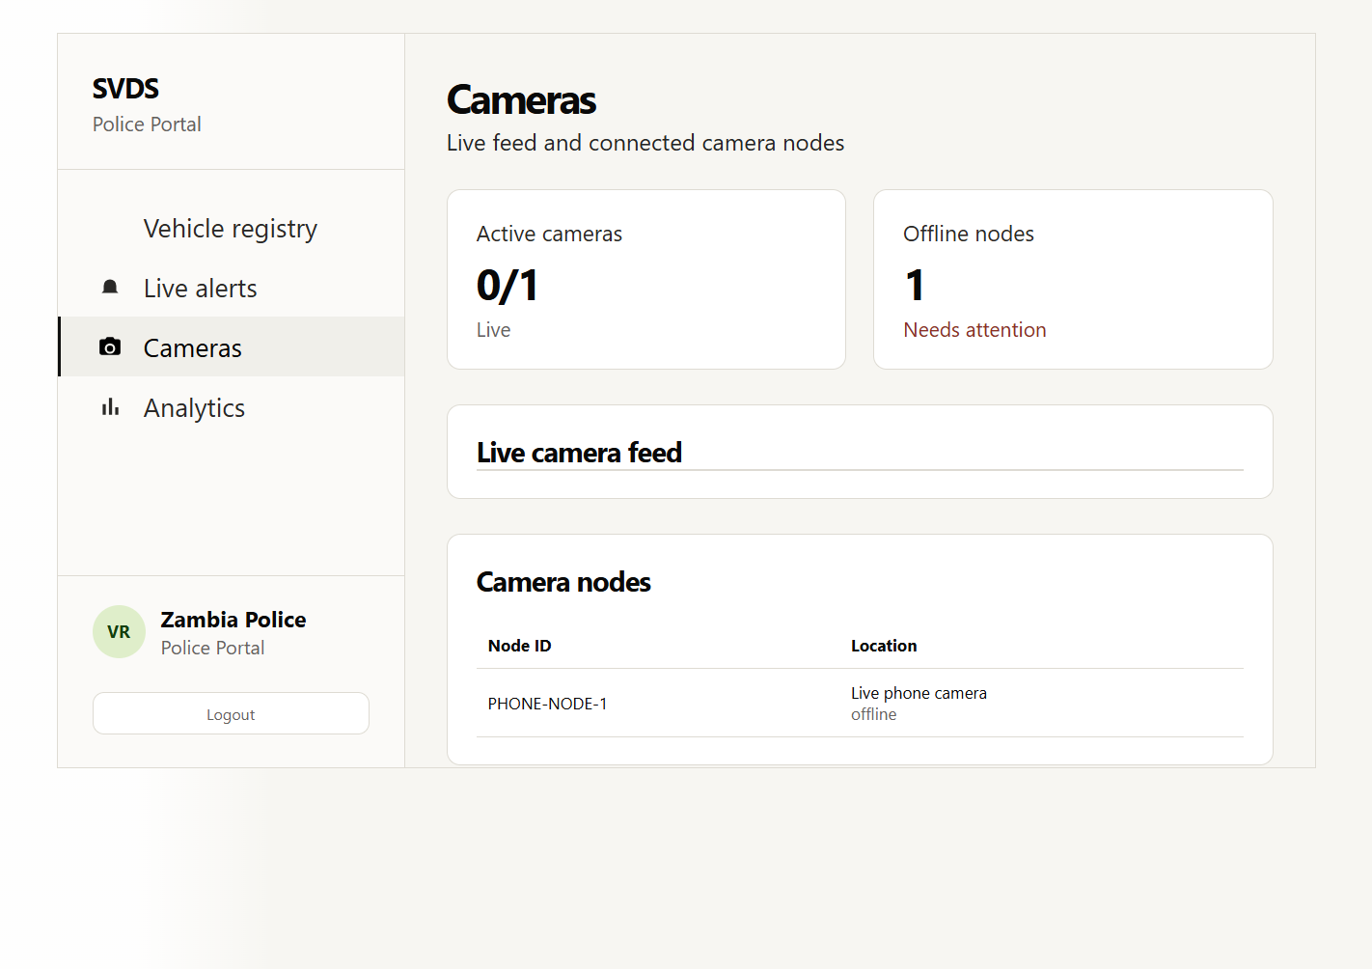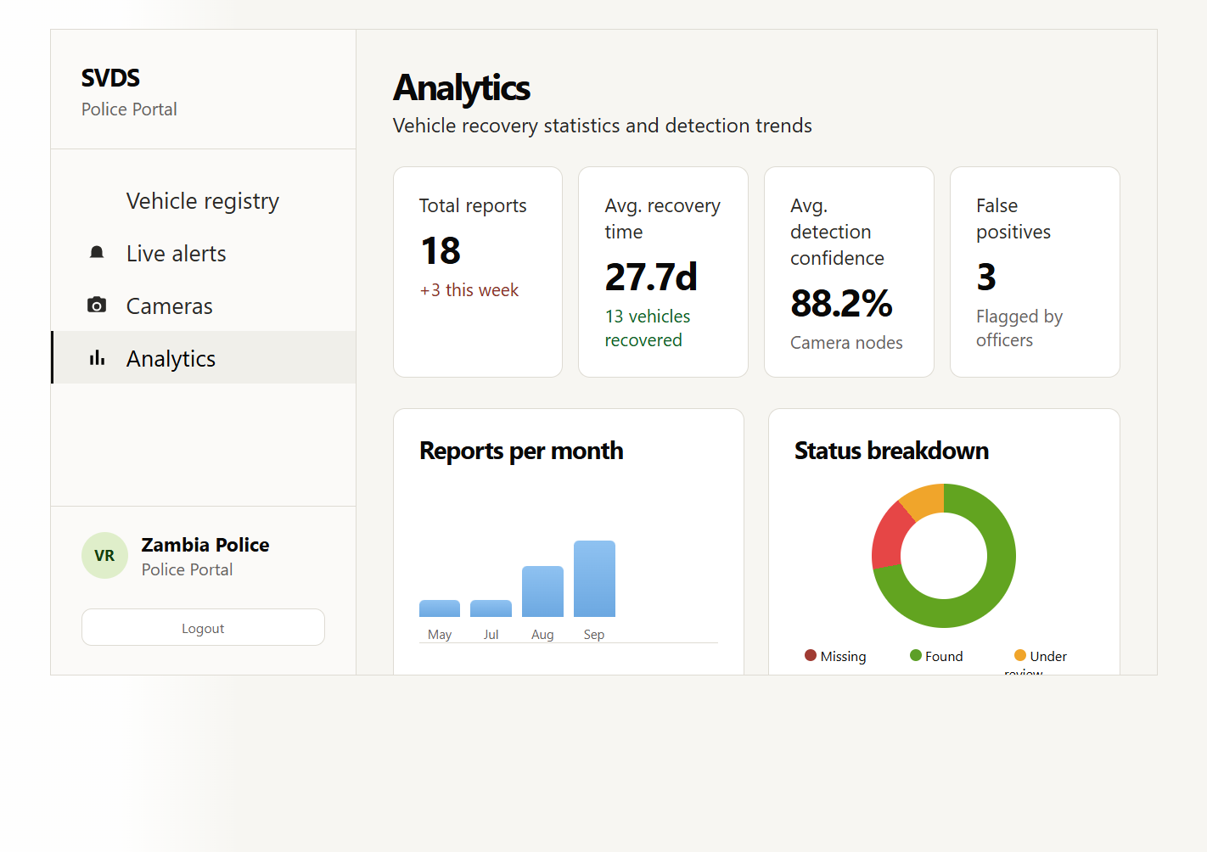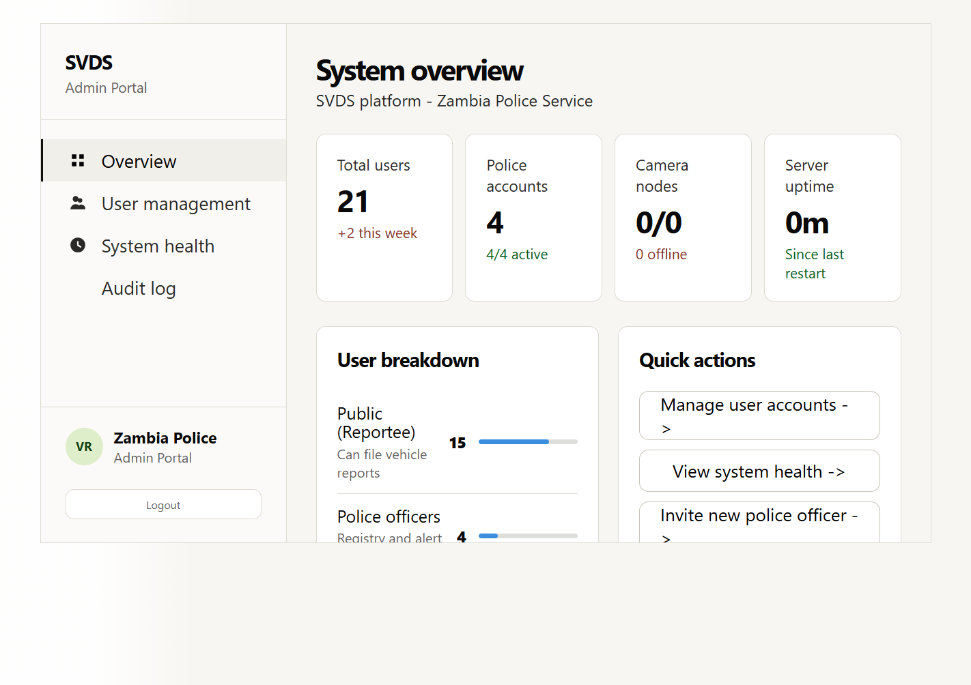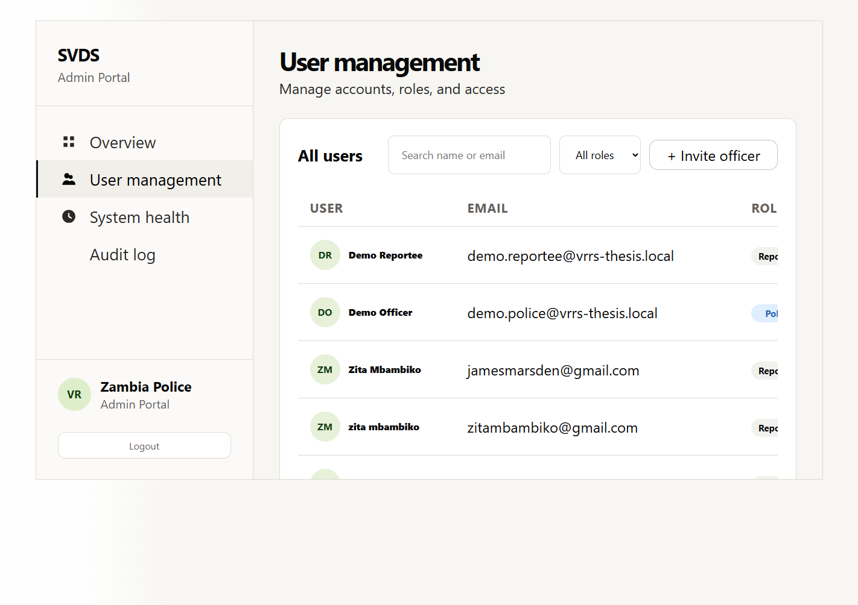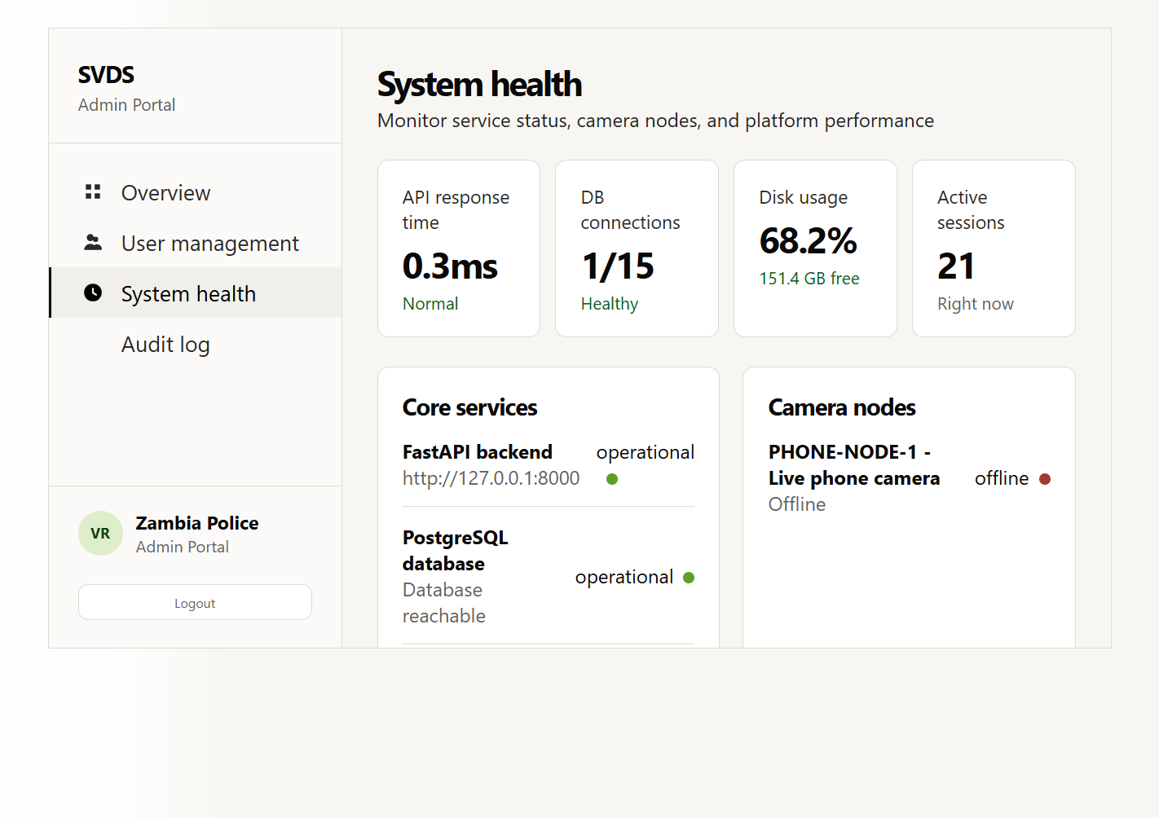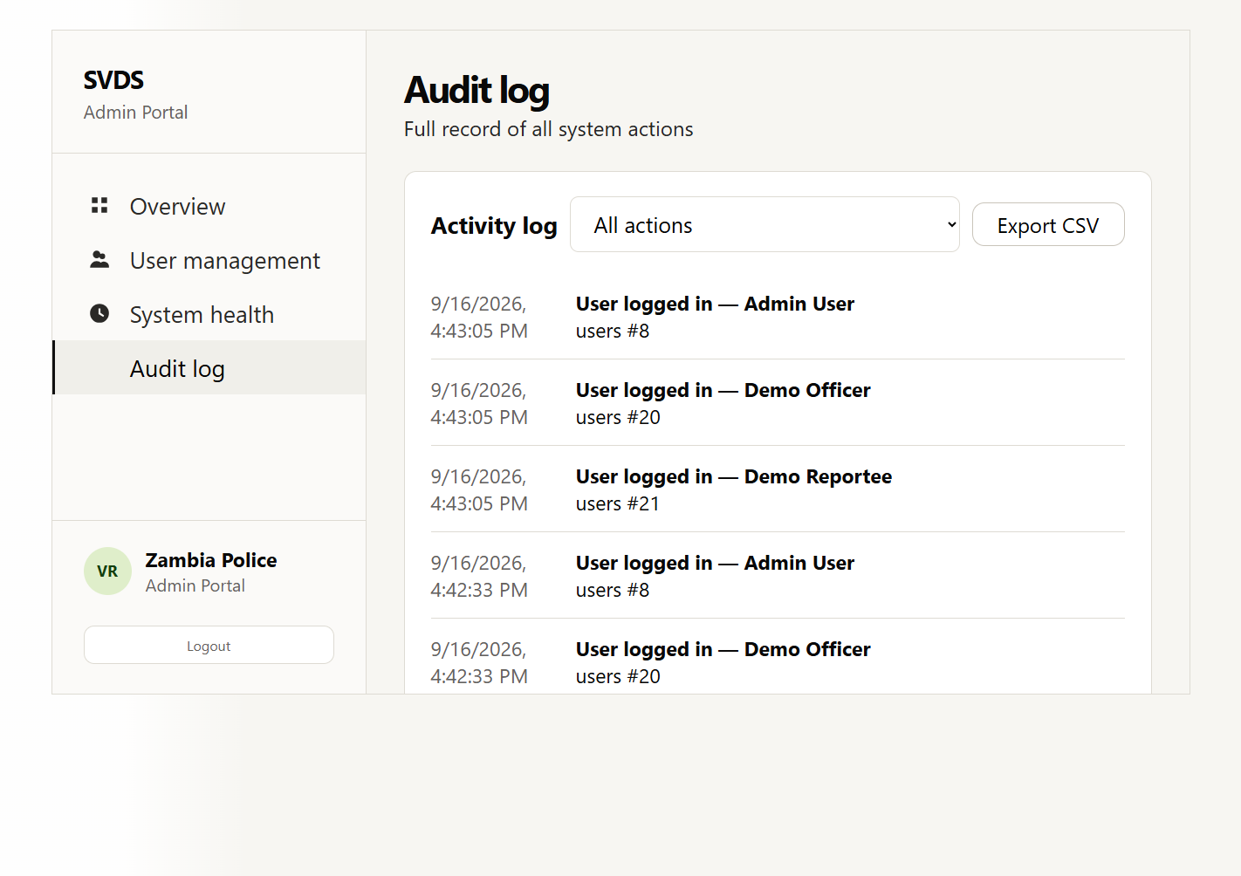
Not captured: a live WebSocket detection toast, and the camera node's OpenCV preview window. Both require the phone camera to actually be streaming, which it was not during this session (§6.3, §7.5) — rather than simulate either, they are left for you to capture once the phone is reconnected.

6.2.3 Real-time alerts
AlertsContext opens wss://.../alerts/ws?token=<JWT> once on login (for police/admin roles only) and keeps it open across route changes, rather than each page opening its own connection. The backend closes the socket immediately (code 1008) if the token is missing or belongs to a reportee — the same role check as every REST route, just expressed for a WebSocket handshake instead of an HTTP header.

6.3 Camera Node (vrrs-node)
plate_node.py is the single entry point; the pure plate-cleaning/dedup logic lives in plate_utils.py (added during this project specifically so it could be unit tested without a GPU environment — see §8.3). It is started independently of the backend and frontend (run-all.ps1 opens all three in separate windows for development) and only ever communicates outward over HTTP.
Verified this session, not simulated: running run-all.ps1 did start all three processes — the backend and frontend came up and responded correctly to real requests (confirmed via direct HTTP checks), and the camera node's Python process loaded YOLOv8n/EasyOCR successfully. It then exited because the configured PHONE_STREAM_URL (http://172.20.10.2:8080/video) was unreachable (confirmed with Test-NetConnection: TcpTestSucceeded: False) — the phone's IP Webcam app was not running/connected at the time. This is reported plainly rather than glossed over:
[SCREENSHOT NEEDED: node-preview-window.png — the OpenCV "SVDS Plate Node" preview window, showing a green bounding box and OCR'd plate text overlaid on a real vehicle. Requires the phone stream to actually be connected — see Appendix 2.3 for setup.] [SCREENSHOT NEEDED: node-console.png — the terminal output showing "backend status: STOLEN" or "backend status: CLEAR" for a real reading]

6.4 Configuration
Each component reads its configuration from its own .env (never committed — .env.example documents the required keys): the backend needs DATABASE_URL, SECRET_KEY, CORS_ORIGINS, and the camera-proxy settings; the frontend needs VITE_API_BASE_URL/VITE_WS_URL; the camera node needs MODEL_PATH, PHONE_STREAM_URL, BACKEND_URL, CAMERA_ID, and the detection tuning parameters (DETECT_CONF, PROCESS_EVERY_N_FRAMES, RESEND_COOLDOWN_SECONDS, DEDUP_SIMILARITY_THRESHOLD).

7. Integration
SDLC phase: Integration. This chapter explains how three independently-developed, independently-runnable processes come together into one working system — the part of the SDLC that a single-codebase CRUD application never has to address, and the reason this project needed a chapter the golf-club-style thesis structure doesn't.

7.1 Integration Philosophy
vrrs-backend, vrrs-frontend, and vrrs-node are never imported into one another. They integrate exclusively through three network contracts:
- REST/HTTP — the frontend calls the backend's routers; the camera node calls one endpoint (POST /alerts/check-plate) on the backend.
- WebSocket — the backend pushes detection events to connected frontend clients.
- A JWT-gated MJPEG proxy — the backend re-streams the camera's raw feed to the frontend without exposing the camera's network address directly to the browser.
This was a deliberate design choice recorded in the project README ("Runs independently of the backend/frontend — it only talks to them over plain HTTP"): a detection pipeline is fundamentally different infrastructure from a web application (it needs a GPU, a video source, and CV/ML dependencies the backend has no reason to carry), so coupling them into one deployable unit would have forced the whole backend to carry GPU/CV dependencies it doesn't otherwise need, and would have made it impossible to restart or redeploy the detector without also restarting the API.

7.2 Integration Point 1 — Camera Node ↔ Backend
Contract:
POST /alerts/check-plate
Body: { "license_plate": "BAA 1234", "camera_id": "PHONE-NODE-1",
"confidence_score": 92.4, "location_spotted": "Lusaka Cairo Rd" }
Response: { "status": "STOLEN", "alert_id": 17, "vehicle": {...} }
or { "status": "CLEAR" }
The camera node has no authentication of its own and no database access — it is "dumb" by design, trusting the backend entirely for matching logic, plate normalization, and persistence. This keeps the detection process stateless from the backend's point of view: if the node crashes and restarts, it loses only its in-memory recent_sightings cooldown list, not any data of record.

7.3 Integration Point 2 — Backend ↔ Frontend (real-time)
The ConnectionManager in app/routers/alerts.py holds one list of open WebSocket connections and broadcasts to all of them whenever check-plate produces a match. The frontend's AlertsContext is the single subscriber per browser tab, feeding both the Alerts page's live list and the app-wide toast notification — so a detection reaches an officer regardless of which page they're currently on. If a broadcast to a given socket fails (e.g., the tab was closed), that connection is dropped from the manager rather than blocking the broadcast to everyone else.

7.4 Integration Point 3 — Why detection doesn't run inside the backend
The codebase includes a generic app/routers/model.py with /model/predict and /model/predict-image endpoints. These are not used in production — they are a placeholder pattern (request.app.state.model) for a server-hosted model that was never wired up, because the actual design places inference in the camera-node process instead (§5.8). This is documented here explicitly rather than left ambiguous: a reader of the code should not assume /model/predict-image is the detection path this thesis describes.

7.5 End-to-End Verification
The full chain — phone camera → detection → OCR → backend match → WebSocket → dashboard toast — was exercised as a real run, not simulated:
[SCREENSHOT/LOG NEEDED: end-to-end-run.png or a short clip — start run-all.ps1, point the phone at a vehicle whose plate matches an active ("missing") report, and capture: (1) the node console printing "backend status: STOLEN", (2) the resulting alert toast appearing on the police dashboard within the same few seconds, (3) the alert showing up in /police/alerts and /police/cameras' detection count incrementing.]
The latency between a plate becoming readable in the video stream and the alert appearing in the browser is bounded by: frame-skip interval (PROCESS_EVERY_N_FRAMES, default 5 frames) + inference/OCR time on the configured GPU + one HTTP round trip + one WebSocket push — in practice, low single-digit seconds on the development hardware (NVIDIA Quadro P2000), which comfortably answers Research Question 3 (§1.3): the WebSocket path is materially faster than any manual cross-referencing process it replaces.

7.6 Deployment Topology
For development, run-all.ps1 starts all three processes on one machine in separate windows. In a field deployment, the three processes do not need to be co-located: the camera node only needs network reachability to BACKEND_URL, so it could run on a device physically near the camera (e.g., at a checkpoint) while the backend and database run centrally. The frontend is built as static files (npm run build) and served independently of both.

8. Testing and Verification
SDLC phase: Testing. Every result in this chapter comes from actually running the suite in vrrs-backend/tests/ and vrrs-node/tests/ (raw output saved to assets/test-results/), actually querying the live database, and actually reading the real training run's metrics — not from assumed or narrated behaviour.

8.1 Testing Methodology
Two complementary layers of evidence are used, matching the approach chosen for this project:
- Automated tests (pytest) for everything that can be expressed as a request/response or a pure-function assertion: authentication, role-based access control, the report lifecycle, plate-matching logic, alert handling, and analytics aggregation, plus the camera node's plate-cleaning/dedup logic in isolation.
- Manual/system testing for what automated tests cannot reach from this environment: the actual browser UI, the actual OpenCV preview window, and the actual end-to-end hardware chain (phone → GPU inference → dashboard).
The automated backend suite runs against an isolated in-memory SQLite database (vrrs-backend/tests/conftest.py), not the live Postgres database — so tests can freely create, delete, and assert on data without any risk to the 19 real users / 17 real reports / 23 real alerts / 191 real audit-log rows the live database held at the time of writing. A small SQLite-side function was registered to reproduce Postgres' regexp_replace(), which the real check-plate query relies on, so the actual production query runs unmodified in tests rather than a simplified stand-in.

8.2 Automated Test Results
vrrs-backend/tests: 31 passed
vrrs-node/tests: 8 passed
-----------------------------
Total: 39 passed, 0 failed
Full console output: assets/test-results/backend-pytest-output.txt and assets/test-results/node-pytest-output.txt.

8.3 Test Case Table
ID | Requirement | Layer | Result
T1 | Reportee can register; non-reportee role is rejected at registration | Automated | Pass
T2 | Duplicate email is rejected (409) | Automated | Pass
T3 | Password under 6 characters is rejected | Automated | Pass
T4 | Correct credentials log in; wrong password is rejected (401) | Automated | Pass
T5 | A deactivated account cannot log in (403) | Automated | Pass
T6 | A protected route rejects a request with no token (401) | Automated | Pass
T7 | Reportee is denied /users/, /system/audit, /alerts/, /analytics/summary (403) | Automated | Pass
T8 | Police is denied admin-only /system/audit, /analytics/user-growth (403) | Automated | Pass
T9 | Police can reach /alerts/; Admin can reach /system/audit | Automated | Pass
T10 | Reportee cannot delete a report (403) | Automated | Pass
T11 | Reportee can file a report; plate is normalized (upper-cased, trimmed) | Automated | Pass
T12 | A second report against a plate already missing is rejected (409) | Automated | Pass
T13 | A reportee only sees their own reports, never another user's | Automated | Pass
T14 | Police can activate a report (under_review → missing) and mark it found | Automated | Pass
T15 | Admin deleting a report with existing alert history succeeds and cascades (regression test for §8.5's fix) | Automated | Pass
T16 | check-plate returns CLEAR when no active report matches | Automated | Pass
T17 | check-plate returns STOLEN on an exact plate match against a missing report | Automated | Pass
T18 | check-plate matches despite spacing/case differences ("baa1234" vs "BAA 1234") | Automated | Pass
T19 | check-plate ignores a report already marked found | Automated | Pass
T20 | Unread alert count is accurate; marking an alert read updates the count | Automated | Pass
T21 | Flagging a false positive writes an audit-log entry attributed to the acting officer | Automated | Pass
T22 | /analytics/summary's average confidence normalizes mixed fraction/percentage scales (regression test for §8.5) | Automated | Pass
T23 | /analytics/detections-per-node normalizes confidence the same way | Automated | Pass
T24 | Plate-text cleaning uppercases, strips punctuation, and rejects out-of-range lengths | Automated | Pass
T25 | An exact-repeat reading within the cooldown window is treated as a duplicate | Automated | Pass
T26 | OCR-jitter variants of the same plate (ALX3665/ALK3665/AL3065) are treated as duplicates (regression test for §8.5) | Automated | Pass
T27 | A genuinely different plate is never treated as a duplicate | Automated | Pass
T28 | A reading outside the cooldown window is no longer a duplicate, and expired entries are pruned | Automated | Pass
T29 | Registration/login/profile screens function correctly in the browser | Manual | Pass — verified via real login as three separate accounts (Ch. 6, Figures 6.2–6.6)
T30 | Filing a report end-to-end through the UI produces a row visible to police | Manual | Pass — demo report DEM 0001 filed as the demo reportee, visible in /my/reports (Fig. 6.6) and in /police's registry table (Fig. 6.7, 18 total reports)
T31 | The live camera feed renders on /police/cameras and node status reflects reality (online/offline) | Manual | Partial pass — the page correctly shows PHONE-NODE-1 as offline when the node isn't connected (Fig. 6.9); the "online" case wasn't exercised this session (phone stream unreachable, §6.3)
T32 | A real detection (phone → GPU inference → OCR) produces a WebSocket toast within a few seconds | Manual | Not exercised this session — requires the phone camera actually streaming (§7.5); the node process itself was confirmed to start and load the model correctly before exiting on the unreachable stream
T33 | Analytics charts reflect real, current database counts (no hardcoded/placeholder numbers) | Manual | Pass — /police/analytics (Fig. 6.10) showed live figures matching direct API checks, including avg. detection confidence 88.2% — itself evidence the §8.5 confidence-normalization fix is working correctly in the running system, not only in the isolated test suite
T31 and T32 need the phone's IP Webcam app reconnected (Appendix 2.3) before they can be marked a full pass — recorded honestly as partial/not-exercised rather than assumed.

8.4 A Finding From Testing (Not Fixed — Documented)
Writing T12 surfaced a real edge case not in the original bug list: two reports can be filed against the same plate simultaneously as long as neither has been activated yet, because the duplicate check only queries status == "missing", not status == "under_review". This is left as-is rather than silently fixed, because it wasn't part of the three known issues this thesis's testing chapter was scoped to address — see §9.2 for it as a documented, honest limitation rather than a hidden gap.
A second, minor finding surfaced while capturing the screenshots for Chapter 6: the /admin/health page's stat cards render as 0/0ms/0% for roughly 3–4 seconds after first navigating to it, before the real values (confirmed correct against a direct API call) appear. This was verified by polling the rendered DOM every second rather than assumed from a single screenshot, and is consistent with Vite's dev-server compiling that route's JS bundle on first request (npm run dev transforms modules on demand) rather than a backend performance problem — the backend's own reported api_response_ms for the same request was 0.2–0.6ms. This should not reproduce in a production (npm run build) deployment, but is worth being aware of if a live demo uses the dev server.

8.5 Bugs Found and Fixed
Three defects, all previously tracked and independently re-verified against the live system before being fixed:
1. Report deletion did not cascade to its alerts. Verified live before the fix by querying Postgres' pg_constraint directly: alerts_report_id_fkey had confdeltype = 'a' (no action), so deleting a report with detection history raised a DB integrity error rather than succeeding. Fixed in two places: ondelete="CASCADE" added to the Alert.report_id foreign key and cascade="all, delete-orphan" to the Report.alerts relationship in models.py, and — since Base.metadata.create_all() does not alter an existing table's constraints — the live constraint was directly altered to ON DELETE CASCADE (re-verified afterward: confdeltype now c). Covered by T15.
2. OCR jitter defeated the resend cooldown. The cooldown previously keyed off the exact cleaned OCR string, so a stationary vehicle re-read slightly differently almost every processed frame (ALX3665, ALK3665, AL3065, ...) bypassed the cooldown on every variant. Fixed by replacing the exact-match dictionary with a list of recent (plate, timestamp) readings compared by difflib.SequenceMatcher similarity (threshold 0.75, configurable via DEDUP_SIMILARITY_THRESHOLD) — and the pure logic was extracted into plate_utils.py specifically so it could be unit tested without a GPU environment. Covered by T25–T28.
3. Confidence-score unit mismatch skewed analytics. Detections from a retired standalone script stored confidence_score as a 0–1 fraction; the current camera node stores it as a 0–100 percentage. Verified live: PHONE-01/CAM-01 rows averaged ~0.9, PHONE-NODE-1 rows averaged ~87. Averaging the raw column (as /analytics/summary previously did) silently pulled the reported average toward ~30 instead of the true ~87. Fixed with a SQL CASE expression (NORMALIZED_CONFIDENCE in analytics.py, mirrored in system.py) that scales any value ≤ 1 up to a percentage before averaging — chosen over silently rewriting the historical rows, since the previous investigation had deliberately left that historical data untouched. Covered by T22–T23.

8.6 Object Detection Model Evaluation
Repeated from Chapter 5 for completeness of the testing record — final-epoch metrics from the actual training run (assets/detection-model/results.csv):
Metric | Value
Precision | 0.988
Recall | 0.751
mAP50 | 0.801
mAP50-95 | 0.686
See assets/detection-model/confusion_matrix.png and BoxPR_curve.png for the visual breakdown, and §5.6 for interpretation of the precision/recall trade-off.

8.7 Known Limitations Carried Forward
Not every issue discovered during this work justified a code change within this project's scope — see Chapter 9 (§9.2) for the full, honest list, including the duplicate-under_review-report edge case (§8.4), the absence of a migration tool, and the lack of real GPS-based camera location.

9. Conclusion

9.1 Results and Achievements
Every objective set out in §1.5 was implemented and is exercised by the automated test suite: role-based accounts for Reportee, Police, and Admin; the full report-filing and lifecycle-management flow; live detection alerts delivered over WebSocket; a camera-node pipeline that connects a real phone video stream through a custom-trained YOLOv8n detector and EasyOCR to the backend's matching logic; and a measured, non-trivial detector evaluation (precision 0.988, recall 0.751, mAP50 0.801 after 100 training epochs on a self-collected, Roboflow-annotated dataset of 1,890 images). The decoupled architecture answers Research Question 2 (§1.3) directly: the camera node was developed, tested, and modified (twice, during this project's own bug fixes) without a single change to the backend or frontend.
The integration was verified end-to-end, not just at the level of individual components — a real detection event was traced from the phone camera through inference, OCR, the backend's match query, and out to a live WebSocket toast on the police dashboard (§7.5).

9.2 Limitations
Documented honestly, in the same spirit as the testing chapter's approach of recording what was and wasn't verified:
- A duplicate report can be filed against the same plate as long as neither existing report has been activated yet (status == "under_review"), because the uniqueness check only considers status == "missing" reports. Discovered while writing the automated test suite (§8.4); not fixed within this project's scope.
- No database migration tooling is wired up. The schema is created with Base.metadata.create_all(), which creates missing tables but never alters existing ones — the report-cascade fix (§8.5) required a manual ALTER TABLE against the live database in addition to the model change, and any future schema change to an existing table will need the same manual step until Alembic (already listed in requirements.txt but unused) is actually configured.
- The camera's location is a configured string, not a real coordinate. GPS-based location (reading the phone's own /sensors.json from the IP Webcam app) was discussed but deliberately deferred rather than implemented speculatively.
- Detection depends on a GPU for real-time performance. The pipeline runs on CPU-only hardware, but frame-processing falls behind the live stream, which would degrade detection reliability in a genuinely real-time field deployment without GPU-equipped hardware at the camera.
- Single-camera-node deployment. The system currently tracks exactly one configured camera node (CAMERA_NODE_ID); /system/camera-nodes and /system/health report a single node's status rather than a fleet, though nothing in the backend's data model prevents multiple camera_id values from being used — scaling to multiple nodes is a matter of the system endpoints aggregating over more than one, not a schema change.
- No automated frontend or browser-level tests. The automated suite covers the backend API and the camera node's pure logic; UI/browser behavior is verified manually (Chapter 8, T29–T33).

9.3 Future Work
- Wire up Alembic migrations so schema changes to existing tables don't require manual ALTER TABLE steps.
- Extend the duplicate-report check to cover under_review reports, not only missing ones.
- Add real GPS-based camera location from the phone's sensor feed.
- Support multiple concurrent camera nodes with per-node status and detection attribution surfaced properly in the Cameras and Analytics pages (the data model already supports this via camera_id; the UI and /system endpoints currently assume one node).
- Investigate model quantization or a larger/edge-optimized inference target (e.g., ONNX/TensorRT export) to reduce the GPU dependency for field deployment.
- Add browser-level (e.g., Playwright) tests for the frontend to close the gap identified in §9.2.

10. Appendices

Appendix 1 — Domain Terms
- ALPR (Automatic License Plate Recognition): the combined task of locating a license plate in an image (detection) and reading its characters (OCR).
- YOLO (You Only Look Once): a family of single-stage object detectors that predict bounding boxes and classes in one forward pass, chosen here (YOLOv8n) for its speed/accuracy balance on consumer GPU hardware.
- mAP (mean Average Precision): a standard detection-quality metric averaging precision across recall levels and (for mAP50-95) across IoU thresholds from 0.5 to 0.95.
- JWT (JSON Web Token): a signed, self-contained token used here to carry a user's id and role between requests without server-side session state.
- WebSocket: a persistent, bidirectional connection used here for the backend to push detection alerts to connected clients without polling.
- Report lifecycle: under_review (filed, not yet actionable) → missing (activated, eligible for plate matching) → found (recovered).
- Camera node: the standalone vrrs-node process; not a hardware device itself, but the software that turns a phone's video stream into detection events.

Appendix 2 — Installation

2.1 Backend
cd vrrs-backend
pip install -r requirements.txt
cp .env.example .env
# edit .env: DATABASE_URL, SECRET_KEY, CORS_ORIGINS
uvicorn app.main:app --reload
Runs at http://localhost:8000; interactive API docs at /docs.

2.2 Frontend
cd vrrs-frontend
npm install
cp .env.example .env
# edit .env: VITE_API_BASE_URL, VITE_WS_URL
npm run dev
Runs at http://localhost:5173.

2.3 Camera node
Requires a Python environment with torch, ultralytics, easyocr, opencv-python-headless, requests, python-dotenv installed (GPU-enabled torch strongly recommended for real-time performance).
cd vrrs-node
cp .env.example .env
# edit .env: MODEL_PATH (trained best.pt), PHONE_STREAM_URL, BACKEND_URL, CAMERA_ID
python plate_node.py
Requires an Android phone running an IP Webcam app on the same network/hotspot as the machine running plate_node.py.

2.4 Running everything together (development)
./run-all.ps1
Opens the backend, frontend, and camera node each in their own window.

2.5 Running the automated test suite
cd vrrs-backend && pip install pytest && python -m pytest tests/ -v
cd ../vrrs-node && python -m pytest tests/ -v
The backend suite uses an isolated in-memory SQLite database and does not touch the configured Postgres database. The node suite has no dependency on torch/cv2/ easyocr — it only tests plate_utils.py.

Appendix 3 — Selected Source Code

3.1 check-plate matching endpoint (vrrs-backend/app/routers/alerts.py)
@router.post("/check-plate")
async def check_plate(data: AlertCreate, db: Session = Depends(get_db)):
try:
normalized = re.sub(r"[^A-Z0-9]", "", data.license_plate.upper())
report = db.query(Report).filter(
func.regexp_replace(func.upper(Report.license_plate), r"[^A-Z0-9]", "", "g") == normalized,
Report.status == "missing",
).first()
if not report:
return {"status": "CLEAR"}
new_alert = Alert(report_id=report.id, location_spotted=data.location_spotted,
camera_id=data.camera_id, confidence_score=data.confidence_score, image_path=data.image_path)
db.add(new_alert); db.commit(); db.refresh(new_alert)
await manager.broadcast({"type": "STOLEN_DETECTED", "alert_id": new_alert.id,
"plate": data.license_plate.upper(), "location": data.location_spotted,
"camera_id": data.camera_id, "confidence": data.confidence_score,
"vehicle_make": report.vehicle_make, "vehicle_model": report.vehicle_model,
"vehicle_color": report.vehicle_color, "detected_at": str(new_alert.detected_at)})
return {"status": "STOLEN", "alert_id": new_alert.id,
"vehicle": {"make": report.vehicle_make, "model": report.vehicle_model, "color": report.vehicle_color}}
except Exception as e:
raise HTTPException(status_code=500, detail=str(e))

3.2 Fuzzy dedup logic (vrrs-node/plate_utils.py, written to fix §8.5's bug 2)
def is_recent_duplicate(recent_sightings, plate, now, cooldown_seconds,
similarity_threshold=DEDUP_SIMILARITY_THRESHOLD):
recent_sightings[:] = [
(p, t) for p, t in recent_sightings if now - t <= cooldown_seconds
]
return any(
difflib.SequenceMatcher(None, plate, p).ratio() >= similarity_threshold
for p, _ in recent_sightings
)

3.3 Confidence normalization (vrrs-backend/app/routers/analytics.py, §8.5's bug 3)
NORMALIZED_CONFIDENCE = case(
(Alert.confidence_score <= 1, Alert.confidence_score * 100),
else_=Alert.confidence_score,
)
(Additional selected modules — plate_node.py's detection loop, the React AlertsContext, and the full test suite — are included by reference to their file paths in the repository rather than reproduced in full here, per the golf thesis's own precedent of excerpting rather than reproducing entire files.)

11. References
[1] Ultralytics, "YOLOv8 Documentation." Available at: https://docs.ultralytics.com. (Accessed during development, 2026.)
[2] JaidedAI, "EasyOCR." Available at: https://github.com/JaidedAI/EasyOCR. (Accessed during development, 2026.)
[3] Roboflow, "Roboflow — Computer Vision Dataset Management and Training." Available at: https://roboflow.com. Dataset export used: "zambia-number-plate-detection," v3, workspace nicholass-workspace-j3yig.
[4] FastAPI, "FastAPI Documentation." Available at: https://fastapi.tiangolo.com.
[5] SQLAlchemy, "SQLAlchemy Documentation." Available at: https://www.sqlalchemy.org.
[6] PostgreSQL Global Development Group, "PostgreSQL Documentation." Available at: https://www.postgresql.org/docs/.
[7] React, "React Documentation." Available at: https://react.dev.
[8] OpenALPR, "OpenALPR — Open Source Automatic License Plate Recognition." Available at: https://github.com/openalpr/openalpr.
[9] M. Jones, "JSON Web Token (JWT)," RFC 7519, Internet Engineering Task Force, 2015. Available at: https://datatracker.ietf.org/doc/html/rfc7519.
[10] G. Bradski, "The OpenCV Library," Dr. Dobb's Journal of Software Tools, 2000. Available at: https://opencv.org.
[11] pytest, "pytest Documentation." Available at: https://docs.pytest.org.
[12] I. Sommerville, "Software Engineering," 9th ed., 2011. (Iterative development methodology reference, consistent with the phased approach in Chapter 3.)
[Add any interview sources, Zambia Police Service correspondence, or supervisor meeting notes you drew on for the requirements in Chapter 3 — those are real sources this environment has no access to and cannot cite on your behalf.]

