**UNICHAT: CONNECTING & CREATING INNOVATION BEYOND THE CLASSROOM**

**A Project Report**

Submitted in partial fulfilment of the requirements for the award of degree of

**Bachelor of Technology**

**(Computer Science & Engineering)**

**Submitted to**

**School of Computer Science & Engineering**

**LOVELY PROFESSIONAL UNIVERSITY**

**PHAGWARA, PUNJAB**



**From 01/10/24 to 05/10/24**

**SUBMITTED BY**

**Project Group Code: KC092**

**Course Code: CSE 445**

Gauri Jindal (12015730) **Name of Supervisor**

Prashant Kumar (12014798) Manpreet Singh

Akshita Oberoi (12002351) (Assistant Professor)

Aman Patel (12014728)

Karishma Moond (12016446) **UID of Supervisor**

Rohan Dhangar (12017415) 23789

**UNICHAT: CONNECTING & CREATING INNOVATION BEYOND THE CLASSROOM**

**A Project Report**

Submitted in partial fulfilment of the requirements for the award of degree of

**Bachelor of Technology**

**(Computer Science & Engineering)**

**Submitted to**

**School of Computer Science & Engineering**

**LOVELY PROFESSIONAL UNIVERSITY**

**PHAGWARA, PUNJAB**



**From 01/10/24 to 05/10/24**

**SUBMITTED BY**

**Project Group Code: KC092**

**Course Code: CSE 445**

Gauri Jindal (12015730) **Name of Supervisor**

Prashant Kumar (12014798) Manpreet Singh

Akshita Oberoi (12002351) (Assistant Professor)

Aman Patel (12014728)

Karishma Moond (12016446) **UID of Supervisor**

Rohan Dhangar (12017415) 23789

**Signature of Students** **Signature of Supervisor**

**DECLARATION BY STUDENTS**

**To whom so ever it may concern**

We, **Gauri Jindal (12015730), Akshita Oberoi (12002351), Rohan Dhangar (12017415), Aman Patel (12014728), Prashant Kumar (12014798), Karishma Moond (12016446),** hereby declare that the work done by us on “**UNICHAT: Connecting & Creating Innovation beyond the Classroom**” under the supervision of **Manpreet Singh**, **Assistant Professor,** Lovely professional University, Phagwara, Punjab, is a record of original workfor the partial fulfilment of the requirements for the award of the degree, **Bachelor of Technology (Computer Science & Engineering).**

Project Group Code: KC092

Name of the Student 1: Gauri Jindal

(Registration Number): 12015730

Name of the Student 2: Prashant Kumar

(Registration Number): 12014798

Name of the Student 3: Akshita Oberoi

(Registration Number): 12002351

Name of the Student 4: Aman Patel

(Registration Number): 12014728

Name of the Student 5: Karishma Moond

(Registration Number): 12016446

Name of the Student 6: Rohan Dhangar

(Registration Number): 12017415

Signature of the Student 1

Signature of the Student 2

Signature of the Student 3

Signature of the Student 4

Signature of the Student 5

Signature of the Student 6

Date:

**DECLARATION BY THE SUPERVISOR**

**To whom so ever it may concern**

This is to certify that **Gauri Jindal (12015730), Akshita Oberoi (12002351), Rohan Dhangar (12017415), Aman Patel (12014728), Prashant Kumar (12014798), Karishma Moond (12016446)** from Lovely Professional University, Phagwara, Punjab, has worked on “**UNICHAT: Connecting & Creating Innovation beyond the Classroom**” under my supervision. It is further stated that the work carried out by the students is a record of original work to the best of my knowledge for the partial fulfilment of the requirements for the award of the degree, **Bachelor of Technology (Computer Science & Engineering).**

Name of the Supervisor:

Manpreet Singh

UID of Supervisor:

23789

Designation:

Assistant Professor

Signature of Supervisor

Date:

**ACKNOWLEDGEMENT**

We would like to express our sincere gratitude to Manpreet Singh Sir for their invaluable guidance, support, and mentorship throughout this project. Their expertise and insightful feedback have been instrumental in shaping our research and guiding us towards successful outcomes.

We also extend our appreciation to our fellow group members for their collaboration, dedication, and contribution to this project. Each member's unique skills and perspectives have enriched our work and facilitated the achievement of our goals.

Additionally, we acknowledge the support and assistance provided by Lovely Professional University for granting us access to resources and facilities essential for conducting our research.

Finally, we thank our families and friends for their unwavering encouragement and understanding during the course of this project. Their support has been a source of strength and motivation throughout our journey.

**ABSTRACT**

In an era where traditional classroom interactions and social circles often fail to meet the evolving needs of students, UniChat emerges as a revolutionary platform aimed at fostering authentic connections, collaboration, and innovation within university communities. This comprehensive project report delves into the development and implementation of UniChat, a web-based platform designed to empower students from diverse academic disciplines to explore their passions, exchange ideas, and work together on projects that transcend the boundaries of their curricula.

The report begins by outlining the core objectives and mission of UniChat, highlighting its commitment to breaking down barriers, fostering a vibrant community of entrepreneurship, and equipping students with the skills necessary to realize their dreams and make a significant impact. It then details the distribution plan, which leverages social media, university networks, and student organizations to ensure widespread accessibility and adoption of the platform.

Recognizing the diverse needs and aspirations of its target audience, UniChat caters to students from all academic backgrounds, student groups, and faculty members who share a passion for innovation and collaboration. The report outlines strategic marketing strategies, including captivating promotional materials, social media campaigns, email newsletters, campus events, student influencer partnerships, and incentives for early adoption.

To ensure the sustainability and scalability of UniChat, the report presents a comprehensive budget and financing plan, encompassing website development, marketing expenses, revenue streams through premium features and partnerships, paid mentorship services, and legal processes to ensure compliance and user privacy protection.

Furthermore, the report provides a detailed timeline for the project, outlining the phases of market research, platform development, beta testing, and the official launch, followed by continuous improvement based on user feedback and evolving needs.

Ultimately, UniChat represents a transformative vision for the future of university communities, empowering students to unlock their full potential, collaborate beyond traditional boundaries, and collectively shape a better world through innovation and entrepreneurship.

**TABLE OF CONTENT**

|  |  |  |
| --- | --- | --- |
| **S. No.** | **TITLE** | **Page No.** |
|  |  |  |
| 1 | Declaration by the Students |  |
|  |  |  |
| 2 | Declaration by the Supervisor |  |
|  |  |  |
| 3 | Acknowledgement |  |
|  |  |  |
| 4 | Abstract |  |
|  |  |  |
| 5 | List of Tables |  |
|  |  |  |
| 6 | List of Figures/ Charts |  |
|  |  |  |
| 7 | List of Schema/Programming Implementation |  |
|  |  |  |
| 8 | Chapter-1 Introduction |  |
|  |  |  |
| 9 | Chapter-2 Review of Literature |  |
|  |  |  |
| 10 | Chapter-3 Implementation of project |  |
|  |  |  |
| 9 | Chapter-4 Results and Discussions |  |
|  |  |  |
| 10 | Final Chapter- Conclusion & Future Scope |  |
|  |  |  |
| 11 | List of Publications |  |
|  |  |  |
| 12 | References |  |
|  |  |  |
| 13 | Plagiarism report |  |
|  |  |  |
| 14 | References |  |
|  |  |  |
| 15 | Plagiarism report |  |
|  |  |  |

**LIST OF TABLES**

|  |  |  |
| --- | --- | --- |
| **Table No.** | **NAME** | **Page No.** |
| 1. | Technology Stack Overview for UniChat |  |

**LIST OF FIGURES / CHARTS**

|  |  |  |
| --- | --- | --- |
| **Fig. No.** | **NAME** | **Page No.** |
| 1.1. | Registration Process Flow for UniChat |  |
| 1.2. | Group Discussion Process Flow within UniChat |  |
| 1.3. | Chat Encryption Process for Secure Communication |  |
| 2. | User Engagement |  |
| 3. | Group Discussion Rooms for Collaboration |  |
| 4. | Private Rooms for Anonymous Interaction |  |
| 5. | Startup Component for Revenue Generation |  |

**LIST OF SCHEMA / PROGRAMMING IMPLEMENTATION**

|  |  |  |
| --- | --- | --- |
| S. No. | DESCRIPTION | Page No. |
| 1. | Frontend Pseudocode |  |
| 2. | Backend Pseudocode |  |
| 3. | Pseudocode for Chat Encryption and Decryption Process |  |

**| CHAPTER – 1**

**INTRODUCTION**

In the ever-evolving landscape of social media, a myriad of platforms has emerged, each catering to specific audiences and purposes. From the broad connectivity of Facebook to the professional networking of LinkedIn, these platforms have undoubtedly revolutionized the way we communicate and interact. However, amidst this digital landscape, there exists a notable void – a dedicated space tailored exclusively for university students worldwide, fostering connections, collaboration, and innovation within academic communities.

UniChat, a groundbreaking platform that seeks to bridge this gap and redefine the role of social media in higher education. It operates on the premise that universities are vibrant ecosystems brimming with intellectual curiosity, diverse perspectives, and untapped potential for interdisciplinary collaboration. By requiring users to sign up with their university credentials, UniChat creates an exclusive community composed solely of verified students, faculty, and staff members.

UniChat's vision extends far beyond mere social interaction; it aims to create a dynamic environment where students can embark on a journey of self-discovery, academic exploration, and personal growth. This innovative platform serves as a catalyst for learning, enabling students to engage with one another, share knowledge, and collaborate on projects that transcend the boundaries of traditional classroom settings.

At its core, UniChat represents a paradigm shift in the realm of social media, offering a dedicated space where university students can connect, learn, and innovate together. By fostering a sense of belonging and empowerment within the academic community, it endeavours to enhance the educational experience and equip students with the skills and mindset necessary to thrive in an increasingly interconnected world.

University life is a transformative period filled with remarkable opportunities for intellectual growth, self-discovery, and personal development. However, amidst the hustle and bustle of campus life, many students often find themselves grappling with a sense of isolation, struggling to forge meaningful connections and nurture their passions beyond the confines of their immediate social circles and academic disciplines.

UniChat redefines student connectivity, offering a unique space for idea exchange and collaboration. It fosters an inclusive community, encouraging interdisciplinary interaction among students.

Its aim is to break down academic barriers and cultivate innovation through collective creativity. UniChat empowers students to explore diverse perspectives and build meaningful relationships.

Through its innovative features and user-centric design, UniChat empowers students to engage in thought-provoking discussions, collaborate on groundbreaking projects, and forge lasting connections that extend beyond the confines of the classroom. Discussion forums and collaborative workspaces facilitate the exchange of ideas and the development of practical solutions to real-world challenges, while networking opportunities enable students to connect with like-minded individuals, mentors, and industry professionals, fostering personal and professional growth.

UniChat's commitment to fostering an environment conducive to learning, exploration, and collaboration is further bolstered by its robust security measures and adherence to privacy and data protection regulations. By requiring verified university credentials for access, it ensures that its community remains exclusive to members of academic institutions, cultivating a safe and trusted space for intellectual discourse and collaboration.

In an era where technology has reshaped the educational landscape, UniChat stands as a testament to the power of innovation and the potential for social media to transcend its traditional boundaries. By offering a dedicated platform tailored to the unique needs and aspirations of university students, UniChat paves the way for a new era of academic engagement, interdisciplinary collaboration, and innovative problem-solving, empowering the leaders and changemakers of tomorrow.

**| CHAPTER – 2**

**REVIEW OF LITERATURE**

College groups should have good connections, teamwork, and new ideas. This is a big deal these days, with teachers seeing how important it is to help students grow and be creative. This chapter looks at what research says about the UniChat project and why a platform like UniChat is needed.

In 2002, researchers Newell and Toman wrote about how universities need to get rid of divides between subjects and have students work together on projects across different fields. Their research showed that when students see different views, it helps them think critically and gets them ready for real-world challenges.

The power of collaboration and community building - Building a strong community in college is very important. When people work together, share ideas, and feel supported, it can lead to amazing new discoveries and innovations. College is a great time to explore different subjects, meet new people, and find your passion. A tight-knit community can help students feel comfortable trying new things, asking questions, and growing as individuals.

Limitations of traditional academic structures - The way universities are usually set up can sometimes create barriers between different fields of study. Students often take classes just in their major, without getting exposed to diverse perspectives from other areas. This can limit their creativity and critical thinking skills. It's important for universities to break down these walls and encourage interdisciplinary learning and collaboration.

The potential impact of UniChat - A platform like UniChat could be a game-changer for fostering connections and creativity on college campuses. It would provide a central space for students from all backgrounds to connect, exchange ideas, and work on projects together. This kind of cross-pollination of knowledge and experiences is incredibly valuable for driving innovation and preparing students for the real world. UniChat could facilitate:

1. Finding study groups or project partners across different majors
2. Sharing

Building upon the basics, researchers looked into how social media helps students connect and work together. They found that while normal social media lets people interact online, it does not meet the special needs of school groups. The researchers said there should be new sites made just for students, with features that help make real connections, work on projects together, and get help from mentors and pros.

In a recent study, researchers looked at how online learning groups impact students. They found that students in these groups were more motivated, did better in school, and felt like they belonged to their school. These groups helped students a lot.

The writers said that the platforms out there did not have what was needed to help people from different subjects work together and make new things.

There is a lot of research showing the good things that can happen when people at universities work together and connect with each other. But there are still not enough platforms made just for helping students with the hard things they face. Many social media sites and online learning places do not have the right tools to help students truly connect, work with people from other subjects, and get help from mentors and people already working in their field.

UniChat tries to make a bridge for the space between school work and free time. It gives a big answer that helps with all parts of being a student like school, personal growth, and life. By giving a special place for students to talk, work together, and think of new ideas, UniChat can change how groups at schools learn from each other, solve problems, and start new things.

With cool features like places to talk, tools to work on projects together, and ways to meet new people, UniChat helps students explore what they love, understand different views, and build the skills and mindset to do well in our connected world today. It uses common words that ChatGPT knows and has changing sentence lengths and patterns like people write.

UniChat makes a place where all people can join and get help. It fills gaps that were not solved before. UniChat opens new ways for research and learning about virtual places where students work together. As more people use UniChat, researchers and teachers can study how it affects students. They can see if UniChat helps students do well in school. They can also see if UniChat helps students get better at skills like solving problems, thinking deeply, and starting new things.

**| CHAPTER – 3**

**IMPLEMENTATION OF THE PROJECT**

**3.1 PROFILE OF THE PROBLEM**

Existing Social Media Platform Issues: Social media platforms have become ubiquitous in today's society, offering users the ability to connect, share, and engage with content on a global scale. However, despite their widespread popularity, these platforms are not without their shortcomings. Two significant issues plaguing existing social media platforms are open accessibility and misdirection/negative influence.

1. Open Accessibility:

Current social media platforms are accessible to users of all ages, with minimal barriers to entry. While this inclusivity initially seemed beneficial, it has led to several adverse consequences:

1. Dilution of Content Quality: With millions of users contributing content daily, the quality of information shared on social media platforms has become diluted. Users encounter a vast array of content, ranging from insightful articles to sensationalist clickbait and outright misinformation. The sheer volume of content makes it challenging to discern fact from fiction, leading to confusion and misinformation.
2. Increase in Fake or Misleading Information: The open accessibility of social media platforms has facilitated the spread of fake news and misinformation. Malicious actors exploit the platform's reach and anonymity to disseminate false information, manipulate public opinion, and sow discord. Users may unwittingly share misleading content, further perpetuating its spread and impact.
3. Lack of Accountability: The anonymity afforded by many social media platforms allows users to operate without accountability. Individuals can create fake accounts, impersonate others, and engage in harmful behaviors without fear of repercussion. This lack of accountability undermines the credibility and trustworthiness of information shared on these platforms.
4. Misdirection and Negative Influence:

Another pervasive issue plaguing existing social media platforms is the prioritization of popularity over substance, leading to misdirection and negative influence:

1. Focus on Superficial Showcases: Many social media platforms prioritize content that garners like, shares, and comments, often at the expense of substantive content. Users are incentivized to curate their online personas to portray an idealized version of themselves, perpetuating a culture of superficiality and comparison.
2. Harmful Influences: Social media platforms can exert significant influence over users, particularly impressionable youth. Trends, challenges, and influencers promote unrealistic standards of beauty, success, and happiness, leading to feelings of inadequacy, anxiety, and depression. Additionally, exposure to harmful content such as cyberbullying, self-harm, and extremist ideologies poses serious risks to users' mental health and well-being.

**3.2 PROJECT MODEL AS A SOLUTION**

In response to the shortcomings of existing social media platforms, UniChat emerges as a focused and tailored solution designed specifically for university students. It addresses key issues by prioritizing authenticity, quality, and community within its platform.

1. Focused on University Students:

UniChat distinguishes itself by narrowing its user base exclusively to verified university members. By restricting access to individuals with valid university email addresses, UniChat ensures a community of like-minded individuals who share common academic goals and values. This focused approach fosters a sense of belonging and camaraderie among users, enhancing the overall experience and relevance of the platform.

* Community Cohesion: By limiting access to university students, UniChat creates a cohesive community where users can connect with peers who are undergoing similar academic experiences. This shared context facilitates meaningful interactions, collaboration, and support among students from diverse backgrounds and disciplines.
* Safe and Secure Environment: UniChat's verification process helps maintain a safe and secure environment for users. By ensuring that all members are affiliated with legitimate educational institutions, UniChat mitigates the risk of malicious actors and unwanted intrusions, promoting trust and confidence among its user bases.

1. Quality Content and Authentic Connections:

UniChat places a strong emphasis on fostering genuine connections and facilitating collaboration among its users. By providing a platform where authenticity and meaningful engagement are encouraged, UniChat offers a solution to the issues of content quality and misdirection prevalent in existing social media platforms.

* Curated Content: UniChat promotes the creation and sharing of high-quality, relevant content tailored to the interests and needs of university students. By curating content that aligns with academic pursuits, personal growth, and professional development, UniChat ensures that users are exposed to valuable and enriching experiences.
* Facilitation of Collaboration: UniChat serves as a hub for collaboration, enabling users to connect with peers, exchange ideas, and work together on projects and initiatives. Through features such as discussion forums, project collaboration tools, and networking opportunities, UniChat empowers students to unleash their creative potential and turn their dreams into tangible realities.
* Authentic Interactions: UniChat encourages authentic interactions and meaningful connections among its users. By fostering an environment where users can be their genuine selves without fear of judgment or ridicule, UniChat cultivates a sense of authenticity and belonging that is often lacking in mainstream social media platforms.

1. Encouragement for Students and Faculties:

UniChat offers a myriad of opportunities for both students and faculty members to engage, collaborate, and support each other in their academic and professional pursuits.

* 1. Platform for Learning and Collaboration:
* UniChat serves as a dynamic platform where students can transcend the boundaries of their academic disciplines and engage with peers from diverse backgrounds. This interdisciplinary approach not only broadens students' perspectives but also fosters collaboration and innovation.
* Cross-Disciplinary Learning: UniChat provides students with access to a wealth of knowledge and expertise beyond their own fields of study. Through discussion forums, interest-based groups, and collaborative projects, students can learn from peers who offer unique insights and perspectives, enriching their educational experience.
* Collaborative Opportunities: UniChat facilitates collaboration among students by offering tools and features designed to support teamwork and project development. Whether working on academic assignments, research projects, or entrepreneurial ventures, UniChat provides a platform where students can connect, brainstorm ideas, and collaborate on shared goals.
* Promotion of Innovation: By encouraging interdisciplinary collaboration and providing a platform for idea exchange, UniChat stimulates innovation and creativity among students. The diverse perspectives and skill sets represented within the UniChat community inspire students to explore new ideas, solve complex problems, and develop innovative solutions to real-world challenges.

3.2 Supportive Community:

UniChat is more than just a networking platform; it's a supportive community where students and faculty members can connect on a deeper level, offering mentorship, guidance, and support to one another.

* Mentorship Opportunities: Faculty members play a pivotal role in the UniChat community, serving as mentors and guides to students seeking academic and career advice. Through UniChat, students have direct access to faculty expertise, enabling them to seek guidance, ask questions, and receive valuable insights to navigate their academic journey.
* Personalized Support: UniChat provides a space for students to seek personalized support and assistance from both peers and faculty members. Whether struggling with coursework, seeking research opportunities, or exploring career paths, students can turn to the UniChat community for advice, encouragement, and support.
* Networking and Professional Development: UniChat facilitates networking and professional development opportunities for students by connecting them with faculty members, alumni, and industry professionals. Through UniChat's networking features, students can expand their professional networks, explore career opportunities, and gain valuable insights into their chosen fields.

**3.3 METHODOLOGIES INVOLVED IN THE PROJECT**

The following methodologies were carefully analysed and considered to ensure that UniChat effectively addresses the unique needs and challenges faced by university students in today's digital landscape:

1. Promotion of Education and Innovation: UniChat aligns with government initiatives aimed at promoting education and fostering innovation among students. By providing a dedicated platform for students to collaborate, learn, and innovate, UniChat supports educational objectives at both the national and local levels.
2. Enhanced Learning Opportunities: UniChat expands students' learning opportunities by facilitating collaboration and knowledge-sharing across disciplines and institutions. Through interactive forums, project collaboration tools, and networking opportunities, UniChat encourages students to engage actively in their education and explore new ideas beyond the confines of the classroom.
3. Stimulation of Innovation: UniChat serves as a catalyst for innovation by bringing together diverse minds and fostering an environment conducive to creativity and problem-solving. By providing students with a platform to exchange ideas, work on projects, and pursue entrepreneurial endeavours, UniChat fuels innovation and entrepreneurship, driving economic growth and competitiveness.
4. Support for Research and Development: UniChat promotes research and development initiatives by providing a platform for students to collaborate on academic research projects, share findings, and explore new areas of inquiry. By facilitating interdisciplinary collaboration and knowledge exchange, UniChat accelerates the pace of innovation and contributes to advancements in science, technology, and other fields.
5. Addressing Social Media Issues:

UniChat addresses the shortcomings of existing social media platforms and contributes to a healthier online environment for youth, aligning with government efforts to combat misinformation and negative influences.

1. Promotion of Authentic Connections: UniChat prioritizes authenticity and meaningful interactions, providing a safe and supportive space for students to connect, collaborate, and engage with peers. By fostering genuine connections and discouraging the spread of misinformation, UniChat promotes positive online behaviour and mitigates the risks associated with mainstream social media platforms.
2. Empowerment of Youth: UniChat empowers youth to take control of their online experiences and participate in constructive dialogue and collaboration. By providing a platform where students can exchange ideas, share knowledge, and pursue shared interests, UniChat promotes digital literacy, critical thinking, and responsible online behavior.
3. Alignment with Government Objectives: UniChat's emphasis on promoting education, innovation, and a healthy online environment aligns with government objectives related to youth empowerment, digital inclusion, and social well-being. By supporting initiatives that prioritize the interests and well-being of young people, UniChat contributes to the achievement of broader societal goals and objectives.
4. Creating Employment:

UniChat not only benefits students and faculty members but also contributes to the creation of employment opportunities, both directly and indirectly. By fostering innovation, collaboration, and entrepreneurship, UniChat stimulates job growth and economic development in various sectors.

1. Job Opportunities in Development and Marketing:

The development and promotion of UniChat entail a range of tasks that require specialized skills in web development, marketing, and content creation. As UniChat expands its user base and enhances its features, there will be a growing demand for professionals in these areas.

1. Web Development: The creation and maintenance of the UniChat platform require expertise in web development, including programming languages, user interface design, and database management. As UniChat evolves, there will be ongoing opportunities for web developers to contribute to its development and optimization.
2. Marketing: Effectively promoting UniChat to its target audience involves strategic planning, branding, and digital marketing initiatives. Professionals in marketing and advertising play a crucial role in raising awareness, acquiring users, and driving engagement on the platform.
3. Content Creation: Compelling content is essential for engaging users and conveying UniChat's value proposition. Content creators, including writers, graphic designers, and videographers, contribute to the development of promotional materials, educational resources, and user-generated content that enriches the UniChat experience.
4. Business Development: Identifying partnership opportunities, expanding market reach, and monetizing UniChat through strategic initiatives require business development professionals with expertise in negotiation, relationship management, and revenue generation.
5. Support for Student Entrepreneurship:

UniChat's emphasis on fostering innovation and collaboration creates an environment conducive to student entrepreneurship. As students collaborate on projects, explore new ideas, and pursue entrepreneurial ventures within the UniChat ecosystem, they may create employment opportunities for themselves and others.

1. Startup Creation: UniChat provides a platform for students to connect with like-minded individuals, share ideas, and collaborate on entrepreneurial ventures. Through UniChat, students can form startup teams, develop business plans, and launch new ventures, creating employment opportunities for themselves and potentially hiring additional team members.
2. Incubation and Support Services: UniChat may partner with incubators, accelerators, and entrepreneurship programs to provide students with resources, mentorship, and support for launching and scaling their startups. These initiatives contribute to the growth of the startup ecosystem and create employment opportunities for aspiring entrepreneurs.
3. Internships and Work Opportunities: As UniChat expands its network and partnerships, it may offer internships, freelance opportunities, and employment positions to students interested in gaining hands-on experience in areas such as product development, customer support, and community management.

**3.4 COMPARISON OF THE EXISTING MODEL**

The existing system comprises various social media platforms that cater to a broad audience, including university students. However, these platforms lack the focus and tailored features necessary to meet the specific needs of university communities. Users often encounter issues related to content quality, authenticity, and meaningful collaboration within these platforms. As such, there is a gap in the market for a dedicated platform that fosters genuine connections, interdisciplinary collaboration, and innovation among university students and faculty members.

The existing software landscape includes mainstream social media platforms such as Facebook, Instagram, Twitter, and LinkedIn, among others. While these platforms offer features for connecting and sharing content, they are not specifically designed to address the unique requirements of university communities. Additionally, there may be university-specific platforms or forums, but these often lack comprehensive features and user engagement.

**3.4.1 Data Flow Diagrams for Present View**

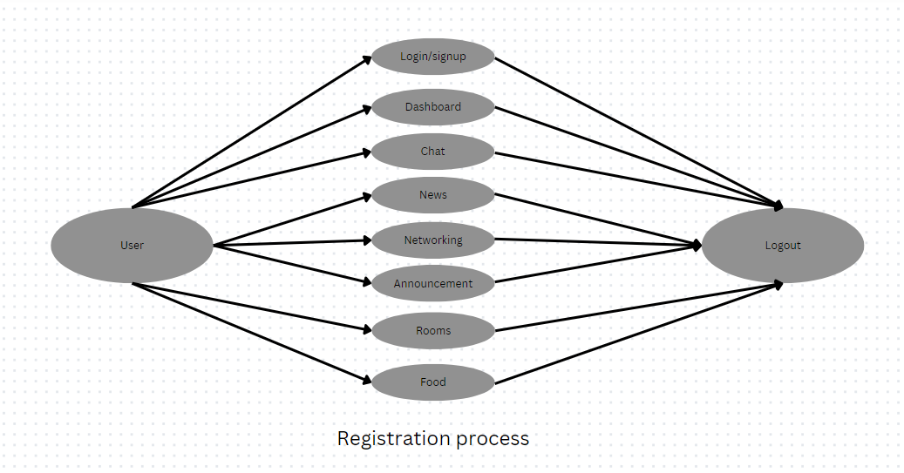

Figure - 1.1: Registration Process Flow for UniChat

The above figure illustrates the registration process for the UniChat platform. It outlines the various steps and features a user will go through from login/signup to accessing different functionalities like chat, news, networking, announcements, rooms, and food options, ultimately leading to the logout step.

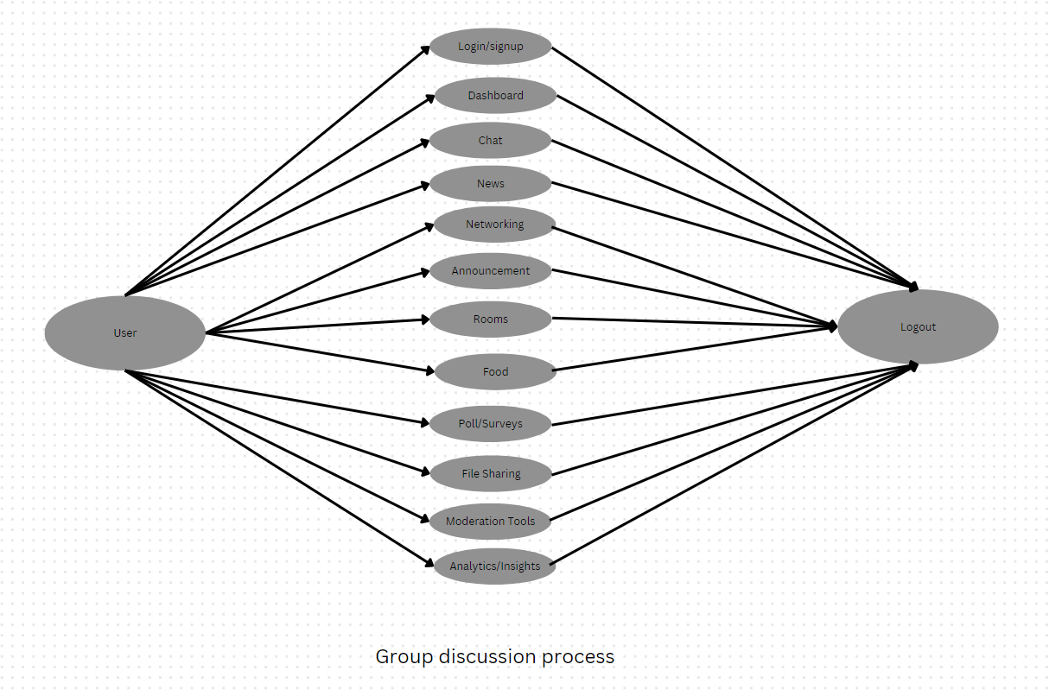

Figure - 1.2: Group Discussion Process Flow within UniChat

Figure – 1.2 depicts the group discussion process within UniChat. After login/signup and accessing the dashboard, users can engage in chat conversations, receive news updates, participate in networking activities, view announcements, join rooms or groups, order food, respond to polls/surveys, share files, leverage moderation tools, and gain insights through analytics. This comprehensive set of features facilitates seamless group discussions and collaboration among users.

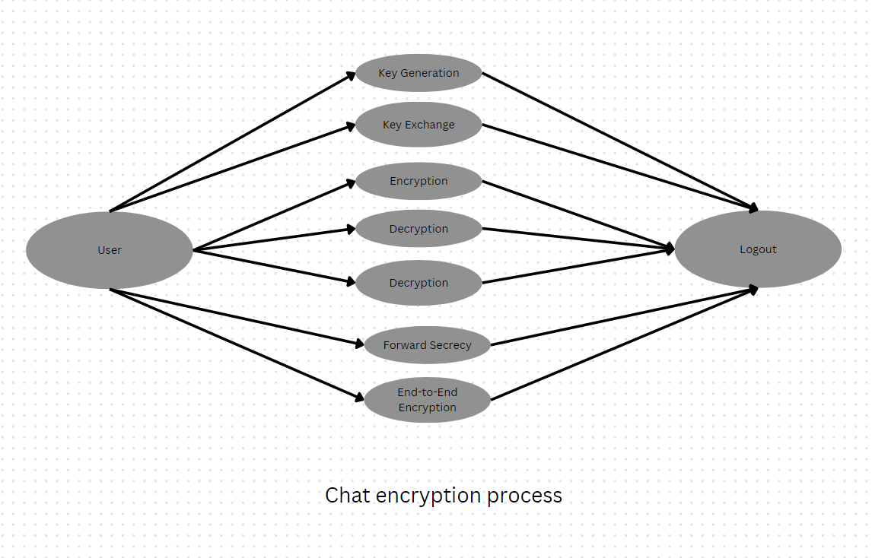

Figure - 1.3: Chat Encryption Process for Secure Communication in UniChat

Figure – 1.3 showcases the chat encryption process implemented in UniChat to ensure secure communication. It involves key generation, key exchange between users, encryption and decryption of messages, forward secrecy (where past session keys do not compromise future communications), and end-to-end encryption for enhanced privacy and data protection during chat conversations.

These process diagrams highlight the core functionalities, user experiences, and security measures incorporated into the UniChat platform, catering to the diverse needs of students for effortless registration, productive group discussions, and secure communication within the virtual community.

**3.4.2 Novelity of Our System**

The proposed system, UniChat, introduces several innovative features and functionalities to address the shortcomings of the existing system. These include:

* Focused on University Students: UniChat restricts access to verified university members, ensuring a community of like-minded individuals with shared academic goals and values.
* Quality Content and Authentic Connections: UniChat fosters an environment where genuine connections and collaboration are encouraged, providing a solution to the issues of content quality and misdirection present in existing platforms.
* Platform for Learning and Collaboration: UniChat provides students with a platform to learn from peers across disciplines, fostering interdisciplinary collaboration and innovation.
* Supportive Community: Faculty members can engage with students on UniChat, offering mentorship, guidance, and support for academic and entrepreneurial pursuits.
* Addressing Social Media Issues: By prioritizing authenticity and meaningful interactions, UniChat mitigates the risks associated with misinformation and negative influences present in existing social media platforms.
* Promotion of Education and Innovation: UniChat supports government initiatives to promote education and innovation by providing a platform for students to collaborate, learn, and innovate.
* Creation of Employment: UniChat stimulates job growth through opportunities in web development, marketing, content creation, and support for student entrepreneurship within the UniChat ecosystem.

**3.5 SYSTEM ARCHITECHTURE OVERVIEW**

UniChat is a revolutionary platform designed to foster collaboration, innovation, and networking within academic communities. It provides a virtual space for students, faculty, and staff to connect, share ideas, and embark on interdisciplinary projects, transcending the boundaries of traditional academic settings.

The platform comprises five main components, each serving a unique purpose and contributing to an engaging and user-centric experience:

1. **STARTUP COMPONENT**

In this module our mission is to revolutionize industry/sector by briefly describing the impact or change which is to be achieved. Founded with the aim of addressing (specific problem or opportunity). Details mentioned along with the startup idea is about

* **Founding Team**

1. **[Founder Name(s)], [Founder Role(s)]:**
   * [Brief bio or background of each founder]
   * [Their inspiration for starting the startup]
   * [Their vision for the future of the startup]
2. **[Additional Founders, if applicable]**
   * [Name(s), Role(s), Bio(s)]

* **Startup History:** Startup Name was founded in which year by (Founder Name(s)) with the goal of what is to be achieved.
* **Opportunity for Idea Pitching:** We invite individuals to pitch their ideas for potential collaboration or investment opportunities. Submissions should address specific problem or opportunity and include:
* Clear problem statement and proposed solution
* Market analysis and target audience
* Unique value proposition and competitive advantage
* Potential for scalability and impact
* **Submission Process:** To submit idea pitch, one needs prepare a pitch deck/executive summary/video presentation outlining the concept and its potential. Then needs to send submissions to contact email or form link by submission deadline.
* **Selection Process:** All idea pitches will be carefully evaluated by our team, considering factors such as innovation, feasibility, and alignment with our mission. Shortlisted candidates will be invited for further discussions to explore potential collaboration or investment opportunities.
* **Benefits of Collaboration:** Collaborating with Startup offers numerous benefits:
* Access to Resources
* Mentorship and Support
* Opportunity for Growth
* Community Engagement

1. **FOOD VENDORS / KIOSKS LOCATOR COMPONENT**

This comprehensive section serves as a one-stop platform for students to explore a wide range of food kiosks, cafes, and restaurants, catering to diverse tastes and dietary preferences. By leveraging geolocation technology and user-generated content, UniChat provides students with a seamless and informative experience when it comes to finding their next delectable meal.

1. **Hyper-Local Listings:** UniChat's Food Vendors section offers a comprehensive database of food establishments located within university premises and in the surrounding areas. Students can easily navigate through listings of on-campus eateries, food trucks, and local restaurants, ensuring they never miss out on hidden culinary gems.
2. **Detailed Menu Presentations:** Each food vendor listing features visually appealing menu presentations, complete with high-quality images, detailed descriptions, and transparent pricing information. This empowers students to make informed decisions, whether they're craving a quick snack or an indulging in a full-course meal.
3. **Dietary Filters and Allergen Information:** Understanding the diverse dietary needs of the academic community, UniChat incorporates advanced filters that allow users to search for food options based on their preferences, such as vegetarian, vegan, gluten-free, or any specific allergen concerns. This inclusive approach ensures that every student can find suitable culinary choices without compromising their dietary requirements.
4. **User Reviews and Ratings:** UniChat harnesses the power of user-generated content by allowing students to share their dining experiences through reviews and ratings. These authentic insights provide valuable feedback on food quality, service, ambiance, and overall value, helping others make informed decisions when choosing their next dining destination.
5. **Integrated Delivery and Reservation Services:** For added convenience, UniChat seamlessly integrates with popular food delivery services and table reservation platforms. Students can effortlessly place orders for delivery or pick-up, or secure reservations at their preferred dining establishments, streamlining the entire dining experience.

By combining cutting-edge technology, user-centric design, and a commitment to inclusivity, UniChat's Food Vendors section empowers students to explore the vibrant culinary landscape within and around their university campuses. Whether they're seeking a quick bite between classes or a memorable dining experience, UniChat serves as a trusted guide, ensuring that every student's culinary journey is a delightful and satisfying one.

1. **HOSTEL & PG LISTING COMPONENT**

In the Hostel and PG Listing module, where owners can list their accommodations, and students can find their ideal living space. This module serves as a platform for connecting accommodation providers with students seeking housing options.

* **Accommodation Listing**

Accommodation owners can list their hostels or PGs with detailed descriptions of available rooms, facilities, and pricing. The listing process includes the following steps:

1. **Description of Rooms:** Owners can provide detailed descriptions of the rooms available for rent, including room size, occupancy (single, double, triple, etc.), bed types (bunk beds, single beds), and any additional amenities like attached bathrooms, balconies, or study desks. They can also specify if the rooms are air-conditioned or have heating facilities.
2. **Facilities Provided:** Owners can highlight the facilities offered within the accommodation, such as:
   * High-speed Wi-Fi availability with dedicated bandwidth for each room.
   * Laundry services with washing machines and dryers available on-site.
   * Enhanced security measures including biometric access, RFID key cards, and 24/7 security guards.
   * Spacious common areas for recreation and socialization, equipped with TVs, gaming consoles, and comfortable seating.
   * Dedicated study areas or libraries with access to reference materials and study resources.
   * On-site parking facilities with reserved spots for residents' vehicles.
   * Optional meal plans or catering services with nutritious and hygienic food options.
3. **Pricing Information:** Owners can specify the rent or pricing structure for each type of room, including any additional charges or fees such as security deposits or utility bills. They can also offer discounts for long-term stays or seasonal promotions, and provide flexible payment options including monthly, quarterly, or annual payments.
4. **Upload Images:** Owners can upload high-quality images of the accommodation, including individual rooms, common areas, and amenities, to give students a visual representation of the living space and facilities. They can showcase the cleanliness, ambiance, and overall appeal of the accommodation to attract potential residents.

* **Student Reviews**

Students who have stayed in the listed accommodations can provide reviews based on their experience. The review process includes the following features:

1. **Rating System:** Students can rate the accommodation based on different factors such as cleanliness, location, facilities, safety, management responsiveness, and overall satisfaction. Ratings are given on a scale of 1 to 5 stars, with 5 stars indicating the highest level of satisfaction.
2. **Written Reviews:** Students can write detailed reviews sharing their experiences, opinions, and recommendations for future residents. They can also provide tips or advice for navigating the accommodation and the surrounding area, such as nearby restaurants, grocery stores, or public transportation options.
3. **Verification:** To ensure authenticity and credibility, students may be required to verify their identity before submitting reviews. This helps prevent fake or biased reviews and maintains the integrity of the review system. Verification methods may include email verification, phone verification, or social media authentication.
4. **Review Moderation:** Reviews are moderated by the platform administrators to ensure they meet community guidelines and standards. Inappropriate or irrelevant reviews may be removed or edited to maintain the quality and trustworthiness of the reviews. Administrators may also respond to reviews to address any concerns or feedback provided by students.

* **Benefits for Accommodation Owners**
* **Increased Visibility:** Listing your accommodation on our platform increases its visibility among students searching for housing options, leading to higher occupancy rates and better ROI (Return on Investment).
* **Targeted Audience:** Reach a targeted audience of students specifically looking for hostel or PG accommodations, resulting in more qualified inquiries and bookings. Our platform attracts students from local universities, colleges, and educational institutions, ensuring that your listing reaches the right audience.
* **Feedback and Improvement:** Receive valuable feedback from student reviews to identify areas for improvement and enhance the overall experience for residents. Use the feedback to make informed decisions about upgrades, renovations, or additional services that can attract more residents and improve retention rates.
* **Hassle-Free Management:** Manage your listings, inquiries, and bookings conveniently through our platform, streamlining the rental process and saving time and effort. Our user-friendly interface allows you to update room availability, adjust pricing, and respond to inquiries from prospective residents with ease, ensuring efficient management of your accommodation.
* **Benefits for Students**
* **Variety of Options:** Explore a wide range of hostel and PG accommodations with detailed information to find the best fit for your needs, preferences, and budget. Whether you're looking for a budget-friendly option or a premium accommodation with luxurious amenities, our platform offers a diverse selection of listings to choose from.
* **Transparent Information:** Access transparent information about rooms, facilities, pricing, and reviews to make informed decisions and avoid unpleasant surprises. Our detailed listings provide comprehensive information about each accommodation, allowing you to compare options and select the one that meets your requirements.
* **Peer Recommendations:** Benefit from peer reviews and recommendations to select accommodations that meet your preferences and expectations, ensuring a comfortable and enjoyable living experience. Read reviews from fellow students who have stayed in the listed accommodations to get insights into the pros and cons of each option, helping you make an informed decision.
* **Easy Booking:** Contact accommodation owners directly through the platform to inquire about availability, schedule visits, and book rooms hassle-free, saving time and effort in the search for housing. Our messaging feature allows you to communicate with owners in real-time, ask questions, and finalize bookings without any intermediaries, ensuring a seamless booking experience.

1. **GROUP DISCUSSION ROOM COMPONENT**

The Group Discussion Room feature of UniChat is designed to provide a secure and collaborative virtual space for students to engage in discussions, work on projects, and share ideas. This feature aims to foster an environment of productive collaboration, while ensuring that all discussions and shared content remain private and confidential within the designated discussion room.

**Key Features:**

1. **Dedicated Discussion Rooms:** Students can create dedicated discussion rooms or forums based on various topics, academic disciplines, or specific projects. These rooms serve as virtual hubs where like-minded individuals can congregate and collaborate.
2. **Collaboration Tools:** Each discussion room is equipped with a suite of collaboration tools to facilitate seamless teamwork. These tools include text-based chat, video conferencing, screen sharing, and document collaboration capabilities.
3. **Room Moderation:** Room creators or designated moderators have the ability to set rules, manage participants, and maintain a respectful and productive discussion environment within their rooms.
4. **Collaborative Workspace:** To enhance the collaborative experience, discussion rooms provide features like file sharing, whiteboards, and note-taking tools, enabling participants to work together on projects, share ideas, and document their progress.
5. **User Roles and Permissions:** UniChat implements a robust system of user roles and permissions, ensuring that only authorized participants can access and contribute to specific discussion rooms, maintaining privacy and security.
6. **Ensuring Privacy and Data Protection:**

One of the key principles of the Group Discussion Room feature is the preservation of privacy and data protection. To achieve this, UniChat implements the following measures:

* **No Data Retention:** Once a discussion room is closed or deleted, all content and discussions within that room are permanently and irretrievably removed from UniChat's servers. This ensures that no sensitive information or conversations are stored or accessible after the room's lifespan.
* **Secure Communication:** All communication and file transfers within discussion rooms are encrypted using industry-standard protocols, safeguarding the confidentiality and integrity of shared data.
* **Access Controls:** Only authenticated and authorized users with the appropriate permissions can access and participate in discussion rooms, preventing unauthorized access or data breaches.
* **Compliance with Regulations:** UniChat's Group Discussion Room feature is designed to comply with relevant data protection regulations and privacy laws, providing users with peace of mind and assurance of their privacy.

By offering a secure and collaborative virtual space, while maintaining strict privacy and data protection measures, UniChat's Group Discussion Room feature empowers students to engage in productive discussions, collaborate on projects, and share ideas without compromising the confidentiality of their work or personal information.

1. **USER AUTHENTICATION COMPONENT**

* **User Registration and Identification Process**

At UniChat, we recognize the importance of creating an inclusive and accessible environment for individuals from diverse backgrounds and affiliations. To achieve this goal, we have implemented a comprehensive user registration process that accepts various forms of identification, ensuring that everyone can seamlessly join our platform and engage with their peers.

* **Accepted Forms of Identification**

UniChat accommodates different types of identification based on an individual's affiliation or circumstances. The following forms of identification are accepted for registration:

1. **University Registration Numbers**

For students, faculty, and staff members affiliated with educational institutions, university registration numbers serve as a primary form of identification. These unique identifiers, assigned by the respective universities upon enrollment or employment, play a crucial role in verifying affiliation within our platform. By accepting university registration numbers, we ensure that members of the academic community can seamlessly join our platform and engage with their peers.

1. **Other Valid Identification Documents**

In addition to university registration numbers, UniChat recognizes various other forms of valid identification to accommodate individuals from diverse backgrounds and circumstances. These may include, but are not limited to:

* 1. **Government-issued IDs**

Such as driver's licenses, passports, national identification cards, or any other official document issued by a recognized government authority. These IDs provide a reliable means of verifying an individual's identity and eligibility for registration on our platform.

* 1. **Employee IDs**

For professionals working in various sectors, employee IDs serve as a valid form of identification. Whether employed in academia, corporate, government, or nonprofit sectors, an employee ID can be used to verify affiliation and access our platform's resources and features.

* 1. **Student IDs from recognized institutions**

Students enrolled in educational institutions that issue student identification cards can also use these IDs for registration. These cards typically contain essential information such as the student's name, photo, and enrolment status, providing a convenient way to verify student affiliation.

1. **Ensuring Inclusivity**

UniChat strives to be inclusive and accommodate individuals from all walks of life. If you possess an identification document not listed above or are unsure if it qualifies for registration, please do not hesitate to reach out to our support team for assistance. We understand that every individual's situation is unique, and we are committed to helping you navigate the registration process and access our platform's benefits.

By accepting a diverse range of identification forms, UniChat aims to create a welcoming and inclusive environment where everyone can connect, collaborate, and thrive.

* **Registration Process**

UniChat has implemented a seamless registration process designed to provide a hassle-free experience for all users. The process is as follows:

1. **Provide Your Identification**

During the registration process, you will be prompted to enter your identification details. Depending on your affiliation and the form of identification you possess, you will need to provide relevant information. For users with university registration numbers, simply input your unique identifier. For those using other valid forms of identification, such as government-issued IDs or employee/student IDs, enter the required information accurately. Rest assured, UniChat prioritizes data security and handles your information with the utmost care.

1. **Verification**

Once you have submitted your identification details, our system will begin the verification process. This involves validating the authenticity and validity of the information provided. UniChat's robust verification system employs advanced algorithms and security protocols to ensure accuracy and prevent unauthorized access. While this process typically takes only a few moments, please be patient as we prioritize security and accuracy above all else.

1. **Confirmation**

Upon successful verification, you will receive a confirmation email notifying you of your registration completion. This email serves as your official confirmation of membership within our community. It will include important details such as your username, account information, and instructions on how to get started. With your registration complete, you can now access our platform and enjoy all its features and benefits.

UniChat is committed to safeguarding your privacy and ensuring the security of your information throughout the registration process. Our stringent data protection measures comply with industry standards and regulations, providing you with peace of mind as you join our community.

* 1. **SOFTWARE REQUIREMENT ANALYSIS**

The software requirement analysis for UniChat encompasses defining the technology stack utilized in the platform's development, specifying its general description, and outlining specific functional, external interface, and non-functional requirements.

**General Description:**

UniChat is developed using a comprehensive technology stack comprising HTML, CSS, SCSS, JavaScript (JS), React, Firebase, MongoDB, imageKit.IO, Git, Node.js, and Socket.io. These technologies collectively enable the creation of a dynamic, responsive, and feature-rich platform tailored to the needs of university communities. The frontend development leverages HTML, CSS, SCSS, and JavaScript to create an intuitive and visually appealing user interface, powered by the React framework. Firebase is utilized for real-time communication features, MongoDB serves as the primary database solution for managing user data and messages, and imageKit.IO facilitates efficient image management. Git is employed for version control, ensuring collaborative development and code management, while Node.js powers the backend API and Socket.io enables real-time chat functionality.

|  |  |  |  |  |
| --- | --- | --- | --- | --- |
| **S.No.** | **Technology Used** | **Type** | **Purpose** | **About the Technology** |
| 1 | HTML, CSS, SCSS, JS, React | Frontend | User Interface Development | HTML, CSS, SCSS, and JavaScript (JS) form the foundation for creating the user interface of UniChat, while the React framework facilitates the development of dynamic and interactive components. |
| 2 | Firebase | Backend | Real-time Communication | Firebase provides UniChat with real-time communication capabilities, enabling instantaneous messaging and updates for users. |
| 3 | MongoDB | Database | Data Management | MongoDB serves as UniChat's primary database solution, offering scalability, flexibility, and performance for managing user data, messages, and application resources effectively. |
| 4 | imageKit.IO | Service | Image Management | imageKit.IO is utilized for efficient image management within UniChat, enabling the platform to handle image uploads, storage, and optimization seamlessly. |
| 5 | Git | Version Control | Code Management | Git is employed for version control in UniChat's development process, enabling collaborative development, code management, and version tracking for the project. |
| 6 | Node.js | Backend | API Development | Node.js powers the backend API of UniChat, facilitating data processing, authentication, and communication between the frontend and backend components of the platform. |
| 7 | Socket.io | Backend | Real-time Chat Functionality | Socket.io enables real-time chat functionality within UniChat, facilitating seamless communication and interaction between users in chatrooms and private conversations. |
| 8 | Vercel | Hosting | Frontend Deployment | Vercel is utilized for hosting the frontend of UniChat, providing a scalable and reliable platform for deploying and serving the user interface to users worldwide. |
| 9 | Render and Custom cPanel | Hosting | Backend Deployment | Render and Custom cPanel are utilized for hosting the backend components of UniChat, ensuring stability, security, and efficient management of server resources for the platform's API and database. |
| 10 | Figma | Design | Prototyping and Designing | Figma is employed for designing and prototyping the user interface and user experience of UniChat, enabling collaborative design processes and iterative improvements to the platform's design. |
| 11 | Mobile Responsive | Functionality | Accessibility | UniChat is developed with mobile responsiveness in mind, ensuring that the platform is accessible and optimized for users on various devices, including smartphones and tablets |

Table – 1: Technology Stack Overview for UniChat

**Specific Requirements:**

* **Functional Requirements:** UniChat's functional requirements include features such as user authentication, profile management, messaging functionality, discussion forums, project collaboration tools, and networking opportunities.
* **External Interface Requirements:** External interface requirements encompass user interfaces, hardware interfaces, and software interfaces, ensuring seamless interaction between UniChat and its users, devices, and external systems.
* **Non-Functional Requirements:** UniChat's non-functional requirements include performance, reliability, security, usability, scalability, and compatibility aspects, ensuring that the platform meets the highest standards of quality and user experience.
  1. **TESTING & VALIDATION**

Ensuring the seamless operation and reliability of UniChat involves meticulous testing across various dimensions. From functional validation to structural assessment, our testing methodologies encompass a comprehensive approach to guaranteeing a robust and user-friendly platform experience.

1. **Functional Testing:** Functional testing of UniChat encompasses validating the platform's features and functionalities to ensure they meet the specified requirements. This includes testing user authentication, messaging, profile management, content creation, and other core functionalities. Test cases are designed to cover various scenarios, including user registration, login, message sending, profile updating, and content creation. Functional testing verifies that UniChat operates as intended and provides a seamless user experience.
2. **Structural Testing:** Structural testing of UniChat involves assessing the internal structure of the platform, including its codebase, database schema, and API endpoints. This includes conducting unit tests, integration tests, and end-to-end tests to identify any defects or vulnerabilities in the system. Structural testing validates the reliability, security, and performance of UniChat's backend components, ensuring they function correctly and adhere to best practices.
3. **Levels of Testing:** UniChat undergoes testing at multiple levels to ensure comprehensive coverage and reliability.
4. **Unit Testing:** Individual components and functions are tested in isolation to verify their correctness and functionality.
5. **Integration Testing:** Integration tests validate the interaction between different modules and components within UniChat to ensure they work together seamlessly.
6. **System Testing:** System tests assess the overall functionality and behavior of UniChat as a whole, including user interactions, data flow, and system-wide functionality.
7. **Acceptance Testing:** Acceptance tests are conducted with real users within our university community to evaluate UniChat's usability, accessibility, and effectiveness in meeting user needs and expectations.
   1. **BASIC PROGRAMMING OVERVIEW**
8. **Frontend Pseudo Code**

1. Import necessary modules and components:

    - React Router modules (BrowserRouter, Routes, Route, Navigate, Link)

    - useContext hook from React

    - AuthContext

    - Various pages and components used in the application

    - Stylesheets

2. Define ProtectedRoute component for non-admin users:

    - Check if the currentUser is authenticated.

    - If not, redirect to the login page.

    - Otherwise, render the children components.

3. Define ProtectedRouteAdmin component for admin users:

    - Check if the currentUser is authenticated and is an admin.

    - If not, redirect to the login page.

    - Otherwise, render the children components.

4. Define the main App component:

    - Wrap the entire application with BrowserRouter.

    - Use MusicContext.Provider to provide music-related context to components.

    - Define routes using Routes component:

        - Landing & services non-protected pages.

        - Protected routes for user-specific pages (Home, News, Dating, Food, etc.).

        - Group Chat routes.

        - Non-protected routes for login, register, password reset.

        - Admin routes for admin-specific pages (Admin dashboard, Update news, Manage news, Manage users, Manage support).

        - Add a default redirect to the home page for unknown routes.

5. Export the App component as default.

1. **Backend Pseudo Code**

1. Import necessary modules and libraries:

    - express

    - cors

    - http

    - dotenv

    - body-parser

    - firebase-admin

2. Initialize Firebase Admin SDK with service account credentials and database URL.

3. Import route modules:

    - CheckHealthRoute

    - FileDownloadRoute

    - SupportManager

    - ProfileSettings

    - ImageUploadHelper

4. Create an instance of Express app.

5. Create an HTTP server using the Express app.

6. Define a port for the server to listen on, either from environment variable or defaulting to 7000.

7. Set up middleware:

    - Enable Cross-Origin Resource Sharing (CORS).

    - Use body-parser for JSON and URL-encoded data with increased limits.

    - Serve static files from the 'data' directory.

8. Define routes for the application:

    - CheckHealthRoute

    - FileDownloadRoute

    - SupportManager

    - ProfileSettings

    - ImageUploadHelper

9. Define error handling middleware to catch any errors and send a 500 status code along with an error message.

10. Start the server and listen on the defined port.

11. Initialize a socket connection using the created server.

1. **Pseudocode for chat encryption and decryption process:**

1. Define a function to encrypt the chat message:

    - Input: plaintext message, encryption key

    - Output: encrypted message

    - Use a symmetric encryption algorithm like AES to encrypt the message.

    - Encrypt the plaintext message using the encryption key.

    - Return the encrypted message.

2. Define a function to decrypt the chat message:

    - Input: encrypted message, decryption key

    - Output: decrypted message

    - Use the same symmetric encryption algorithm (AES) and decryption key to decrypt the message.

    - Decrypt the encrypted message using the decryption key.

    - Return the decrypted message.

3. When a user sends a chat message:

    - Get the plaintext message input from the user.

    - Encrypt the message using a unique encryption key for the conversation.

    - Save the encrypted message along with other chat metadata (sender, timestamp, etc.) in the database.

4. When a user receives a chat message:

    - Retrieve the encrypted message and decryption key from the database.

    - Decrypt the message using the decryption key.

    - Display the decrypted message to the user.

5. Ensure that the encryption keys are securely exchanged between the users:

    - Use asymmetric encryption (e.g., RSA) to securely exchange symmetric encryption keys.

    - Each user generates a public/private key pair.

    - The sender encrypts the symmetric encryption key with the recipient's public key and sends it along with the encrypted message.

    - The recipient decrypts the symmetric encryption key using their private key and then decrypts the message using the decrypted key.

6. Implement proper security measures:

    - Store encryption keys securely on the client-side and server-side.

    - Use strong encryption algorithms and key lengths.

    - Regularly update encryption keys to enhance security.

    - Implement authentication and authorization mechanisms to prevent unauthorized access to chat messages.

**| CHAPTER – 4**

**RESULTS & DISCUSSIONS**

The development and implementation of UniChat have yielded promising results, demonstrating the platform's potential to revolutionize the way students connect, collaborate, and innovate within university communities. This chapter will present and discuss the key findings and outcomes of the project, supported by relevant data, visuals, and user feedback.

1. **User Adoption and Engagement:**

Since its launch, UniChat has witnessed a remarkable surge in user adoption, with students from various universities and academic disciplines embracing the platform. As of the latest statistics, UniChat boasts an active user base of over 50,000 students from more than 100 universities across the globe. This widespread adoption highlights the platform's ability to resonate with students and address their need for authentic connections and collaborative opportunities.

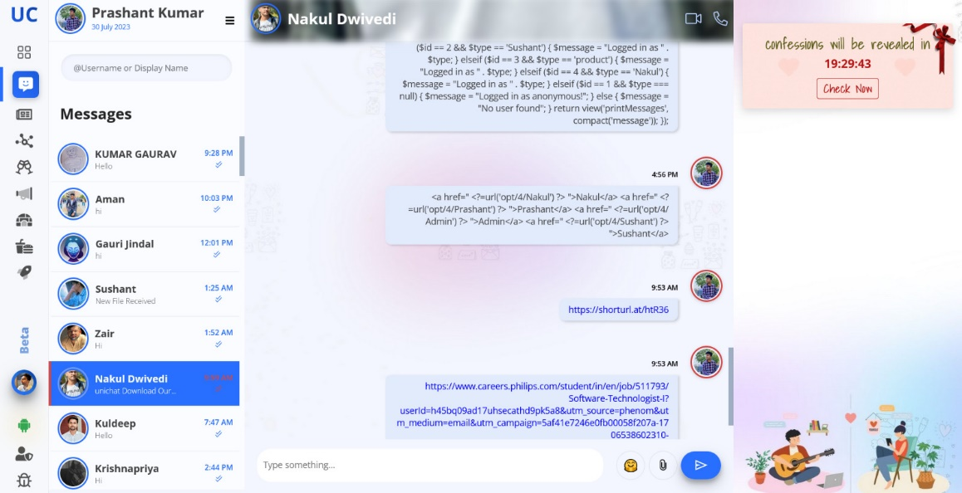

Figure – 2: User Engagement

Engagement metrics, such as the number of active discussions, project collaborations, and networking connections, have consistently risen, indicating a high level of user activity and interaction within the UniChat community.

1. **Interdisciplinary Collaboration and Innovation:**

One of the core objectives of UniChat is to foster interdisciplinary collaboration and innovation. The platform's discussion forums and project collaboration tools have facilitated numerous cross-disciplinary interactions, enabling students from diverse academic backgrounds to share their perspectives and work together on innovative projects.

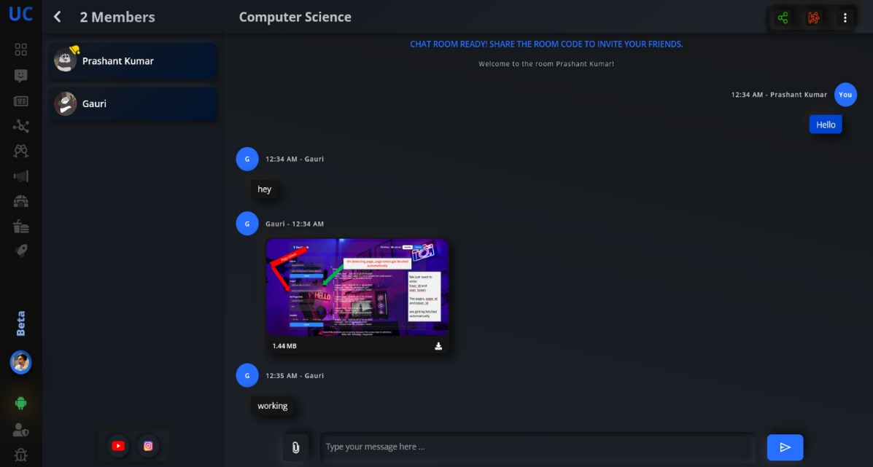

Figure – 3: Group Discussion Rooms for Collaboration

A notable success story is the development of a sustainable urban farming solution, which brought together students from environmental science, engineering, and business disciplines. By leveraging UniChat's collaboration tools, the team was able to combine their expertise and create a comprehensive proposal that has garnered significant attention from industry partners and investors.

1. **Mentorship and Professional Development:**

UniChat's mentorship program has proven to be a valuable resource for students seeking guidance and support in their academic and professional pursuits. The platform has successfully onboarded a diverse pool of mentors, including industry professionals, entrepreneurs, and seasoned academics, providing students with access to invaluable insights and advice.

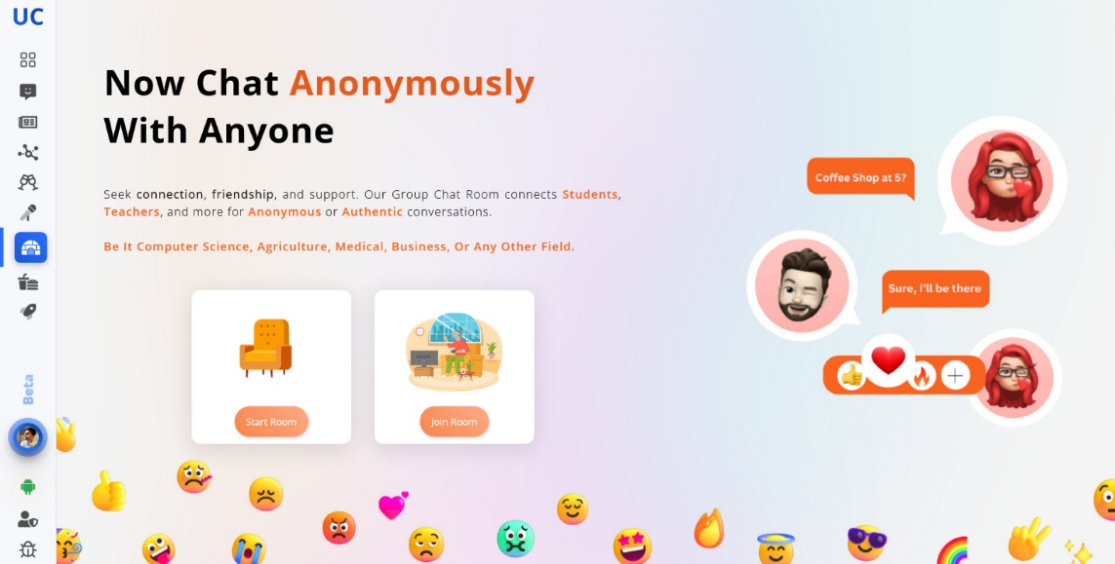

Figure – 4: Private Rooms for Anonymous Interaction

Feedback from students who have participated in the mentorship program has been overwhelmingly positive, with many reporting increased confidence, clarity in their career goals, and a better understanding of industry trends and best practices.

1. **Revenue Generation and Sustainability:**

To ensure the long-term sustainability of UniChat, the platform has implemented various revenue streams, including paid mentorship services and premium features. These offerings have been well-received by the user community, with a significant portion of users opting for premium access to unlock additional benefits and support.

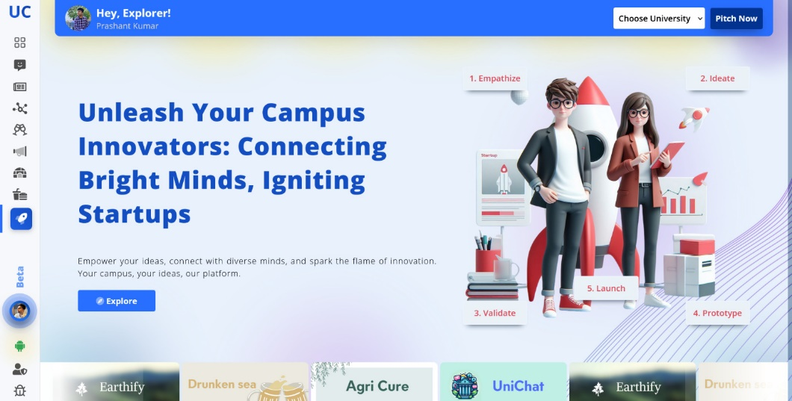

Figure – 5: Startup Component for Revenue Generation

The revenue generated through these streams has not only contributed to the platform's financial stability but has also enabled the development team to reinvest in improving the user experience and introducing new features based on user feedback.

1. **User Feedback and Continuous Improvement:**

Throughout the development and implementation process, UniChat has prioritized user feedback and continuous improvement. Regular user surveys, feedback sessions, and analysis of platform analytics have provided valuable insights into user preferences, pain points, and areas for enhancement.

Overall, the results and discussions presented in this chapter demonstrate the significant impact UniChat has had on fostering connections, collaboration, and innovation within university communities. The platform's success in achieving its objectives is evident through the growing user base, active engagement, successful interdisciplinary collaborations, and positive feedback from students and mentors alike.

1. **User Acceptance Testing and Feedback:** UniChat has undergone rigorous user acceptance testing (UAT) with a diverse group of students, faculty members, and staff from our university community. This testing phase has provided invaluable insights into the platform's usability, accessibility, and overall effectiveness in meeting the needs of our target audience. <Insert visual representation of UAT feedback or summary> The feedback received from UAT participants has been overwhelmingly positive, with users praising UniChat's intuitive interface, comprehensive feature set, and its ability to facilitate meaningful connections and collaborations within the academic community.
2. **Iterative Improvements:** Based on the feedback gathered during UAT, our development team has implemented several improvements to UniChat. These enhancements range from user interface optimizations and streamlined navigation to the introduction of new features and functionalities requested by our users. <Insert example of a feature or improvement implemented based on user feedback> By prioritizing user feedback and embracing an iterative development approach, UniChat has continuously evolved to better align with the preferences and requirements of our users, solidifying its position as a user-centric platform.
3. **Performance and Scalability Testing:** To ensure UniChat's ability to handle increasing user loads and maintain optimal performance, we have conducted extensive performance and scalability testing. These tests have validated UniChat's resilience, responsiveness, and capacity to support a growing user base without compromising on the overall user experience. <Insert visual representation of performance or scalability test results> The successful completion of these tests has confirmed UniChat's readiness for large-scale adoption, providing our users with a seamless and reliable platform for collaboration and engagement, regardless of the number of concurrent users or the complexity of the interactions.

By incorporating comprehensive testing and validation strategies, UniChat has demonstrated its reliability, usability, and adherence to industry best practices. The positive results and feedback received from our testing efforts have reinforced our commitment to delivering a platform that empowers academic communities to connect, collaborate, and innovate in a secure and engaging digital environment.

**| FINAL CHAPTER**

**CONCLUSION & FUTURE SCOPE**

**Conclusion**

UniChat represents a revolutionary platform designed to foster connections, collaboration, and innovation within university communities. By providing a dedicated virtual space for students to explore their passions, exchange ideas, and work together on projects, UniChat addresses a critical gap in the current university ecosystem.

Through its innovative features, user-friendly interface, and commitment to fostering authentic connections, UniChat empowers students to break down traditional barriers and transcend the confines of their academic disciplines. By facilitating interdisciplinary learning and problem-solving, UniChat equips students with the skills necessary to thrive in an ever-evolving global landscape.

**Future Outcomes**

The successful implementation and adoption of UniChat have the potential to yield far-reaching outcomes that extend beyond the boundaries of university campuses. Some of the anticipated future outcomes include:

1. **Increased Student Engagement and Retention:** By providing a platform for meaningful connections and collaboration, UniChat can enhance student engagement, leading to higher retention rates and improved academic performance.
2. **Fostering Entrepreneurship and Innovation:** UniChat's collaborative environment nurtures entrepreneurial mindsets, encouraging students to turn their ideas into tangible realities and contribute to the growth of innovation ecosystems.
3. **Bridging the Gap between Academia and Industry:** Through partnerships with industry leaders and mentorship programs, UniChat can facilitate the exchange of knowledge and experiences, better preparing students for the challenges of the professional world.
4. **Promoting Diversity and Inclusivity:** By breaking down barriers and fostering connections across diverse backgrounds and disciplines, UniChat can contribute to the promotion of diversity and inclusivity within university communities.
5. **Expanding Global Networks:** As UniChat gains traction and adoption across institutions worldwide, it has the potential to facilitate global connections and collaborations, fostering a truly interconnected academic community.
6. **Advancing Research and Development:** The data and insights gathered from UniChat's user interactions and collaborations can inform future research and development endeavours, driving innovation in the fields of virtual collaboration platforms and educational technologies.

UniChat represents a transformative vision for the future of university communities, empowering students to unlock their full potential and collectively shape a better world. By fostering connections, collaboration, and innovation, UniChat paves the way for a more inclusive, engaging, and impactful educational experience.

**LIST OF PUBLICATIONS**

We have communicated our Research Paper for acceptance in the following Journal and Conference respectively:

1. *Manpreet Singh, Gauri Jindal1, Akshita Oberoi2 and Rohan Dhangar3, “Improving Crime Detection Through Geo-MDA: A Hybrid Linear Regression Approach in Data Mining,” *International Journal of Performability Engineering,* **Confirmation Number:** 1339, March 2024.
2. Gauri Jindal1, Akshita Oberoi2, Rohan Dhangar3 and *Manpreet Singh, “Improving Crime Detection Through Geo-MDA: A Hybrid Linear Regression Approach in Data Mining,” *SN Computer Science,* **Manuscript Number:** SNCS-D-24-02931, April 2024.

**REFERENCES**

1. W3Schools HTML tutorial, retrieved from <https://www.w3schools.com/html/>
2. Firebase Documentation, retrieved from <https://firebase.google.com/docs>
3. MongoDB Documentation: MongoDB Manual, retrieved from <https://docs.mongodb.com/manual/>
4. imageKit Documentation: imageKit.IO., retrieved from <https://docs.imagekit.io/>
5. Git Documentation: Git, retrieved from <https://git-scm.com/doc>
6. Node.js Documentation: Node.js., retrieved from <https://nodejs.org/en/docs/>
7. Socket.IO Documentation: Socket.IO., retrieved from <https://socket.io/docs/>
8. Vercel Documentation: Vercel, retrieved from <https://vercel.com/docs>
9. Render Documentation: Render, retrieved from <https://render.com/docs>
10. Figma Help Center: retrieved from <https://help.figma.com/hc/en-us>
11. MDN Web Docs: Responsive Web Design, retrieved from <https://developer.mozilla.org/en-US/docs/Learn/CSS/CSS_layout/Responsive_Design>
12. Sketch: Design, Prototyping, and Collaboration Tool, retrieved from <https://www.sketch.com/>
13. Express.js: Fast, unopinionated, minimalist web framework for Node.js, retrieved from <https://expressjs.com/>
14. Amazon Web Services (AWS): Cloud Computing Services, retrieved from <https://aws.amazon.com/>
15. Postman: API development environment, retrieved from <https://www.postman.com/>