SOFTWARE REQUIREMENTS SPECIFICATION
(IEEE 830 - Based Format)

for
TRAVEL AGENCY WEBSITE
A Frontend-Based Travel Booking Platform with Customer and Admin Modules
Project Title | Travel Agency Website
Document Type | Software Requirements Specification (SRS)
Version | 1.0
Prepared By | Somesh Kumar
Enrollment No. | 22515000133
Guided By | Gautam Mukherjee
Institution | GLA University, Greater Noida
Department | Department of Computer Engineering & Applications
Date | 18 August 2026

Document Control

Document Revision History
Version | Date | Description | Author
0.1 | Draft | Initial draft of SRS structure and scope | Somesh Kumar
1.0 | 18/8/2026 | Complete SRS prepared for faculty review and submission | Somesh Kumar

Table of Contents
1 Introduction 5
1.1 Purpose 5
1.2 Document Conventions 5
1.3 Intended Audience and Reading Suggestions 5
1.4 Project Scope 6
1.5 Definitions, Acronyms, and Abbreviations 6
1.6 References 7
2 Overall Description 8
2.1 Product Perspective 8
2.2 Product Functions 8
2.3 User Classes and Characteristics 8
2.4 Operating Environment 8
2.5 Design and Implementation Constraints 9
2.6 Assumptions and Dependencies 9
2.7 Apportioning of Requirements 9
3 System Features (Functional Requirements) 10
3.1 Customer Module 10
3.2 Admin Module 12
4 External Interface Requirements 14
4.1 User Interfaces 14
4.2 Hardware Interfaces 14
4.3 Software Interfaces 14
4.4 Communication Interfaces 15
5 System Architecture 16
5.1 Architectural Layers 16
6 Use Case Model 17
6.1 Actors 17
6.2 Use Case Specification: Book Package 17
6.3 Use Case Specification: Manage Packages (Admin) 18
7 Data Design (Database Planning – Current & Future Phase) 19
7.1 Entity – Attribute Overview 19
7.2 Entity Relationships 19
7.3 Future Phase – API Endpoint Planning 19
8 Non-Functional Requirements 21
8.1 Performance Requirements 21
8.2 Security Requirements 21
8.3 Usability Requirements 21
8.4 Reliability and Availability 21
8.5 Maintainability and Portability 22
8.6 Scalability (Future Phase Consideration) 22
9 Other Requirements 23
10 Software Testing Plan (Overview) 24
10.1 Testing Approach 24
10.2 Levels of Testing 24
10.3 Sample Test Cases 24
11 Appendices 26
11.1 Appendix A – Glossary 26
11.2 Appendix B – Assumptions Log 26
11.3 Appendix C – Future Enhancements 26

1 Introduction

1.1 Purpose
The purpose of this Software Requirements Specification (SRS) document is to provide a complete, unambiguous, and detailed description of the functional and non-functional requirements of the “Travel Agency Website” project. This document is intended to serve as a formal agreement between the student developer and the project guide regarding the scope, behaviour, and expected outcome of the system. It defines what the system will do, the constraints under which it must operate, and the interfaces it must support, without prescribing internal design details beyond what is necessary for planning.
This document will be used as the primary reference for requirement analysis, UI/UX design, module development, database and API planning for future phases, software testing, and final project evaluation and presentation.

1.2 Document Conventions
The following conventions are used throughout this document:
- Functional requirements are labelled using the prefix “FR” followed by a module code and a serial number (e.g., FR-CUST-01, FR-ADM-03).
- Non-functional requirements are labelled using the prefix “NFR” followed by a serial number (e.g., NFR-01).
- Priority levels used are High, Medium, and Low, indicating relative implementation importance for the current academic scope.
- The terms “system”, “application”, and “website” are used interchangeably to refer to the Travel Agency Website.
- Sections marked “Future Phase” describe planned enhancements (backend/API/database integration) that are outside the current frontend-based implementation scope but included for architectural completeness.

1.3 Intended Audience and Reading Suggestions
This document is intended for the following audience:
- Project Guide / Faculty Evaluator – for reviewing scope, feasibility, and evaluating deliverables against defined requirements.
- Student Developer(s) – as the primary reference for design, implementation, and testing.
- Reviewers / Examination Panel – for understanding system scope during project presentation and viva.
- Future Contributors – for extending the project with backend, API, and database integration.
Readers are advised to go through Sections 1 and 2 first for context, followed by Section 3 for detailed functional requirements, and Sections 4–10 for interface, data, non-functional, and testing details relevant to their role.

1.4 Project Scope
The Travel Agency Website is a modern, frontend-based web application inspired by real-world travel booking platforms (such as MakeMyTrip, Yatra, and Booking.com), scaled down to a realistic and achievable academic project. The system enables customers to explore travel destinations and packages, view detailed itineraries, and submit booking requests through a simple and intuitive interface. It also provides an Admin module through which the travel agency staff can manage destinations, packages, bookings, and customer inquiries.
The current phase of the project is implemented primarily using frontend technologies (HTML, CSS, JavaScript, and a CSS framework such as Bootstrap), with data managed using structured JSON files / browser LocalStorage to simulate real application behaviour. The document also defines a future-phase scope covering REST API design and database integration (using Node.js/Express with MySQL or MongoDB), so that the project can be extended beyond the academic submission if desired.
In scope for the current phase:
- Customer-facing website: Home, Destinations, Packages, Package Details, Booking Form, About, Contact, Login/Register, Profile, Booking History.
- Admin panel: Admin Login, Dashboard, manage Destinations/Packages, manage Bookings, manage Inquiries, manage Testimonials.
- Client-side form validation, responsive design, and simulated data persistence.
Out of scope for the current phase (documented as future work):
- Real payment gateway integration.
- Live third-party flight/hotel API integration.
- Production-grade backend server, authentication tokens, and cloud database.
- Multi-language and multi-currency support.

1.5 Definitions, Acronyms, and Abbreviations
Term | Description
SRS | Software Requirements Specification
UI / UX | User Interface / User Experience
FR | Functional Requirement
NFR | Non-Functional Requirement
CRUD | Create, Read, Update, Delete operations
Admin | Travel agency staff member who manages system content
Customer | End user who browses and books travel packages
Package | A predefined travel offering consisting of destination, duration, price, and inclusions
API | Application Programming Interface
LocalStorage | Browser-based client-side storage used to simulate persistence in the current phase
Responsive Design | Layout that adapts to different screen sizes (desktop, tablet, mobile)

1.6 References
- IEEE Std 830-1998, IEEE Recommended Practice for Software Requirements Specifications.
- Sommerville, I., “Software Engineering”, 10th Edition, Pearson Education.
- Publicly available travel booking platforms (referenced for UI/UX inspiration only): MakeMyTrip, Yatra, Booking.com.
- Bootstrap Documentation – getbootstrap.com
- MDN Web Docs – developer.mozilla.org

2 Overall Description

2.1 Product Perspective
The Travel Agency Website is a new, self-contained academic software product. It is not a modification of an existing system. It is designed as a two-module system — a Customer Module (public-facing website) and an Admin Module (management panel) — that together simulate the core functioning of a real-world travel booking platform. The current implementation is frontend-based; the architecture is nonetheless designed so that a backend (REST API) and database layer can be integrated in a future phase without redesigning the user interface.

2.2 Product Functions
A high-level summary of the major functions provided by the system is given below. Detailed functional requirements are provided in Section 3.
- Customer registration, login, and profile management.
- Browsing of travel destinations and curated packages with search and filter options.
- Detailed package view with itinerary, inclusions, price, and images.
- Booking request submission with traveller details and simulated confirmation.
- Customer booking history and profile management.
- Contact/inquiry form for customer support requests.
- Admin authentication and a protected admin dashboard.
- Admin management (CRUD) of destinations, packages, bookings, inquiries, and testimonials.
- Basic reporting/summary view for the admin (e.g., total bookings, popular packages).

2.3 User Classes and Characteristics
User Class | Description | Technical Expertise
Guest Visitor | Any unauthenticated visitor who can browse public content such as destinations, packages, and the About/Contact pages. | Low – general internet user
Registered Customer | A visitor who has created an account and can search, book packages, view booking history, and manage their profile. | Low to Medium
Admin / Travel Agency Staff | Authorized personnel responsible for managing destinations, packages, bookings, and customer inquiries through the admin panel. | Medium – comfortable with web-based dashboards
Project Evaluator | Faculty/examiner who reviews the system for functional correctness and academic evaluation. | High – technical background

2.4 Operating Environment
The system is designed to operate in the following environment:
- Client Side: Any modern web browser – Google Chrome, Mozilla Firefox, Microsoft Edge, or Safari (latest two major versions).
- Devices: Desktop, laptop, tablet, and smartphone via responsive design.
- Current Phase Hosting: Static hosting (e.g., local server / GitHub Pages / Netlify) since the system is frontend-based with JSON/LocalStorage data.
- Future Phase Hosting: Node.js runtime environment with a MySQL or MongoDB database server, deployable on any standard cloud hosting platform.

2.5 Design and Implementation Constraints
- The current phase must function without a live backend server; all dynamic data is simulated using JSON files and/or browser LocalStorage.
- The project must be completed using technologies suitable for a college-level timeline (HTML5, CSS3, JavaScript (ES6), Bootstrap/Tailwind).
- No real financial transactions are permitted; payment steps are simulated for demonstration purposes only.
- The system must remain a single, coherent codebase suitable for individual or small-team development.
- The UI must follow a consistent, professional design theme suitable for demonstration and evaluation.

2.6 Assumptions and Dependencies
- It is assumed that users have access to a device with a modern web browser and an internet connection (for static hosting) or local setup.
- It is assumed that destination, package, and pricing data used in the project is either self-created sample data or publicly available non-copyrighted content used strictly for academic demonstration.
- The project depends on open-source libraries/frameworks (e.g., Bootstrap) which are assumed to remain freely available under their current licenses.
- Future backend integration is dependent on the availability of a suitable hosting environment and database server, which is outside the current academic scope.

2.7 Apportioning of Requirements
Certain requirements described in this document (particularly real payment gateway integration, live third-party API integration, and full backend/database deployment) are explicitly identified as “Future Phase” requirements. These are included to demonstrate architectural planning and completeness of design, but are not mandatory for the current academic submission. The current, mandatory scope is the fully functional frontend-based Customer and Admin website using simulated data.

3 System Features (Functional Requirements)
This section describes the functional requirements of the system, organized by module. Each requirement is uniquely identified, described, and assigned a priority level to guide the development schedule.

3.1 Customer Module

3.1.1 User Registration and Login
Allows a new visitor to create an account and existing customers to log in securely to access personalized features.
ID | Requirement Description | Priority
FR-CUST-01 | The system shall allow a visitor to register using name, email, phone number, and password. | High
FR-CUST-02 | The system shall validate that the email is in a correct format and the password meets minimum length requirements before submission. | High
FR-CUST-03 | The system shall allow a registered customer to log in using email and password. | High
FR-CUST-04 | The system shall display an appropriate error message for invalid login credentials. | Medium
FR-CUST-05 | The system shall allow a logged-in customer to log out securely. | Medium

3.1.2 Browse Destinations
ID | Requirement Description | Priority
FR-CUST-06 | The system shall display a list of available travel destinations with images and short descriptions on the Destinations page. | High
FR-CUST-07 | The system shall allow the customer to click a destination to view associated packages. | Medium

3.1.3 Search and Filter Packages
ID | Requirement Description | Priority
FR-CUST-08 | The system shall provide a search bar allowing the customer to search packages by destination name. | High
FR-CUST-09 | The system shall allow filtering of packages by price range, duration, and category (e.g., adventure, honeymoon, family). | Medium
FR-CUST-10 | The system shall display “No results found” when a search/filter returns no matching packages. | Low

3.1.4 View Package Details
ID | Requirement Description | Priority
FR-CUST-11 | The system shall display full package details including itinerary, duration, price, inclusions/exclusions, and images. | High
FR-CUST-12 | The system shall display customer reviews/ratings (if available) on the package details page. | Low
FR-CUST-13 | The system shall provide a “Book Now” button on the package details page. | High

3.1.5 Booking and Checkout (Simulated)
ID | Requirement Description | Priority
FR-CUST-14 | The system shall provide a booking form to capture traveller name(s), number of travellers, travel date, and contact details. | High
FR-CUST-15 | The system shall validate all mandatory booking form fields before submission. | High
FR-CUST-16 | The system shall calculate and display the total estimated cost based on number of travellers and package price. | Medium
FR-CUST-17 | The system shall display a booking confirmation message/page with a generated booking reference ID upon successful submission. | High
FR-CUST-18 | The system shall simulate the payment step (e.g., a “Confirm Payment” action) without processing real financial transactions. | Medium

3.1.6 Manage Profile and Booking History
ID | Requirement Description | Priority
FR-CUST-19 | The system shall allow a logged-in customer to view and edit their profile information. | Medium
FR-CUST-20 | The system shall display a list of the customer’s past and upcoming bookings with status. | High

3.1.7 Inquiry / Contact Us
ID | Requirement Description | Priority
FR-CUST-21 | The system shall provide a Contact Us form allowing visitors to submit name, email, subject, and message. | Medium
FR-CUST-22 | The system shall display a confirmation message after successful inquiry submission. | Low

3.1.8 Reviews and Testimonials
ID | Requirement Description | Priority
FR-CUST-23 | The system shall display customer testimonials on the Home page. | Low
FR-CUST-24 | The system shall allow a logged-in customer to submit a rating/review for a booked package. | Low

3.2 Admin Module

3.2.1 Admin Login
ID | Requirement Description | Priority
FR-ADM-01 | The system shall provide a separate, secured login page for admin users. | High
FR-ADM-02 | The system shall restrict access to all admin pages to authenticated admin sessions only. | High

3.2.2 Manage Destinations and Packages
ID | Requirement Description | Priority
FR-ADM-03 | The system shall allow the admin to add a new destination with name, description, and image. | High
FR-ADM-04 | The system shall allow the admin to add a new travel package linked to a destination, including price, duration, itinerary, and inclusions. | High
FR-ADM-05 | The system shall allow the admin to edit or delete existing destinations and packages. | High
FR-ADM-06 | The system shall display a confirmation prompt before deleting a destination or package. | Medium

3.2.3 Manage Bookings
ID | Requirement Description | Priority
FR-ADM-07 | The system shall display a list of all customer bookings with filter options (e.g., by status, date). | High
FR-ADM-08 | The system shall allow the admin to update the status of a booking (e.g., Pending, Confirmed, Cancelled). | High
FR-ADM-09 | The system shall allow the admin to view full details of a specific booking. | Medium

3.2.4 Manage Customer Inquiries
ID | Requirement Description | Priority
FR-ADM-10 | The system shall display all customer inquiries submitted through the Contact Us form. | Medium
FR-ADM-11 | The system shall allow the admin to mark an inquiry as resolved. | Low

3.2.5 Dashboard and Reports
ID | Requirement Description | Priority
FR-ADM-12 | The system shall display summary statistics on the admin dashboard (e.g., total bookings, total packages, total customers, pending inquiries). | Medium
FR-ADM-13 | The system shall display the most popular/most booked packages on the dashboard. | Low

3.2.6 Manage Testimonials and Site Content
ID | Requirement Description | Priority
FR-ADM-14 | The system shall allow the admin to add, edit, or remove customer testimonials shown on the Home page. | Low

4 External Interface Requirements

4.1 User Interfaces
The system shall provide the following primary screens/pages. The visual theme shall follow a clean, modern layout suitable for a travel booking platform, using a consistent colour palette, typography, and iconography across all pages.
Page / Screen | Purpose
Home Page | Landing page featuring banner, featured destinations, popular packages, and testimonials.
Destinations Page | Grid/list view of all available destinations with search and category filters.
Packages Page | List of travel packages with filter by price, duration, and category.
Package Details Page | Detailed itinerary, pricing, images, inclusions, and “Book Now” action.
Booking Form Page | Form to capture traveller details and confirm booking.
Login / Register Page | Authentication forms for customer accounts.
Customer Profile / Dashboard | View/edit profile and booking history.
About Us Page | Information about the (fictional) travel agency.
Contact Us Page | Inquiry form and contact information.
Admin Login Page | Secure login for admin users.
Admin Dashboard | Summary statistics and quick navigation to management modules.
Manage Destinations/Packages (Admin) | CRUD interface for destinations and packages.
Manage Bookings (Admin) | List and update status of customer bookings.
Manage Inquiries (Admin) | List and resolve customer inquiries.

4.2 Hardware Interfaces
The system does not require any specialized hardware. It shall run on any standard computer, laptop, tablet, or smartphone with a functioning display, input device, and network/local access sufficient to load the application.

4.3 Software Interfaces
Component | Description
Web Browser | Chrome, Firefox, Edge, or Safari (latest two major versions) required to render and execute the application.
Frontend Framework/Library | HTML5, CSS3, JavaScript (ES6), Bootstrap (or Tailwind CSS) for layout and styling.
Data Store (Current Phase) | JSON files and/or browser LocalStorage used to simulate persistent data.
Future Phase – Backend Runtime | Node.js with Express.js framework for REST API services.
Future Phase – Database | MySQL (relational) or MongoDB (NoSQL), selected based on final data design.

4.4 Communication Interfaces
In the current phase, all communication is local to the browser (client-side rendering with simulated data), requiring no network protocol beyond standard HTTP for loading static assets. In the future phase, the system shall communicate with the backend using HTTPS-based RESTful API calls exchanging data in JSON format.

5 System Architecture
The system follows a layered architecture that separates presentation, application logic, and data concerns. In the current academic phase, the presentation layer (Customer and Admin interfaces) communicates directly with a client-side application logic layer, which reads and writes data to a local JSON/LocalStorage-based data store. The architecture is intentionally designed to allow a future REST API and database layer to be introduced beneath the existing application logic layer without requiring a redesign of the user interface, ensuring the project remains extensible beyond the current academic submission.
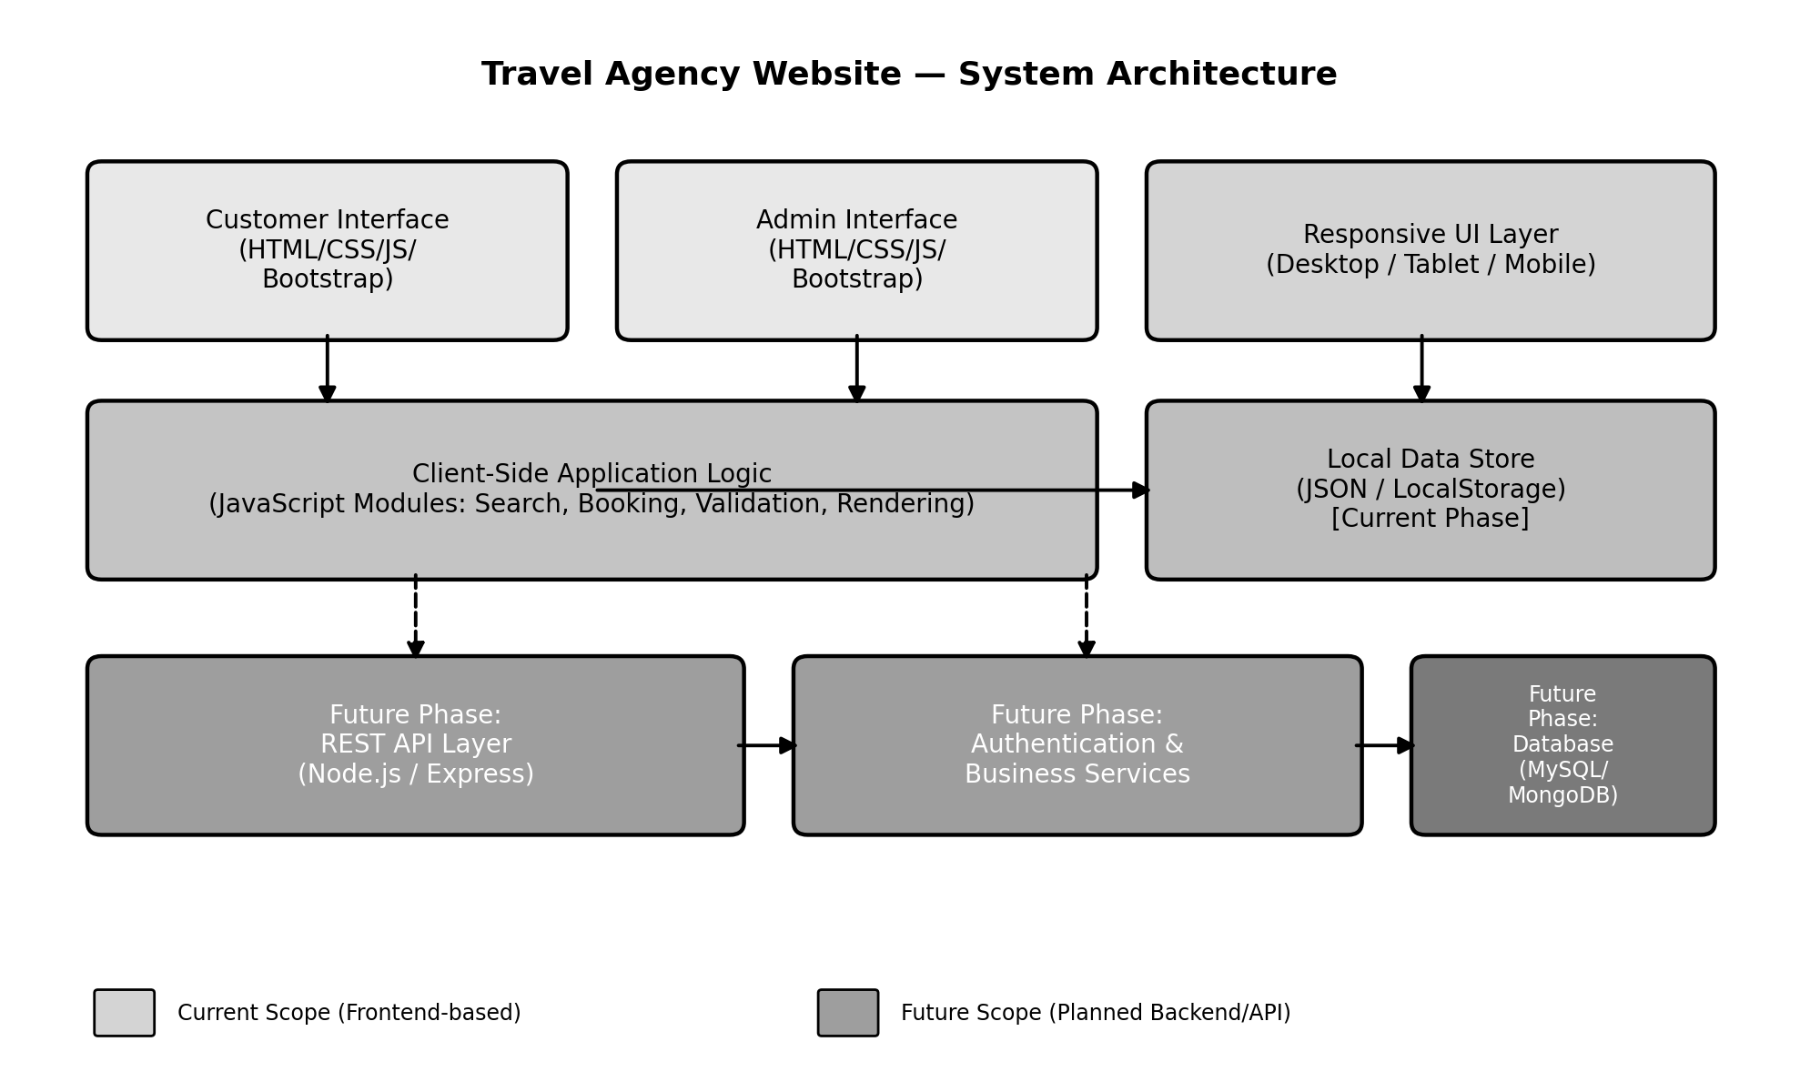
Figure 5.1 – System Architecture of the Travel Agency Website

5.1 Architectural Layers
- Presentation Layer: Responsive HTML/CSS/JavaScript pages for Customer and Admin interfaces.
- Application Logic Layer: JavaScript modules handling search, filtering, form validation, booking calculations, and dynamic rendering.
- Data Layer (Current Phase): Structured JSON files and LocalStorage simulating persistent storage of destinations, packages, bookings, users, and inquiries.
- Data Layer (Future Phase): REST API built on Node.js/Express, backed by a MySQL or MongoDB database, replacing the local data store without changing the presentation layer.

6 Use Case Model
This section presents the use case diagram for the system along with a summary table of actors and use cases, followed by two detailed use case specifications for representative high-priority scenarios.
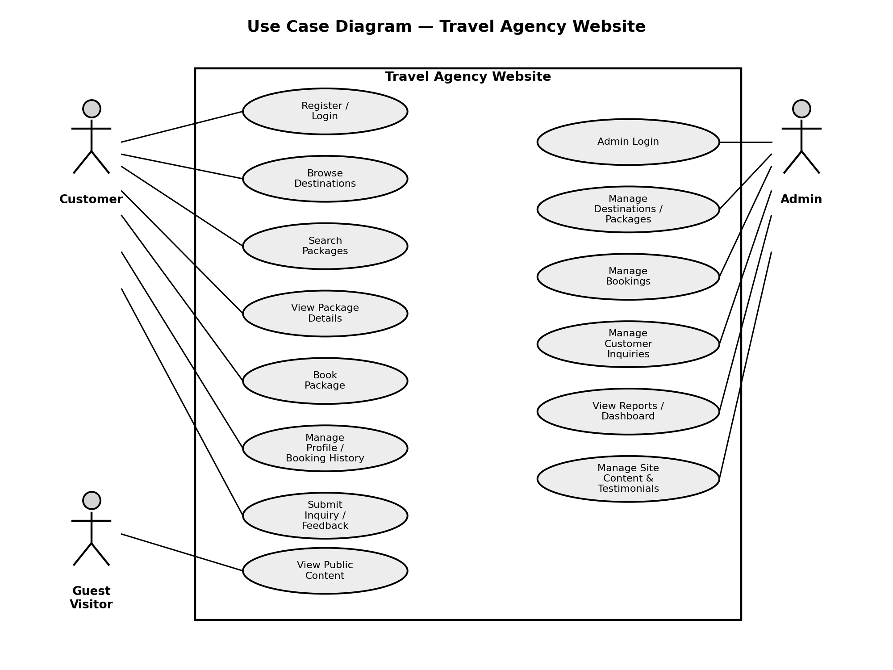
Figure 6.1 – Use Case Diagram of the Travel Agency Website

6.1 Actors
Actor | Description
Guest Visitor | An unauthenticated user who can browse public pages such as destinations and packages.
Customer | A registered user who can search, book packages, and manage their profile and bookings.
Admin | Authorized staff who manage destinations, packages, bookings, inquiries, and site content.

6.2 Use Case Specification: Book Package
Field | Detail
Use Case ID | UC-05
Use Case Name | Book Package
Actor(s) | Customer
Pre-condition | Customer is logged in and has navigated to a package details page.
Main Flow | 1. Customer clicks “Book Now” on a package. 2. System displays the booking form. 3. Customer enters traveller details and travel date. 4. System validates input and calculates total cost. 5. Customer confirms the (simulated) payment step. 6. System generates a booking reference and displays a confirmation.
Alternate Flow | If mandatory fields are missing or invalid, the system displays validation errors and the booking is not submitted.
Post-condition | A new booking record is created and visible in the customer’s booking history and the admin’s bookings list.

6.3 Use Case Specification: Manage Packages (Admin)
Field | Detail
Use Case ID | UC-10
Use Case Name | Manage Packages
Actor(s) | Admin
Pre-condition | Admin is authenticated and viewing the “Manage Packages” screen.
Main Flow | 1. Admin selects “Add New Package” or selects an existing package to edit. 2. System displays a form with package fields (destination, price, duration, itinerary, images). 3. Admin enters/updates the details and submits. 4. System validates and saves the package data. 5. System displays the updated package list.
Alternate Flow | If the admin selects “Delete”, the system prompts for confirmation before removing the package.
Post-condition | The package list is updated and immediately reflected on the customer-facing Packages page.

7 Data Design (Database Planning – Current & Future Phase)
Although the current academic phase uses JSON/LocalStorage to simulate data persistence, the data has been modelled in a normalized, relational-friendly structure so that it can be directly mapped to a relational database (MySQL) or a document database (MongoDB) in the future phase. The core entities and their key attributes are described below.

7.1 Entity – Attribute Overview
Entity | Key Attributes | Description
User (Customer) | user_id (PK), name, email, phone, password_hash, created_at | Stores registered customer account information.
Admin | admin_id (PK), username, password_hash, role | Stores authorized admin login credentials.
Destination | destination_id (PK), name, description, image_url, category | Represents a travel destination available in the catalogue.
Package | package_id (PK), destination_id (FK), title, description, price, duration_days, inclusions, image_url | Represents a bookable travel package linked to a destination.
Booking | booking_id (PK), user_id (FK), package_id (FK), travel_date, num_travellers, total_amount, status, created_at | Represents a customer’s booking request and its current status.
Inquiry | inquiry_id (PK), name, email, subject, message, status, created_at | Stores customer inquiries submitted via the Contact Us form.
Testimonial | testimonial_id (PK), user_id (FK, optional), content, rating, created_at | Stores customer reviews/testimonials displayed on the site.

7.2 Entity Relationships
- One Destination can have many Packages (1–to–many).
- One User can have many Bookings (1–to–many).
- One Package can be associated with many Bookings (1–to–many).
- One User can submit many Testimonials (1–to–many, optional relationship).
This structure is intentionally kept simple and normalized to third normal form (3NF) equivalence, appropriate for a student project while remaining realistic and extensible.

7.3 Future Phase – API Endpoint Planning
The following REST API endpoints are proposed for the future backend-integrated phase of the project, to be implemented using Node.js and Express.js:
Method | Endpoint | Description
POST | /api/auth/register | Register a new customer account.
POST | /api/auth/login | Authenticate a customer and issue a session/token.
POST | /api/admin/login | Authenticate an admin user.
GET | /api/destinations | Retrieve all destinations.
GET | /api/packages | Retrieve all packages, with optional filter query parameters.
GET | /api/packages/:id | Retrieve details of a specific package.
POST | /api/packages | (Admin) Create a new package.
PUT | /api/packages/:id | (Admin) Update an existing package.
DELETE | /api/packages/:id | (Admin) Delete a package.
POST | /api/bookings | Create a new booking request.
GET | /api/bookings/user/:userId | Retrieve booking history for a specific customer.
GET | /api/bookings | (Admin) Retrieve all bookings.
PUT | /api/bookings/:id/status | (Admin) Update the status of a booking.
POST | /api/inquiries | Submit a customer inquiry.
GET | /api/inquiries | (Admin) Retrieve all inquiries.

8 Non-Functional Requirements

8.1 Performance Requirements
ID | Requirement
NFR-01 | The system shall load any primary page (Home, Destinations, Packages) within 3 seconds under normal conditions on a standard broadband/local connection.
NFR-02 | Search and filter operations on packages shall return results within 1 second, given the dataset size expected for an academic project (under 200 records).

8.2 Security Requirements
ID | Requirement
NFR-03 | Passwords shall not be stored or displayed in plain text; a basic hashing approach shall be used even in the simulated data phase.
NFR-04 | Admin pages shall not be accessible without a valid authenticated admin session.
NFR-05 | All form inputs shall be validated on the client side to prevent obviously malformed or empty submissions.

8.3 Usability Requirements
ID | Requirement
NFR-06 | The user interface shall follow a consistent design system (colours, typography, spacing) across all pages.
NFR-07 | The system shall be fully responsive and usable on screen widths ranging from 360px (mobile) to 1920px (desktop).
NFR-08 | All interactive elements (buttons, links, form fields) shall provide clear visual feedback on hover/focus/active states.

8.4 Reliability and Availability
ID | Requirement
NFR-09 | The system shall handle invalid or unexpected user input gracefully without crashing or displaying raw error messages.
NFR-10 | Since the current phase is static/frontend-based, the system shall be available whenever the hosting page is reachable, with no server downtime dependency.

8.5 Maintainability and Portability
ID | Requirement
NFR-11 | The codebase shall be organized into clearly separated files/modules (pages, styles, scripts, data) to support easy maintenance and future extension.
NFR-12 | The application shall run identically across major modern browsers without requiring browser-specific code.

8.6 Scalability (Future Phase Consideration)
While scalability is not a primary concern for the current academic dataset, the data model and architecture described in Sections 5 and 7 have been designed so that migrating from JSON/LocalStorage to a proper relational or NoSQL database would not require significant redesign, allowing the system to scale to a larger, real-world dataset if extended beyond the academic scope.

9 Other Requirements
- Legal/Academic: All sample images, destination information, and pricing used in the project shall be either self-created, royalty-free, or clearly used for non-commercial academic demonstration only.
- Documentation: The project shall be accompanied by supporting documentation including this SRS, a user manual/README, and source code comments sufficient for evaluation.
- Version Control: The project source code shall be maintained using a version control system (e.g., Git) to track development progress.

10 Software Testing Plan (Overview)

10.1 Testing Approach
Testing for the Travel Agency Website shall follow a structured, incremental approach appropriate for a college project. Each module shall be tested individually as it is developed (unit-level), followed by integration testing across the Customer and Admin modules, and finally overall system and user-acceptance testing before final submission.

10.2 Levels of Testing
Level | Description
Unit Testing | Individual functions/components (e.g., form validation logic, price calculation, search/filter logic) are tested in isolation.
Integration Testing | Interaction between UI components and the local data layer (e.g., booking form correctly creating and displaying a booking record) is verified.
System Testing | The complete application is tested end-to-end across all Customer and Admin workflows on multiple browsers and screen sizes.
User Acceptance Testing (UAT) | The system is reviewed against the requirements in this document by the project guide/evaluator to confirm it meets expectations.

10.3 Sample Test Cases
Test ID | Test Scenario | Expected Result
TC-01 | Register with a valid name, email, phone, and password. | Account is created and success message is shown.
TC-02 | Register with an invalid email format. | System displays an email validation error and blocks submission.
TC-03 | Log in with correct credentials. | Customer is redirected to their profile/dashboard.
TC-04 | Log in with incorrect password. | System displays an appropriate error message and denies access.
TC-05 | Search for a package using a valid destination keyword. | Matching packages are displayed.
TC-06 | Search for a package using a non-existent keyword. | “No results found” message is displayed.
TC-07 | Submit a booking form with all mandatory fields filled correctly. | Booking is created and a confirmation with reference ID is shown.
TC-08 | Submit a booking form with a missing mandatory field. | System highlights the missing field and blocks submission.
TC-09 | Admin adds a new package with valid details. | Package appears in both the admin list and the customer-facing Packages page.
TC-10 | Admin deletes an existing package. | System asks for confirmation, then removes the package from all listings.
TC-11 | Unauthenticated user attempts to access an admin page directly via URL. | System redirects to the Admin Login page.
TC-12 | Resize browser window from desktop to mobile width. | Layout adjusts responsively without broken elements or overlapping content.

11 Appendices

11.1 Appendix A – Glossary
- Booking Reference ID: A unique identifier generated for each successful booking, used for tracking.
- Itinerary: The day-wise plan of activities included in a travel package.
- Inclusions/Exclusions: Items explicitly included or excluded from a package price (e.g., meals, transport).

11.2 Appendix B – Assumptions Log
- All monetary values are assumed to be in INR (₹) unless otherwise specified in the implementation.
- The project is developed and evaluated within a single academic semester timeline.

11.3 Appendix C – Future Enhancements
- Integration with a real backend (Node.js/Express) and database (MySQL/MongoDB) as outlined in Section 7.3.
- Integration with a real payment gateway (e.g., Razorpay/Stripe test mode) for end-to-end booking simulation.
- Email/SMS notifications for booking confirmations.
- Admin analytics dashboard with charts for booking trends.
- Multi-language and multi-currency support for broader usability.

