1. **Write a Python program which accepts the user's first and last name and print them in reverse order with a space between them**

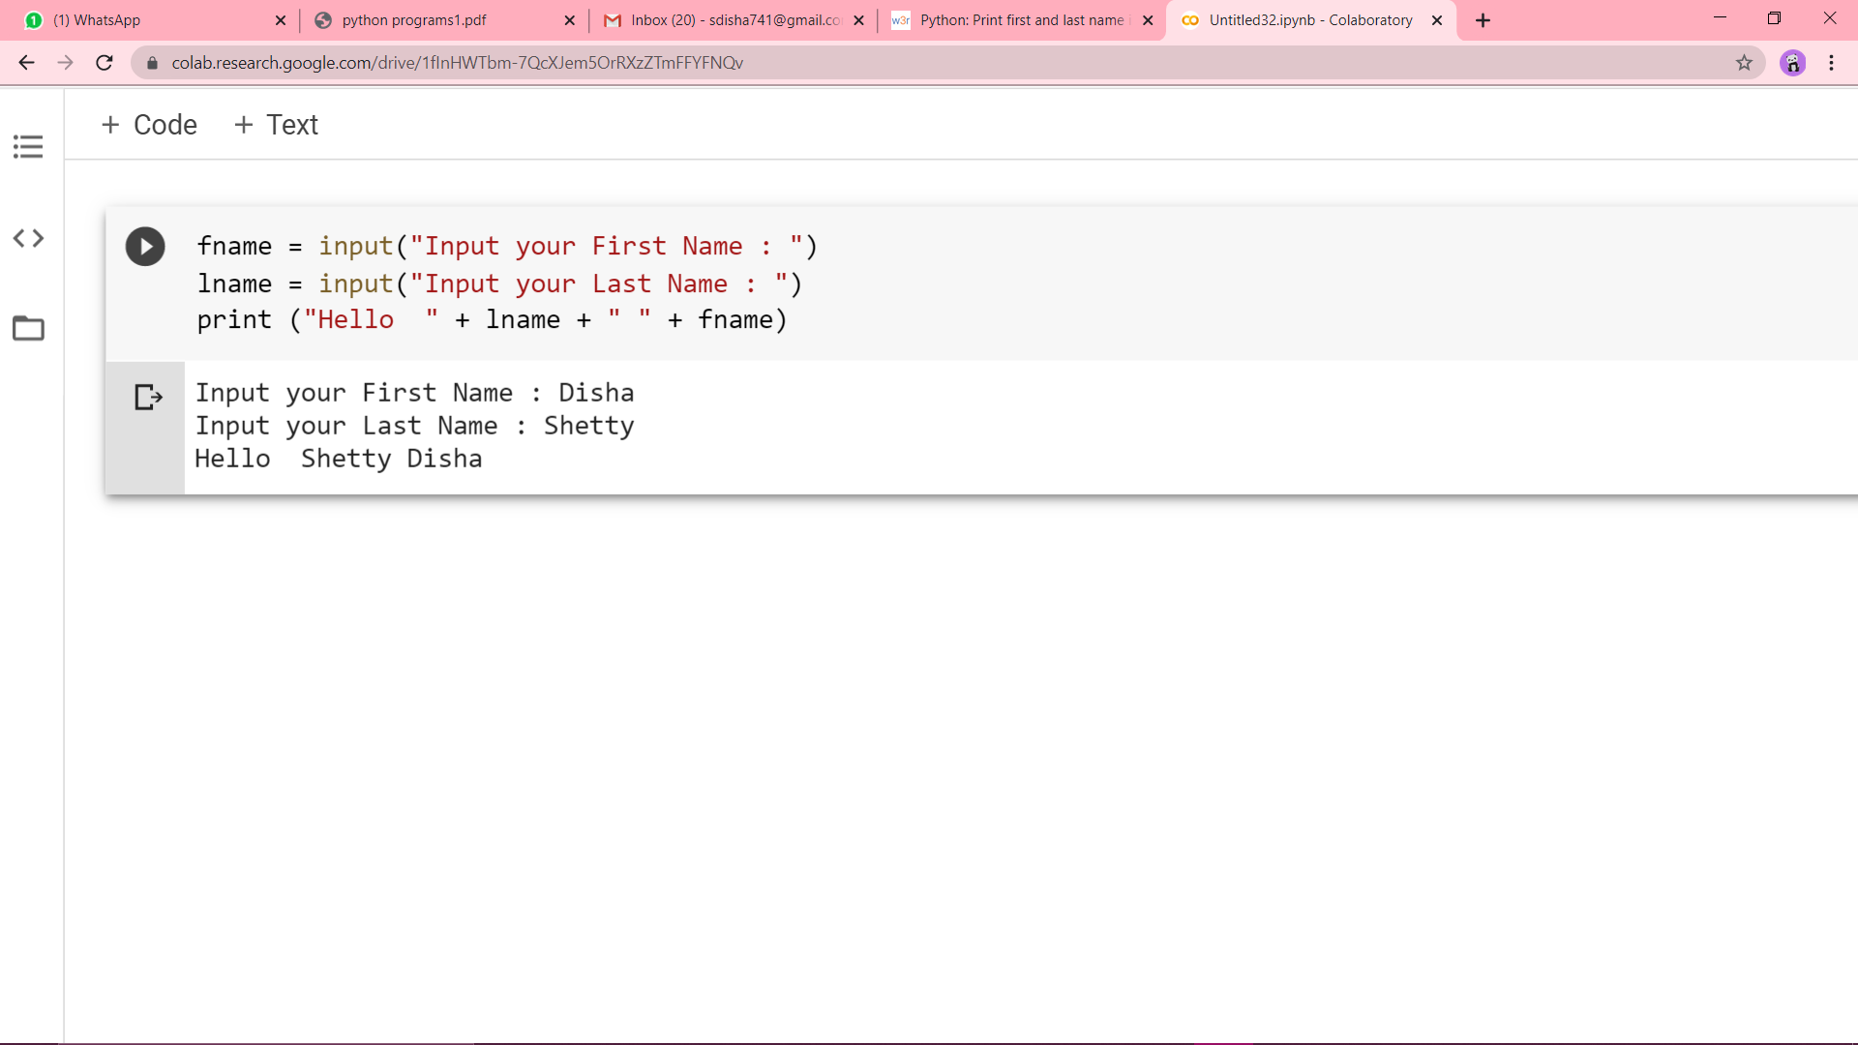

1. **Write a Python program to calculate number of days between two dates.**

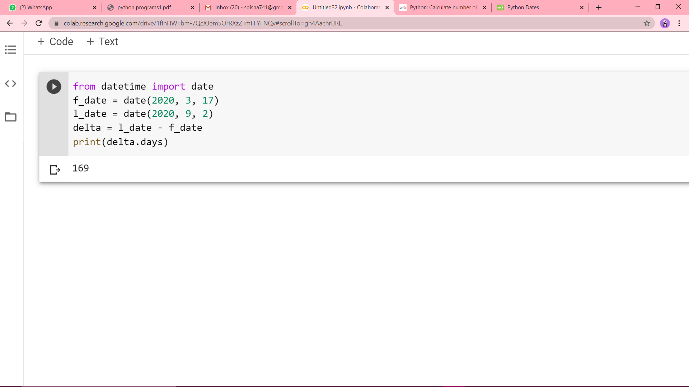

1. **Write a Python program to test whether a passed letter is a vowel or not**

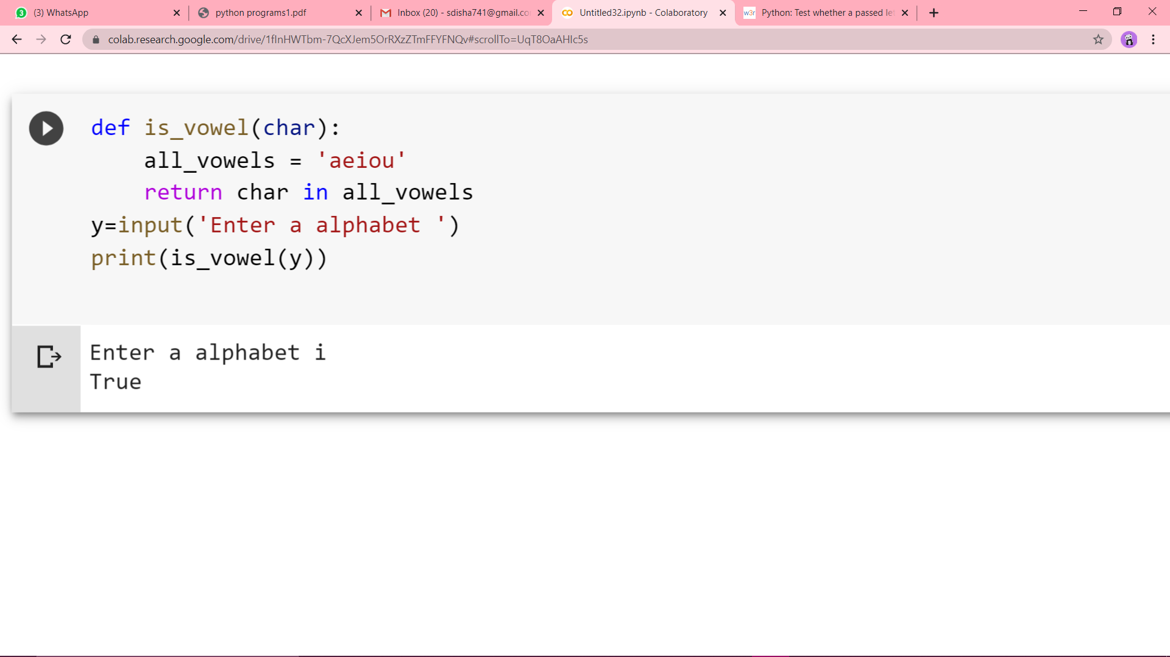

**4.Write a Python program to sum of three given integers. However, if two values are equal sum will be zero.**

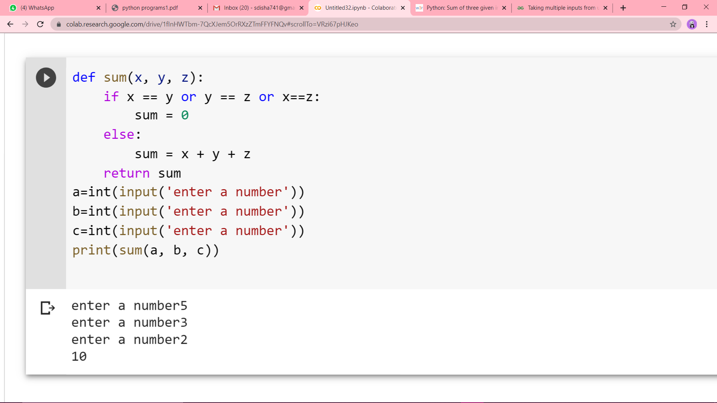

**5.Write a Python program to count the number of characters (character frequency) in a string.**

