**1. Write a Python program to count the occurrences of each word in a given sentence.**

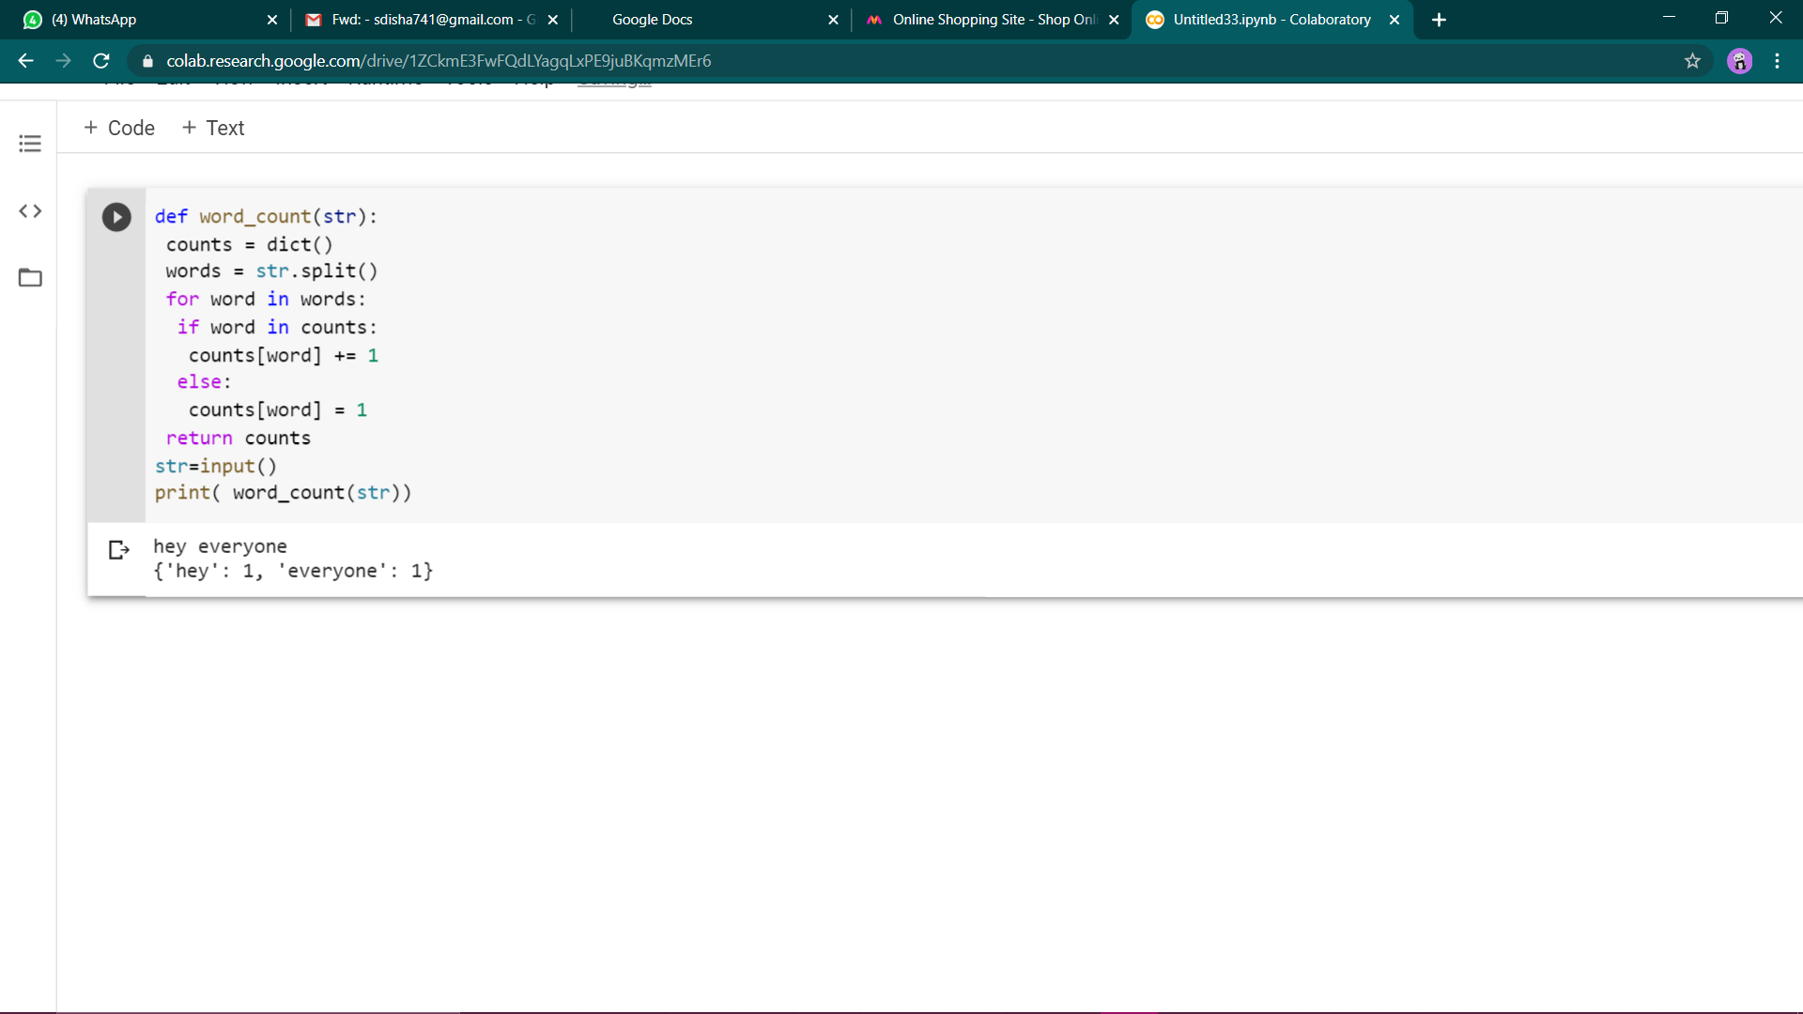

**2. Write a Python program to remove duplicates from a list. 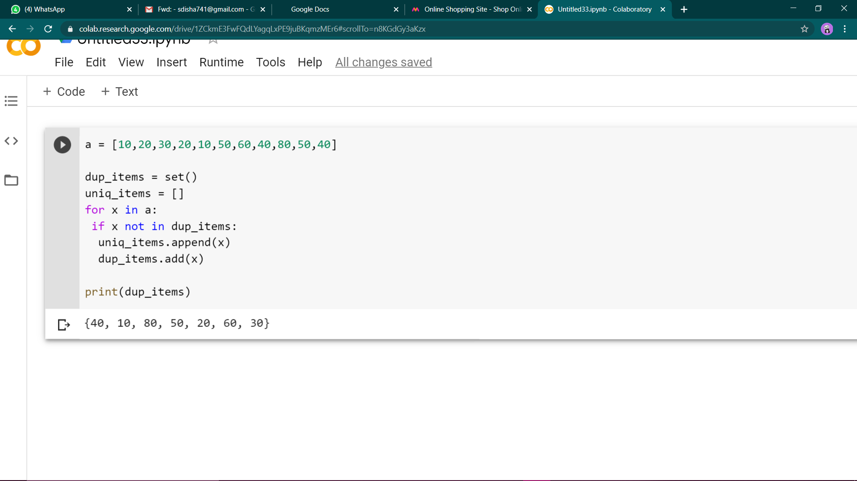3. Write a Python program to count the number of elements in a list within a specified range.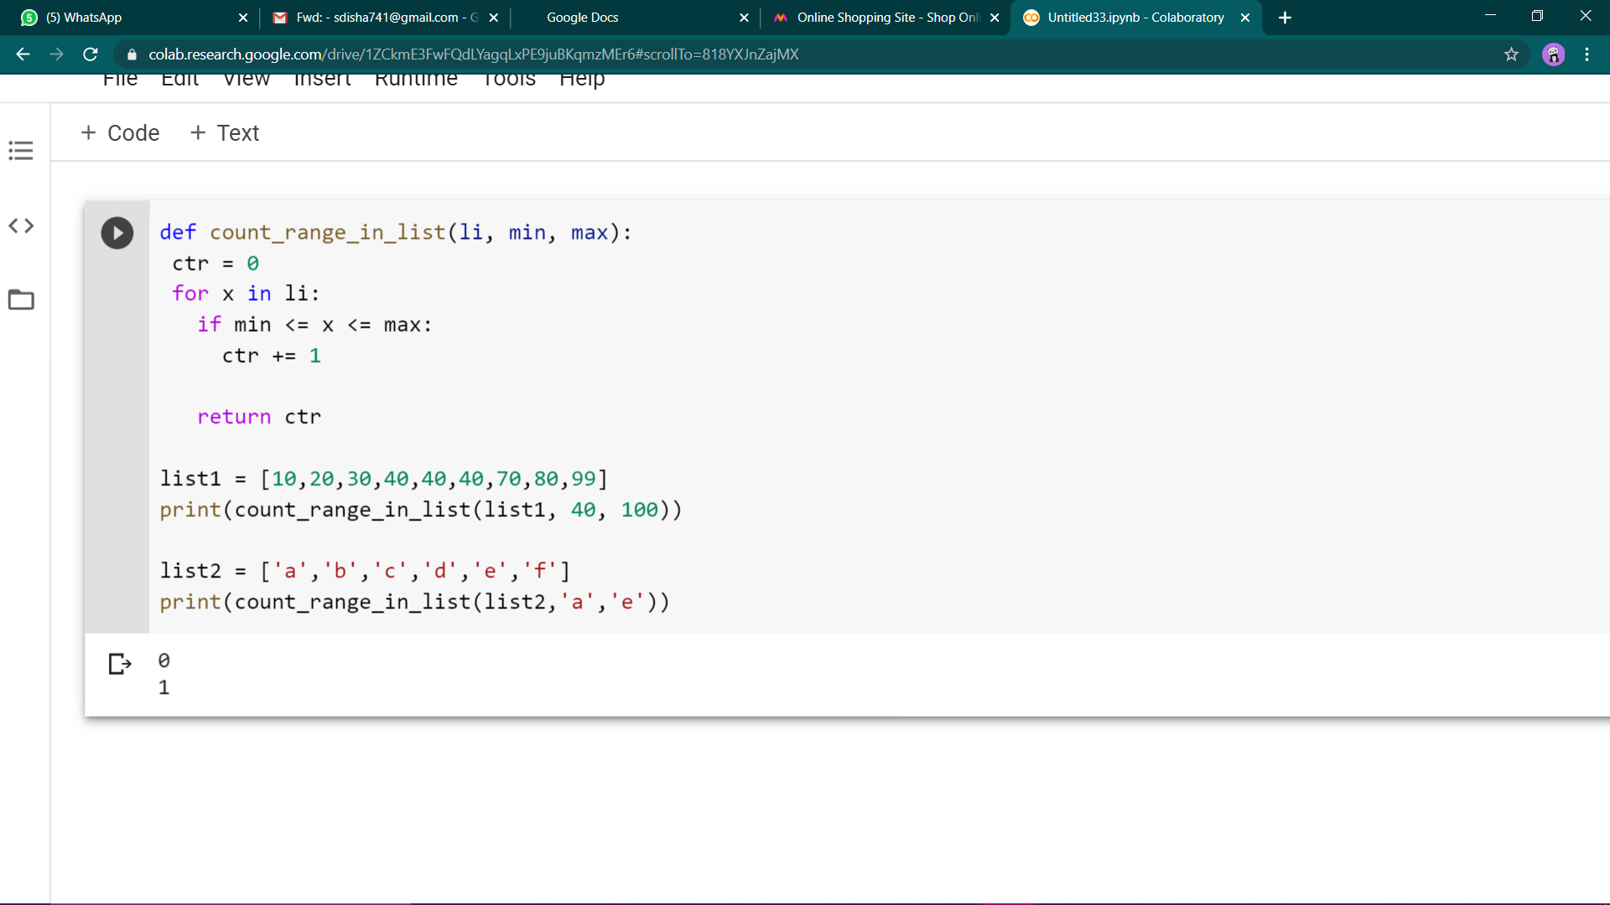 4. Write a Python script to merge two Python dictionaries 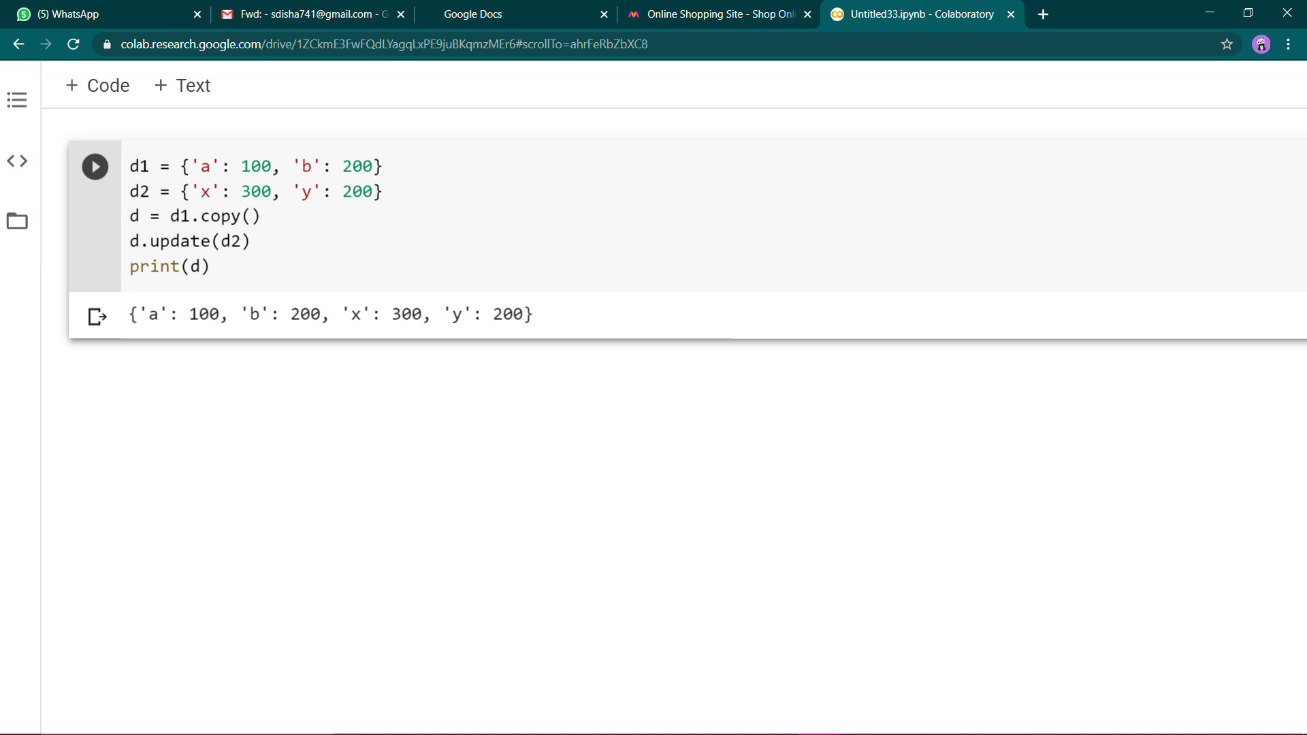5. Write a Python program to find the highest 3 values in a dictionary. 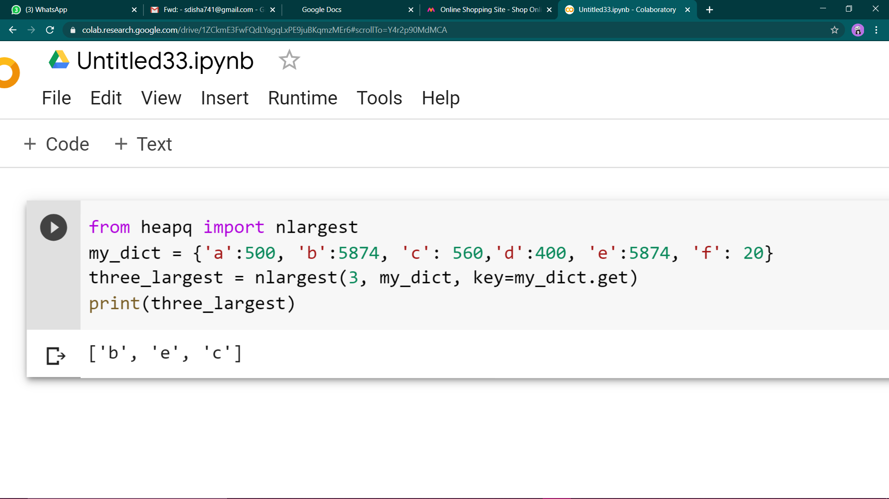6. Write a Python program to convert a tuple to a string. 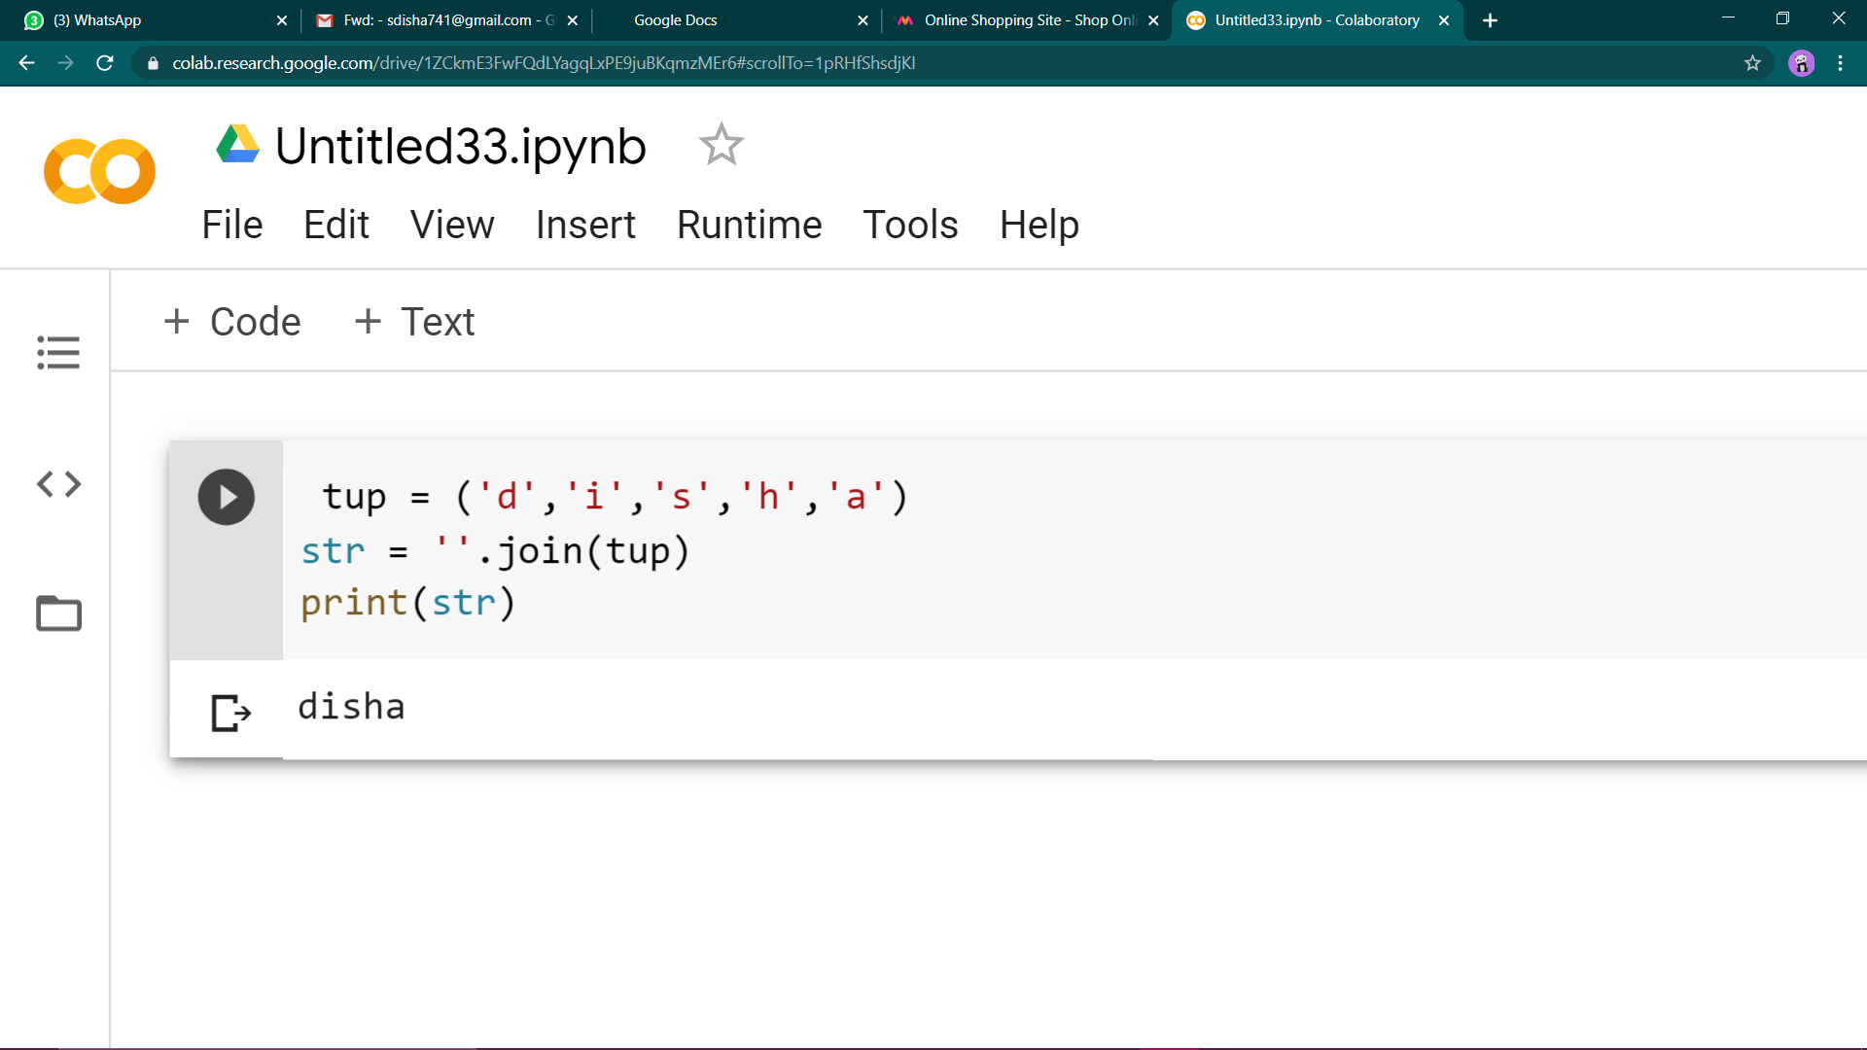7. Write a Python program to reverse a tuple. 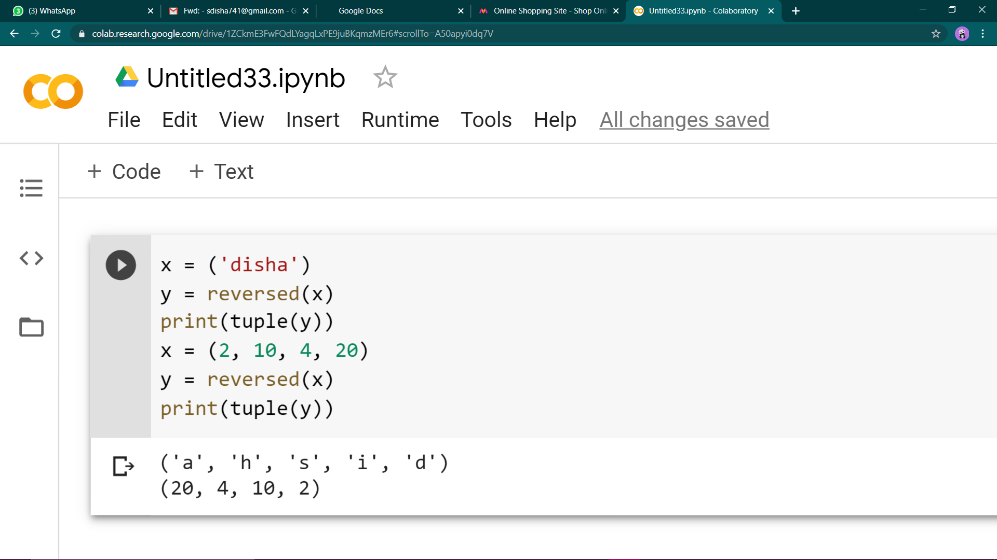8. Write a Python program to remove existing indentation from all of the lines in a given text**