電通二甲微處理器實驗 實驗結報

實驗名稱 | Lab 06 – 音樂教室
組別 | 12 | 組員 | 04052572鍾承翰 / 04050042 郭品沅

- 實驗目的
* 如何使 Arduino 發出特定旋律的聲音?
1. Arduino 接喇叭如何接線?
2. 如何使用 tone library?
3. 如何演奏一段音樂?
4. 如何使用 4x4 鍵盤演奏音樂?
5. 如何發報摩斯電碼?

- 實驗步驟
* Arduino 演奏一段特定的音樂, 旋律不得是小蜜蜂
* 使用 4x4 鍵盤演奏音樂
* 發報摩斯電碼

- 程式碼
POINT 1:
#define NOTE_C3 131
#define NOTE_CS3 139
#define NOTE_D3 147
#define NOTE_DS3 156
#define NOTE_E3 165
#define NOTE_F3 175
#define NOTE_FS3 185
#define NOTE_G3 196
#define NOTE_GS3 208
#define NOTE_A3 220
#define NOTE_AS3 233
#define NOTE_B3 247
#define NOTE_C4 262
#define NOTE_CS4 277
#define NOTE_D4 294
#define NOTE_DS4 311
#define NOTE_E4 330
#define NOTE_F4 349
#define NOTE_FS4 370
#define NOTE_G4 392
#define NOTE_GS4 415
#define NOTE_A4 440
#define NOTE_AS4 466
#define NOTE_B4 494
#define WHOLE 1 //全分符
#define HALF 0.5 //半分符
#define QUARTER 0.25
#define EIGHTH 0.125
#define SIXTEENTH 0.0625

int tune[] = { NOTE_C3, NOTE_C3, NOTE_G3,
NOTE_G3, NOTE_A3, NOTE_A3, NOTE_G3,
NOTE_F3, NOTE_F3, NOTE_E3, NOTE_E3,
NOTE_D3, NOTE_D3, NOTE_C3, NOTE_G3,
NOTE_G3, NOTE_F3, NOTE_F3, NOTE_E3,
NOTE_E3, NOTE_D3, NOTE_G3,NOTE_G3, NOTE_F3, NOTE_F3, NOTE_E3,
NOTE_E3, NOTE_D3,NOTE_C3, NOTE_C3, NOTE_G3,
NOTE_G3, NOTE_A3, NOTE_A3, NOTE_G3,NOTE_F3, NOTE_F3, NOTE_E3, NOTE_E3,
NOTE_D3, NOTE_D3, NOTE_C3};
float duration[] = { QUARTER,
QUARTER,QUARTER,QUARTER,QUARTER,QUARTER,
HALF, QUARTER,QUARTER,QUARTER,QUARTER,QUARTER,QUARTER,
HALF,QUARTER,QUARTER,QUARTER,QUARTER,QUARTER,QUARTER,
HALF,QUARTER,QUARTER,QUARTER,QUARTER,QUARTER,QUARTER,
HALF,QUARTER,QUARTER,QUARTER,QUARTER,QUARTER,QUARTER,
HALF,QUARTER,QUARTER,QUARTER,QUARTER,QUARTER,QUARTER,
HALF
};
int length;

void setup()
{
pinMode(8, OUTPUT);
length = sizeof(tune) /
sizeof(tune[0]);
}
void loop()
{
for (int x=0; x<length; x++)
{
tone(8, tune[x]);
delay(2500 *duration[x]);
noTone(8);
}
delay(5000);
}

POINT 2:
#include <Key.h>
#include <Keypad.h>

#define KEY_ROWS 4
#define KEY_COLS 4
int tune[] = { 261,294,329,349,
392, 440, 493,523,
523,587,659,698,
784,880,988,1046
};

char keymap[KEY_ROWS][KEY_COLS] = {
{'0', '4', '8', 'C'},
{'1', '5', '9', 'D'},
{'2', '6', 'A', 'E'},
{'3', '7', 'B', 'F'}};

byte colPins[KEY_COLS] = {9,8,7,6};
byte rowPins[KEY_ROWS] = {5,4,3,2};

Keypad myKeypad = Keypad(makeKeymap(keymap), rowPins, colPins, KEY_ROWS, KEY_COLS);

void setup()
{
Serial.begin(9600);
byte numDigits = 1;
byte digitPins[] = {10};
byte segmentPins[] = {A0,A1,A4,A3,A2,12,A5,13};
}

void loop()
{
char x=myKeypad.getKey();
if (x != NO_KEY)
{
if(x>='0' && x<='9')
{
tone(10, tune[x-48]);
delay(300);
noTone(10);
}
if(x>='A' && x<='F')
{
tone(10, tune[x-55]);
delay(300);
noTone(10);
}
}
}

POINT 3:

char *morse[]={
"01","1000","1010","100", //A~D
"0","0010","110","0000", //E~H
"00","0111","101","0100", //I~L
"11","10","111","0110", //M~P
"1101","010","000","1", //Q~T
"001","0001","11","1001", //U~X
"1011","1100" //Y~Z
};
const byte Buzzer=10;
char chr,index;
char *ptr;

void setup() {
pinMode(Buzzer,OUTPUT);
Serial.begin(9600);
}

void loop() {
if( Serial.available() ){
chr=Serial.read();
Serial.println(chr);
if( (chr-'A')>=0 && (chr-'Z')<=0 ){
index=chr-'A';
ptr=morse[index];
while(*ptr!='\0'){
if(*ptr=='0'){
tone(Buzzer,440,100);
delay(100);
}
else{
tone(Buzzer,440,300);
delay(300);
}
ptr++;
delay(100);
}
delay(300);
}
else
delay(700);
}
}

- 實驗結果及分析
POINT 1:
燒錄後，直接演奏出一閃一閃亮晶晶，結束後5秒再演奏一次。
POINT 2:
用4X4鍵盤演奏出一閃一閃亮晶晶。
POINT 3:
PC輸入字母，可演奏出相對應的摩斯密碼滴答聲。

- 心得討論

- 電路圖
POINT1:
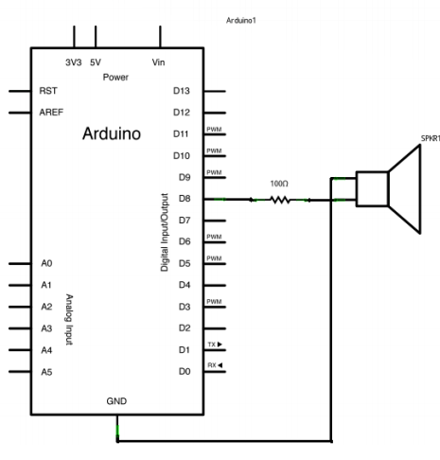
POINT2:
