電通二甲微處理器實驗 實驗結報

實驗名稱 | Lab 01 – LED Blink
組別 | 12 | 組員 | 04052572 鍾承翰 / 04050042 郭品沅

- 實驗目的
1.使用 circuits.io 模擬 Arduino UNO 電路及程式
2.繪製電路圖
3.觀察 Arduino UNO 之輸出
4.學習將程式碼及實驗報告上傳至 Github

- 實驗步驟
1.填寫分組表單
2.啓動 Arduino IDE, 載入 Blink 程式碼
3.至 circuits.io 註冊帳號，啟動 Arduino 模擬器
4.接上 LED 電路
5.修改程式，將 LED 輸出改為 Pin 9
6.觀察 LED 之閃爍間隔
7.修改程式, 使 LED 閃爍間隔分別增加為 2 倍及 ½ 倍, 重新量測並截圖
8.畫出電路圖

- 程式碼

// Pin 13 has an LED connected on most Arduino boards.
// give it a name:
int led = 13;

// the setup routine runs once when you press reset:
void setup() {
// initialize the digital pin as an output.
pinMode(led, OUTPUT);
}

// the loop routine runs over and over again forever:
void loop() {
digitalWrite(led, HIGH); // turn the LED on (HIGH is the voltage level)
delay(1000); // wait for a second
digitalWrite(led, LOW); // turn the LED off by making the voltage LOW
delay(1000); // wait for a second
}

- 實驗結果及分析
透過更改 delay 時間為 500或 2000 ms,閃爍間隔時間變快或變慢
透過更改電路圖以及程式中 LED 的腳位改成 pin 9

- 心得討論
第一次使用github，看說明感覺很複雜，但是之後如果熟悉了，以後改code就會變得非常方便，讓我知道之前改了哪些部分的程式碼，和組員一起改程式碼也變得很方便。
- 修正電路圖
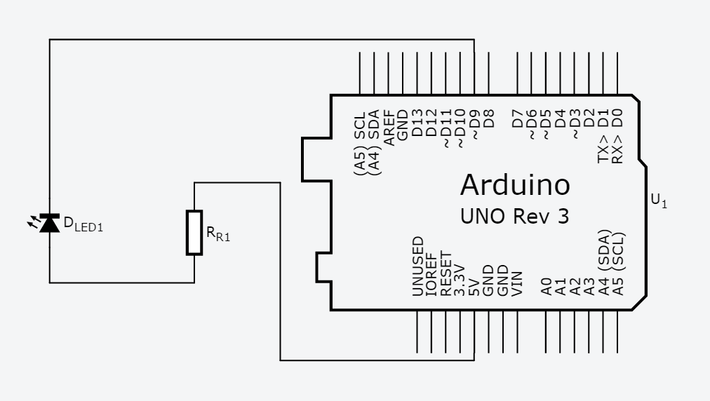
- 修正程式碼
(1)
// Pin 9 has an LED connected on most Arduino boards.
// give it a name:
int led = 9;

// the setup routine runs once when you press reset:
void setup() {
// initialize the digital pin as an output.
pinMode(led, OUTPUT);
}

// the loop routine runs over and over again forever:
void loop() {
digitalWrite(led, HIGH); // turn the LED on (HIGH is the voltage level)
delay(2000); // wait for a second
digitalWrite(led, LOW); // turn the LED off by making the voltage LOW
delay(2000); // wait for a second
}

(2)
// Pin 9 has an LED connected on most Arduino boards.
// give it a name:
int led = 9;

// the setup routine runs once when you press reset:
void setup() {
// initialize the digital pin as an output.
pinMode(led, OUTPUT);
}

// the loop routine runs over and over again forever:
void loop() {
digitalWrite(led, HIGH); // turn the LED on (HIGH is the voltage level)
delay(500); // wait for a second
digitalWrite(led, LOW); // turn the LED off by making the voltage LOW
delay(500); // wait for a second
}

