電通二甲微處理器實驗 實驗結報

實驗名稱 | Lab 02 –跑馬燈
組別 | 12 | 組員 | 04052572 鍾承翰 / 04050042 郭品沅

- 實驗目的
Arduino UNO D1 – D8 分別接到 LED，實作跑馬燈展示。
- 實驗步驟
#1
1. LED 向左及向右執行花色展示
2.執行自定花色展示: 所有LED亮滅兩次 -> 左移八次 -> 所有LED亮滅兩次-> 右移八次
#2
1. Arduino 接上一個開關
2. 開關 OFF -> LED 向左及向右執行花色展示 3. 開關 ON -> 執行自定花色展示
- 程式碼
// Lab02_1
// 使用for迴圈的跑馬燈程式
//
// 每個 LED 正極接到 Pin 0 - 7, 負極接地
const byte startPin = 1;
const byte endPin = 8;
void setup() {
// 將每個 Pin 設定成輸出
for (byte i = startPin; i<= endPin; i++) {
pinMode(i, OUTPUT);
}
}
void loop()
{
byte i;
byte lightPin = startPin;
// 所有 LED OFF
for (i=startPin; i<= endPin; i++) {
digitalWrite(i,LOW);
}
// 設定要點亮的 LED 位置
// 如果點亮的腳位編號小於結束腳位,
則腳位編號+1
// 否則從頭開始
if (lightPin < endPin) {
lightPin ++;
} else {
lightPin = startPin;
}
// 點亮 LED
digitalWrite(lightPin, HIGH);
delay (100);
}
- 實驗結果及分析
1.LED 向左及向右依序亮
2.LED 自訂所有LED亮滅兩次 ->向左及向右依序亮-> 所有LED亮滅兩次
->向右及向左依序亮
亮滅一開始打了8行程式碼後來才改用for迴圈
3.接開關需要先試要接哪邊會通才能完成
- 心得討論
開關試了很久才找到會接通的點，接了電路讓我們知道哪種接髮比較省電，透過這次實驗，讓我們更熟悉Arduino。
修正電路圖
(1)
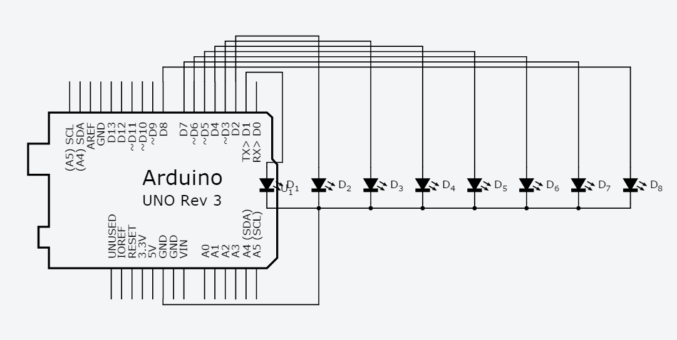
(2)
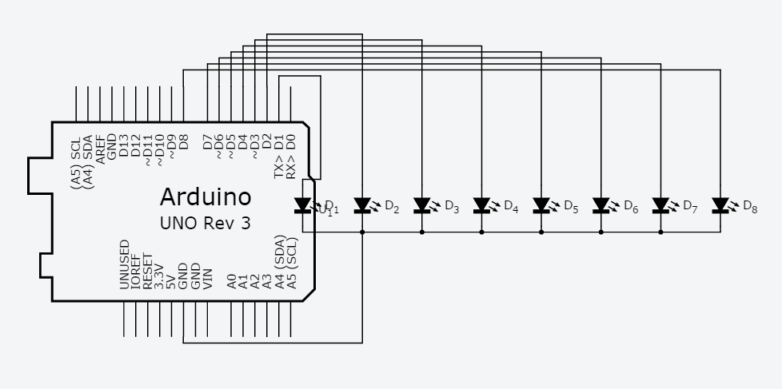
(3)
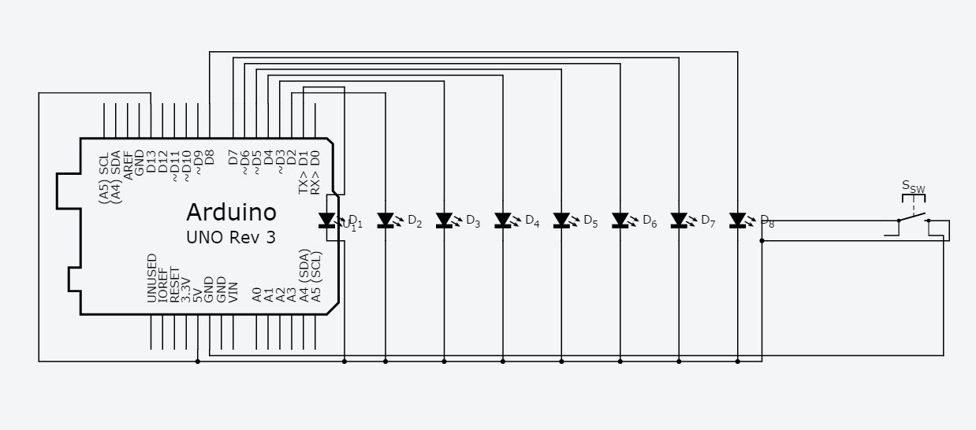
- 修正程式碼
(1)
const byte startPin = 1;
const byte endPin = 8;

void setup() {
// put your setup code here, to run once:
for (byte i = startPin; i<= endPin; i++)
{
pinMode(i, OUTPUT);
}
}

void loop() {
// put your main code here, to run repeatedly:
byte i;
byte lightPin = startPin;
for (i=startPin; i<= endPin; i++)
{
digitalWrite(i,LOW);

if (lightPin < endPin)
{
lightPin ++;
}
else
{
lightPin = endPin;
}
digitalWrite(lightPin, HIGH);
delay (100);
}
lightPin = endPin;
for (i=endPin; i>= startPin; i--)
{
digitalWrite(i,LOW);
if (lightPin > startPin)
{
lightPin --;
}
else
{
lightPin = startPin;
}
digitalWrite(lightPin, HIGH);
delay (100);
}
}
(2)
const byte startPin = 1;
const byte endPin = 8;

void setup() {
// put your setup code here, to run once:
for (byte i = startPin; i<= endPin; i++)
{
pinMode(i, OUTPUT);
}
}

void loop() {
// put your main code here, to run repeatedly:
byte i,j;
byte lightPin = startPin;

for(j=0;j<=1;j++)
{
for(i=lightPin;i<=endPin;i++)
digitalWrite(i,HIGH);
delay (300);
for(i=lightPin;i<=endPin;i++)
digitalWrite(i,LOW);
delay (300);
}
for (i=startPin; i<= endPin; i++)
{
digitalWrite(i,LOW);

if (lightPin < endPin)
{
lightPin ++;
}
else
{
lightPin = endPin;
}
digitalWrite(lightPin, HIGH);
delay (100);
}
lightPin = startPin;
for(j=0;j<=1;j++)
{
for(i=lightPin;i<=endPin;i++)
digitalWrite(i,HIGH);
delay (300);
for(i=lightPin;i<=endPin;i++)
digitalWrite(i,LOW);
delay (300);
}
lightPin = endPin;
for (i=endPin; i>= startPin; i--)
{
digitalWrite(i,LOW);
if (lightPin > startPin)
{
lightPin --;
}
else
{
lightPin = startPin;
}
digitalWrite(lightPin, HIGH);
delay (100);
}
}
(3)
const byte startPin = 1;
const byte endPin = 8;
const byte LED = 13;
const byte SW = 13;

void setup() {
pinMode(SW,INPUT);
// put your setup code here, to run once:
//boolean SW;
for (byte i = startPin; i<= endPin; i++)
{
pinMode(i, OUTPUT);
pinMode(LED, OUTPUT);

}
}

void loop() {
// put your main code here, to run repeatedly:
byte i,j;
byte lightPin = startPin;
boolean val = digitalRead(13);

if(val==0)
{
byte i;
byte lightPin = startPin;
for (i=startPin; i<= endPin; i++)
{
digitalWrite(i,LOW);

if (lightPin < endPin)
{
lightPin ++;
}
else
{
lightPin = endPin;
}
digitalWrite(lightPin, HIGH);
delay (100);
}
lightPin = endPin;
for (i=endPin; i>= startPin; i--)
{
digitalWrite(i,LOW);
if (lightPin > startPin)
{
lightPin --;
}
else
{
lightPin = startPin;
}
digitalWrite(lightPin, HIGH);
delay (100);
}
}
else
{
for(j=0;j<=1;j++)
{
for(i=lightPin;i<=endPin;i++)
digitalWrite(i,HIGH);
delay (300);
for(i=lightPin;i<=endPin;i++)
digitalWrite(i,LOW);
delay (300);
}
for (i=startPin; i<= endPin; i++)
{
digitalWrite(i,LOW);

if (lightPin < endPin)
{
lightPin ++;
}
else
{
lightPin = endPin;
}
digitalWrite(lightPin, HIGH);
delay (100);
}
lightPin = startPin;
for(j=0;j<=1;j++)
{
for(i=lightPin;i<=endPin;i++)
digitalWrite(i,HIGH);
delay (300);
for(i=lightPin;i<=endPin;i++)
digitalWrite(i,LOW);
delay (300);
}
lightPin = endPin;
for (i=endPin; i>= startPin; i--)
{
digitalWrite(i,LOW);
if (lightPin > startPin)
{
lightPin --;
}
else
{
lightPin = startPin;
}
digitalWrite(lightPin, HIGH);
delay (100);
}
}
}

