**電通二甲微處理器實驗 實驗結報**

|  |  |  |  |
| --- | --- | --- | --- |
| **實驗名稱** | Lab08-I2C通訊 | | |
| **組別** | **15** | **組員** | **周子成、康書豪** |

1. **實驗目的**

*使用 Arduino wire 程式庫, 實現多台 Arduino 透過 I2C介面 通訊.

1. 一台 Arduino, 作為 Master 端，讀取 slave 端之溫濕度感測器讀值, 顯示在 LCD 螢幕上。

2. 一台 Arduino, 作為 Slave 端，將溫濕度感測器之讀值，傳送到 Master 及 PC。

1. **實驗步驟**

1. Slave 端, 可透過 I2C 傳出溫濕度感測器之讀值。

2. Master 端, 可透過 I2C 讀取溫濕度感測器之讀值。

1. **程式碼**

(讀取 DHT-11)

#include <dht.h>

#define dht_dpin 2 //定義訊號要從Pin A0 進來

dht DHT;

void setup(){

Serial.begin(9600); delay(300);

Serial.println("Humidity and temperature\n\n");

delay(700); }

void loop(){

DHT.read11(dht_dpin); //去library裡面找DHT.read11

Serial.print("Humidity = "); Serial.print(DHT.humidity);

Serial.print("% ");

Serial.print("temperature = ");Serial.print(DHT.temperature);

Serial.println("C ");

delay(1000);

//Slave端

#include <Wire.h>

const int SLAVE_ADDRESS = 1;

void setup(){

Wire.begin(SLAVE_ADDRESS); // join I2C bus as a slave with

addres

Wire.onRequest(requestEvent); // register event

}

void loop() { }

void requestEvent() {

DHT.read11(dht_dpin); //讀取DHT-11

Wire.write(”XXX“); //將溫濕度讀值輸出

}

//Master 端

#include <Wire.h>

const int SLAVE_ADDRESS = 1;

char incomingByte = 0;

void setup() {

Wire.begin(); // join I2C bus as a Master

}

void loop() {

Wire.requestFrom(SLAVE_ADDRESS, X);

// request X bytes from slave

while (Wire.available()) {

incomingByte = Wire.read(); // receive a byte

// Display at LCD }

delay(1000);

// LCD 換行

}

1. **實驗結果及分析**

分別寫出對應Master端和Slave端的程式碼，再利用上一周LCD實驗的程式碼，讓一端溫濕度感應器偵測到的值傳到另一端讀取並在LCD上顯示出來

1. **心得討論**

第一次在實驗課做需要讓arduino對接的課題所以遇到了不少問題，像是LCD讀取不到溫濕度感測器、LCD無法正常顯示讀取到的值**修正電路圖**

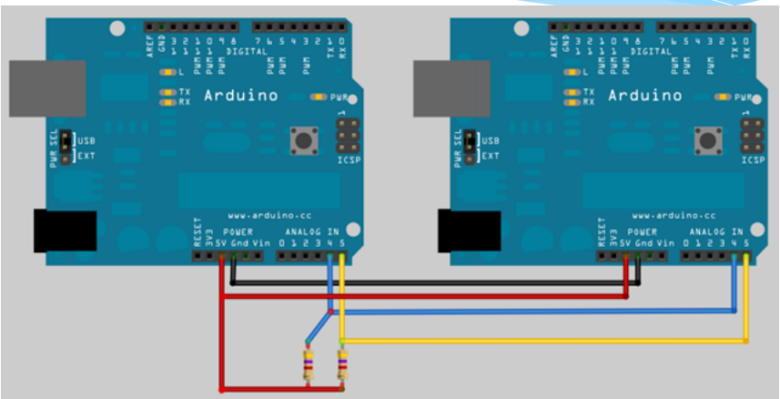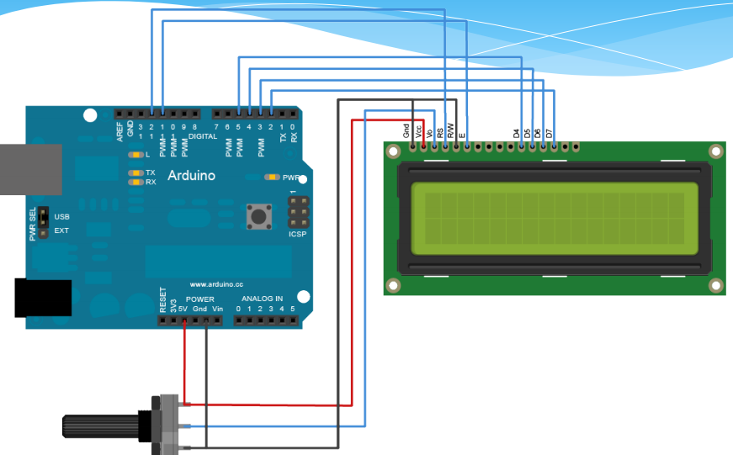

1. **修正程式碼**

**//Slave端**

**#include <Wire.h>**

**#include <dht.h>**

**#define dht_dpin 2**

**dht DHT;**

**const int SLAVE_ADDRESS = 1;**

**char h[2];**

**char t[2];**

**char p[7];**

**void setup()**

**{**

**Serial.begin(9600);**

**Wire.begin(SLAVE_ADDRESS); // join I2C bus as a slave with**

**Wire.onRequest(requestEvent); // register event**

**}**

**void loop()**

**{**

**DHT.read11(dht_dpin);**

**Serial.print("Humidity = ");**

**Serial.print(DHT.humidity);**

**Serial.print("% ");**

**Serial.print("temperature = ");**

**Serial.print(DHT.temperature);**

**Serial.println("C ");**

**dtostrf(DHT.humidity,2,0,h);**

**p[0] = h[0];**

**p[1] = h[1];**

**p[2] = '%';**

**p[3] = ' ';**

**dtostrf(DHT.temperature,2,0,t);**

**p[4] = t[0];**

**p[5] = t[1];**

**p[6] = 'C';**

**delay(1000);**

**}**

**void requestEvent()**

**{**

**Wire.write(p);**

**}**

**//Master端**

**#include <Wire.h>**

**#include <LiquidCrystal.h>**

**LiquidCrystal lcd(12, 11, 5, 4, 3, 2);**

**const int SLAVE_ADDRESS = 1;**

**char incomingByte = 0;**

**void setup()**

**{**

**lcd.begin(20,2);**

**Wire.begin();**

**}**

**void loop()**

**{**

**delay(2000);**

**lcd.setCursor(0,0);**

**Wire.requestFrom(SLAVE_ADDRESS,7);**

**while (Wire.available())**

**{**

**incomingByte = Wire.read();**

**lcd.write(incomingByte);**

**}**

**}**