電通二乙微處理器實驗 實驗結報

實驗名稱 | Lab02-跑馬燈
組別 | 15 | 組員 | 04050582周子成 04050742康書豪

- 實驗目的
Arduino UNO D1 – D8 分別接到 LED，實作跑馬燈展 示。

- 實驗步驟
1. LED 向左及向右執行花色展示
2. 執行自定花色展示: 所有LED亮滅兩次 -> 左移八次 -> 所有LED亮滅兩次 -> 右移八次

- 程式碼
// Pin 13 has an LED connected on most Arduino boards.
// give it a name:
int led[8] = {2,3,4,5,6,7,8,9};
int i,num;
// the setup routine runs once when you press reset:
void setup() {
// initialize the digital pin as an output.
for (i=0;i<8;i++)
{
pinMode(led[i], OUTPUT);
}
}

// the loop routine runs over and over again forever:
void loop() {

for (i=0;i<=7;i++){
digitalWrite(led[i], HIGH); // turn the LED on (HIGH is the voltage level)
delay(50); // wait for a second
digitalWrite(led[i], LOW); // turn the LED off by making the voltage LOW
delay(50); // wait for a second
}

for (i=7;i>=0;i--){
digitalWrite(led[i], HIGH); // turn the LED on (HIGH is the voltage level)
delay(50); // wait for a second
digitalWrite(led[i], LOW); // turn the LED off by making the voltage LOW
delay(50); // wait for a second
}
}
// Pin 13 has an LED connected on most Arduino boards.
// give it a name:
int led[8] = {2,3,4,5,6,7,8,9};
int i,num;
// the setup routine runs once when you press reset:
void setup() {
// initialize the digital pin as an output.
for (i=0;i<8;i++)
{
pinMode(led[i], OUTPUT);
}
}

// the loop routine runs over and over again forever:
void loop() {
for (num=0;num<2;num++){ //全亮滅2次
for (i=7;i>=0;i--){
digitalWrite(led[i], HIGH); // turn the LED on (HIGH is the voltage level
}
delay(1000);
for (i=7;i>=0;i--){
digitalWrite(led[i], LOW); // turn the LED on (HIGH is the voltage level
}
delay(1000);
}
for (num=0;num<1;num++){ //左移8次
for (i=0;i<=7;i++){
digitalWrite(led[i], HIGH); // turn the LED on (HIGH is the voltage level)
delay(50); // wait for a second
digitalWrite(led[i], LOW); // turn the LED off by making the voltage LOW
delay(50); // wait for a second
}
}
for (num=0;num<2;num++){ //亮滅2次
for (i=7;i>=0;i--){
digitalWrite(led[i], HIGH); // turn the LED on (HIGH is the voltage level
}
delay(1000);
for (i=7;i>=0;i--){
digitalWrite(led[i], LOW); // turn the LED on (HIGH is the voltage level
}
delay(1000);
}
for (num=0;num<1;num++){ //右移2次
for (i=7;i>=0;i--){
digitalWrite(led[i], HIGH); // turn the LED on (HIGH is the voltage level)
delay(50); // wait for a second
digitalWrite(led[i], LOW); // turn the LED off by making the voltage LOW
delay(50); // wait for a second
}
}
}
-------------------------------------------------------------------------------------------------------
// Pin 13 has an LED connected on most Arduino boards.
// give it a name:
int led[8] = {2,3,4,5,6,7,8,9};
int i,num;
// the setup routine runs once when you press reset:
void setup() {
// initialize the digital pin as an output.
for (i=0;i<8;i++)
{
pinMode(led[i], OUTPUT);
}
pinMode(13,INPUT);
Serial.begin(9600);
for (i=0;i<8;i++)
{
digitalWrite(led[i], LOW);
}
}

// the loop routine runs over and over again forever:
void loop() {

if(digitalRead(13)==0)
{
for (num=0;num<2;num++){ //全亮滅2次
for (i=7;i>=0;i--){
digitalWrite(led[i], HIGH); // turn the LED on (HIGH is the voltage level
}
delay(1000);
for (i=7;i>=0;i--){
digitalWrite(led[i], LOW); // turn the LED on (HIGH is the voltage level
}
delay(1000);
}
for (num=0;num<1;num++){ //左移1次
for (i=7;i>=0;i--){
digitalWrite(led[i], HIGH); // turn the LED on (HIGH is the voltage level)
delay(100); // wait for a second
digitalWrite(led[i], LOW); // turn the LED off by making the voltage LOW
delay(100); // wait for a second
}
}
for (num=0;num<2;num++){ //亮滅2次
for (i=7;i>=0;i--){
digitalWrite(led[i], HIGH); // turn the LED on (HIGH is the voltage level
}
delay(1000);
for (i=7;i>=0;i--){
digitalWrite(led[i], LOW); // turn the LED on (HIGH is the voltage level
}
delay(1000);
}
for (num=0;num<1;num++){ //右移1次
for (i=0;i<8;i++){
digitalWrite(led[i], HIGH); // turn the LED on (HIGH is the voltage level)
delay(100); // wait for a second
digitalWrite(led[i], LOW); // turn the LED off by making the voltage LOW
delay(100); // wait for a second
}
}

for (i=0;i<=7;i++){
if(digitalRead(13)==1)
{
break;
}
else
{
digitalWrite(led[i], HIGH); // turn the LED on (HIGH is the voltage level)
delay(100); // wait for a second
digitalWrite(led[i], LOW); // turn the LED off by making the voltage LOW
delay(100);
// wait for a second
}
}
/* for (num=0;num<2;num++){ //亮滅2次
for (i=7;i>=0;i--){
digitalWrite(led[i], HIGH); // turn the LED on (HIGH is the voltage level
}
delay(1000);
for (i=7;i>=0;i--){
digitalWrite(led[i], LOW); // turn the LED on (HIGH is the voltage level
}
delay(1000);
}*/

for (i=7;i>=0;i--){
if(digitalRead(13)==1)
{
break;
}
else
{
digitalWrite(led[i], HIGH); // turn the LED on (HIGH is the voltage level)
delay(100); // wait for a second
digitalWrite(led[i], LOW); // turn the LED off by making the voltage LOW
delay(100); // wait for a second
}
}

}
else
{
for (num=0;num<1;num++){ //左移1次
for (i=7;i>=0;i--){
digitalWrite(led[i], HIGH); // turn the LED on (HIGH is the voltage level)
delay(100); // wait for a second
digitalWrite(led[i], LOW); // turn the LED off by making the voltage LOW
delay(100); } // wait for a second
}
for (num=0;num<1;num++){ //右移1次
for (i=0;i<8;i++){
digitalWrite(led[i], HIGH); // turn the LED on (HIGH is the voltage level)
delay(100); // wait for a second
digitalWrite(led[i], LOW); // turn the LED off by making the voltage LOW
delay(100); // wait for a second
}
}
}
}
- 實驗結果及分析
利用現有程式稍微更改程式碼讓LED亮2次或者是左右跑馬燈
，以及自訂開關
- 心得討論
雖然程式碼有點複雜，還有確定接腳位置，不過最後發現程式運作模式後更改程式碼就容易許多
- 修正電路圖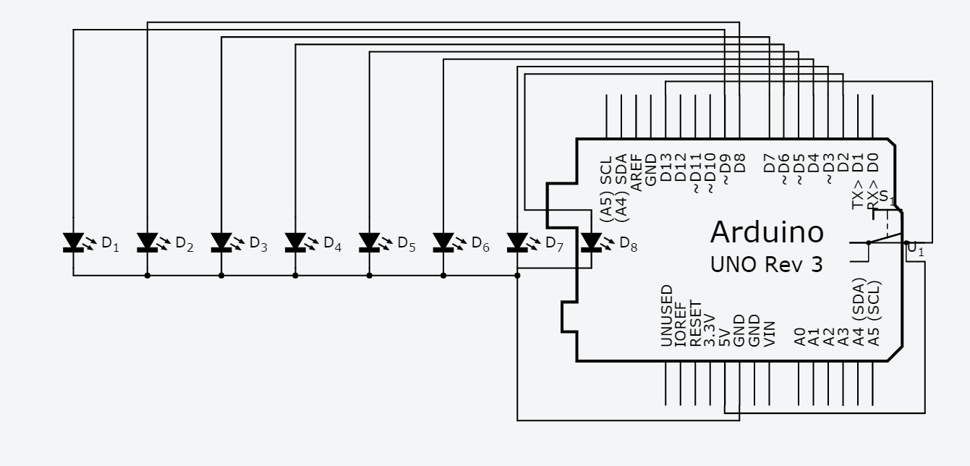
- 修正程式碼

