電通二乙微處理器實驗 實驗結報

實驗名稱 | LAB07-I²c通訊
組別 | 21 | 組員 | 陳昱叡

- 實驗目的
溫濕度感測器接線，讀取溫濕度感測器讀值，傳到PC

- 實驗步驟
照圖接線，找好程式庫，將值傳到電腦

- 程式碼
#include "DHT.h"

#define DHTPIN 2
#define DHTTYPE DHT11

DHT dht(DHTPIN, DHTTYPE);

void setup() {
Serial.begin(9600);
Serial.println("Humidity and temperature\n\n");

dht.begin();
}
void loop() {
// Wait a few seconds between measurements.
delay(2000);

// Reading temperature or humidity takes about 250 milliseconds!
// Sensor readings may also be up to 2 seconds 'old' (its a very slow sensor)
float h = dht.readHumidity();
// Read temperature as Celsius (the default)
float t = dht.readTemperature();
// Read temperature as Fahrenheit (isFahrenheit = true)
float f = dht.readTemperature(true);

// Check if any reads failed and exit early (to try again).
if (isnan(h) || isnan(t) || isnan(f)) {
Serial.println("Failed to read from DHT sensor!");
return;
}

// Compute heat index in Fahrenheit (the default)
float hif = dht.computeHeatIndex(f, h);
// Compute heat index in Celsius (isFahreheit = false)
float hic = dht.computeHeatIndex(t, h, false);

Serial.print("Humidity: ");
Serial.print(h);
Serial.print(" %\t");
Serial.print("Temperature: ");
Serial.print(t);
Serial.print(" *C ");
Serial.print(f);
Serial.print(" *F\t");
Serial.print("Heat index: ");
Serial.print(hic);
Serial.print(" *C ");
Serial.print(hif);
Serial.println(" *F");

}

- 實驗結果及分析
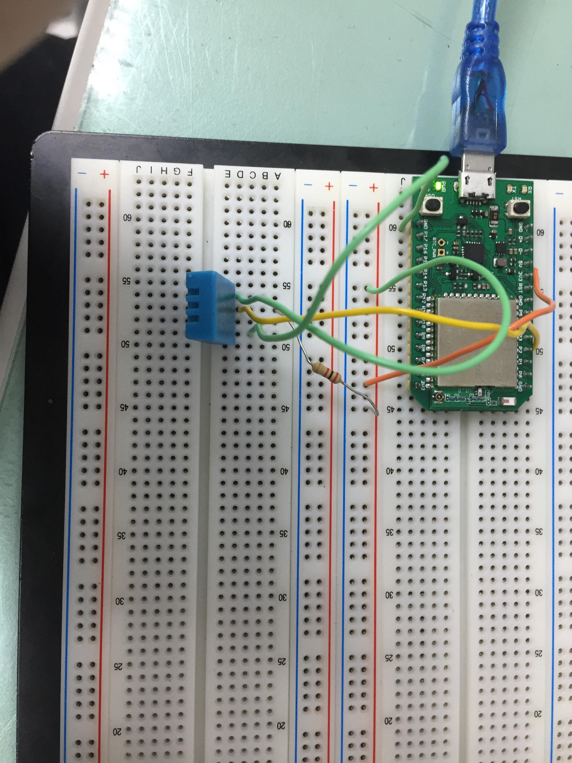
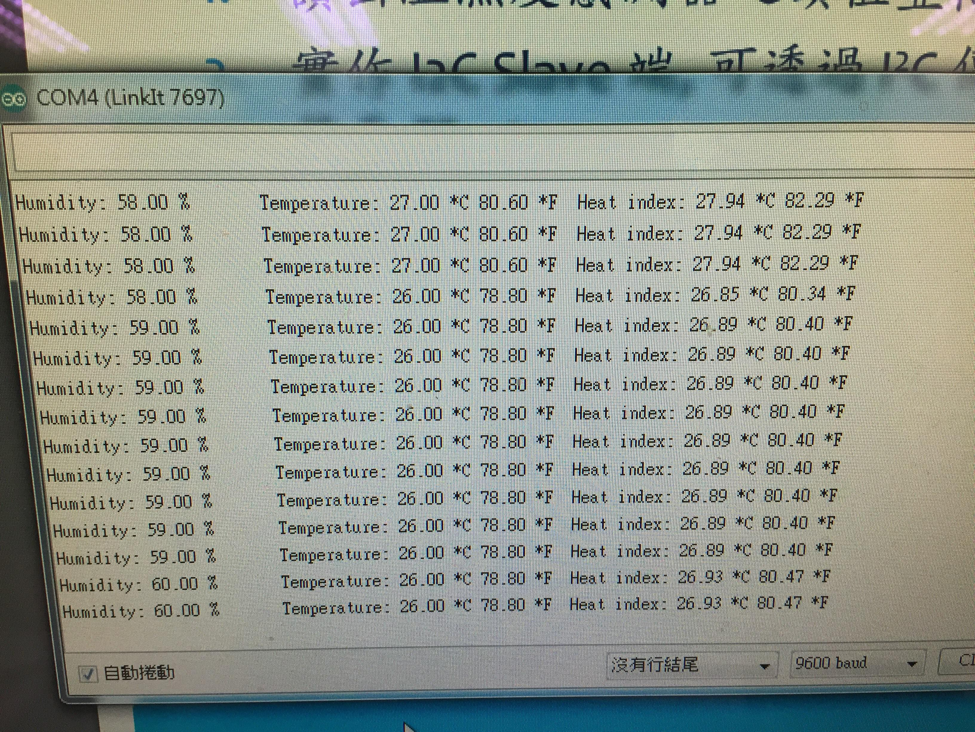

分析:
程式庫要裝完全，有兩個library要裝，一個是adalfruit，還有一個在程式打完後上網找，電阻不能太大顆(外型)(實際要2K)。

- 心得討論
程式寫法要熟悉，接線要小心，要看好腳位是代表甚麼，2和3實驗因為程式碼有問題，所以老師取消，下次才做。

