電通二乙微處理器實驗 實驗結報

實驗名稱 | Lab 11 – MCS Cloud
組別 | 21 | 組員 | 陳昱叡

- 實驗目的
  - 建立MCS帳號
  - 透過MCS溝通7696
  - 控制LED並檢視狀態
  - 將 A0 電阻值上傳

- 實驗步驟
Check1
MCS新增on/off 控制器/顯示器各一個
Check2
接一可變電阻，將A0類比讀值上傳，並看到變化圖

- 程式碼
Check1
=============================================================
#include <LWiFi.h>
#include "MCS.h"

char _lwifi_ssid[] = "04052474";
char _lwifi_pass[] = "13422828";
MCSDevice mcs("DwZuBB0a", "fyT67fazQP3LNaQp");

MCSControllerOnOff led("LED_Control");
MCSDisplayOnOff remote("LED");

void setup()
{
Serial.begin(9600);

Serial.println("Connect to Wifi");
while (WiFi.begin(_lwifi_ssid, _lwifi_pass) != WL_CONNECTED) {
Serial.println("Wifi Reconnecting..");
delay(1000);
}

Serial.println("Connect to MCS...");
while (!mcs.connected()) {
Serial.println("MCS Reconnecting..");
mcs.connect();
}
Serial.println("MCS Connected!");
mcs.addChannel(led);
mcs.addChannel(remote);

pinMode(7, OUTPUT);

}

void loop()
{
while (!mcs.connected()) {
mcs.connect();
if (mcs.connected()) {
Serial.println("MCS Reconnect");
}
}
mcs.process(1000);
while(!led.valid())
{
Serial.println("read LED value from MCS...");
led.value(); //取得MCS數值
}
Serial.print("done, LED value = ");
Serial.println(led.value()); //顯示出來

if (led.value() == 1) {
digitalWrite(7, HIGH);

} else {
digitalWrite(7, LOW);

}
if(!remote.set(led.value()))
{
Serial.print("Failed to update remote");
Serial.println(remote.value());
}

delay(200);
}
=============================================================
Check2
=============================================================
#include <LWiFi.h>
#include "MCS.h"

char _lwifi_ssid[] = "04052474";
char _lwifi_pass[] = "13422828";
MCSDevice mcs("DnQst00J", "lMgd7jakJ8205QIh");

MCSDisplayInteger Temp("Temp");

void setup()
{
Serial.begin(9600);

Serial.println("Connect to Wifi");
while (WiFi.begin(_lwifi_ssid, _lwifi_pass) != WL_CONNECTED) {
Serial.println("Wifi Reconnecting..");
delay(1000);
}

Serial.println("Connect to MCS...");
while (!mcs.connected()) {
Serial.println("MCS Reconnecting..");
mcs.connect();
}
Serial.println("MCS Connected!");

mcs.addChannel(Temp);

}

void loop()
{
while (!mcs.connected()) {
mcs.connect();
if (mcs.connected()) {
Serial.println("MCS Reconnect");
}
}
mcs.process(1000);

int sensor = analogRead(A0);

Temp.set(sensor);
Serial.println("Add sensor value.");
delay(200);
}

- 實驗結果及分析
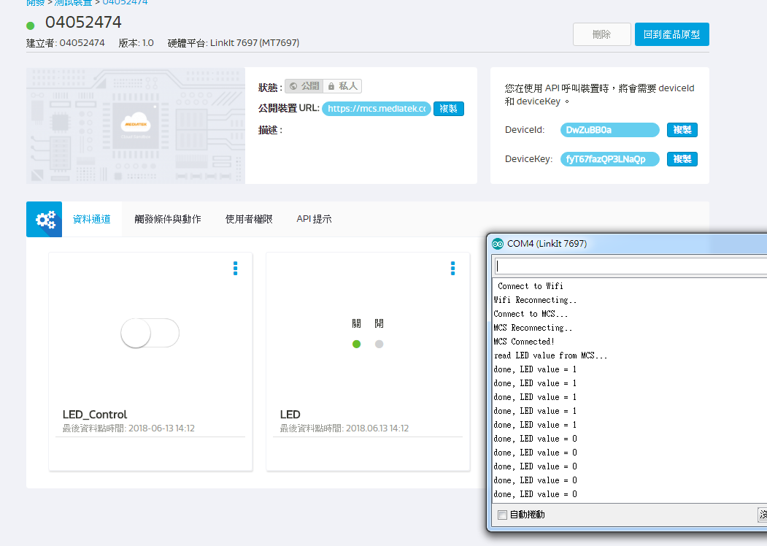
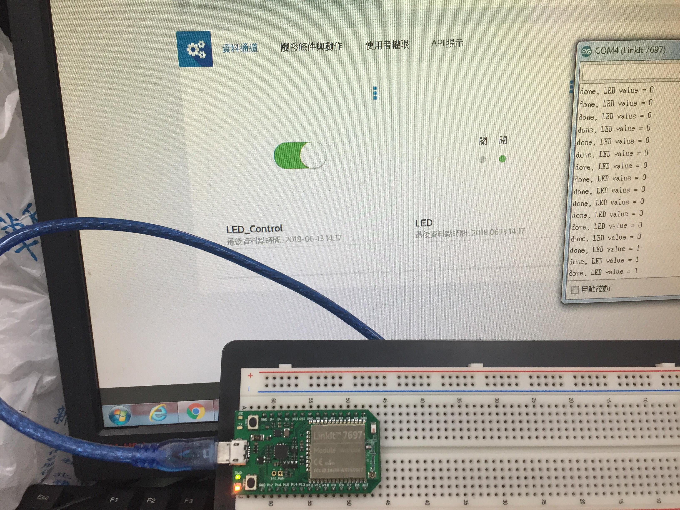
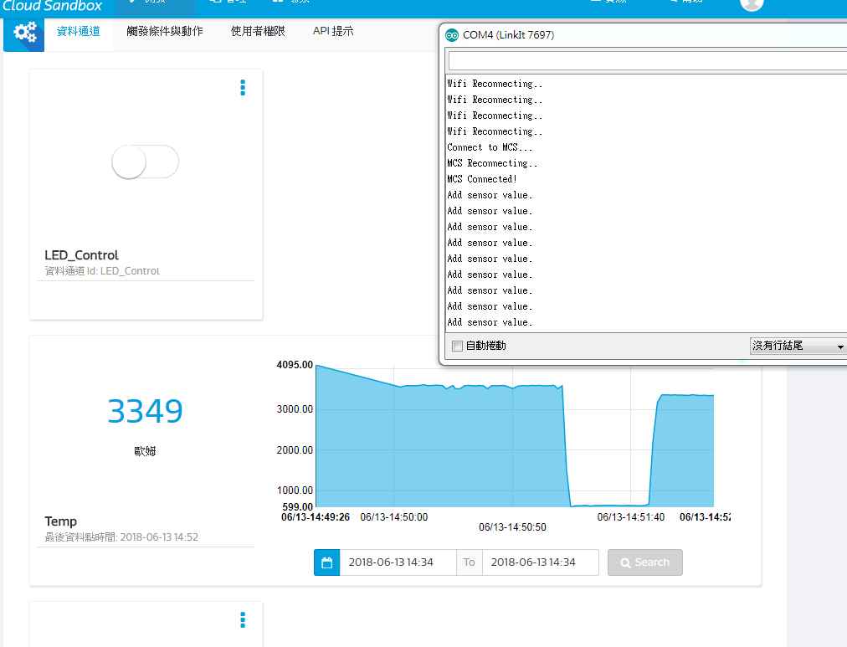
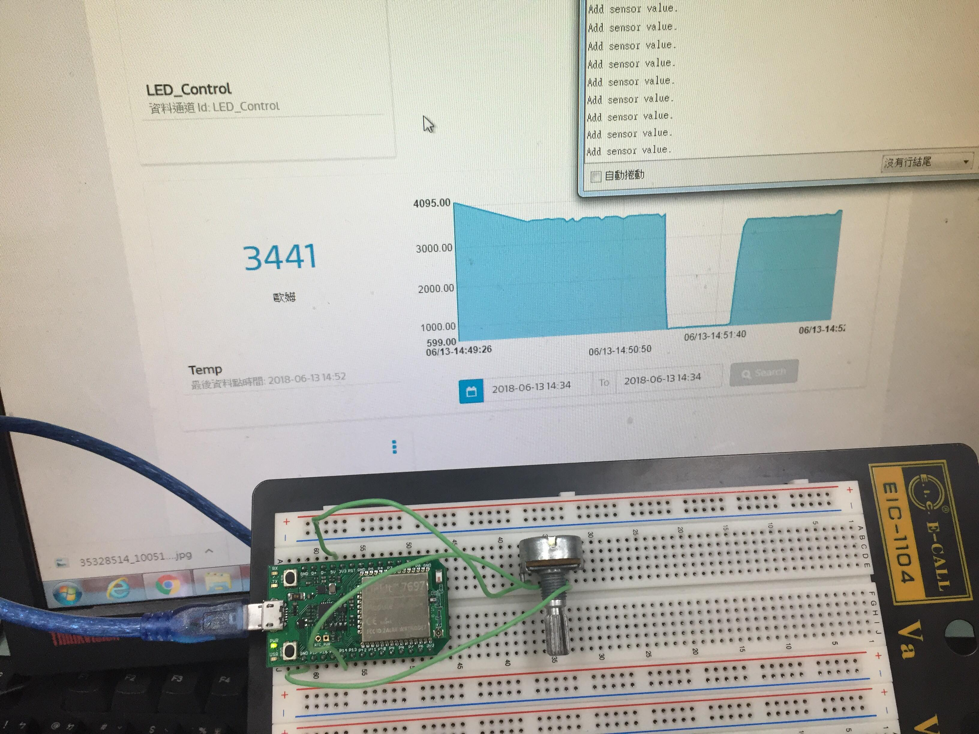
分析:
SSID跟KEY要設對，MCSDevice mcs會再創建產品時生成，控制用的channel id要填對，要加入mcs.addChannel();。

- 心得討論
Mcs產品新方案的創建要多熟悉，按回到產品原型，可以在測試裝置那找到創建的裝置，要小心不要刪錯東西，要確認好會不會全刪。
