**基本元件練習**

1. 請參考投影片內容，建立以下的Android應用程式

並請將1.**建立過程**; 2.程式**執行結果**截圖; 2.程式**原始檔 copy&paste**置入作業中

1. 建立Android應用程式 – 學習建議，其介面內容為
   1. 年級，供使用者輸入1,2,3,4
   2. 修課學分，供使用者輸入學分數
   3. 學習建議Button，供使用者點選執行
   4. 結果，輸出建議結果

**-- 請注意所有的文字均統一存放於strings.xml中**

判斷規則舉例如下

一年級，學分數小於等於9，修太少課了

學分數小於15，不多不少，努力吧

學分數小於25，有點吃力喔，加油加油

**一至四年級的規則請自行設計!!**

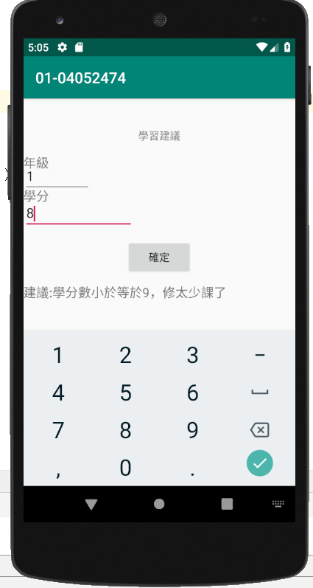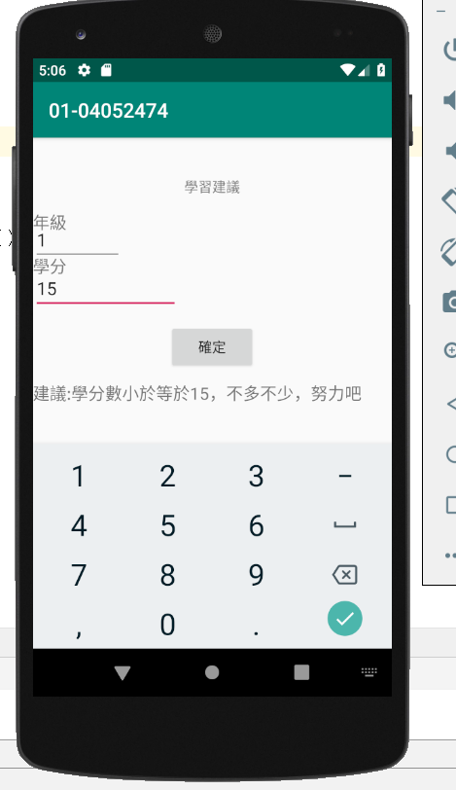

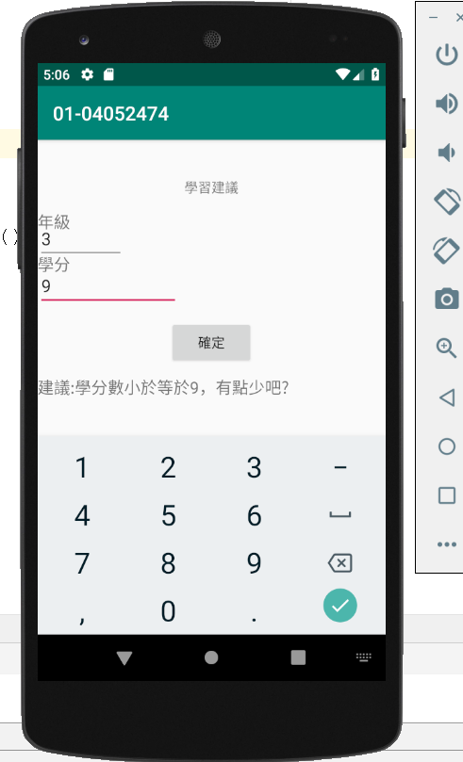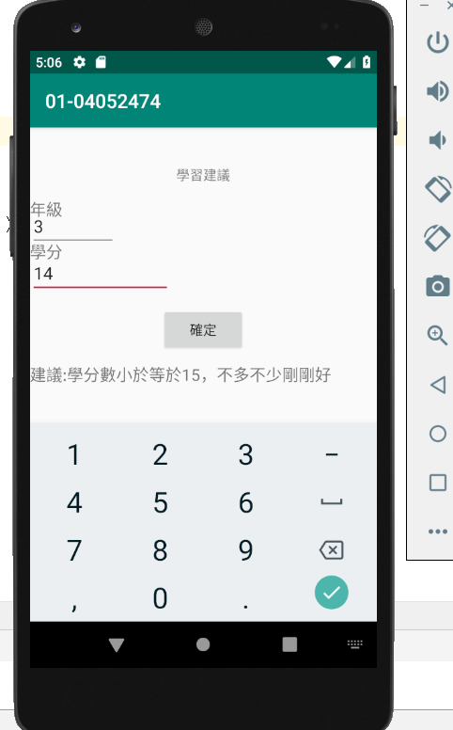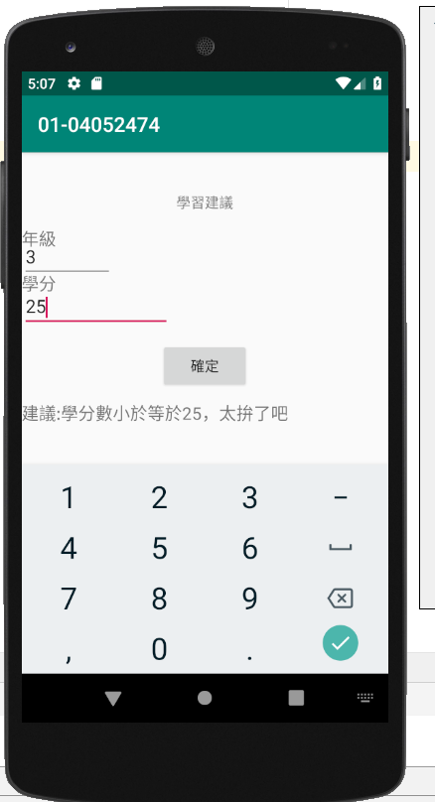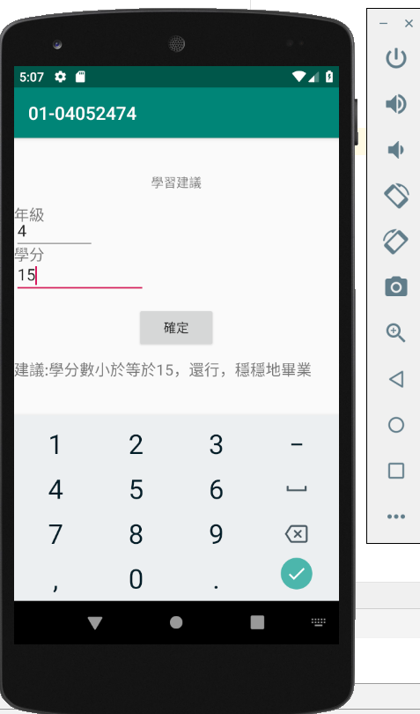

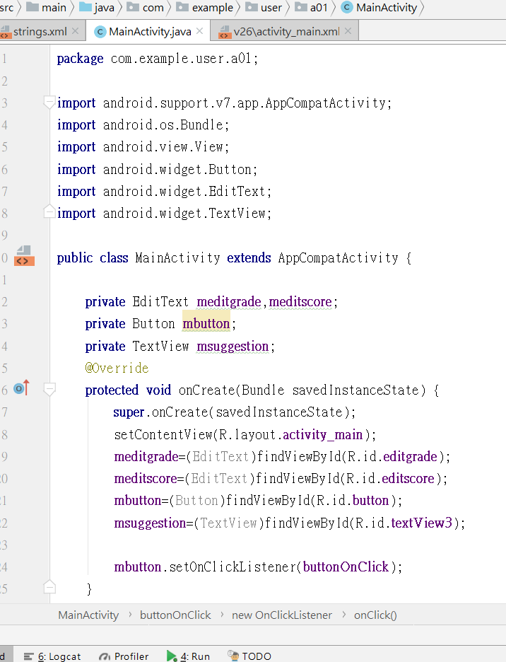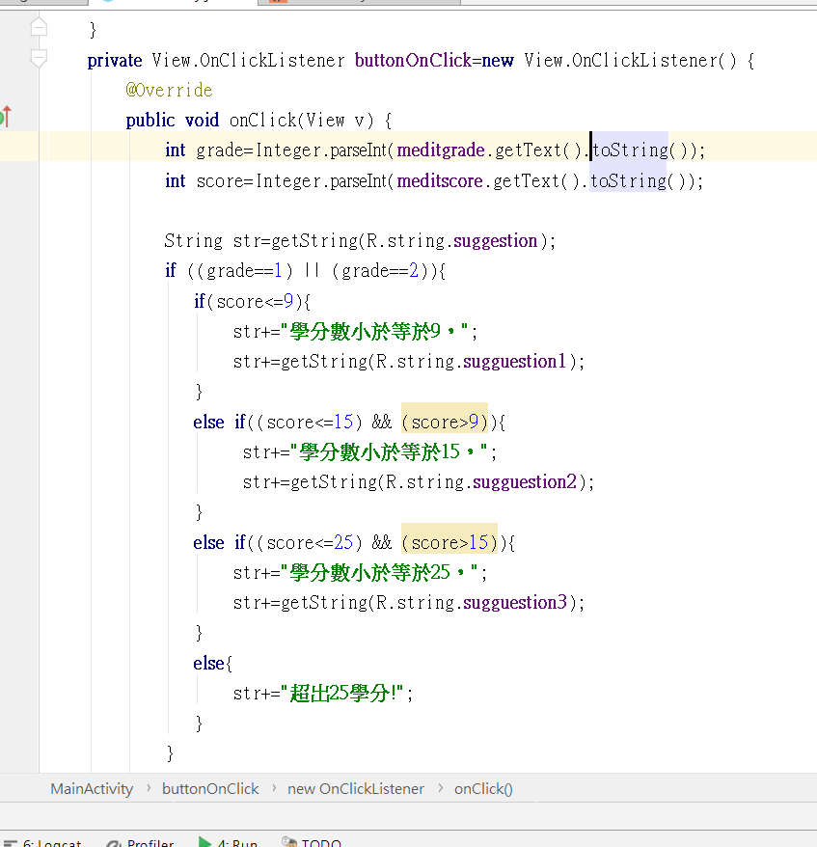

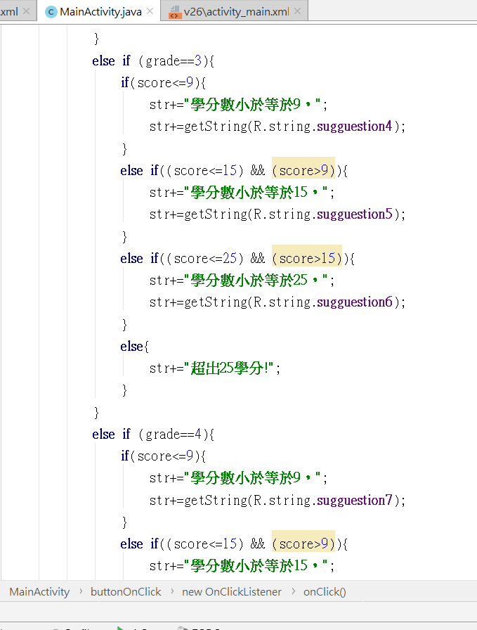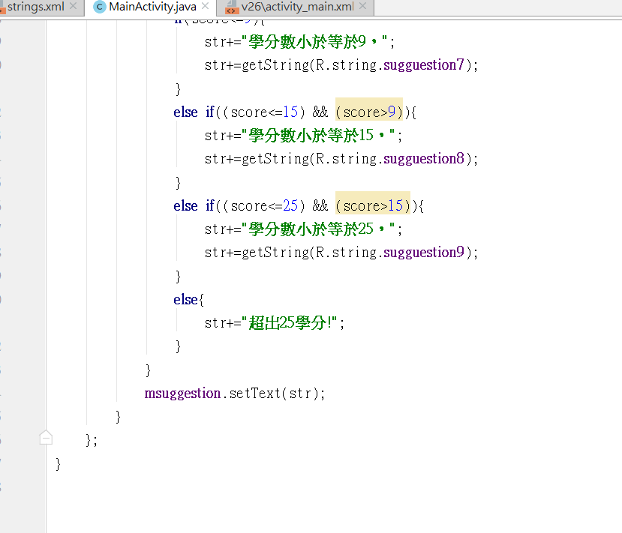

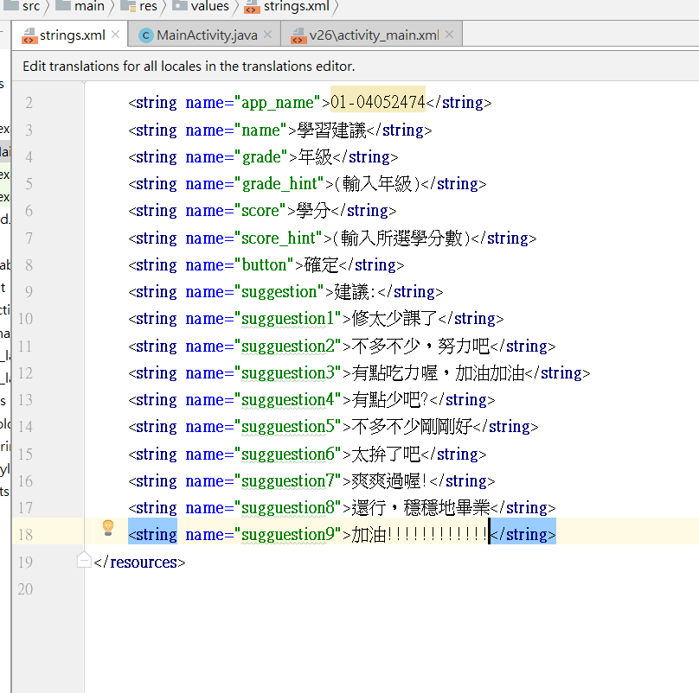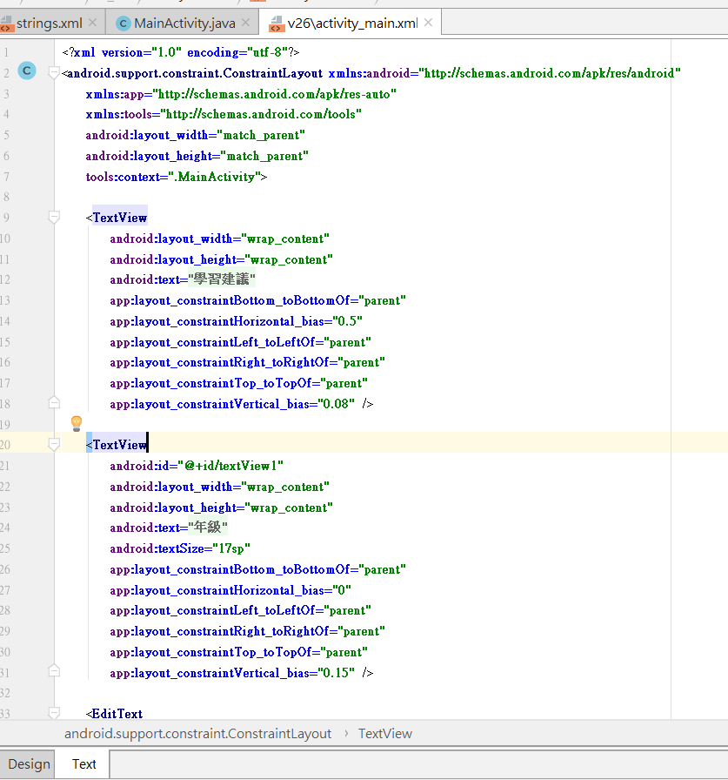

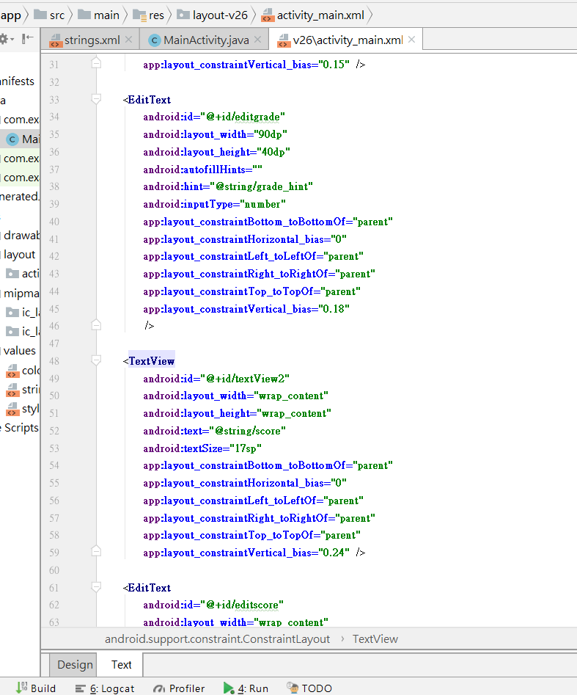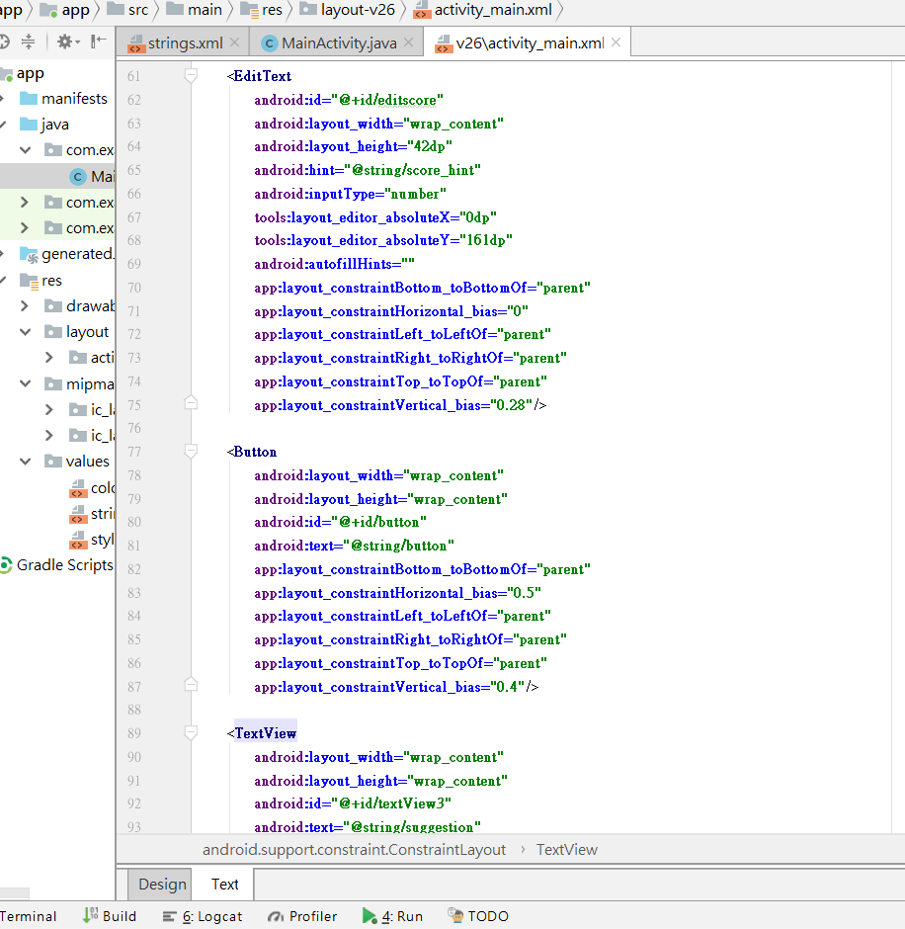

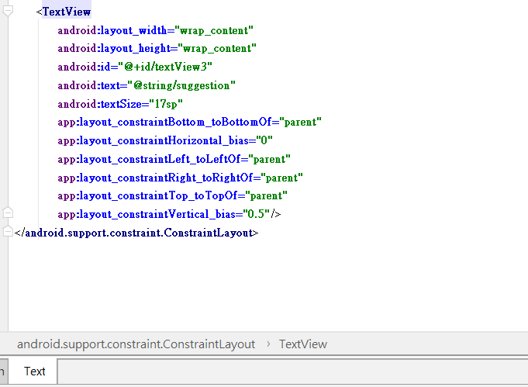

**package** com.example.user.a01;  
  
**import** android.support.v7.app.AppCompatActivity;  
**import** android.os.Bundle;  
**import** android.view.View;  
**import** android.widget.Button;  
**import** android.widget.EditText;  
**import** android.widget.TextView;  
  
**public class** MainActivity **extends** AppCompatActivity {  
  
 **private** EditText **meditgrade**,**meditscore**;  
 **private** Button **mbutton**;  
 **private** TextView **msuggestion**;  
 @Override  
 **protected void** onCreate(Bundle savedInstanceState) {  
 **super**.onCreate(savedInstanceState);  
 setContentView(R.layout.***activity_main***);  
 **meditgrade**=(EditText)findViewById(R.id.***editgrade***);  
 **meditscore**=(EditText)findViewById(R.id.***editscore***);  
 **mbutton**=(Button)findViewById(R.id.***button***);  
 **msuggestion**=(TextView)findViewById(R.id.***textView3***);  
  
 **mbutton**.setOnClickListener(**buttonOnClick**);  
 }  
 **private** View.OnClickListener **buttonOnClick**=**new** View.OnClickListener() {  
 @Override  
 **public void** onClick(View v) {  
 **int** grade=Integer.*parseInt*(**meditgrade**.getText().toString());  
 **int** score=Integer.*parseInt*(**meditscore**.getText().toString());  
  
 String str=getString(R.string.***suggestion***);  
 **if** ((grade==1) || (grade==2)){  
 **if**(score<=9){  
 str+=**"學分數小於等於9，"**;  
 str+=getString(R.string.***sugguestion1***);  
 }  
 **else if**((score<=15) && (score>9)){  
 str+=**"學分數小於等於15，"**;  
 str+=getString(R.string.***sugguestion2***);  
 }  
 **else if**((score<=25) && (score>15)){  
 str+=**"學分數小於等於25，"**;  
 str+=getString(R.string.***sugguestion3***);  
 }  
 **else**{  
 str+=**"超出25學分!"**;  
 }  
 }  
 **else if** (grade==3){  
 **if**(score<=9){  
 str+=**"學分數小於等於9，"**;  
 str+=getString(R.string.***sugguestion4***);  
 }  
 **else if**((score<=15) && (score>9)){  
 str+=**"學分數小於等於15，"**;  
 str+=getString(R.string.***sugguestion5***);  
 }  
 **else if**((score<=25) && (score>15)){  
 str+=**"學分數小於等於25，"**;  
 str+=getString(R.string.***sugguestion6***);  
 }  
 **else**{  
 str+=**"超出25學分!"**;  
 }  
 }  
 **else if** (grade==4){  
 **if**(score<=9){  
 str+=**"學分數小於等於9，"**;  
 str+=getString(R.string.***sugguestion7***);  
 }  
 **else if**((score<=15) && (score>9)){  
 str+=**"學分數小於等於15，"**;  
 str+=getString(R.string.***sugguestion8***);  
 }  
 **else if**((score<=25) && (score>15)){  
 str+=**"學分數小於等於25，"**;  
 str+=getString(R.string.***sugguestion9***);  
 }  
 **else**{  
 str+=**"超出25學分!"**;  
 }  
 }  
 **msuggestion**.setText(str);  
 }  
 };  
}

================================================================================

<**resources**>  
 <**string name="app_name"**>01-04052474</**string**>  
 <**string name="name"**>學習建議</**string**>  
 <**string name="grade"**>年級</**string**>  
 <**string name="grade_hint"**>(輸入年級)</**string**>  
 <**string name="score"**>學分</**string**>  
 <**string name="score_hint"**>(輸入所選學分數)</**string**>  
 <**string name="button"**>確定</**string**>  
 <**string name="suggestion"**>建議:</**string**>  
 <**string name="sugguestion1"**>修太少課了</**string**>  
 <**string name="sugguestion2"**>不多不少，努力吧</**string**>  
 <**string name="sugguestion3"**>有點吃力喔，加油加油</**string**>  
 <**string name="sugguestion4"**>有點少吧?</**string**>  
 <**string name="sugguestion5"**>不多不少剛剛好</**string**>  
 <**string name="sugguestion6"**>太拚了吧</**string**>  
 <**string name="sugguestion7"**>爽爽過喔!</**string**>  
 <**string name="sugguestion8"**>還行，穩穩地畢業</**string**>  
 <**string name="sugguestion9"**>加油!!!!!!!!!!!!</**string**>  
</**resources**>

==================================================================================

*<?***xml version="1.0" encoding="utf-8"***?>*<**android.support.constraint.ConstraintLayout xmlns:android="http://schemas.android.com/apk/res/android"  
 xmlns:app="http://schemas.android.com/apk/res-auto"  
 xmlns:tools="http://schemas.android.com/tools"  
 android:layout_width="match_parent"  
 android:layout_height="match_parent"  
 tools:context=".MainActivity"**>  
  
 <**TextView  
 android:layout_width="wrap_content"  
 android:layout_height="wrap_content"  
 android:text="@string/name"  
 app:layout_constraintBottom_toBottomOf="parent"  
 app:layout_constraintHorizontal_bias="0.5"  
 app:layout_constraintLeft_toLeftOf="parent"  
 app:layout_constraintRight_toRightOf="parent"  
 app:layout_constraintTop_toTopOf="parent"  
 app:layout_constraintVertical_bias="0.08"** />  
  
 <**TextView  
 android:id="@+id/textView1"  
 android:layout_width="wrap_content"  
 android:layout_height="wrap_content"  
 android:text="@string/grade"  
 android:textSize="17sp"  
 app:layout_constraintBottom_toBottomOf="parent"  
 app:layout_constraintHorizontal_bias="0"  
 app:layout_constraintLeft_toLeftOf="parent"  
 app:layout_constraintRight_toRightOf="parent"  
 app:layout_constraintTop_toTopOf="parent"  
 app:layout_constraintVertical_bias="0.15"** />  
  
 <**EditText  
 android:id="@+id/editgrade"  
 android:layout_width="90dp"  
 android:layout_height="40dp"  
 android:autofillHints=""  
 android:hint="@string/grade_hint"  
 android:inputType="number"  
 app:layout_constraintBottom_toBottomOf="parent"  
 app:layout_constraintHorizontal_bias="0"  
 app:layout_constraintLeft_toLeftOf="parent"  
 app:layout_constraintRight_toRightOf="parent"  
 app:layout_constraintTop_toTopOf="parent"  
 app:layout_constraintVertical_bias="0.18"** />  
  
 <**TextView  
 android:id="@+id/textView2"  
 android:layout_width="wrap_content"  
 android:layout_height="wrap_content"  
 android:text="@string/score"  
 android:textSize="17sp"  
 app:layout_constraintBottom_toBottomOf="parent"  
 app:layout_constraintHorizontal_bias="0"  
 app:layout_constraintLeft_toLeftOf="parent"  
 app:layout_constraintRight_toRightOf="parent"  
 app:layout_constraintTop_toTopOf="parent"  
 app:layout_constraintVertical_bias="0.24"** />  
  
 <**EditText  
 android:id="@+id/editscore"  
 android:layout_width="wrap_content"  
 android:layout_height="42dp"  
 android:hint="@string/score_hint"  
 android:inputType="number"  
 tools:layout_editor_absoluteX="0dp"  
 tools:layout_editor_absoluteY="161dp"  
 android:autofillHints=""  
 app:layout_constraintBottom_toBottomOf="parent"  
 app:layout_constraintHorizontal_bias="0"  
 app:layout_constraintLeft_toLeftOf="parent"  
 app:layout_constraintRight_toRightOf="parent"  
 app:layout_constraintTop_toTopOf="parent"  
 app:layout_constraintVertical_bias="0.28"**/>  
  
 <**Button  
 android:layout_width="wrap_content"  
 android:layout_height="wrap_content"  
 android:id="@+id/button"  
 android:text="@string/button"  
 app:layout_constraintBottom_toBottomOf="parent"  
 app:layout_constraintHorizontal_bias="0.5"  
 app:layout_constraintLeft_toLeftOf="parent"  
 app:layout_constraintRight_toRightOf="parent"  
 app:layout_constraintTop_toTopOf="parent"  
 app:layout_constraintVertical_bias="0.4"**/>  
  
 <**TextView  
 android:layout_width="wrap_content"  
 android:layout_height="wrap_content"  
 android:id="@+id/textView3"  
 android:text="@string/suggestion"  
 android:textSize="17sp"  
 app:layout_constraintBottom_toBottomOf="parent"  
 app:layout_constraintHorizontal_bias="0"  
 app:layout_constraintLeft_toLeftOf="parent"  
 app:layout_constraintRight_toRightOf="parent"  
 app:layout_constraintTop_toTopOf="parent"  
 app:layout_constraintVertical_bias="0.5"**/>  
</**android.support.constraint.ConstraintLayout**>