1.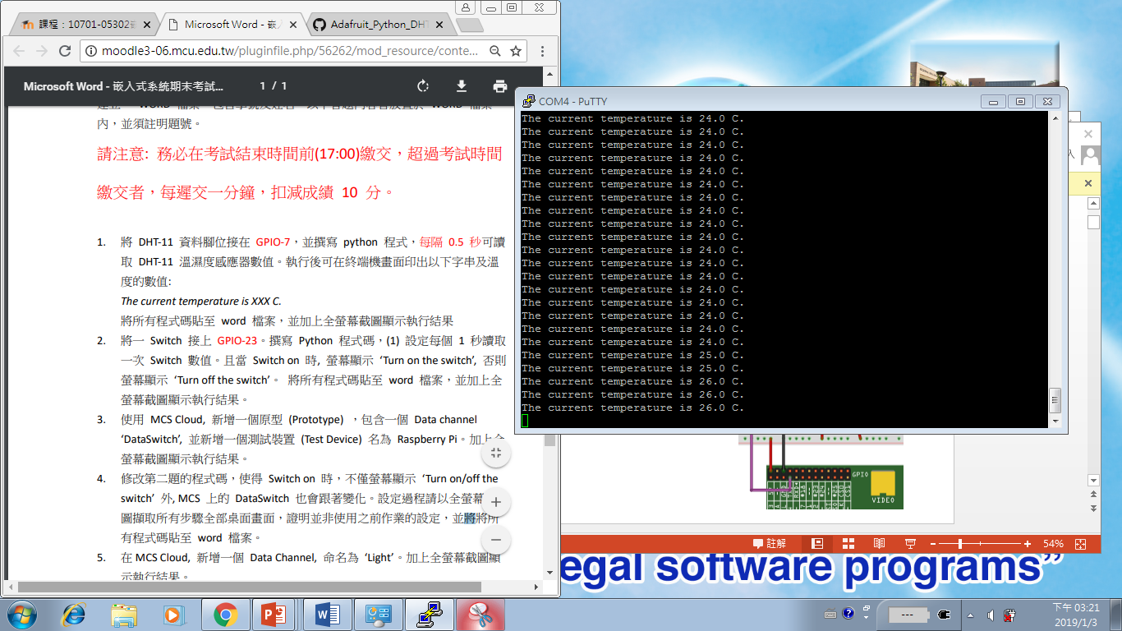

#!/usr/bin/python

# Copyright (c) 2014 Adafruit Industries

# Author: Tony DiCola

# Permission is hereby granted, free of charge, to any person obtaining a copy

# of this software and associated documentation files (the "Software"), to deal

# in the Software without restriction, including without limitation the rights

# to use, copy, modify, merge, publish, distribute, sublicense, and/or sell

# copies of the Software, and to permit persons to whom the Software is

# furnished to do so, subject to the following conditions:

# The above copyright notice and this permission notice shall be included in all

# copies or substantial portions of the Software.

# THE SOFTWARE IS PROVIDED "AS IS", WITHOUT WARRANTY OF ANY KIND, EXPRESS OR

# IMPLIED, INCLUDING BUT NOT LIMITED TO THE WARRANTIES OF MERCHANTABILITY,

# FITNESS FOR A PARTICULAR PURPOSE AND NONINFRINGEMENT. IN NO EVENT SHALL THE

# AUTHORS OR COPYRIGHT HOLDERS BE LIABLE FOR ANY CLAIM, DAMAGES OR OTHER

# LIABILITY, WHETHER IN AN ACTION OF CONTRACT, TORT OR OTHERWISE, ARISING FROM,

# OUT OF OR IN CONNECTION WITH THE SOFTWARE OR THE USE OR OTHER DEALINGS IN THE

# SOFTWARE.

import sys

import time

import Adafruit_DHT

# Parse command line parameters.

sensor_args = { '11': Adafruit_DHT.DHT11,

'22': Adafruit_DHT.DHT22,

'2302': Adafruit_DHT.AM2302 }

if len(sys.argv) == 3 and sys.argv[1] in sensor_args:

sensor = sensor_args[sys.argv[1]]

pin = sys.argv[2]

else:

print('Usage: sudo ./Adafruit_DHT.py [11|22|2302] <GPIO pin number>')

print('Example: sudo ./Adafruit_DHT.py 2302 4 - Read from an AM2302 connected to GPIO pin #4')

sys.exit(1)

# Try to grab a sensor reading. Use the read_retry method which will retry up

# to 15 times to get a sensor reading (waiting 2 seconds between each retry).

while 1:

humidity, temperature = Adafruit_DHT.read_retry(sensor, pin)

# Un-comment the line below to convert the temperature to Fahrenheit.

# temperature = temperature * 9/5.0 + 32

# Note that sometimes you won't get a reading and

# the results will be null (because Linux can't

# guarantee the timing of calls to read the sensor).

# If this happens try again!

if humidity is not None and temperature is not None:

print('The current temperature is {0:0.1f} C.'.format(temperature))

time.sleep(0.5)

else:

print('Failed to get reading. Try again!')

sys.exit(1)