電通二乙微處理器實驗 實驗結報

實驗名稱 | Lab_01
組別 | 21 | 組員 | 04052474陳昱叡

- 實驗目的

學習使用tinkercad，繪製電路圖，使用ardunio程式碼，註冊並使用Github

- 實驗步驟

更改delay時間，使小燈亮暗
更改pin腳

- 程式碼

void setup() {
// initialize digital pin LED_BUILTIN as an output.
pinMode(LED_BUILTIN, OUTPUT);
}

// the loop function runs over and over again forever
void loop() {
digitalWrite(LED_BUILTIN, HIGH); // turn the LED on (HIGH is the voltage level)
delay(1000); // wait for a second
digitalWrite(LED_BUILTIN, LOW); // turn the LED off by making the voltage LOW
delay(1000); // wait for a second
}

- 實驗結果及分析

LED燈會有亮暗變化，delay時間500間隔時間短，變化會變快，delay時間2000間隔時間長，變化會變慢。

- 心得討論
接腳要注意，電路圖和程式要互相配合。
- 修正電路圖
500
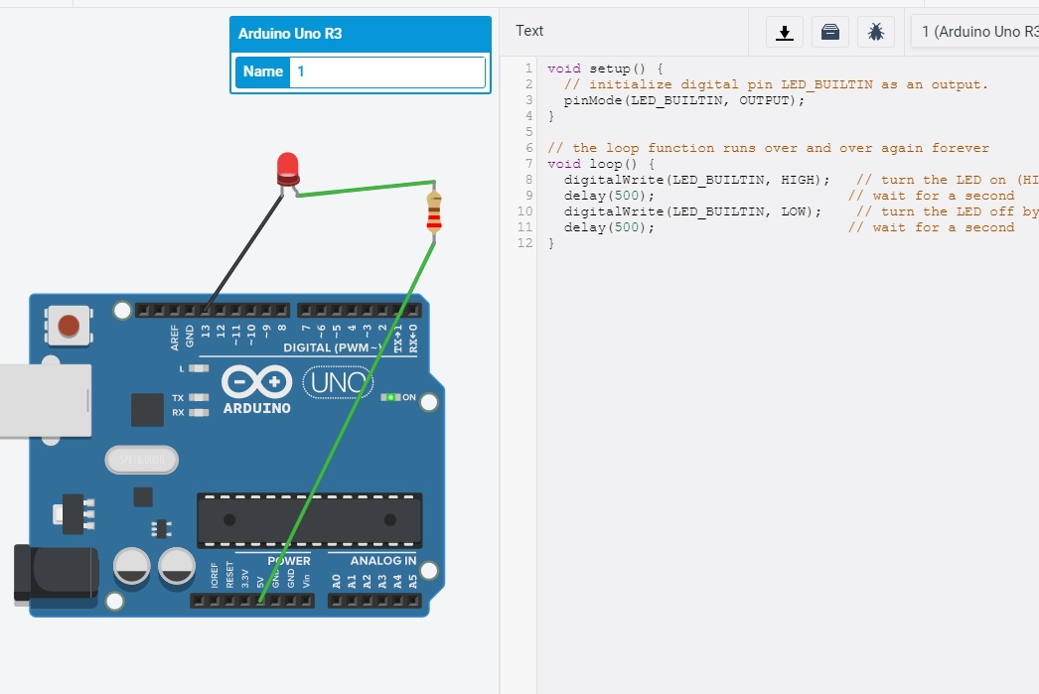
2000
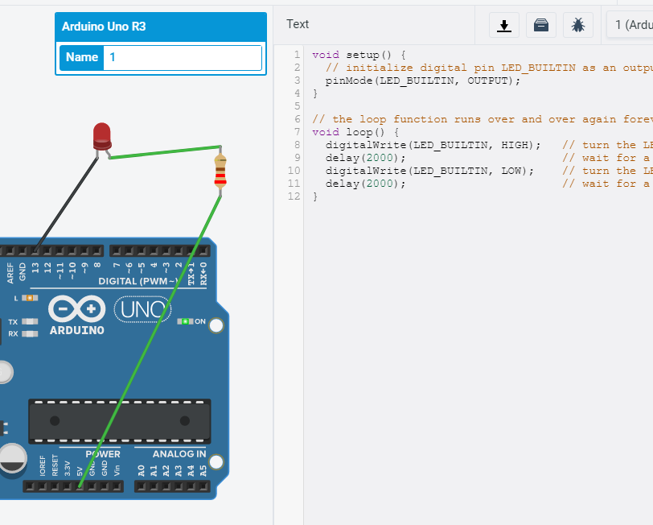

Pin9
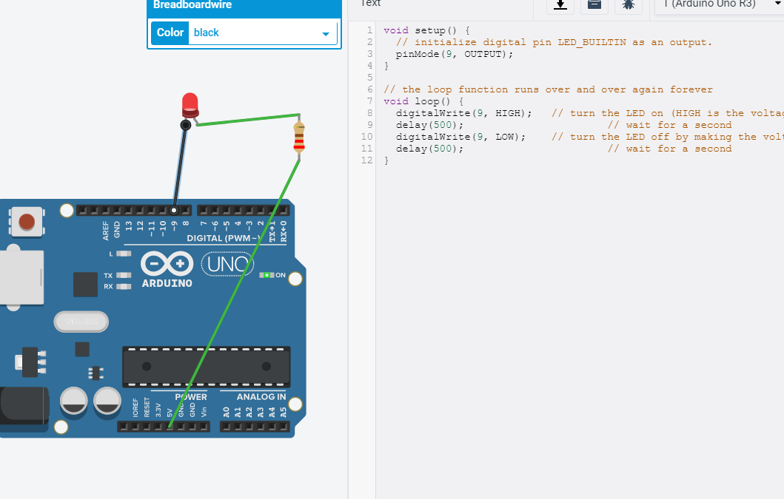
- 修正程式碼

500的

void setup() {
// initialize digital pin LED_BUILTIN as an output.
pinMode(LED_BUILTIN, OUTPUT);
}

// the loop function runs over and over again forever
void loop() {
digitalWrite(LED_BUILTIN, HIGH); // turn the LED on (HIGH is the voltage level)
delay(500); // wait for a second
digitalWrite(LED_BUILTIN, LOW); // turn the LED off by making the voltage LOW
delay(500); // wait for a second
}

2000的

void setup() {
// initialize digital pin LED_BUILTIN as an output.
pinMode(LED_BUILTIN, OUTPUT);
}

// the loop function runs over and over again forever
void loop() {
digitalWrite(LED_BUILTIN, HIGH); // turn the LED on (HIGH is the voltage level)
delay(2000); // wait for a second
digitalWrite(LED_BUILTIN, LOW); // turn the LED off by making the voltage LOW
delay(2000); // wait for a second
}
修改為pin9的

void setup() {
// initialize digital pin LED_BUILTIN as an output.
pinMode(9, OUTPUT);
}

// the loop function runs over and over again forever
void loop() {
digitalWrite(9, HIGH); // turn the LED on (HIGH is the voltage level)
delay(500); // wait for a second
digitalWrite(9, LOW); // turn the LED off by making the voltage LOW
delay(500); // wait for a second
}

