電通二甲微處理器實驗 實驗結報

實驗名稱 | Arduino_lab01
組別 | 07 | 組員 | 04053106黃柏翔 / 03053124 林顥軒

- 實驗目的

學習ARDUINO
使LED閃爍

- 實驗步驟

一開始先用個範例腳位13 delay1000 1000，然後截圖跟複製程式碼|
第二步驟 把LED腳位改在9，delay改為500 2000

- 程式碼

// Pin 13 has an LED connected on most Arduino boards.
// give it a name:
int led = 13;

// the setup routine runs once when you press reset:
void setup() {
// initialize the digital pin as an output.
pinMode(led, OUTPUT);
}

// the loop routine runs over and over again forever:
void loop() {
digitalWrite(led, HIGH); // turn the LED on (HIGH is the voltage level)
delay(1000); // wait for a second
digitalWrite(led, LOW); // turn the LED off by making the voltage LOW
delay(1000); // wait for a second
}

- 實驗結果及分析

更改delay數字使led閃爍速度變換

- 心得討論

學會使用GitHub 和Arduino
- 修正電路圖
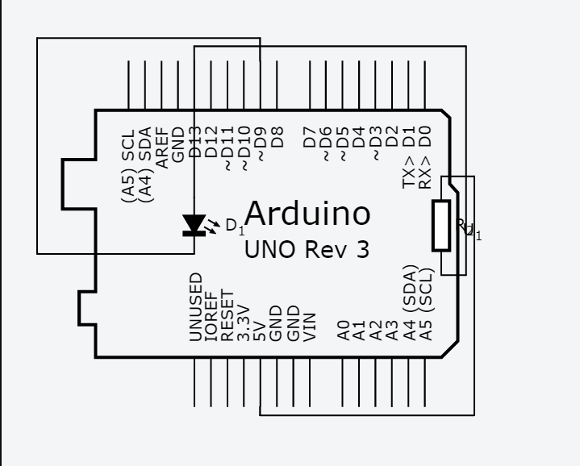
- 修正程式碼

// Pin 13 has an LED connected on most Arduino boards.
// give it a name:
int led = 9;

// the setup routine runs once when you press reset:
void setup() {
// initialize the digital pin as an output.
pinMode(led, OUTPUT);
}

// the loop routine runs over and over again forever:
void loop() {
digitalWrite(led, HIGH); // turn the LED on (HIGH is the voltage level)
delay(500); // wait for a second
digitalWrite(led, LOW); // turn the LED off by making the voltage LOW
delay(2000); // wait for a second
}

