電通二乙微處理器實驗 實驗結報

實驗名稱 | Lab01
組別 |  | 組員 | 林顥軒

- 實驗目的

- 實驗步驟

- 程式碼
Check1:
void setup()
{
pinMode(9, OUTPUT);
}

void loop()
{
digitalWrite(9, HIGH);
delay(1000); // Wait for 1000 millisecond(s)
digitalWrite(9, LOW);
delay(1000); // Wait for 1000 millisecond(s)
}
Check2:
void setup()
{
pinMode(9, OUTPUT);
}

void loop()
{
digitalWrite(9, HIGH);
delay(100); // Wait for 100 millisecond(s)
digitalWrite(9, LOW);
delay(100); // Wait for 100 millisecond(s)
digitalWrite(9, HIGH);
delay(100); // Wait for 100 millisecond(s)
digitalWrite(9, LOW);
delay(100); // Wait for 100 millisecond(s)
digitalWrite(9, HIGH);
delay(100); // Wait for 100 millisecond(s)
digitalWrite(9, LOW);
delay(100); // Wait for 100 millisecond(s)
digitalWrite(9, HIGH);
delay(300); // Wait for 100 millisecond(s)
digitalWrite(9, LOW);
delay(100); // Wait for 100 millisecond(s)
digitalWrite(9, HIGH);
delay(300); // Wait for 100 millisecond(s)
digitalWrite(9, LOW);
delay(100); // Wait for 100 millisecond(s)
digitalWrite(9, HIGH);
delay(300); // Wait for 100 millisecond(s)
digitalWrite(9, LOW);
delay(100); // Wait for 100 millisecond(s)
digitalWrite(9, HIGH);
delay(100); // Wait for 100 millisecond(s)
digitalWrite(9, LOW);
delay(100); // Wait for 100 millisecond(s)
digitalWrite(9, HIGH);
delay(100); // Wait for 100 millisecond(s)
digitalWrite(9, LOW);
delay(100); // Wait for 100 millisecond(s)
digitalWrite(9, HIGH);
delay(100); // Wait for 100 millisecond(s)
digitalWrite(9, LOW);
delay(300); // Wait for 100 millisecond(s)
}
- 實驗結果及分析
成功
- 心得討論
今天第一次上課，程式碼很簡單，但是繪圖很難。
- 修正電路圖

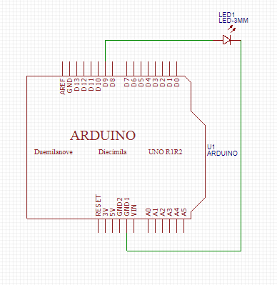
- 修正程式碼

