**電通二乙微處理器實驗 實驗結報**

|  |  |  |  |
| --- | --- | --- | --- |
| **實驗名稱** | **Lab10-紅外線控制** | | |
| **組別** |  | **組員** | **04053124 林顥軒** |

1. **實驗目的**

**接收紅外線遙控器編碼**

**發射紅外線編碼並可由另一台正確接收**

1. **實驗步驟**

**接上電路與紅外線接收器,再由遙控制輸出訊號,結果顯示在序列埠**

1. **程式碼**

|  |
| --- |
| #include <IRremote.h> |
|  | const int irReceiverPin=2; |
|  | IRrecv irrecv(irReceiverPin); |
|  | decode_results results; |
|  |  |
|  | void setup() { |
|  | Serial.begin(9600); |
|  | irrecv.enableIRIn(); |
|  | } |
|  |  |
|  | void loop() { |
|  | if(irrecv.decode(&results)) |
|  | { |
|  | Serial.print("irCode: "); |
|  | Serial.print(results.value, HEX); |
|  | Serial.print(", bits: "); |
|  | Serial.println(results.bits); |
|  | irrecv.resume(); |
|  | } |
|  |  |
|  | } |

**程式碼2**

|  |
| --- |
| #include <IRremote.h> |
|  | //led 燈要用第3腳 |
|  | const int buttonPin=6; |
|  | int buttonState=0; |
|  | IRsend irsend; |
|  | void setup() { |
|  | pinMode(buttonPin, INPUT); |
|  | } |
|  |  |
|  | void loop() { |
|  | buttonState=digitalRead(buttonPin); |
|  | if(buttonState==HIGH) |
|  | { |
|  | irsend.sendNEC(0x4FB48B7, 32); |
|  | } |
|  |  |
|  | } |

1. **實驗結果及分析**

**實驗2一直接收不到。**

1. **心得討論**

**這次實驗2一直接收不到訊號，很奇怪。**

1. **修正電路圖**

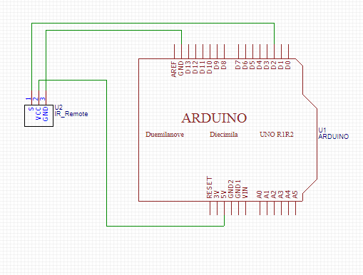

1. **修正程式碼**

**#include <IRremote.h>**

**const int buttonPin=6;**

**int buttonState =0;**

**IRsend irsend;**

**void setup()**

**{**

**pinMode(buttonPin,INPUT);**

**}**

**void loop()**

**{**

**buttonState=digitalRead(buttonPin);**

**if(buttonState==HIGH)**

**{**

**irsend.sendNEC(0x4FB48B7, 32);**

**}**

**}**