**電通二乙微處理器實驗 實驗結報**

|  |  |  |  |
| --- | --- | --- | --- |
| **實驗名稱** | **Lab 12 – 溫溼度MCS Cloud** | | |
| **組別** |  | **組員** | **04053124 林顥軒** |

1. **實驗目的**
   1. **讓DHT-11 可以一直量測溫濕度**
   2. **整合Timer與DHT-11測量溫濕度**
   3. **使用Timer每隔10秒將溫濕度上傳至MCS Cloud**
2. **程式碼**

|  |
| --- |
| #include <LWiFi.h> |
|  | #include "MCS.h" |
|  | #include "DHT.h" |
|  |  |
|  | #define DHTPIN 2 |
|  | #define DHTTYPE DHT11 |
|  |  |
|  | DHT dht(DHTPIN, DHTTYPE); |
|  | char _lwifi_ssid[] = "Big"; |
|  | char _lwifi_pass[] = "00000001"; |
|  | MCSDevice mcs("DmsY1Hy0", "iXeZ9o2Ap282DaJj"); |
|  |  |
|  | MCSDisplayFloat Temperature("Temperature"); |
|  | MCSDisplayFloat Humidity("Humidity"); |
|  | void setup() |
|  | { |
|  | dht.begin(); |
|  | Serial.begin(9600); |
|  | Serial.println("Connect to Wifi"); |
|  | while (WiFi.begin(_lwifi_ssid, _lwifi_pass) != WL_CONNECTED) { |
|  | Serial.println("Wifi Reconnecting.."); |
|  | delay(1000); |
|  | } |
|  |  |
|  | Serial.println("Connect to MCS..."); |
|  | while (!mcs.connected()) { |
|  | Serial.println("MCS Reconnecting.."); |
|  | mcs.connect(); |
|  | } |
|  | Serial.println("MCS Connected!"); |
|  | Serial.println("Humidity and temperature\n\n"); |
|  | mcs.addChannel(Temperature); |
|  | mcs.addChannel(Humidity); |
|  | } |
|  |  |
|  |  |
|  | void loop() |
|  | { |
|  | while (!mcs.connected()) { |
|  | mcs.connect(); |
|  | if (mcs.connected()) { |
|  | Serial.println("MCS Reconnect"); |
|  | } |
|  | } |
|  | mcs.process(1000); |
|  | float h = dht.readHumidity(); |
|  | float t = dht.readTemperature(); |
|  | if (isnan(h) || isnan(t)) { |
|  | Serial.println("Failed to read from DHT sensor!"); |
|  | return; |
|  | } |
|  | Serial.print("Humidity: "); |
|  | Serial.print(h); |
|  | Serial.print(" %\t"); |
|  | Serial.print("Temperature: "); |
|  | Serial.print(t); |
|  | Serial.print(" *C "); |
|  | Humidity.set(h); |
|  | Temperature.set(t); |
|  | Serial.println("Add sensor value."); |
|  | delay(200); |
|  | } |

1. **實驗結果及分析**

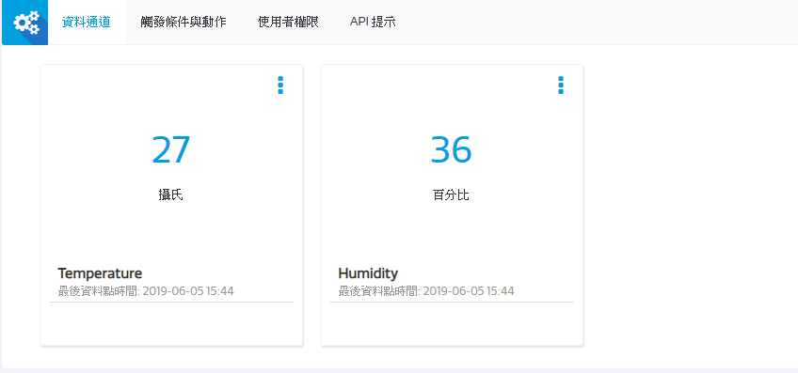

1. **心得討論**

**這次實驗挺困難的，中途遇到很多障礙。**