**BASAVARAJESWARI GROUP OF INSTITUTIONS**

# Ballari Institute of Technology & Management

# AUTONOMOUS INSTITUTE UNDER VISVESVARAYA TECHNOLOGICAL UNIVERSITY JNANA SANGAMA, BELAGAVI 590018



## Internship Report On

**“Login System”**

Submitted in partial fulfillment of the requirements for the award of degree of

**Bachelor of Engineering In**

# ARITIFICIAL INTELLIGENCE AND MACHINE LEARNING

**Submitted by Srinivas M**

**3BR21AI108**

# Internship Carried Out

# By

**“Destination Technologies”**

**BANGALORE.**

**Internal Guide External Guide**

**Mr. Irayya Shikkerimath Mr. Shekhar Kumar M**

**Asst.Professor Technical Trainer**

**Department of Mechanical, BITM, Ballari**

### BALLARI INSTITUTE OF TECHNOLOGY & MANAGEMENT

NACC Accredited Institution*

**(Recognized by Govt. of Karnataka, approved by AICTE, New Delhi & Affiliated to Visvesvaraya Technological University, Belagavi)**

**"Jnana Gangotri" Campus, No.873/2, Ballari-Hospet Road, Allipur, Ballar1-583 104 (Karnataka) (India)**

**Ph: 08392 – 237100 / 237190, Fax: 08392 – 237197**

# 2022-2023

**BASAVARAJESWARI GROUP OF INSTITUTIONS**

# BALLARI INSTITUTE OF TECHNOLOGY & MANAGEMENT

# Autonomous institute under VISVESVARAYA TECHNOLOGICAL UNIVERSITY JNANA SANGAMA, BELAGAVI 590018

NACC Accredited Institution*

**(Recognized by Govt. of Karnataka, approved by AICTE, New Delhi & Affiliated to Visvesvaraya Technological University, Belagavi)**

**"JnanaGangotri"Campus,No.873/2,Ballari-HospetRoad,Allipur, Ballar1-583 104 (Karnataka)(India)**

**Ph: 08392 – 237100 / 237190, Fax: 08392 –237197**

# DEPARTMENT OF COMPUTER SCIENCE AND ENGINEERING

**CERTIFICATE**

This is to certify that the Internship entitled **“LOGIN SYSTEM”** has been successfully completed by **SRINIVAS M** bearing USN **3B21AI108** a bonafide student of Ballari Institute of Technology and Management, Ballari. For the partial fulfillment of the requirements for the **Bachelor’s Degree in Aritificial Intelligence and Machine Learning** of the VISVESVARAYA TECHNOLOGICAL UNIVERSITY, Belagavi during the academic year 2022-2023.

|  |  |  |
| --- | --- | --- |
| **Signature of Internship**  **Co-ordinator** |  | **Signature of HOD** |
| **Mr. ShekharKumar M** |  | **Dr. B M Vidyavathi** |

|  |
| --- |
|  |
|  |
|  | |  |  |  |

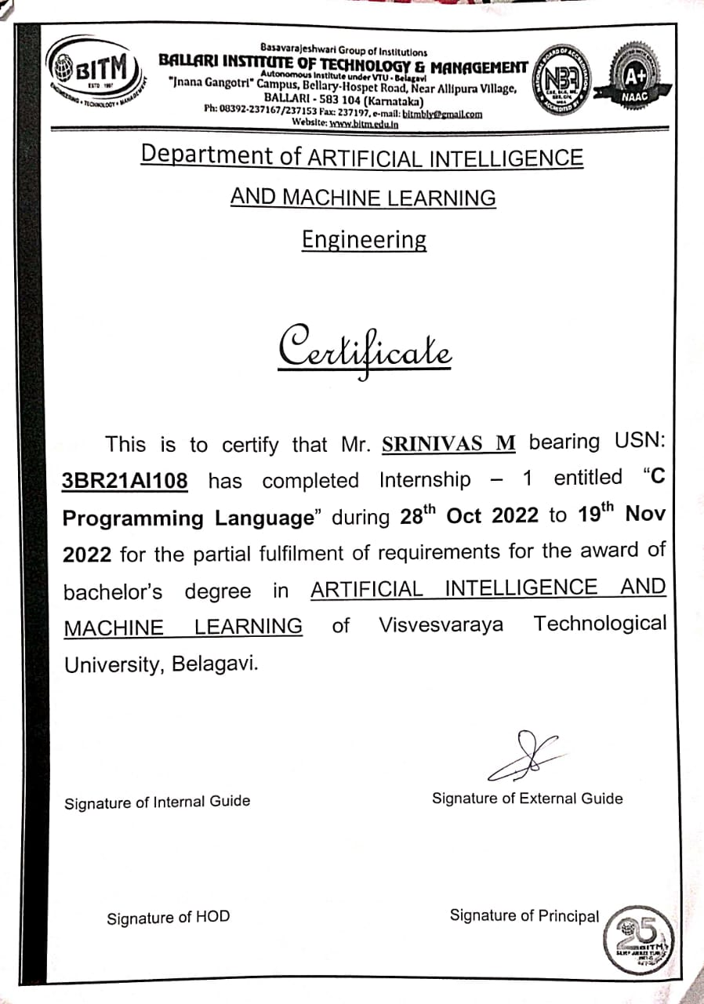S

**DECLARATION**

I, **SRINIVAS M,** final year student of Aritificial Intelligence and Machine Learning, Ballari Institute of Technology, Ballari, declare that Internship entitled **“LOGIN SYSTEM”** is a part of Internship Training successfully carried out by **“Destination Technologies” Bangalore,** at “**BITM,BALLARI”.** This report is submitted in partial fulfillment of the requirements for the award of the degree, Bachelor of Engineering in Aritificial Intelligence and Machine Learning of the Visvesvaraya Technological University, Belagavi.

**Date: Signature of the Student**

**Place: Ballari**

# ACKNOWLEDGEMENT

The satisfactions that a company the successful completion of my internship on **“ LOGIN SYSTEM ”** would be incomplete without the mention of people who made it possible, whose noble gesture, affection, guidance, encouragement and support crowned my efforts with success. It is my privilege to express my gratitude and respect to all those who inspired me in the completion of my internship.

I am grateful to our respective coordinator **“ SHEKHAR KUMAR M ”** for his/her noble gesture, support co- ordination and valuable suggestions given to me in the completion of Internship.

I also thank **Dr. B M VIDYAVATHI,** H.O.D. Aritificial Intelligence and Machine Learning for extending all his valuable support and encouragement.

### 

**Table of Contents**

* Certificate of completion of internship
* Company profile
* Day to day activities (student diary extract)
* Abstract
* Introduction of the project
* Module description
* Flowchart/algorithm/pseudocode
* Results and discussions
* Conclusion
* Reference

**Company Profile**

About Company: **Destination Technologies**

**Locations**: Bangalore, Vijayawada, Hyderabad.

 Destination Technologies is a one-stop solution for Graduates looking to get skilled and be a part of the IT Industry. We train the candidates as per the expectations of the IT Industry in various technologies like C, C++, Java, Python, .NET and Manual / Automation Testing.

      We are passionate about providing indispensable career guidance and core competency skills to budding youngsters so that they can keep abreast of the latest developments in the world of dynamic and challenging careers. Join hands with us to build a skilled nation.

     Destination provides internship training on latest cutting-edge technologies in the industry for easy placements of students. We provide hands-on experience on our real time projects to expose the students on the real world challenges and industry standards of implementing a project. We provide uniquely designed learning experiences with certified internship programs for Technical graduates in the field of any programming languages.

Below is a brief insight into us.

We train the candidates as per the expectations of the IT Industry in various technologies and here are our products:

1.Java Full Stack Course

2. Python Full Stack Course

3. Internship Course

4. Aptitude Course

5. Testing Course

6. Database Course

7. Web Technologies

8. Soft skill Course

9. C++

10. C

11. Projects and internships.

We are passionate about providing indispensable career guidance and core competency skills to budding youngsters so that they can keep abreast of the latest developments in the world of dynamic and challenging careers. Join hands with us to build a skilled nation.

# 

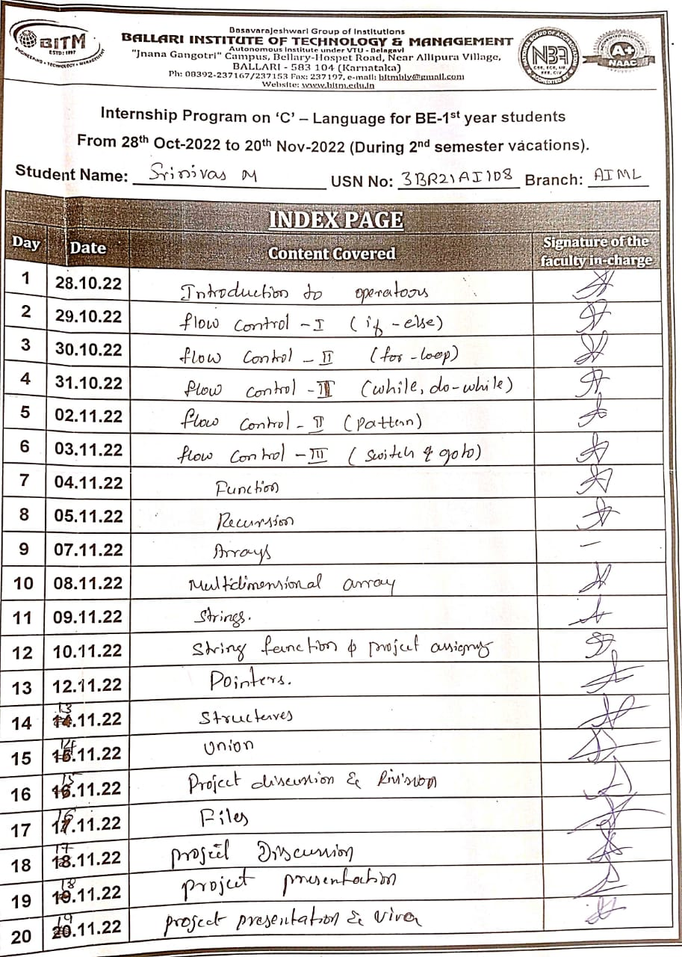

# Abstract

# The Login System project is designed to provide a secure authentication mechanism to a web application. The project's main goal is to create a user-friendly login page that ensures secure access to the web application.

# The system involves user registration, login, and logout functionalities. It uses password hashing and salting techniques to ensure that the user's passwords are secure.

# The system also includes a password reset feature to help users recover their accounts if they forget their passwords. Overall, the Login System project provides a robust authentication mechanism that enhances the security of the web application.

# Introduction

# A login system project is a software application that provides users with a secure and reliable means of accessing their accounts on a website or application.

# It typically involves authentication mechanisms that verify user identities through passwords, biometrics, or other forms of identification. The login system project may also involve authorization mechanisms that determine what actions or resources a user can access once they are logged in.

# The login system typically includes a user interface that prompts users to enter their username and password It allows users to create accounts and log in to access their personalized content, settings, and other features A login system is a fundamental component of many web applications and software projects..

# Secure login screens are essential for protecting sensitive information and preventing unauthorized access to a system. It includes additional features like password reset and changing the password.

# Module description

# Signup():This function asks the user to enter their information like first name, last name, username, gender, Ph no, password and creates a account and stored into file

# login(): This function prompts the user to enter their username and password, and compares them to the values stored in file. If the values match, the user is logged in and the program moves on to the next menu.

# forgot(): This function allows the user to reset their password if they have forgotten it. The user is prompted to enter their username and phone number, and if the values match the account in file, the user is prompted to enter a new password.

# Change_password(): This function allows the user to change their password. The user is prompted to enter their current password and their new password. If the current password matches the one stored in file, the program writes the new password to the file.

# delete_account(): This function allows the user to delete their account. The user is prompted to enter their username and password, and if the values match the ones stored in account.txt, the file is deleted.

# The program also includes several helper functions:

# divider(): This function prints a line of dashes to help visually separate different sections of the program.

# takepassword(): This function takes input from the user without displaying it on the screen (useful for password entry).

# The program checks for input validation such as making sure the phone number contains only numbers, the gender is either "M" or "F", and the first and last names contain only letters. If the user enters an invalid input, they are prompted to try again

# Algorithm

# Step 1: Start

# Step 2: read choice

# Step 3: if choice=1

# goto Step 4

# if choice=2

# goto Step 5

# if choice=3

# goto Step 6

# if choice=4

# goto Step 7

# if choice=5

# goto Step 8

# Step 4: signup()

# Step 5: login()

# Step 6: forgot()

# Step 5: change_password()

# Step 6: delete()

# Signup()

# Enter first name

# Enter last name

# Enter username

# Enter phno

# Enter gender(m/f)

# Enter password

# Open file and store the details

# Close the file

# Login()

# Open file in read mode

# Enter username

# Label: Enter password

# if password entered is correct

# print details

# else

# goto Label

# Close the file

# forgot()

# read ch

# if ch=1

# Label1: enter username

# if username entered is correct

# print details

# else

# goto Label1

# if ch=2

# Label2: enter password

# if password entered is correct

# print details

# else

# goto Label2

# if ch=3

# Label3: enter password

# if password entered is correct

# print details

# else

# goto Label3

# change_password()

# declare two numbers n1,n2

# n1=rand()

# label: enter the number(n2)

# if n1=n2

# enter new password

# else

# goto label

# print change password successful

# delete()

# read option

# if(option=Y/y)

# print account delete successful

# elseif (option=N/n)

# print account not deleted

# 

# Result and Discussion

# This program is a simple login system that allows users to sign up for an account, log in, change their password, delete their account, or recover a forgotten password.

# When the program runs, the user is presented with a main menu that allows them to choose from these options. The implementation of each of these functions is done using functions defined in the code. One thing to note is that the program does not handle multiple users. It only allows for a single user account to be created and logged in at a time, as it only reads and writes to a single file.

# 

# 

# 

**Conclusion**

In conclusion, a login screen program is an essential component of any system that requires user authentication.It provides a secure and user-friendly way for users to access their accounts while keeping unauthorized individuals from accessing sensitive information a well designed login system project should have the following features

1. User registration
2. Login page
3. Password reset
4. User verification
5. Only athorized user can access the data
6. Security

Overall,a login system project should prioritize security and user experience to provide a seamless and secure authentication process.

**Reference**

* Programming In Ansi C 8th Edition By E. Balagurusamy.
* C Programming Mike McGrath 5Th Edition.
* For generating random number

<https://youtu.be/oXEDMNXzuo4>

* For forgot password and change password

<https://youtu.be/HFNAs3NGVes>