電通二乙微處理器實驗 實驗結報

實驗名稱 | Lab01
組別 |  | 組員 | 李仲朗04242456

- 實驗目的
使用Tinkercad模擬Arduino UNO電路及程式
繪製電路圖
觀察Arduino Uno之輸出
學習將程式碼及實驗報告上傳至Github

- 實驗步驟
填寫分組表單
啟動Arduino IDE,載入Blink程式碼
至www.tinkercad.com註冊帳號,啟動Arduino模擬器
接上LED電路
修改程式,將LED輸出改為Pin9
觀察LED之閃爍間隔
修改程式,使LED閃爍間格分別增加為2倍及1/2倍,重新量測並結圖
畫出電路圖

- 程式碼
int led=9;
void setup()
{
pinMode(led, OUTPUT);
}

void loop()
{
digitalWrite(led, HIGH);
delay(1000);
digitalWrite(led, LOW);
delay(1000);

}
- 實驗結果及分析
觀察LED的閃爍,在修改數值後,觀察LED閃爍間隔時間

- 心得討論
我觉得SKR
- 修正電路圖
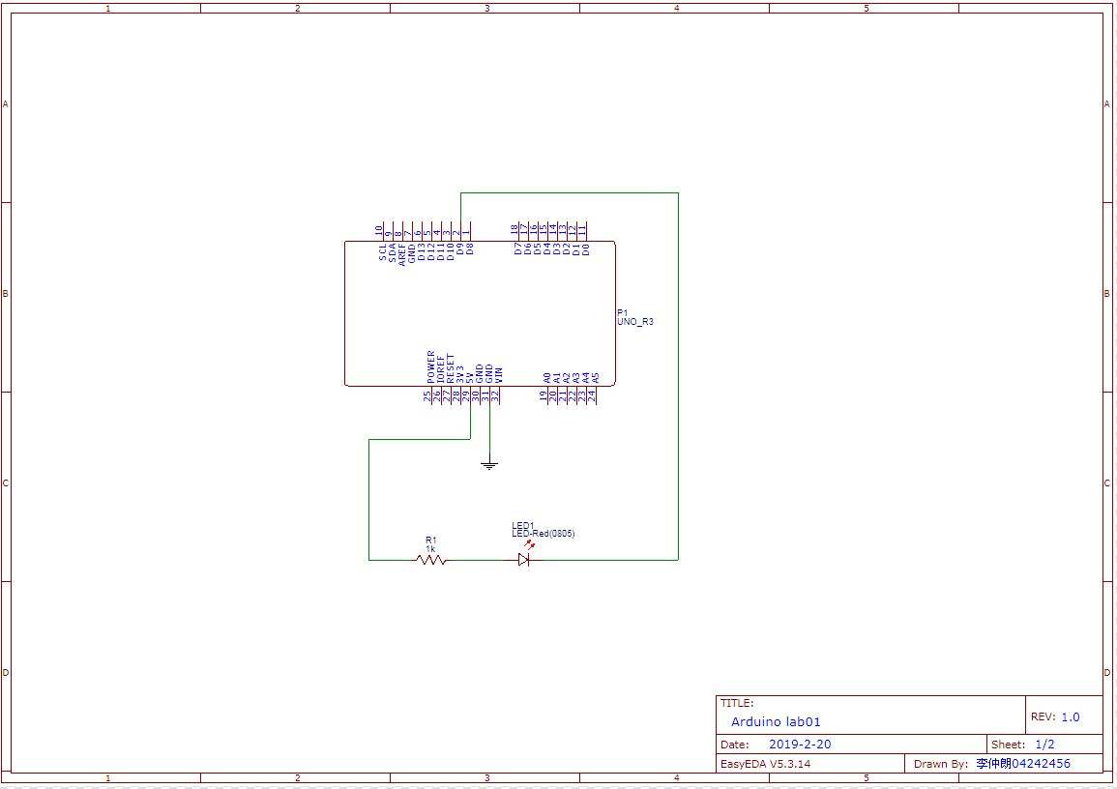
- 修正程式碼

2倍
int led=9;
void setup()
{
pinMode(led, OUTPUT);
}

void loop()
{
digitalWrite(led, HIGH);
delay(2000); // Wait for 1000 millisecond(s)
digitalWrite(led, LOW);
delay(2000); // Wait for 1000 millisecond(s)

}
1/2倍
int led=9;
void setup()
{
pinMode(led, OUTPUT);
}

void loop()
{
digitalWrite(led, HIGH);
delay(500); // Wait for 1000 millisecond(s)
digitalWrite(led, LOW);
delay(500); // Wait for 1000 millisecond(s)

}
Sos
int led=9;
void setup()
{
pinMode(led, OUTPUT);
}

void loop()
{
digitalWrite(led, HIGH);
delay(100); // Wait for 1000 millisecond(s)
digitalWrite(led, LOW);
delay(100); // Wait for 1000 millisecond(s)
digitalWrite(led, HIGH);
delay(100); // Wait for 1000 millisecond(s)
digitalWrite(led, LOW);
delay(100); // Wait for 1000 millisecond(s)
digitalWrite(led, HIGH);
delay(100); // Wait for 1000 millisecond(s)
digitalWrite(led, LOW);
delay(200); // Wait for 1000 millisecond(s)
digitalWrite(led, HIGH);
delay(300); // Wait for 1000 millisecond(s)
digitalWrite(led, LOW);
delay(100); // Wait for 1000 millisecond(s)
digitalWrite(led, HIGH);
delay(300); // Wait for 1000 millisecond(s)
digitalWrite(led, LOW);
delay(100); // Wait for 1000 millisecond(s)
digitalWrite(led, HIGH);
delay(300); // Wait for 1000 millisecond(s)
digitalWrite(led, LOW);
delay(200); // Wait for 1000 millisecond(s)
digitalWrite(led, HIGH);
delay(100); // Wait for 1000 millisecond(s)
digitalWrite(led, LOW);
delay(100); // Wait for 1000 millisecond(s)
digitalWrite(led, HIGH);
delay(100); // Wait for 1000 millisecond(s)
digitalWrite(led, LOW);
delay(100); // Wait for 1000 millisecond(s)
digitalWrite(led, HIGH);
delay(100); // Wait for 1000 millisecond(s)
digitalWrite(led, LOW);
delay(300); // Wait for 1000 millisecond(s)

}

