DSP Final Exam. Class:________, Student ID:_________, Name:_________

1. The z-transform of *x*(*n*) is  (a) Determine the z-transform of the sequence, where * denotes convolution. (b) Indicate its region of convergence (ROC).
2. The z-transDetermine the z-transform of the following sequences. Indicate the ROC for each sequence.
   1. *x*(*n*)={3, 2, 1, -2, -3}
   2. 
3. A linear, causal, and time-invariant system:

*y*(*n*)*=*2*x*(*n*)*+*0.9*y*(*n-*1)

Determine

1. the impulse response *h*(*n*)
2. the system function H(z)
3. the pole-zero plot

close all;

clear all;

b = [2,0];

a = [1, -0.9];

[R,P,C]=residuez(b,a);

zplane(b,a);

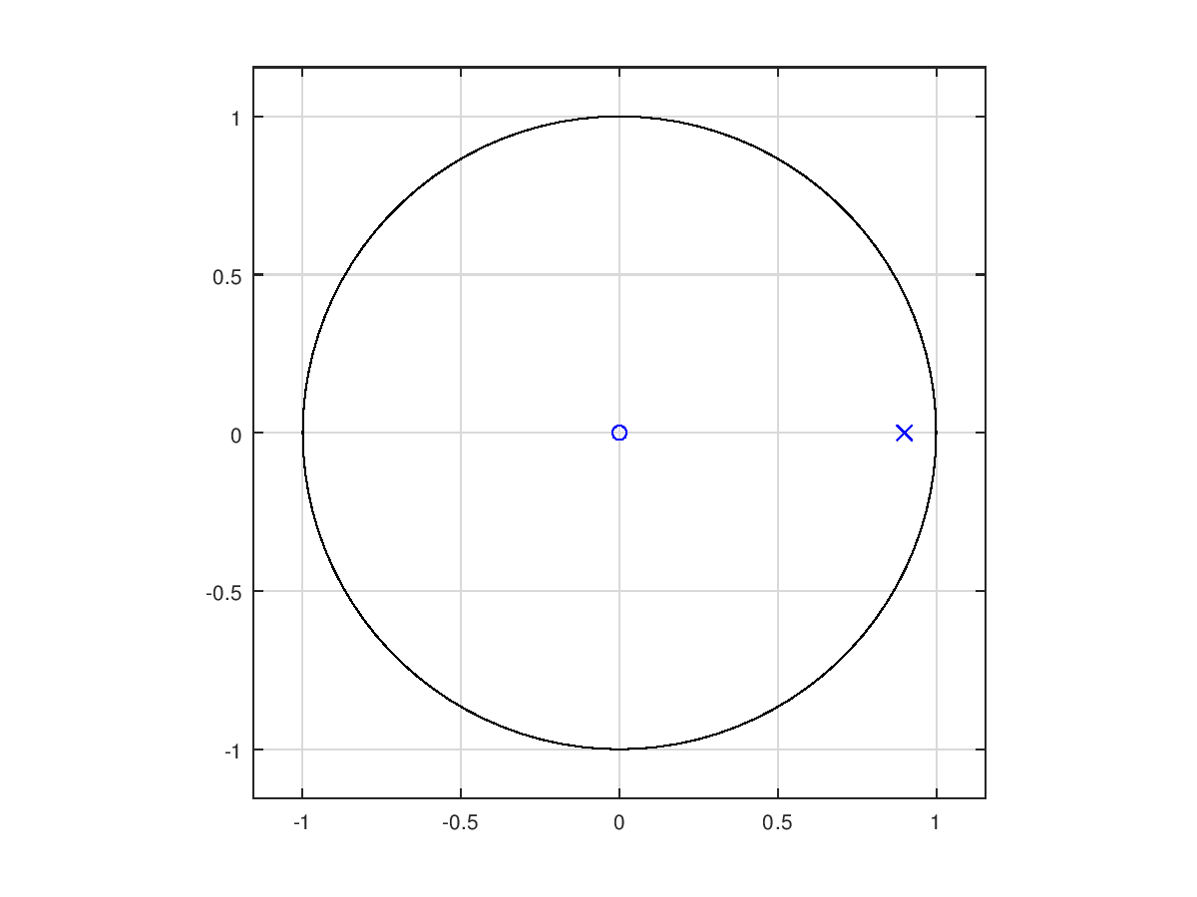

1. Compute the DFS coefficients of the following periodic sequences using the DFS definition

.

1. Compute the DFS coefficients of the following periodic sequences using Octave.

.

close all;

clear all;

xn=[2 0 0 0 -1 0 0 0];

N=8;

Xk=dfs[xn,N];

Xk =

Column 1:

1.0000 + 0.0000i

Column 2:

3.0000 + 0.0000i

Column 3:

1.0000 - 0.0000i

Column 4:

3.0000 + 0.0000i

Column 5:

1.0000 - 0.0000i

Column 6:

3.0000 + 0.0000i

Column 7:

1.0000 - 0.0000i

Column 8:

3.0000 + 0.0000i

1. Plot the DFT (a) magnitude and (b) angle of the following sequence (N=100, ω: 0~π).

*x*(*n*)={1, 2, 3, 4, 3, 2, 1}

clear all;

n=-3:3;

x2=[1 2 3 4 3 2 1];

%x3=x2.*n;

n2=length(n);

N=100;

x2=[x2,zeros(1,N-n2)];

X2=DFT(x2,N);

mag=abs(X2);

K=0:N-1,W=pi/N*K;

pha=angle(X2);

subplot(211),plot(W,mag);

subplot(212),plot(W,pha);

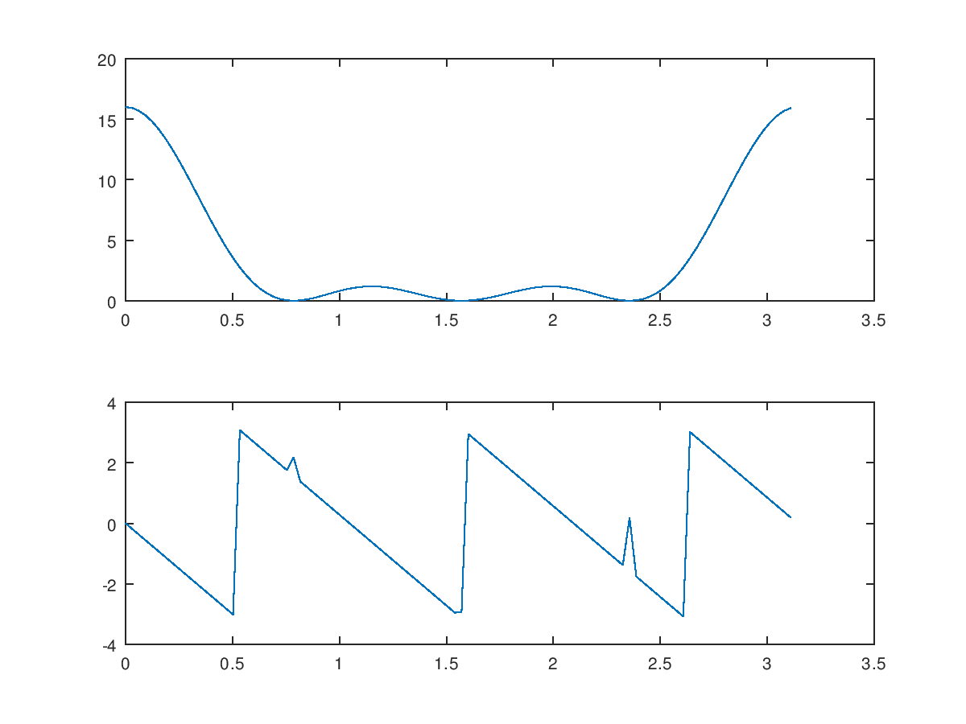

1. Let *x*(*n*) be a 4-point sequence:



* 1. Compute the discrete-time Fourier transform (DTFT)and plot its magnitude and phase.

clear all;

w = [0:500]*(pi/250);

x = 1+exp(-j*w)+exp(-j*2*w)+exp(-j*3*w);

mag = abs(x);

pha = angle(x);

subplot(2,1,1);

plot(w/pi,mag);

grid on;

subplot(2,1,2);

plot(w/pi,pha);

grid on;



* 1. Compute and plot the 8-point DFT of *x*(*n*).

clear all;

x = [1 1 1 1 zeros(1,4)];

N = 8;

X = dft(x,N);

n = 0:7;

mag = abs(X);

pha = angle(X);

subplot(2,1,1);

stem(n,mag);

subplot(2,1,2);

stem(n,pha);



(c) Compute and plot the 16-point DFT of *x*(*n*).

clear all;

x = [1 1 1 1 zeros(1,12)];

N = 16;

X = dft(x,N);

n = 0:15;

mag = abs(X);

pha = angle(X);

subplot(2,1,1);

stem(n,mag);

subplot(2,1,2);

stem(n,pha);

