**電通二乙微處理器實驗 實驗結報**

|  |  |  |  |
| --- | --- | --- | --- |
| **實驗名稱** | **4x4鍵盤** | | |
| **組別** |  | **組員** | **李仲朗04242456** |

1. **實驗目的**

了解4x4的工作原理

1.4x4鍵盤如何接線?

2.如何使用Arduino keyboard library?

3.如何讀取鍵盤顯示值?

4. 如何讓七段顯示器顯示鍵盤輸入值?

**1.實驗步驟**

**4x4鍵盤之案件值經由串列傳輸.顯示在PC上**

**電路圖**

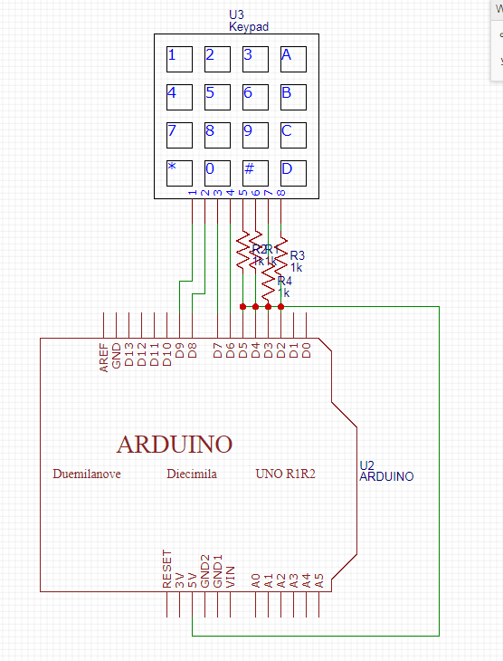

**程式碼**

1

**實驗結果及分析**

**結果就是在PC上顯示出0~F**

**2.實驗步驟**

**4x4鍵盤之案件值顯示在七段顯示器上**

**電路圖**

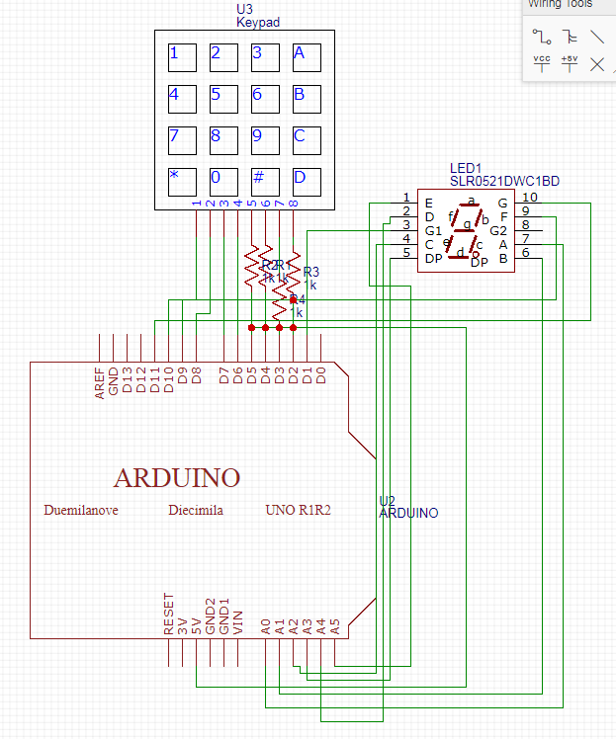

**程式碼**

**#include "SevSeg.h"**

**SevSeg sevseg;**

**#include <Keypad.h>**

**const byte ROWS = 4;**

**const byte COLS = 4;**

**char keys[ROWS][COLS] = {**

**{'F', 'E', 'D', 'C'}, {'B','3','6', '9'},**

**{'A', '2', '5', '8'}, {'0', '1', '4', '7'}**

**};**

**byte rowPins[ROWS] = {11,10,9,8};**

**byte colPins[COLS] = {15,14,13,12};**

**Keypad keypad =**

**Keypad( makeKeymap(keys), rowPins,colPins, ROWS, COLS );**

**void setup()**

**{**

**byte numDigits = 1;**

**byte digitPins[] = {17};**

**byte segmentPins[] = {2,3,4,5,6,7,16};**

**sevseg.begin(COMMON_CATHODE, numDigits, digitPins,segmentPins);**

**Serial.begin(9600);**

**}**

**void loop(){**

**char key = keypad.getKey();**

**static int deciSeconds = 0;**

**if (key != NO_KEY){**

**Serial.println(key);**

**if(key<='9'&&key>='0')**

**{**

**sevseg.setNumber(key-'0');**

**}**

**}**

**sevseg.refreshDisplay();**

**}**

**實驗結果及分析**

**案件值顯示在七段顯示器上**

1. **心得討論**

**這次實驗比較簡單，但經常會卡在接線或電阻接觸不良的問題上- -**