**電通二乙微處理器實驗 實驗結報**

|  |  |  |  |
| --- | --- | --- | --- |
| **實驗名稱** | **Lab 11 – MCS Cloud** | | |
| **組別** |  | **組員** | **李仲朗** |

1. **實驗目的**
   1. **建立MCS帳號**
   2. **透過MCS溝通7696**
   3. **控制LED並檢視狀態**
   4. **將 A0 電阻值上傳**
2. **實驗步驟**

**Check1**

**MCS新增on/off 控制器/顯示器各一個**

**Check2**

**接一可變電阻，將A0類比讀值上傳，並看到變化圖**

1. **程式碼**

**Check1**

**=============================================================**

**#include <LWiFi.h>**

**#include "MCS.h"**

**char _lwifi_ssid[] = "04242456";**

**char _lwifi_pass[] = "01234567";**

**MCSDevice mcs("DCQYw2yl", "jVKoCoDe5i0wragN");**

**MCSControllerOnOff led("KZQ");**

**MCSDisplayOnOff remote("XSQ");**

**void setup()**

**{**

**Serial.begin(9600);**

**Serial.println("Connect to Wifi");**

**while (WiFi.begin(_lwifi_ssid, _lwifi_pass) != WL_CONNECTED) {**

**Serial.println("Wifi Reconnecting..");**

**delay(1000);**

**}**

**Serial.println("Connect to MCS...");**

**while (!mcs.connected()) {**

**Serial.println("MCS Reconnecting..");**

**mcs.connect();**

**}**

**Serial.println("MCS Connected!");**

**mcs.addChannel(led);**

**mcs.addChannel(remote);**

**pinMode(7, OUTPUT);**

**}**

**void loop()**

**{**

**while (!mcs.connected()) {**

**mcs.connect();**

**if (mcs.connected()) {**

**Serial.println("MCS Reconnect");**

**}**

**}**

**mcs.process(1000);**

**while(!led.valid())**

**{**

**Serial.println("read LED value from MCS...");**

**led.value(); //取得MCS數值**

**}**

**Serial.print("done, LED value = ");**

**Serial.println(led.value()); //顯示出來**

**if (led.value() == 1) {**

**digitalWrite(7, HIGH);**

**} else {**

**digitalWrite(7, LOW);**

**}**

**if(!remote.set(led.value()))**

**{**

**Serial.print("Failed to update remote");**

**Serial.println(remote.value());**

**}**

**delay(200);**

**}**

**=============================================================**

**Check2**

**#include <LWiFi.h>**

**#include "MCS.h"**

**char _lwifi_ssid[] = "04242456";**

**char _lwifi_pass[] = "01234567";**

**MCSDevice mcs("DCQYw2yl", "jVKoCoDe5i0wragN");**

**MCSDisplayInteger Temp("dzq");**

**void setup()**

**{**

**Serial.begin(9600);**

**pinMode(17, INPUT);**

**Serial.println("Connect to Wifi");**

**while (WiFi.begin(_lwifi_ssid, _lwifi_pass) != WL_CONNECTED) {**

**Serial.println("Wifi Reconnecting..");**

**delay(1000);**

**}**

**Serial.println("Connect to MCS...");**

**while (!mcs.connected()) {**

**Serial.println("MCS Reconnecting..");**

**mcs.connect();**

**}**

**Serial.println("MCS Connected!");**

**mcs.addChannel(Temp);**

**}**

**void loop()**

**{**

**while (!mcs.connected()) {**

**mcs.connect();**

**if (mcs.connected()) {**

**Serial.println("MCS Reconnect");**

**}**

**}**

**mcs.process(1000);**

**int sensor = analogRead(17);**

**Temp.set(sensor);**

**Serial.println("Add sensor value.");**

**delay(200);**

**}**

**=============================================================**

1. **實驗結果及分析**

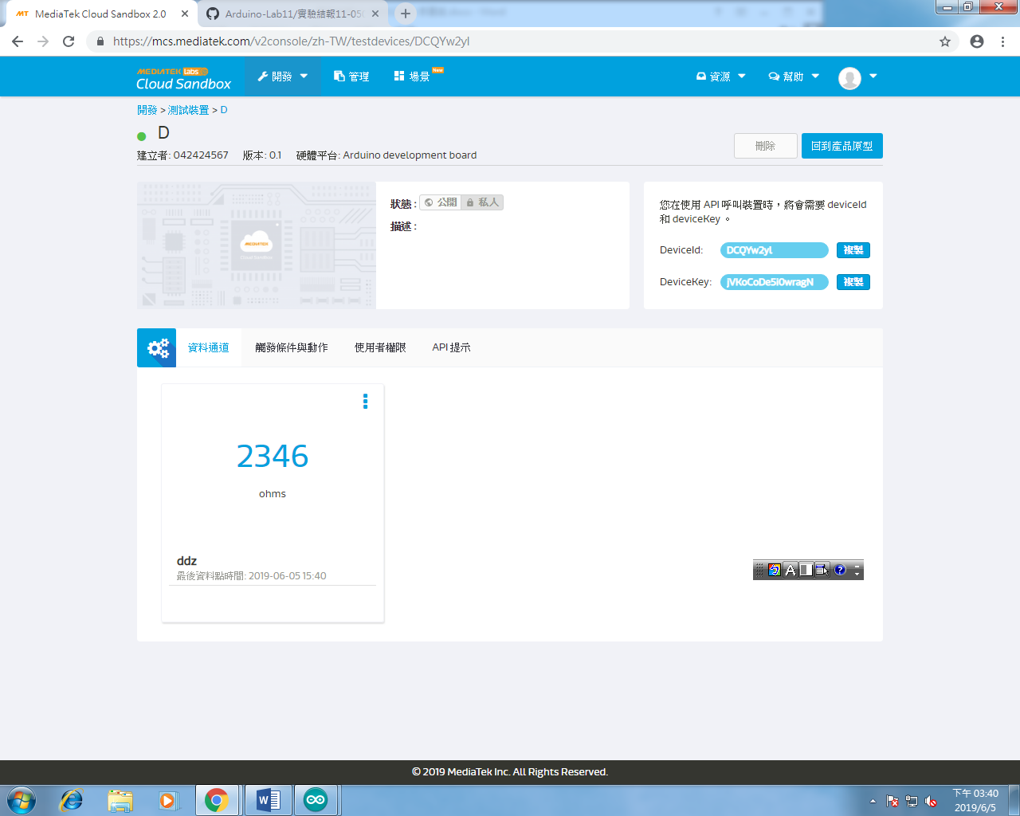

**分析:**

**Its easy for I had studied in raspberry pi class last year.**

**心得討論**

**If you add your pin number,you should rember it.x**