COBOL IMAGE COMPARISON REPORT
Expected Output vs Actual Output
Generated: 2026-09-15T06:07:14.953778+00:00

Overall Summary
Metric | Value
Expected images | 7
Actual images | 7
Matched filenames | 7
Changed | 7
Identical | 0
Missing | 0
Extra | 0

Note: This is a visual comparison. No OCR is used. Changed areas are shown using the original image pixels.

pair3_json_image1.png
STATUS: CHANGED
Pixel difference: 0.036%
Changed regions: 0

EXPECTED IMAGE
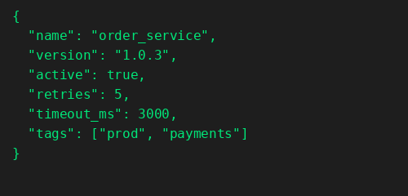

ACTUAL IMAGE
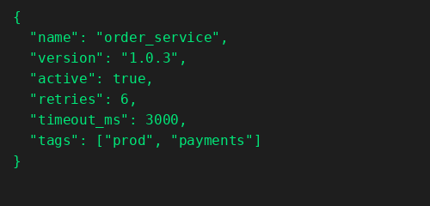

DIFFERENCE
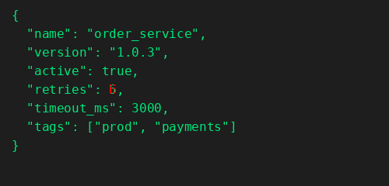

CHANGES FOUND

Line 6 - CHANGED
Word 4: CHANGED
EXPECTED | ACTUAL

pair4_cobol_image1.png
STATUS: CHANGED
Pixel difference: 0.033%
Changed regions: 0

EXPECTED IMAGE
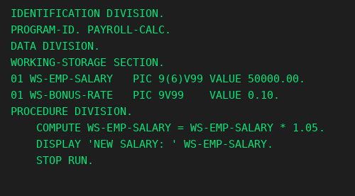

ACTUAL IMAGE
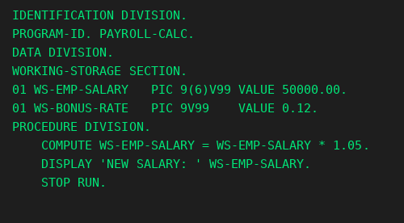

DIFFERENCE
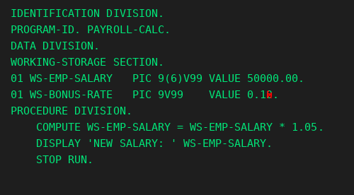

CHANGES FOUND

Line 6 - CHANGED
Word 6: CHANGED
EXPECTED | ACTUAL

PROGRAM1.png
STATUS: CHANGED
Pixel difference: 0.01%
Changed regions: 0

EXPECTED IMAGE
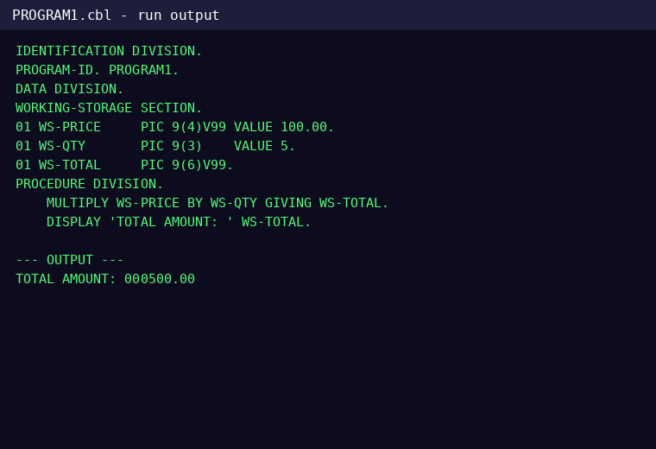

ACTUAL IMAGE
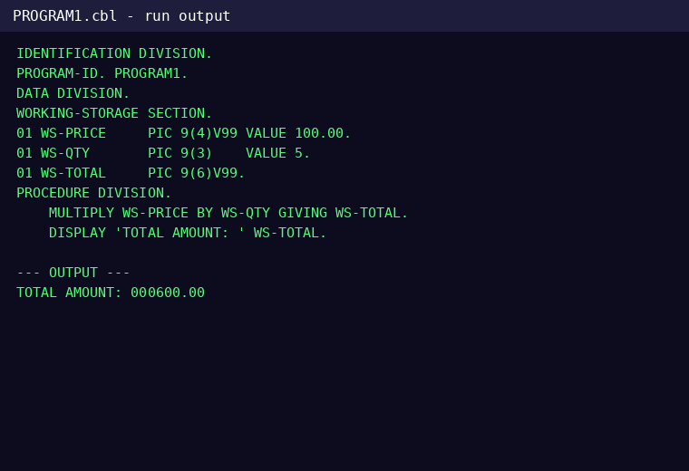

DIFFERENCE
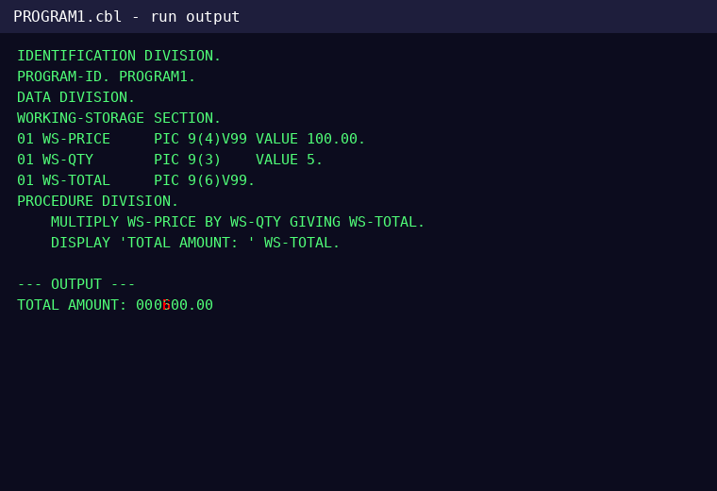

CHANGES FOUND

Line 13 - CHANGED
Word 3: CHANGED
EXPECTED | ACTUAL

PROGRAM2.png
STATUS: CHANGED
Pixel difference: 0.073%
Changed regions: 0

EXPECTED IMAGE
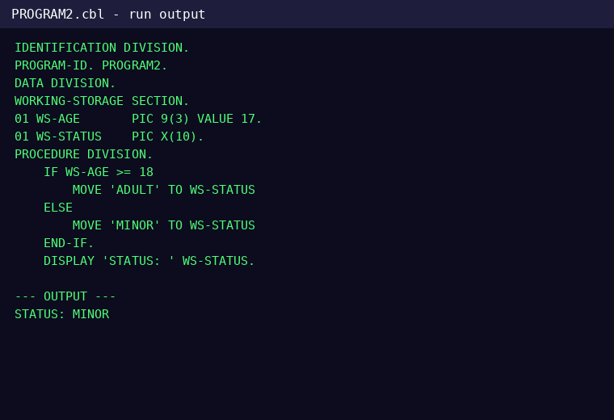

ACTUAL IMAGE
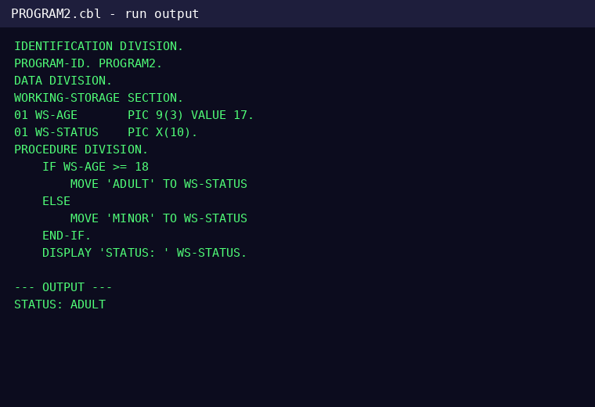

DIFFERENCE
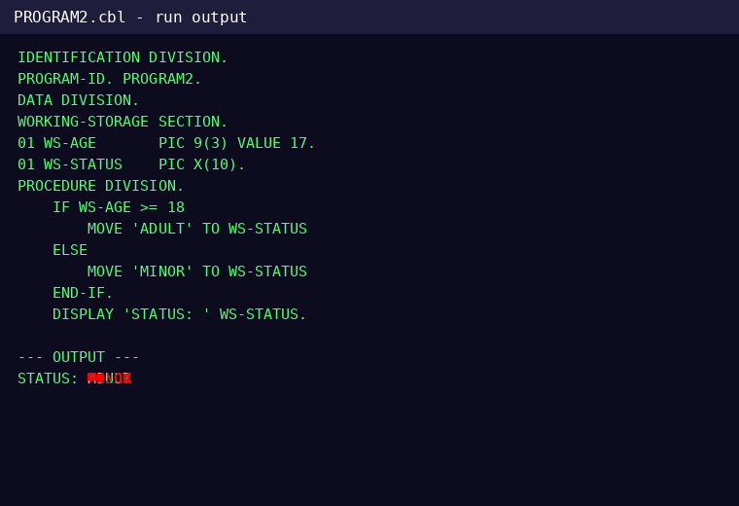

CHANGES FOUND

Line 16 - CHANGED
Word 2: CHANGED
EXPECTED | ACTUAL

PROGRAM3.png
STATUS: CHANGED
Pixel difference: 0.01%
Changed regions: 0

EXPECTED IMAGE
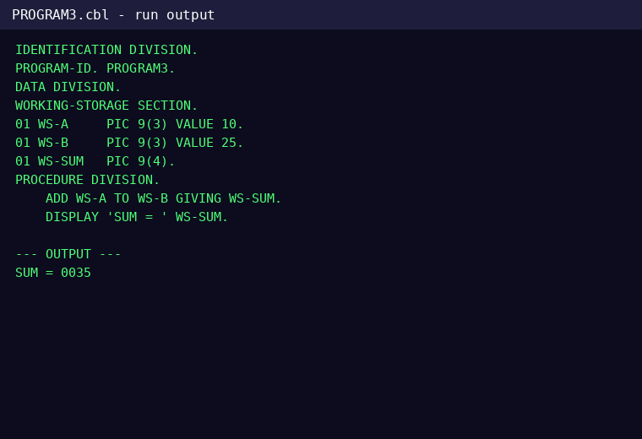

ACTUAL IMAGE
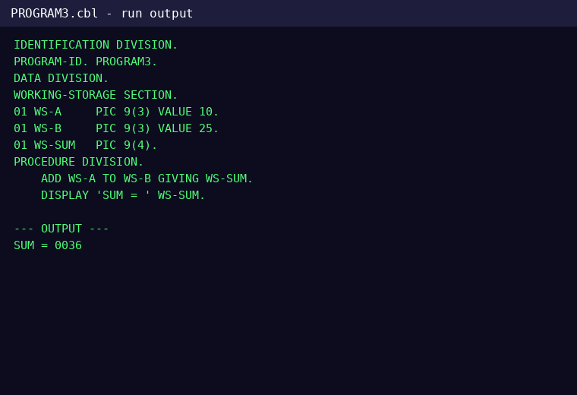

DIFFERENCE
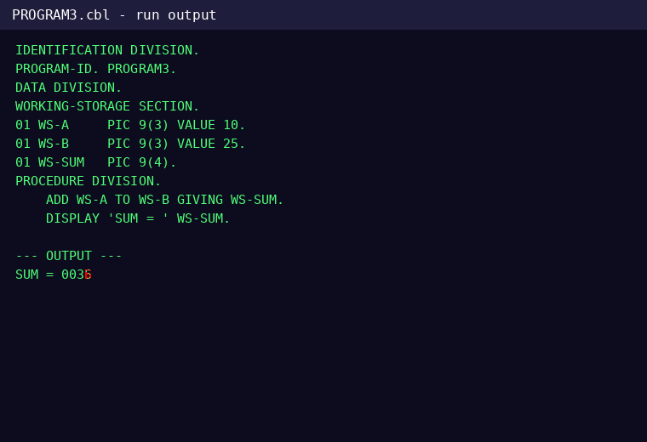

CHANGES FOUND

Line 13 - CHANGED
Word 3: CHANGED
EXPECTED | ACTUAL

PROGRAM4.png
STATUS: CHANGED
Pixel difference: 0.009%
Changed regions: 0

EXPECTED IMAGE
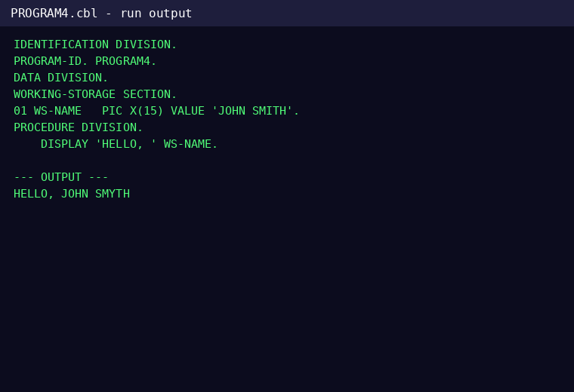

ACTUAL IMAGE
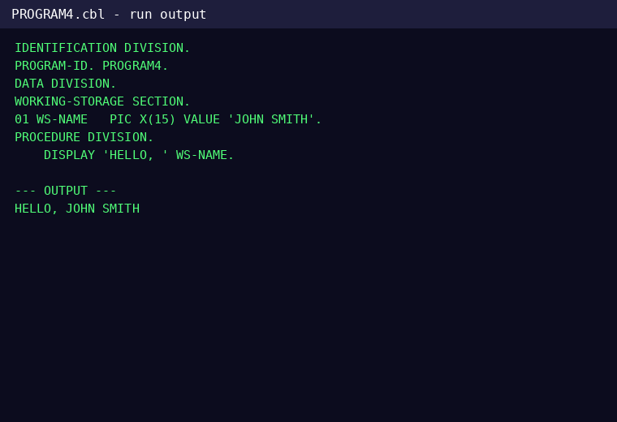

DIFFERENCE
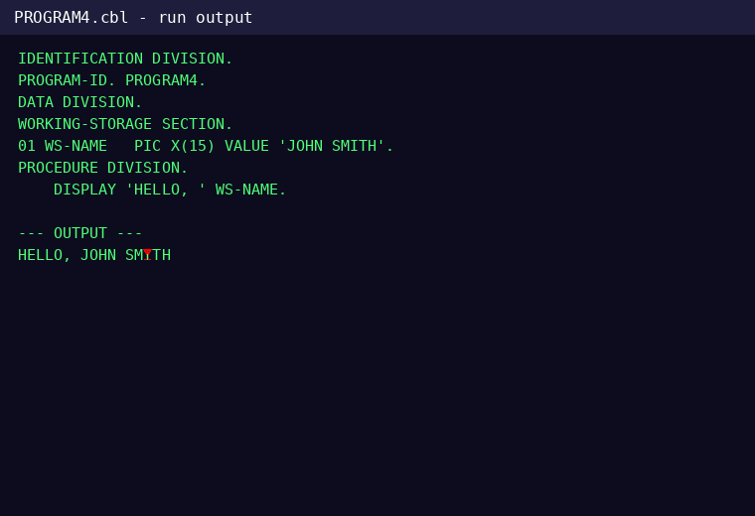

CHANGES FOUND

Line 10 - CHANGED
Word 3: CHANGED
EXPECTED | ACTUAL

PROGRAM5.png
STATUS: CHANGED
Pixel difference: 0.086%
Changed regions: 0

EXPECTED IMAGE
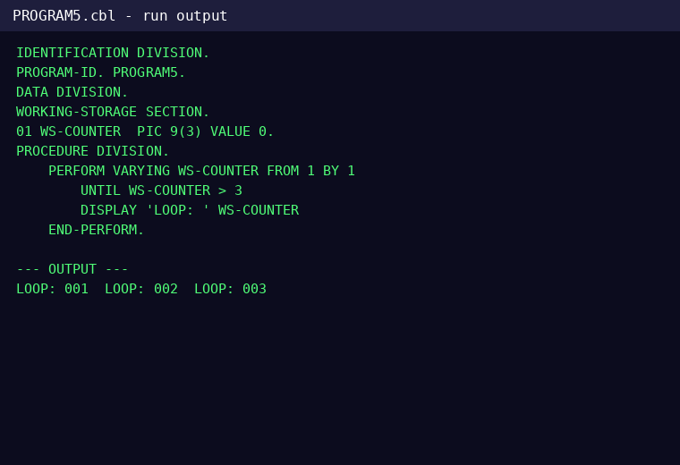

ACTUAL IMAGE
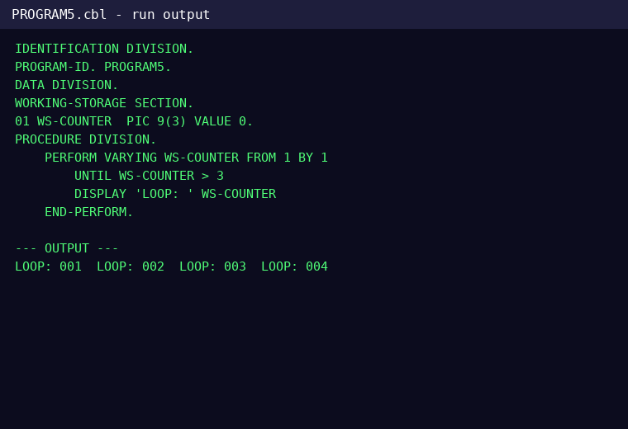

DIFFERENCE
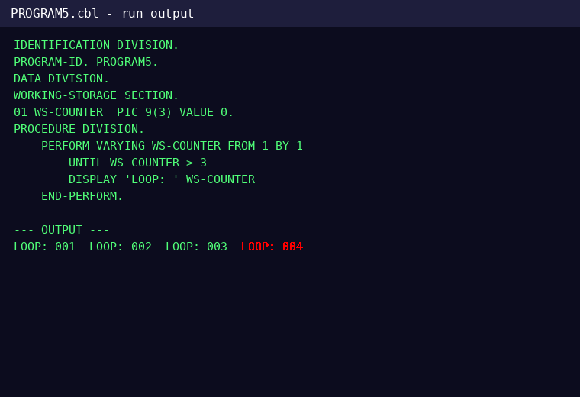

CHANGES FOUND

Line 13 - CHANGED
Word 7: EXTRA
EXPECTED | ACTUAL
Not present

Word 8: EXTRA
EXPECTED | ACTUAL
Not present

