COBOL IMAGE COMPARISON REPORT
Expected Output vs Actual Output
Generated: 2026-09-16T12:05:08.134360+00:00

Overall Summary
Metric | Value
Expected images | 1
Actual images | 1
Matched filenames | 1
Changed | 1
Identical | 0
Missing | 0
Extra | 0

Note: This is a visual comparison. No OCR is used. Changed areas are shown using the original image pixels.

PROGRAM1.png
STATUS: CHANGED
Pixel difference: 0.01%
Changed regions: 0

EXPECTED IMAGE
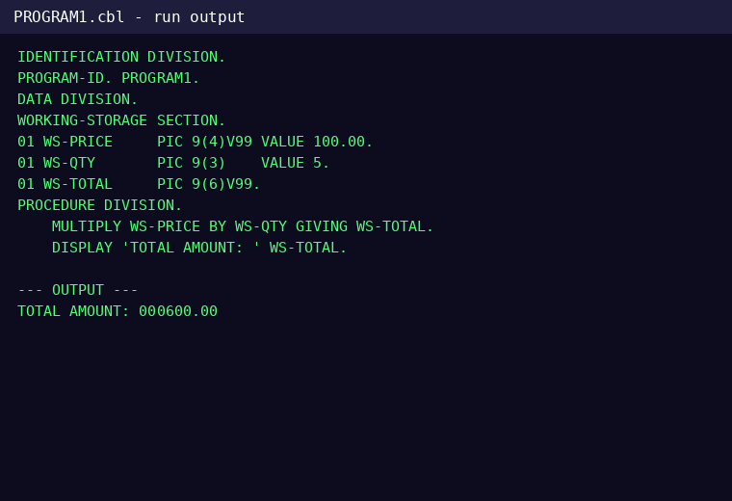

ACTUAL IMAGE
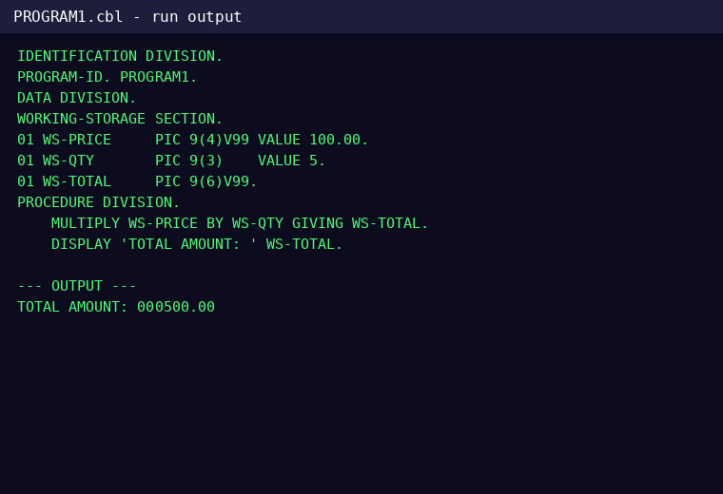

DIFFERENCE
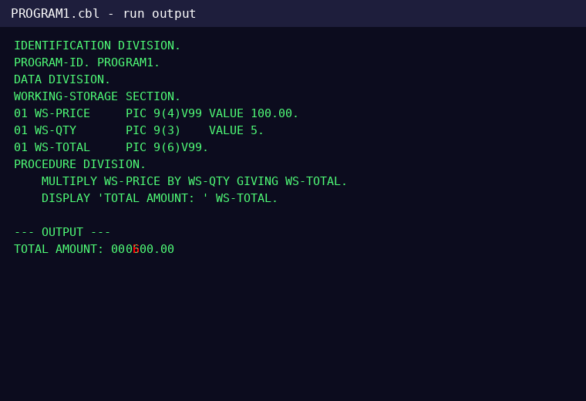

CHANGES FOUND

Line 13 - CHANGED
Word 3: CHANGED
EXPECTED | ACTUAL

