COBOL IMAGE COMPARISON REPORT
Expected Output vs Actual Output
Generated: 2026-09-17T04:31:54.881960+00:00

Run Details
Run Information | Value
Status | COMPLETED
Start Time | 2026-09-17 10:01:54
End Time | 2026-09-17 10:01:58
Processing Time | 3.40 seconds
Actual Images | 3
Expected Images | 3
Total Images Processed | 6
Images Compared | 3
Matched | 3
Changed | 3
Missing | 0
Extra | 0

Overall Summary
Metric | Value
Expected images | 3
Actual images | 3
Matched filenames | 3
Changed | 3
Identical | 0
Missing | 0
Extra | 0

Note: This is a visual comparison. No OCR is used. Changed areas are shown using the original image pixels.

PROGRAM1.png
STATUS: CHANGED
Pixel difference: 0.01%
Changed regions: 0

EXPECTED IMAGE
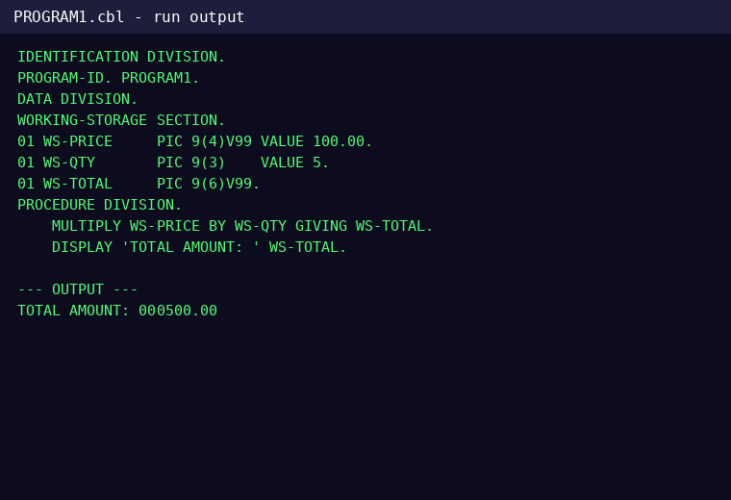

ACTUAL IMAGE
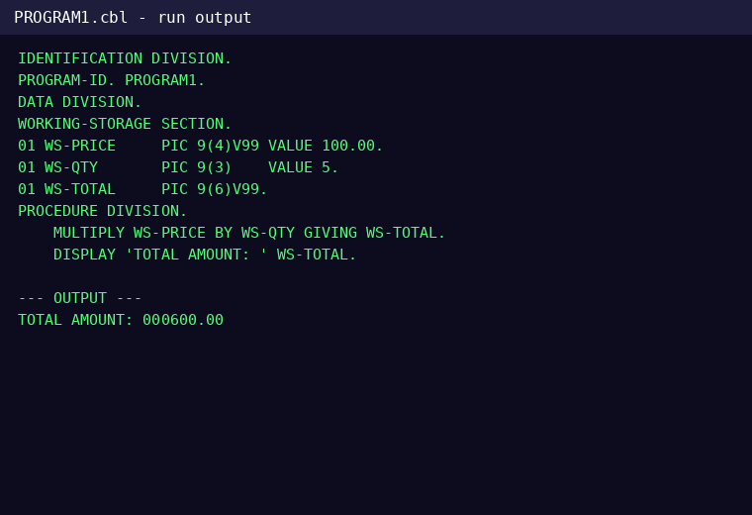

DIFFERENCE
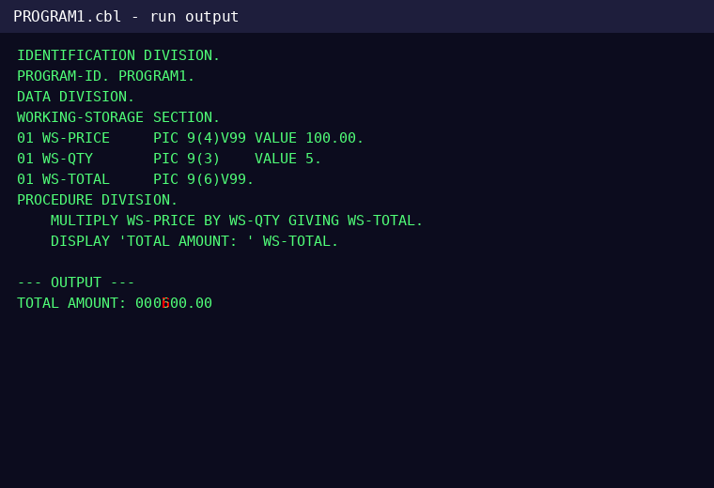

CHANGES FOUND

Line 13 - CHANGED
Word 3: CHANGED
EXPECTED | ACTUAL

PROGRAM2.png
STATUS: CHANGED
Pixel difference: 0.073%
Changed regions: 0

EXPECTED IMAGE
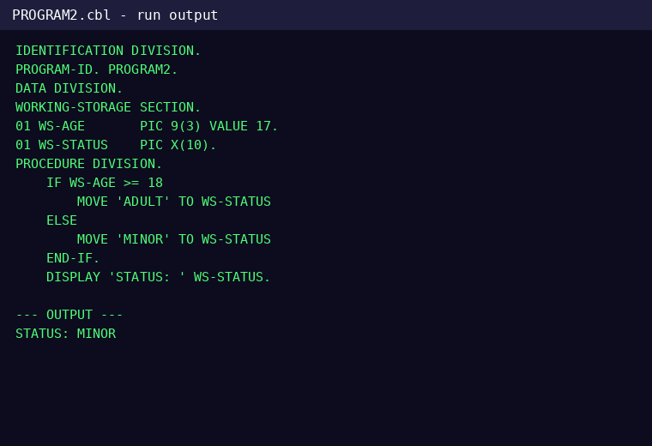

ACTUAL IMAGE
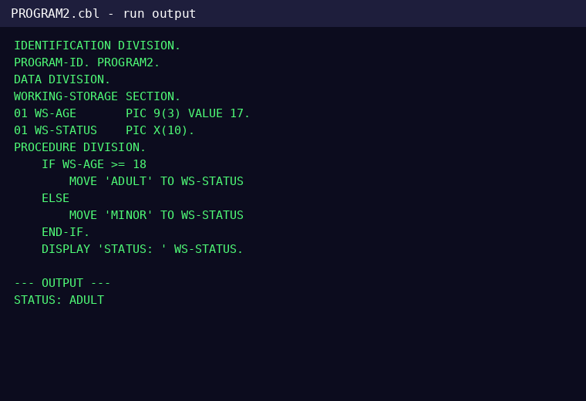

DIFFERENCE
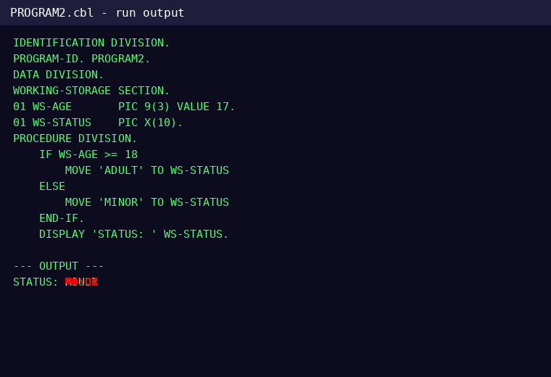

CHANGES FOUND

Line 16 - CHANGED
Word 2: CHANGED
EXPECTED | ACTUAL

PROGRAM3.png
STATUS: CHANGED
Pixel difference: 0.01%
Changed regions: 0

EXPECTED IMAGE
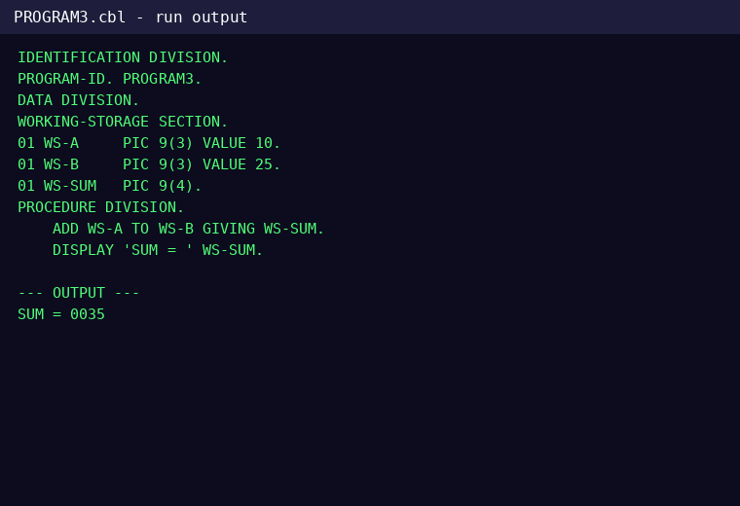

ACTUAL IMAGE
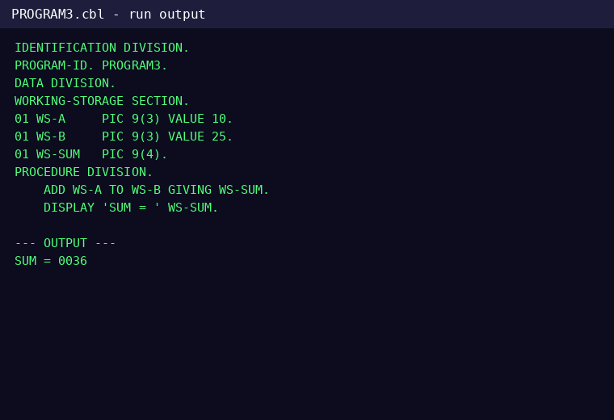

DIFFERENCE
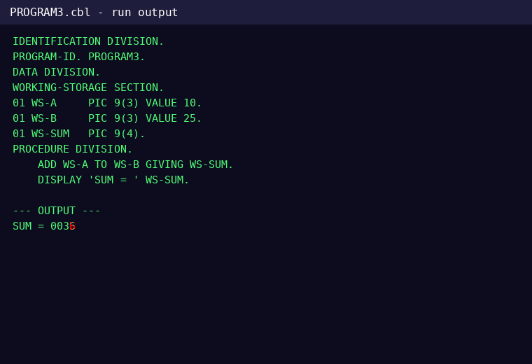

CHANGES FOUND

Line 13 - CHANGED
Word 3: CHANGED
EXPECTED | ACTUAL

