COBOL IMAGE COMPARISON REPORT
Expected Output vs Actual Output
Generated: 2026-09-11T08:41:28.295701+00:00

Overall Summary
Metric | Value
Expected images | 4
Actual images | 4
Matched filenames | 3
Changed | 3
Identical | 0
Missing | 1
Extra | 1

Note: This is a visual comparison. No OCR is used. Changed areas are shown using the original image pixels.

PROGRAM1.png
STATUS: CHANGED
Pixel difference: 0.01%
Changed regions: 0

EXPECTED IMAGE
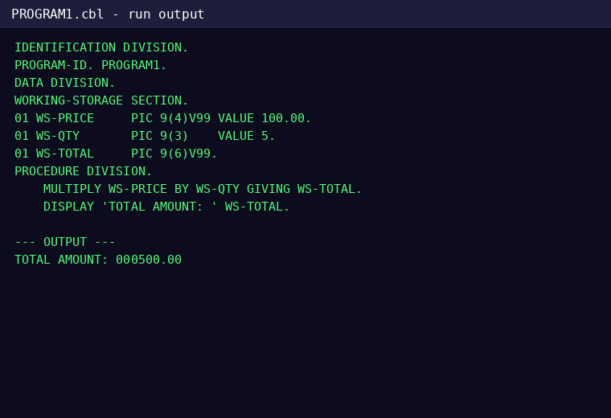

ACTUAL IMAGE
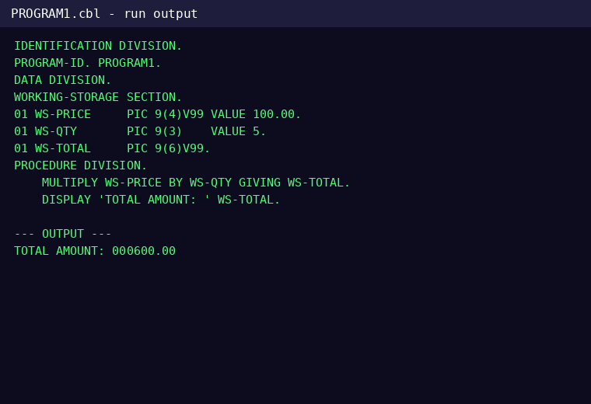

DIFFERENCE
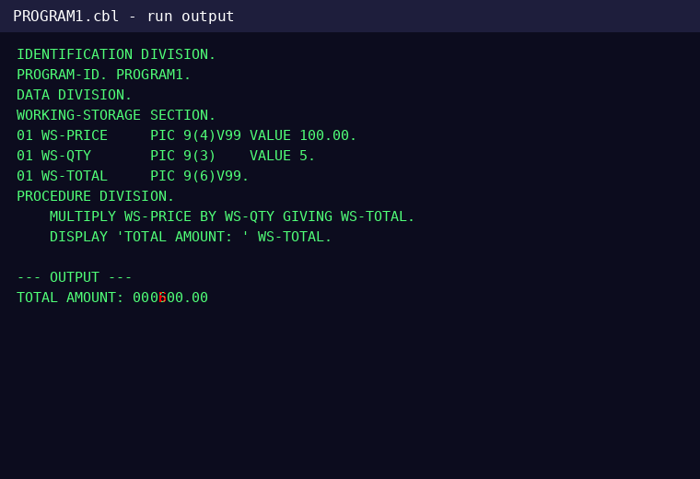

CHANGES FOUND

Line 13 - CHANGED
Word 3: CHANGED
EXPECTED | ACTUAL

PROGRAM2.png
STATUS: CHANGED
Pixel difference: 0.073%
Changed regions: 0

EXPECTED IMAGE
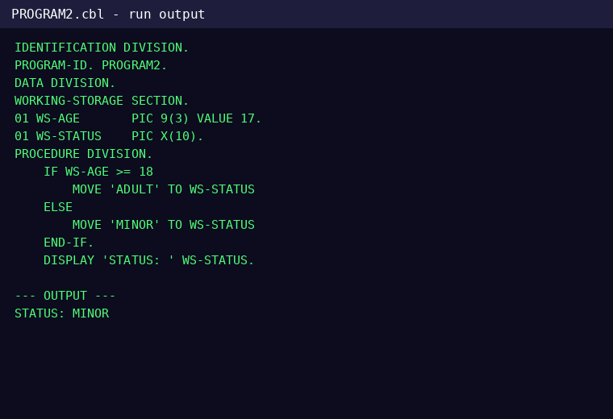

ACTUAL IMAGE
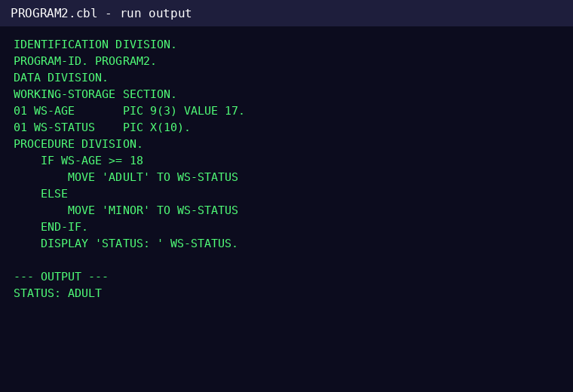

DIFFERENCE
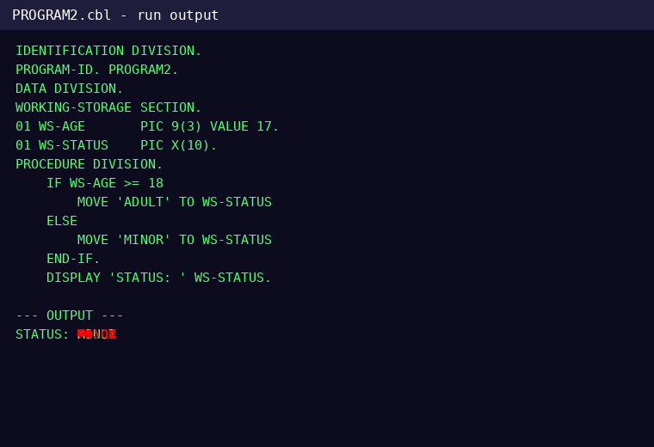

CHANGES FOUND

Line 16 - CHANGED
Word 2: CHANGED
EXPECTED | ACTUAL

PROGRAM4.png
STATUS: CHANGED
Pixel difference: 0.009%
Changed regions: 0

EXPECTED IMAGE
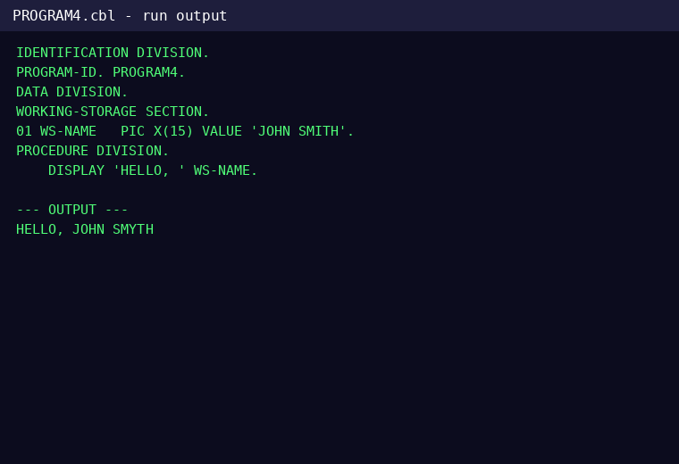

ACTUAL IMAGE
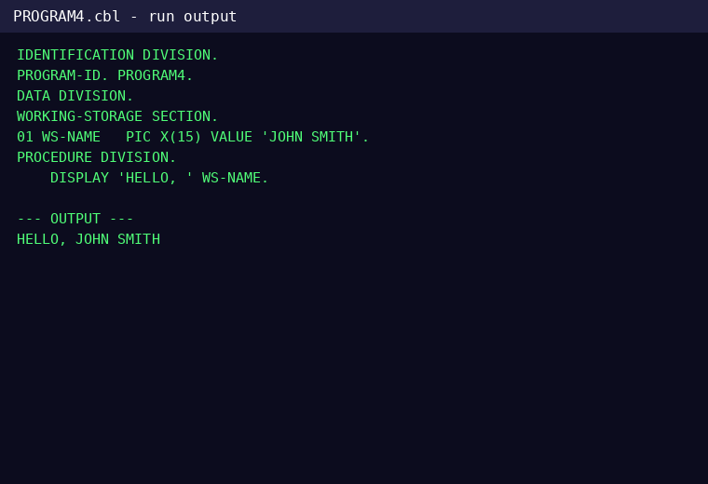

DIFFERENCE
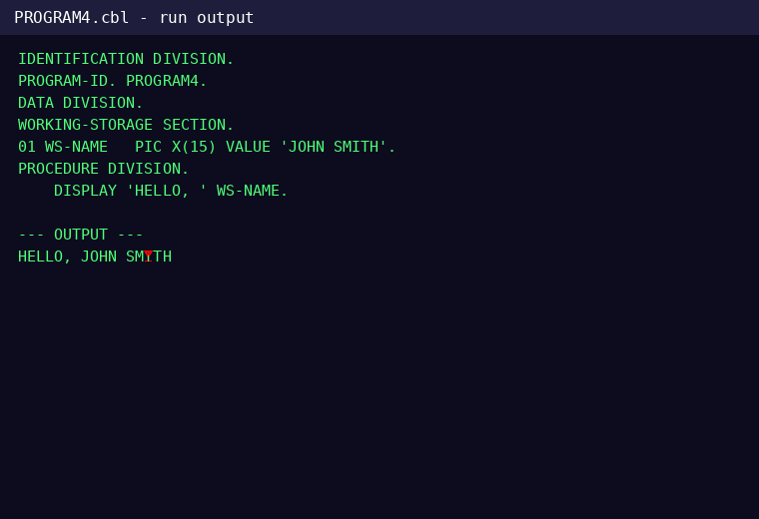

CHANGES FOUND

Line 10 - CHANGED
Word 3: CHANGED
EXPECTED | ACTUAL

Expected Images Without Matching Actual Image
PROGRAM3.png

Actual Images Without Matching Expected Image
PROGRAM5.png

