COBOL IMAGE COMPARISON REPORT
Expected Output vs Actual Output
Generated: 2026-09-11T09:07:48.490956+00:00

Overall Summary
Metric | Value
Expected images | 1
Actual images | 1
Matched filenames | 1
Changed | 1
Identical | 0
Missing | 0
Extra | 0

Note: This is a visual comparison. No OCR is used. Changed areas are shown using the original image pixels.

PROGRAM1.png
STATUS: CHANGED
Pixel difference: 3.922%
Changed regions: 0

EXPECTED IMAGE
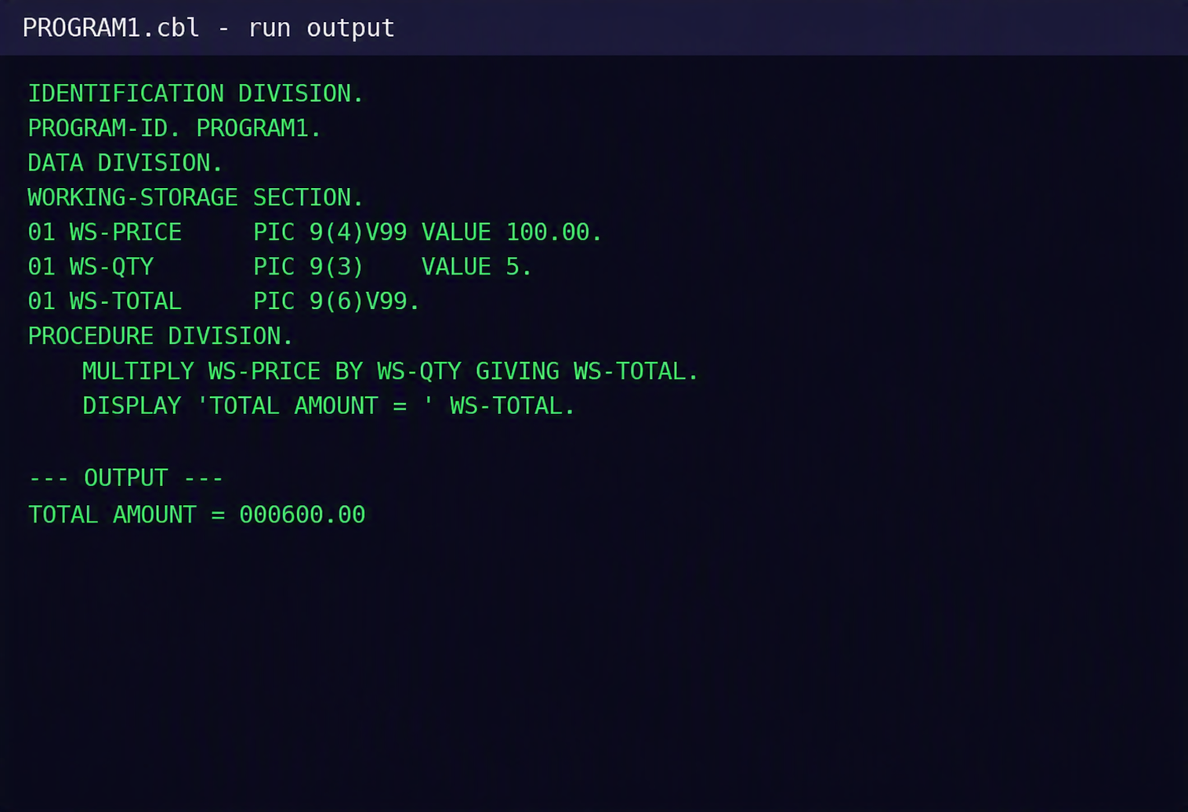

ACTUAL IMAGE
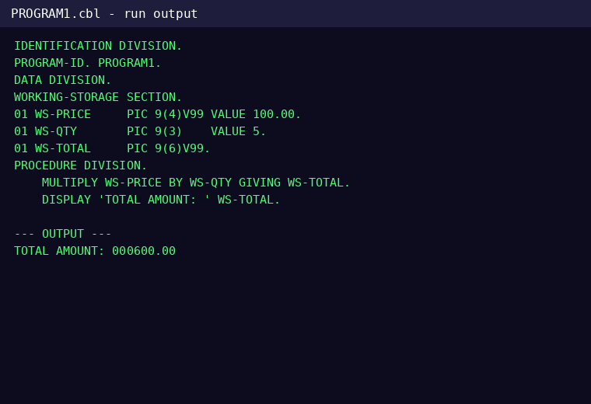

DIFFERENCE
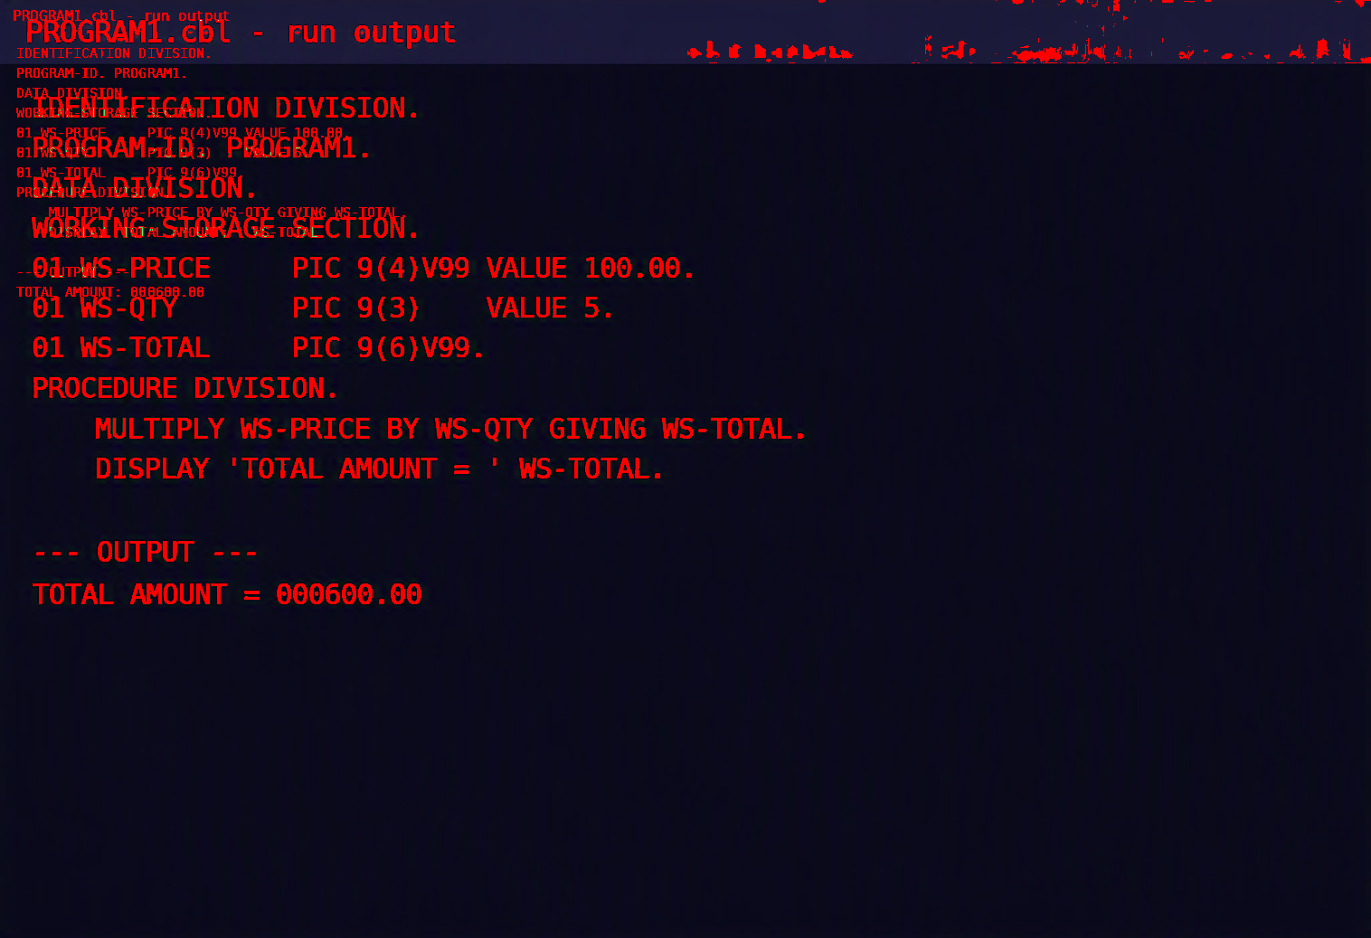

CHANGES FOUND

Line 1 - CHANGED
Word 1: CHANGED
EXPECTED | ACTUAL
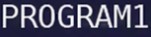

Word 2: CHANGED
EXPECTED | ACTUAL

Word 3: CHANGED
EXPECTED | ACTUAL


Word 4: CHANGED
EXPECTED | ACTUAL

Word 5: MISSING
EXPECTED | ACTUAL
 | Not present

Word 6: MISSING
EXPECTED | ACTUAL
 | Not present

Line 2 - CHANGED
Word 1: CHANGED
EXPECTED | ACTUAL

Word 2: CHANGED
EXPECTED | ACTUAL

Word 3: MISSING
EXPECTED | ACTUAL
 | Not present

Word 4: MISSING
EXPECTED | ACTUAL
 | Not present

Line 3 - CHANGED
Word 1: CHANGED
EXPECTED | ACTUAL

Word 2: CHANGED
EXPECTED | ACTUAL

Word 3: MISSING
EXPECTED | ACTUAL
 | Not present

Word 4: MISSING
EXPECTED | ACTUAL
 | Not present

Word 5: MISSING
EXPECTED | ACTUAL
 | Not present

Word 6: MISSING
EXPECTED | ACTUAL
 | Not present

Line 4 - CHANGED
Word 1: CHANGED
EXPECTED | ACTUAL

Word 2: CHANGED
EXPECTED | ACTUAL

Word 3: MISSING
EXPECTED | ACTUAL
 | Not present

Line 5 - CHANGED
Word 1: CHANGED
EXPECTED | ACTUAL

Word 2: CHANGED
EXPECTED | ACTUAL

Word 3: MISSING
EXPECTED | ACTUAL
 | Not present

Word 4: MISSING
EXPECTED | ACTUAL
 | Not present

Word 5: MISSING
EXPECTED | ACTUAL
 | Not present

Line 6 - CHANGED
Word 1: CHANGED
EXPECTED | ACTUAL
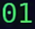

Word 2: CHANGED
EXPECTED | ACTUAL


Word 3: CHANGED
EXPECTED | ACTUAL

Word 4: CHANGED
EXPECTED | ACTUAL


Word 5: CHANGED
EXPECTED | ACTUAL


Word 6: CHANGED
EXPECTED | ACTUAL

Word 7: MISSING
EXPECTED | ACTUAL
 | Not present

Word 8: MISSING
EXPECTED | ACTUAL
 | Not present

Word 9: MISSING
EXPECTED | ACTUAL
 | Not present

Word 10: MISSING
EXPECTED | ACTUAL
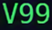 | Not present

Word 11: MISSING
EXPECTED | ACTUAL
 | Not present

Word 12: MISSING
EXPECTED | ACTUAL
 | Not present

Word 13: MISSING
EXPECTED | ACTUAL
 | Not present

Word 14: MISSING
EXPECTED | ACTUAL
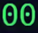 | Not present

Word 15: MISSING
EXPECTED | ACTUAL
 | Not present

Line 7 - CHANGED
Word 1: CHANGED
EXPECTED | ACTUAL
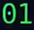

Word 2: CHANGED
EXPECTED | ACTUAL


Word 3: CHANGED
EXPECTED | ACTUAL

Word 4: CHANGED
EXPECTED | ACTUAL


Word 5: CHANGED
EXPECTED | ACTUAL


Word 6: CHANGED
EXPECTED | ACTUAL

Word 7: MISSING
EXPECTED | ACTUAL
 | Not present

Word 8: MISSING
EXPECTED | ACTUAL
 | Not present

Word 9: MISSING
EXPECTED | ACTUAL
 | Not present

Word 10: MISSING
EXPECTED | ACTUAL
 | Not present

Word 11: MISSING
EXPECTED | ACTUAL
 | Not present

Word 12: MISSING
EXPECTED | ACTUAL
 | Not present

Line 8 - CHANGED
Word 1: CHANGED
EXPECTED | ACTUAL
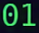

Word 2: CHANGED
EXPECTED | ACTUAL


Word 3: CHANGED
EXPECTED | ACTUAL


Word 4: CHANGED
EXPECTED | ACTUAL


Word 5: MISSING
EXPECTED | ACTUAL
 | Not present

Word 6: MISSING
EXPECTED | ACTUAL
 | Not present

Word 7: MISSING
EXPECTED | ACTUAL
 | Not present

Word 8: MISSING
EXPECTED | ACTUAL
 | Not present

Word 9: MISSING
EXPECTED | ACTUAL
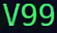 | Not present

Word 10: MISSING
EXPECTED | ACTUAL
 | Not present

Line 9 - CHANGED
Word 1: CHANGED
EXPECTED | ACTUAL

Word 2: CHANGED
EXPECTED | ACTUAL

Word 3: MISSING
EXPECTED | ACTUAL
 | Not present

Line 10 - CHANGED
Word 1: CHANGED
EXPECTED | ACTUAL


Word 2: CHANGED
EXPECTED | ACTUAL


Word 3: CHANGED
EXPECTED | ACTUAL

Word 4: CHANGED
EXPECTED | ACTUAL


Word 5: CHANGED
EXPECTED | ACTUAL


Word 6: CHANGED
EXPECTED | ACTUAL


Word 7: MISSING
EXPECTED | ACTUAL
 | Not present

Word 8: MISSING
EXPECTED | ACTUAL
 | Not present

Word 9: MISSING
EXPECTED | ACTUAL
 | Not present

Word 10: MISSING
EXPECTED | ACTUAL
 | Not present

Word 11: MISSING
EXPECTED | ACTUAL
 | Not present

Word 12: MISSING
EXPECTED | ACTUAL
 | Not present

Line 11 - CHANGED
Word 1: CHANGED
EXPECTED | ACTUAL

Word 2: CHANGED
EXPECTED | ACTUAL

Word 3: CHANGED
EXPECTED | ACTUAL

Word 4: CHANGED
EXPECTED | ACTUAL

Word 5: MISSING
EXPECTED | ACTUAL
 | Not present

Word 6: MISSING
EXPECTED | ACTUAL
 | Not present

Word 7: MISSING
EXPECTED | ACTUAL
 | Not present

Word 8: MISSING
EXPECTED | ACTUAL
 | Not present

Word 9: MISSING
EXPECTED | ACTUAL
 | Not present

Word 10: MISSING
EXPECTED | ACTUAL
 | Not present

Line 12 - CHANGED
Word 1: CHANGED
EXPECTED | ACTUAL

Word 2: CHANGED
EXPECTED | ACTUAL

Word 3: CHANGED
EXPECTED | ACTUAL

Word 4: MISSING
EXPECTED | ACTUAL
 | Not present

Word 5: MISSING
EXPECTED | ACTUAL
 | Not present

Word 6: MISSING
EXPECTED | ACTUAL
 | Not present

Word 7: MISSING
EXPECTED | ACTUAL
 | Not present

Line 13 - CHANGED
Word 1: CHANGED
EXPECTED | ACTUAL

Word 2: CHANGED
EXPECTED | ACTUAL

Word 3: CHANGED
EXPECTED | ACTUAL

Word 4: MISSING
EXPECTED | ACTUAL
 | Not present

Word 5: MISSING
EXPECTED | ACTUAL
 | Not present

Word 6: MISSING
EXPECTED | ACTUAL
 | Not present

