COBOL IMAGE COMPARISON REPORT
Expected Output vs Actual Output
Generated: 2026-09-11T09:26:03.243731+00:00

Overall Summary
Metric | Value
Expected images | 1
Actual images | 1
Matched filenames | 1
Changed | 1
Identical | 0
Missing | 0
Extra | 0

Note: This is a visual comparison. No OCR is used. Changed areas are shown using the original image pixels.

pair3_json_image1.png
STATUS: CHANGED
Pixel difference: 0.036%
Changed regions: 0

EXPECTED IMAGE
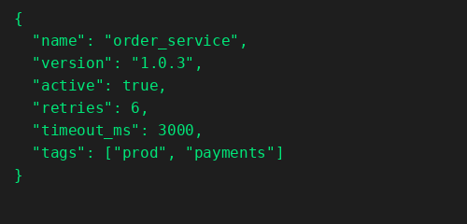

ACTUAL IMAGE
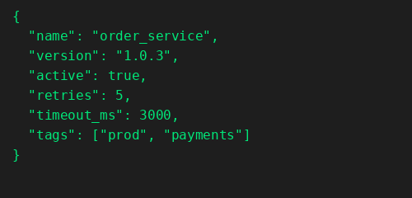

DIFFERENCE
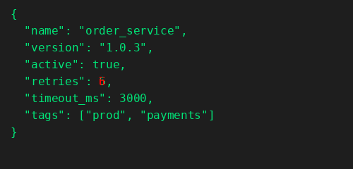

CHANGES FOUND

Line 6 - CHANGED
Word 4: CHANGED
EXPECTED | ACTUAL

