**Python Project**

**Project : Design a Web Scraper to Scrape Data from a Website. Analyze the Data and Make a Report on the Analysis.**

**Subject: Data Exploration & Visualization using Python I**

**Name : Shantanu Bharvirkar**

**Roll no : 045052**

**Submitted to :Prof. Amarnath Mitra**

**GitHub :** [**https://github.com/045052FSMShantanuBharvirkar/045052_Python_Project_AsianPaintsBalanceSheetAnalysis**](https://github.com/045052FSMShantanuBharvirkar/045052_Python_Project_AsianPaintsBalanceSheetAnalysis%20)

**Topic: Asian Paints Balance Sheet Analysis**

**Objectives**

To analyze the balance sheet of Asian paints and gain some insights and visualize the data which makes it easier to understand the balance sheet data.

**Introduction**

We wanted to find out how well Asian Paints has been doing in the last 10 years, from 2012 to 2023. To do this, we scraped their balance sheet data from a website called Screener. We then used graphs and some math (linear regression) to see what the numbers are telling us about the company's financial health. This analysis will help us understand Asian Paints' performance over the years.

This is the URL I web scraped.

* <https://www.screener.in/company/ASIANPAINT/consolidated/>

This is the table on the website.

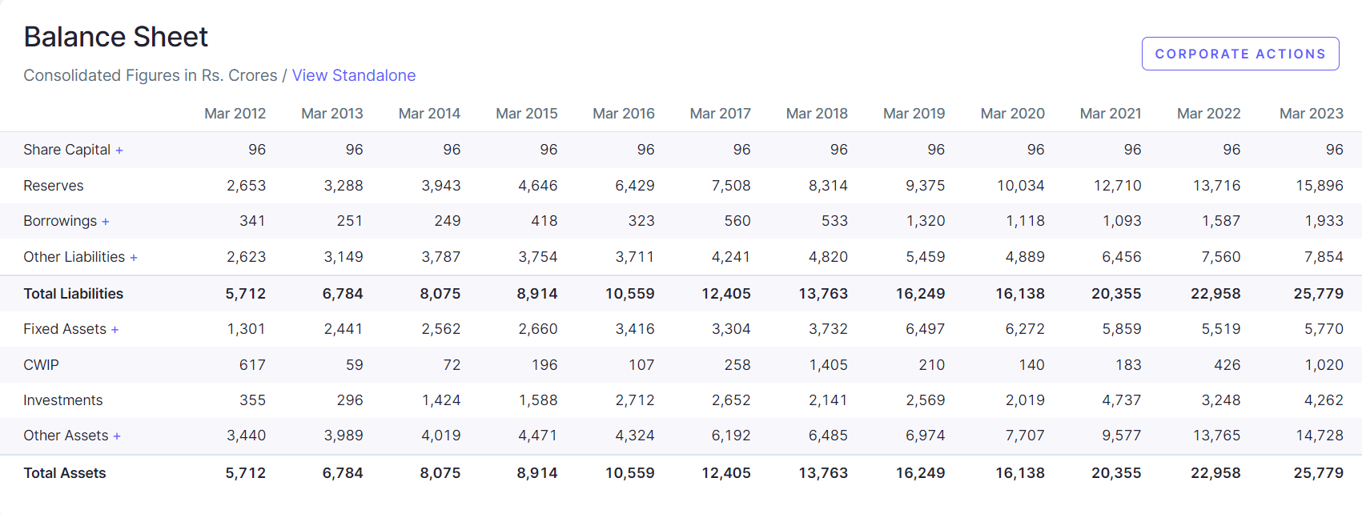

It was scrapped in a DataFrame called df.

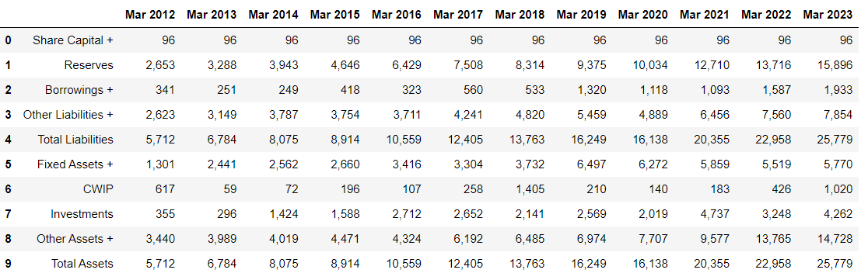

**Data Preprocessing**

The data wasn’t in the right format so I performed operations to remove the ‘+’ signs, and comma and spacings in Data Frame. Also transformed the table so that the years are in the first column which makes it easier to analyse the data.

Here is how the data looks like after the data cleaning.

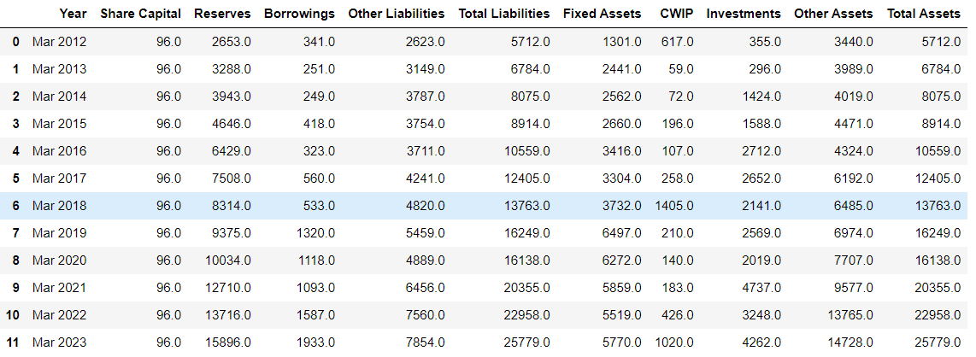

**General Description of Data**

Original Data Frame has 11 columns of information

**Year :** This column has data about March of every year from 2012 to 2023

**Share Capital**: This represents the amount of capital invested by shareholders in the company through the purchase of shares. It's a key component of a company's equity.

**Reserves**: Reserves are accumulated profits or retained earnings that a company has kept aside over time, typically to reinvest in the business or cover future expenses.

**Borrowings**: This column represents the total amount of money the company has borrowed, often through loans or bonds, which it is obligated to repay in the future.

**Other Liabilities**: This category typically includes various non-specific liabilities, such as accrued expenses, provisions, and other obligations that don't fall into the previous categories.

**Total Liabilities**: The sum of all the company's obligations, including Share Capital, Reserves, Borrowings, and Other Liabilities. It represents the company's total financial obligations.

**Fixed Assets**: Fixed assets are long-term assets that a company uses to generate revenue, such as buildings, machinery, and equipment.

**CWIP (Capital Work in Progress)**: This represents the value of assets that are currently in the process of being constructed or developed but are not yet completed.

**Investments**: This includes investments made by the company in other businesses or securities, typically for the purpose of generating income or capital appreciation.

**Other Assets**: Similar to Other Liabilities, this category typically includes various non-specific assets, such as prepaid expenses, deferred tax assets, and other miscellaneous items.

**Total Assets**: The sum of all the company's assets, including Fixed Assets, CWIP, Investments, and Other Assets. It represents the total value of what the company owns.

These column headers provide an overview of a company's financial situation, including its sources of capital (Share Capital and Reserves), its debt (Borrowings), its obligations (Other Liabilities), and its assets (Fixed Assets, CWIP, Investments, and Other Assets). The Total Liabilities and Total Assets columns help assess the overall financial health and balance of the company.

**Data Analysis**

Here is basic statistical analysis of the data

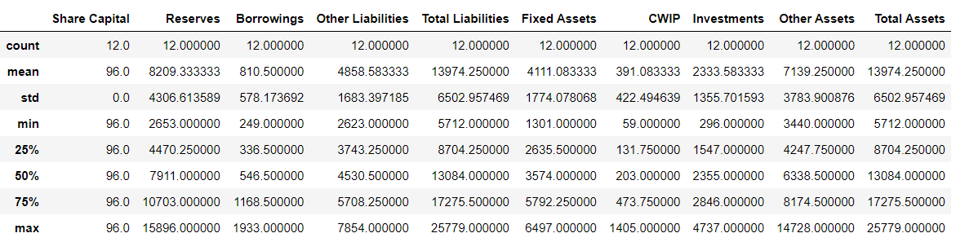

count - The number of not-empty values  
mean - The average (mean) value  
std - The standard deviation  
min - the minimum value  
25% - The 25% percentile  
50% - The 50% percentile  
75% - The 75% percentile  
max - the maximum value

**Debt/Asset Ratio Over the Years**

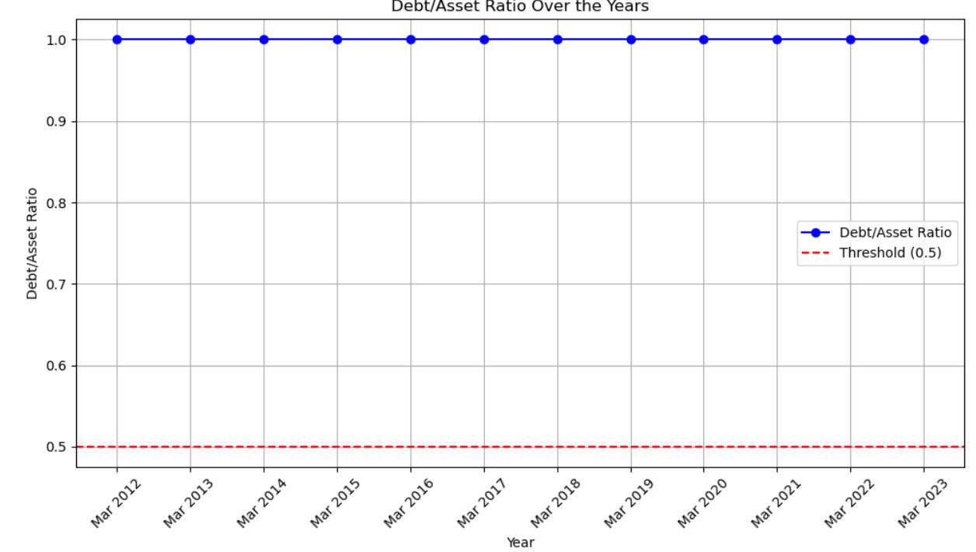

This indicates the balance sheet is tallied correctly as Assets = Liabilities + Equity.

**Equity Ratio Over the Years**

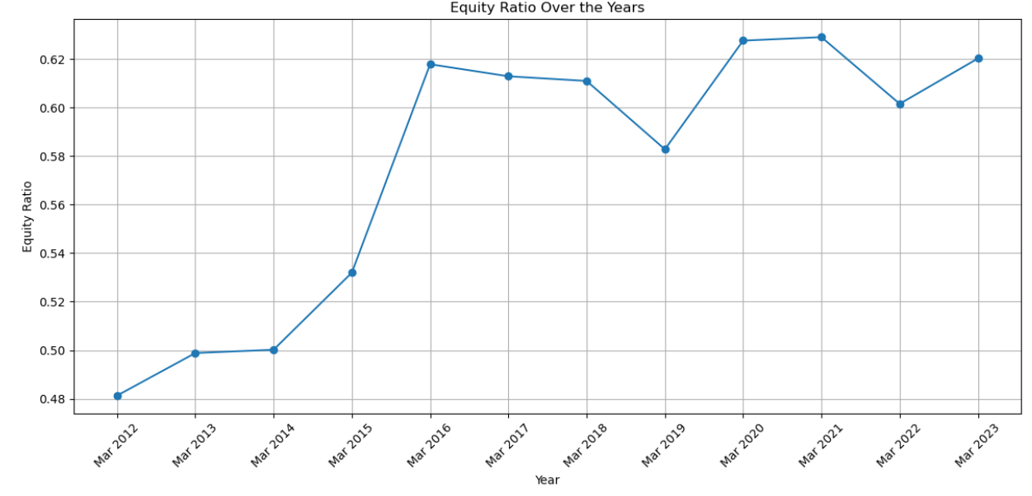

-The equity ratio is a financial metric that measures how much of a company's assets are financed by the owners' capital.

-A value of 0.6 means that shareholders' equity represents 60% of the company's total assets. In other words, for every dollar of assets the company holds, 60 cents are contributed by the shareholders, and the remaining 40 cents may be financed through debt or other liabilities.

**Debt Ratio Over the Years**

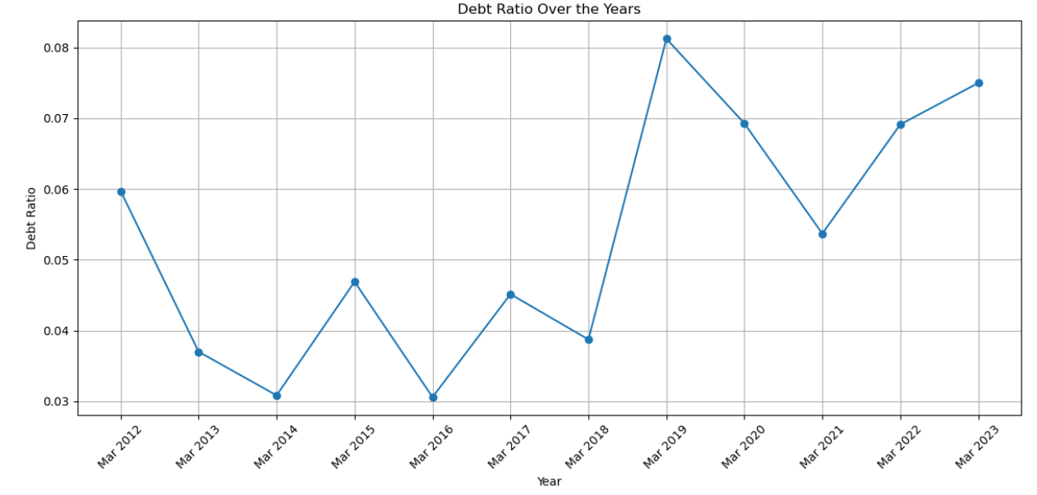

-The debt ratio determines the relative proportion of debt to total assets; it measures the proportion of debt used to finance the company’s assets. One can evaluate leverage in a firm with the help of this ratio.

-This ratio is being used by Top Management (to take decisions) as well as Investors (before making investment).

-0.50 is considered as an Ideal Debt Ratio. It depends on Capital Requirement and Level of Cash Flow.

-Higher the ratio implies more levered company and it shows that the company has more financial risk.

-Here we observe after 2019 it has more financial risk as Asian paints have borrowed a lot.

**Asset Allocation Over the Years**

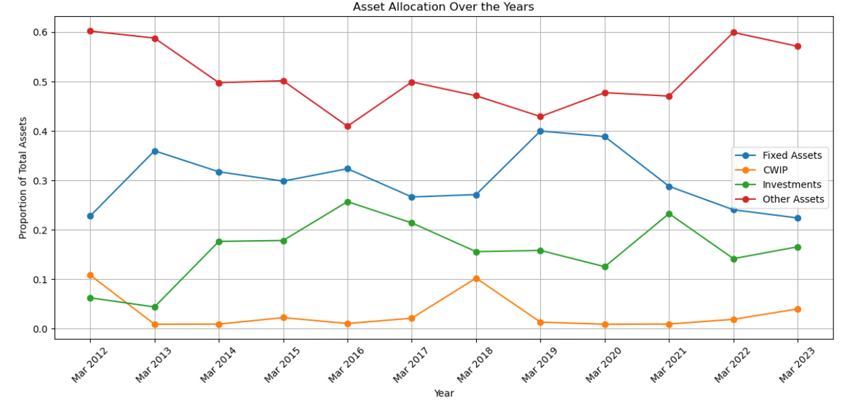

-The numbers on the y-axis indicate the values of the asset allocation ratio for each year. This ratio reflects how the company has allocated its assets among these categories.

-The y-axis values show the asset allocation proportions for each category, allowing you to analyse how the company has distributed its resources over time.

-This graph indicates that more assets are allocated to other assets which consists of Inventories, Trade receivables, Cash Equivalents, Other asset items,

-Roughly half are allocated to other assets over the last 10 years

**Debt and Equity Trends Over the Years**

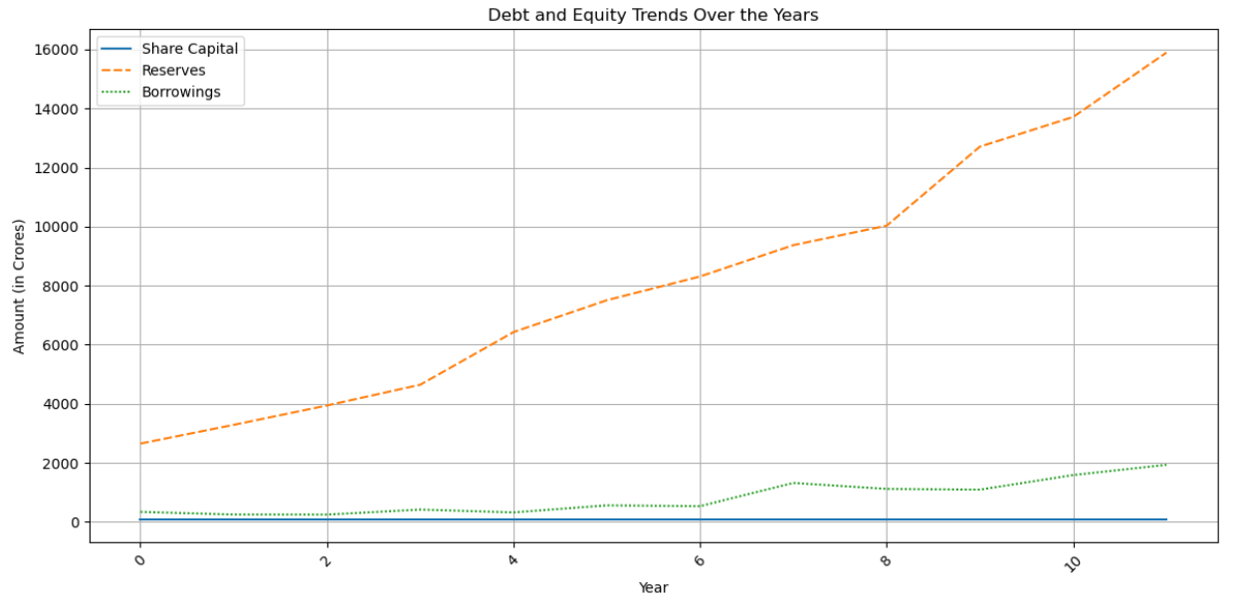

-Reserves over the years have grown from 2653 CR in 2012 to 15896 CR and they have consistently grown over the last 10 years.

-Borrowings have grown from 341 CR in 2012 to 1933 CR in 2023, only from 2019 the they have borrowed lot more as we observe borrowings jumped from 533 CR in 2018 to 1320 CR in 2019 which is a 147.6% increase.

**Total Assets Trend Over Time**

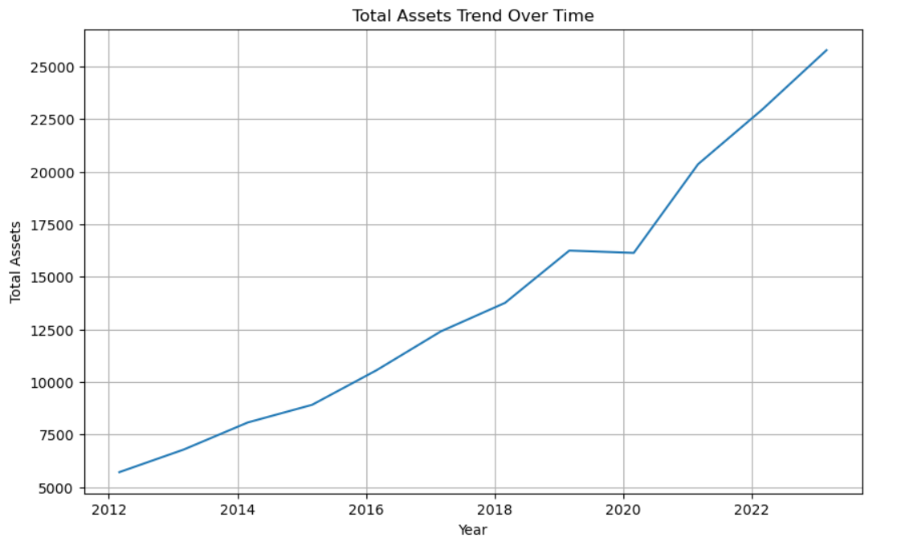

-From this graph we observe that assets went from 5712 Cr in 2012 to 25779

-Equity issuance and growth in retained earnings both lead to an increase in the book equity of a firm and, as a result, to an increase in total assets.

-So, this does indicate the company is growing at a healthy rate.

**Reserves over the years**

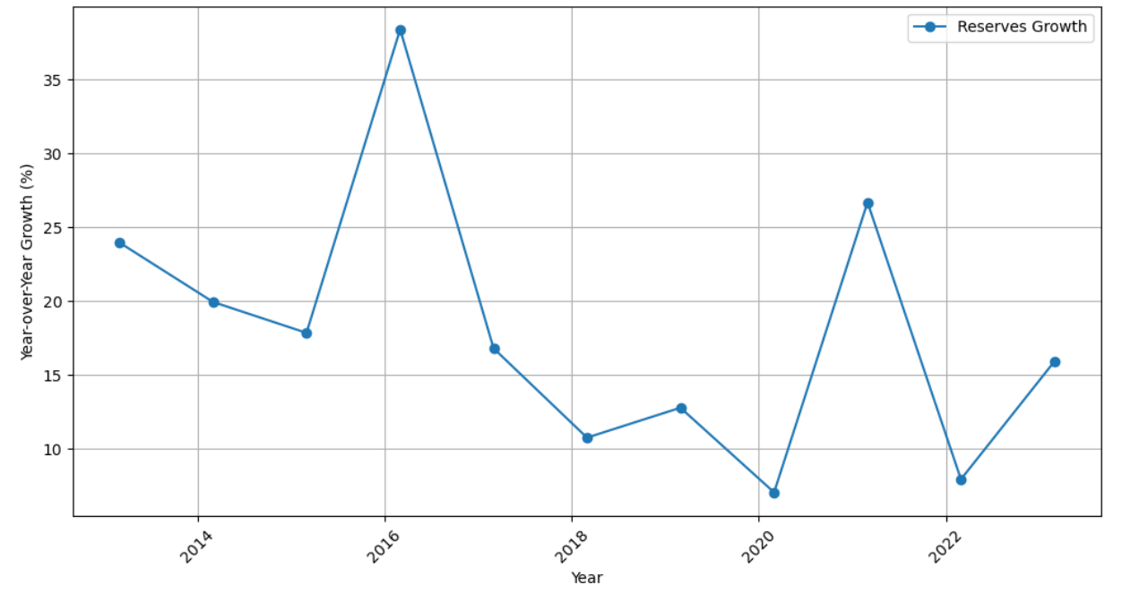

This is the plot the year-over-year growth rates of Reserves over the years

**Simple Linear Regression with Reserves and Borrowings**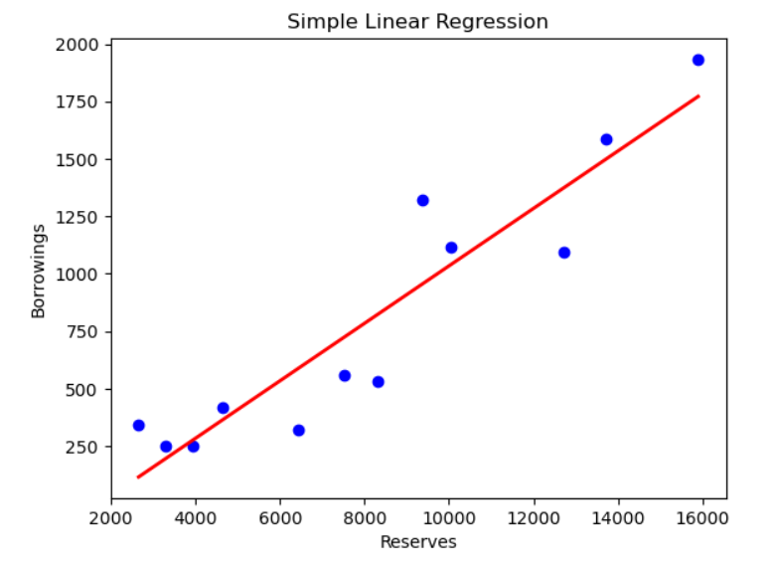

-Reserves are like savings accounts – an accumulation of funds for a future purpose. The source of funding for a reserve might be surpluses from operations, or scheduled transfers that have been planned and budgeted.

-Having significant cash reserves gives an individual, group of individuals, or company the ability to make a large purchase immediately. It should also ensure they are able to cover themselves when they go through a rough patch financially and need to make sudden, unexpected payments.

-By performing simple linear regression we observe that as Asian paints borrows more, they earn more revenue as they are using the borrowed money well and as a result they are able to save more money in reserves for a rainy day.

-We also observe that there is correlation between Borrowings and Reserves.

**Simple Linear Regression with Borrowings and Total Liabilities**

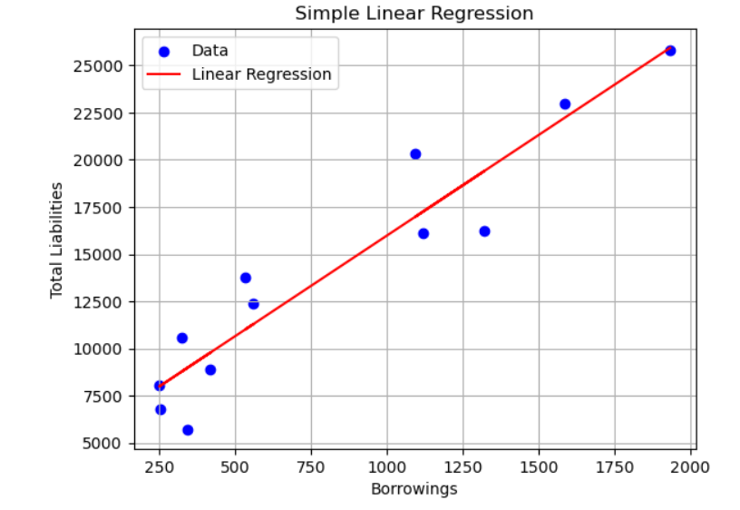

-This shows that there is correlation between Total Liabilities and borrowings as borrowings is part of Total liabilities hence this makes sense.

**Year-over-Year Growth Rates for Share Capital, Reserves, Borrowings, Total Assets**

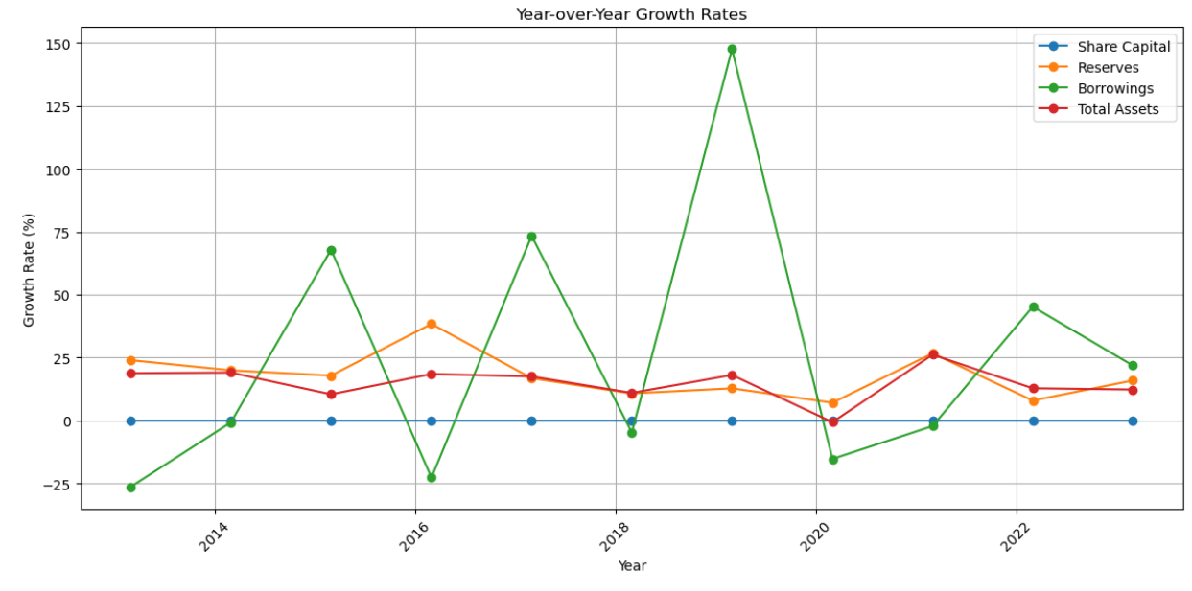

-This shows the percentage change year over year.

**Managerial Insights | Implications**

1. **Debt Management**:
   * The Debt Ratio has indeed been relatively stable, suggesting good debt management practices.
2. **Asset Allocation**:
   * The shift in asset allocation could indicate strategic decisions. However, understanding the nature of "Other Assets" and "Investments" is essential to assess their impact on the company's performance.
3. **Profitability and Growth**:
   * The consistent growth in Reserves indicates profitability and financial stability.
4. **Capital Structure**:
   * The constant Share Capital implies that the company is not diluting its equity base.
5. **Growth Rates**:
   * While Reserves, Share Capital, and Total Assets have grown, the volatile Borrowings Growth Rate requires closer attention. It's important to understand the reasons behind this volatility.
6. **Investment in Fixed Assets**:
   * The decreasing proportion of Fixed Assets may be a strategic choice. A deeper analysis is needed to confirm whether this aligns with the company's strategy.
7. **Reserves Growth**:
   * The consistent growth in Reserves is a positive sign for financial stability.
8. **Shareholder Equity**:
   * The stability in Share Capital can be seen as a sign of financial prudence.
9. **Liquidity and Solvency**:
   * More specific liquidity ratios would provide a clearer picture of the company's short-term financial health.
10. **Future Planning**:
    * The significant investments in Other Assets and Investments do require clarification regarding their purpose and alignment with the company's strategy.

**Conclusion**

The company has shown financial stability and profitability, as evidenced by consistent growth in reserves and shareholder equity. Debt management practices appear sound, with a relatively stable Debt Ratio, although the fluctuating Borrowings Growth Rate requires attention. The company's asset allocation has shifted towards more liquid assets and investments, suggesting a potential shift in strategy. Overall, while the company appears stable, further clarification on its asset allocation strategy and the reasons behind borrowing fluctuations is needed to make more informed conclusions about its financial health and future direction.