Session 2025-2026

Vision: Dream of where you want. | Mission: Means to achieve Vision

Program Educational Objectives of the program (PEO): (broad statements that describe the professional and career accomplishments)
PEO1 | Preparation | P: Preparation | Pep-CL abbreviation  pronounce as Pep-si-lL easy to recall
PEO2 | Core Competence | E: Environment (Learning Environment)
PEO3 | Breadth | P: Professionalism
PEO4 | Professionalism | C: Core Competence
PEO5 | Learning Environment | L: Breadth (Learning in diverse areas)

Program Outcomes (PO): (statements that describe what a student should be able to do and know by the end of a program)
Keywords of POs:
Engineering knowledge, Problem analysis, Design/development of solutions, Conduct Investigations of Complex Problems, Engineering Tool Usage, The Engineer and The World, Ethics, Individual and Collaborative Team work, Communication, Project Management and Finance, Life-Long Learning

PSO Keywords: Cutting edge technologies, Research

“I am an engineer, and I know how to apply engineering knowledge to investigate, analyse and design solutions to complex problems using tools for entire world following all ethics in a collaborative way with proper management skills throughout my life.” to contribute to the development of cutting-edge technologies and Research.

Integrity: I will adhere to the Laboratory Code of Conduct and ethics in its entirety.



Sahil Anup Kale
Name and Signature of Student and Date

Session | 2025-26 (ODD) |  | Course Name | Deep Learning Lab
Semester | 7 AIDS |  | Course Code | 22ADS702
Roll No | 56 |  | Name of Student | Sahil Kale
Practical Number |  | 01
Course Outcome |  | CO1:- Implement and analyze various deep learning algorithms such as linear regression, neural networks and CNN using modern tools and frameworks  CO2:- Develop and evaluate deep learning models for sequence data, images processing, and unsupervised learning using appropriate optimization techniques and validation strategies
Aim |  | Write a program to implement multilayer perceptron using python
Problem Definition |  | The objective is to build a multilayer perceptron (MLP) to classify iris flowers into three species (setosa, versicolor, or virginica) based on their sepal length, sepal width, petal length, and petal width.
Theory  (100 words) |  | Multilayer Perceptron:-  - MLP is a type of artificial neural network used for classification tasks.  - It consists of input, hidden, and output layers.  - Each layer has neurons (nodes) connected with weights.  - Activation functions like ReLU and softmax help model complex patterns.  - MLP uses backpropagation to minimize error by adjusting weights. And it is a supervised learning model.  Activation Functions:-  - Activation functions decide whether a neuron should be activated or not.  - They introduce non-linearity into the network, allowing it to learn complex patterns.  - Without them, the neural network behaves like a linear model.  - Examples: ReLU, Sigmoid, Softmax.
Procedure and Execution  (100 Words) |  | Steps of Implementation:-  - Load the Dataset (Iris data)  - Data pre-processing (Normalization & Encoding)  - Data Scaling, Splitting  - Define MLP model-  - Dense layer or Hidden layer  - ReLU, Softmax  - Compile the model-  - Adam – optimizer  - Train the model on training data  - Evaluate the model on test data  - Predict and analyse the results
Code:
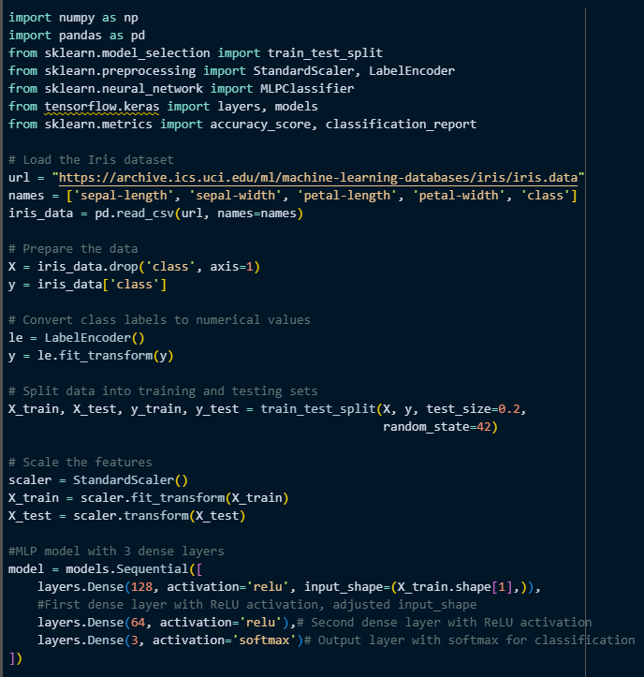

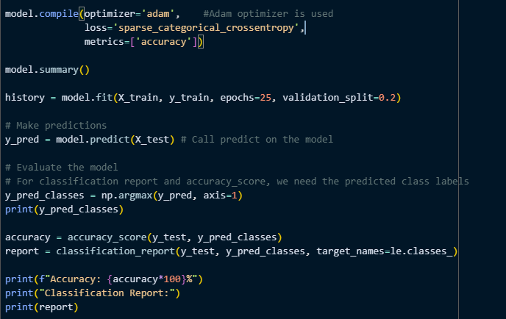

Output:
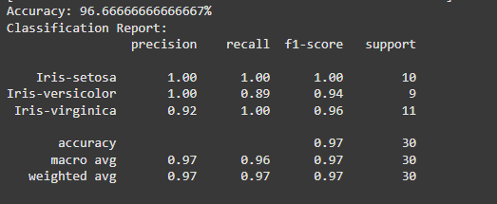

Output Analysis |  | The model performs very well on the Iris dataset, achieving high overall accuracy and good performance metrics for each class. The slight dip in recall for Iris-versicolor and precision for Iris-virginica suggests there might be a small degree of confusion between these two classes, which is common with the Iris dataset due to their overlapping characteristics.
Link of student GitHub profile where lab assignment has been uploaded |  | https://github.com/04Sahil/Deep-Learning
Conclusion |  | This practical successfully illustrated how a basic neural network can be applied to a classification problem and how to interpret the training and evaluation outputs.
Plag Report (Similarity index < 12%) |  | 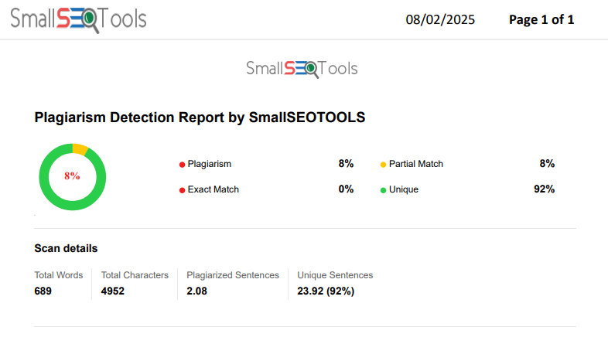
Date |  | 24/07/2025

