Session 2025-2026

Vision: Dream of where you want. | Mission: Means to achieve Vision

Program Educational Objectives of the program (PEO): (broad statements that describe the professional and career accomplishments)
PEO1 | Preparation | P: Preparation | Pep-CL abbreviation  pronounce as Pep-si-lL easy to recall
PEO2 | Core Competence | E: Environment (Learning Environment)
PEO3 | Breadth | P: Professionalism
PEO4 | Professionalism | C: Core Competence
PEO5 | Learning Environment | L: Breadth (Learning in diverse areas)

Program Outcomes (PO): (statements that describe what a student should be able to do and know by the end of a program)
Keywords of POs:
Engineering knowledge, Problem analysis, Design/development of solutions, Conduct Investigations of Complex Problems, Engineering Tool Usage, The Engineer and The World, Ethics, Individual and Collaborative Team work, Communication, Project Management and Finance, Life-Long Learning

PSO Keywords: Cutting edge technologies, Research

“I am an engineer, and I know how to apply engineering knowledge to investigate, analyse and design solutions to complex problems using tools for entire world following all ethics in a collaborative way with proper management skills throughout my life.” to contribute to the development of cutting-edge technologies and Research.

Integrity: I will adhere to the Laboratory Code of Conduct and ethics in its entirety.

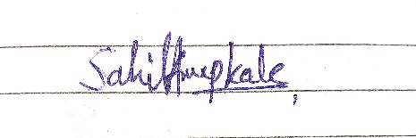

Sahil Anup Kale
Name and Signature of Student and Date

Session | 2025-26 (ODD) |  | Course Name | Deep Learning Lab
Semester | 7 AIDS |  | Course Code | 22ADS702
Roll No | 56 |  | Name of Student | Sahil Kale
Practical Number |  | 02
Course Outcome |  | CO1:- Implement and analyze various deep learning algorithms such as linear regression, neural networks and CNN using modern tools and frameworks  CO2:- Develop and evaluate deep learning models for sequence data, images processing, and unsupervised learning using appropriate optimization techniques and validation strategies
Aim |  | Write a program to Experiment with different datasets to demonstrate overfitting and underfitting issues
Problem Definition |  | The objective is to illustrate the concepts of overfitting and underfitting using polynomial regression on synthetic datasets. We aim to generate synthetic datasets with known relationships, fit polynomial regression models of varying degrees, and visualize how model complexity affects performance on training and test datasets.
Theory  (100 Words) |  | Underfitting: - Underfitting occurs when a model is too simple to capture the underlying structure of the data. This often happens when the model has too few parameters or when the degree of the polynomial is too low.  - Characteristics:  - High bias  - Poor performance on both training and test data  - Model fails to learn the trends in the data  Overfitting: - Overfitting occurs when a model is too complex and learns not only the underlying pattern but also the noise in the training data. It performs well on the training set but poorly on the test set.  - Characteristics:  - High variance  - Excellent performance on training data but poor generalization on test data  - Model captures noise as if it were part of the actual pattern
Procedure and Execution  (100 Words) |  | Steps of Implementation:-  - Generate Synthetic data  - Splitting of the data into train and test  - Define degree of polynomial to fit.  - Fit and evaluate the polynomial model  - Transform input data  - Fit linear regression model  - Prediction of the training set & test set  - Calculate MSE  - Plot the curve
Code:

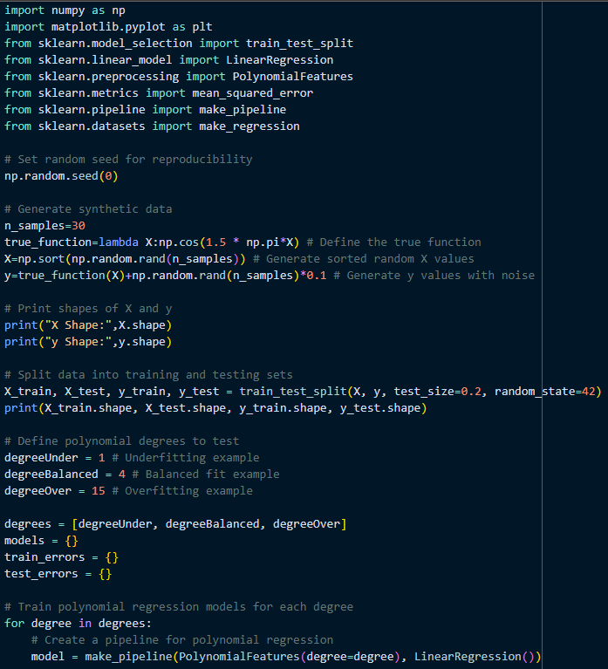

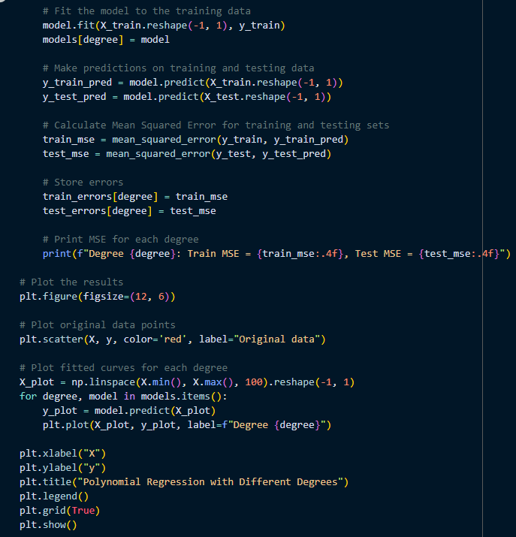

Output:

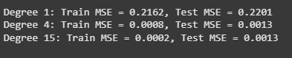

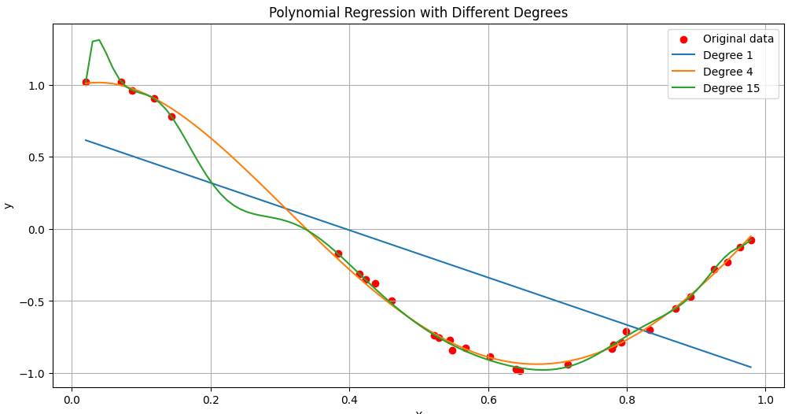

Output Analysis |  | - Underfitting (Degree 1):- High training and test MSE. The linear model is too simple to fit the data.  - Balanced Fit (Degree 4):- Low training and test MSE. The model fits the data well without overfitting.  - Overfitting (Degree 15):- Very low training MSE but slightly higher test MSE. The complex model fits the training data perfectly but struggles to generalize the new data, as seen in the erratic curve.
Link of student GitHub profile |  | https://github.com/04Sahil/Deep-Learning
Conclusion |  | Successfully illustrates the concepts of model complexity in regression by varying the polynomial degree. Low degree results in a model too simplistic for the data’s pattern, exhibiting underfitting. High degree produced an overly complex model that memorized the training noise, demonstrating overfitting.
Plag Report (Similarity index < 12%) |  | 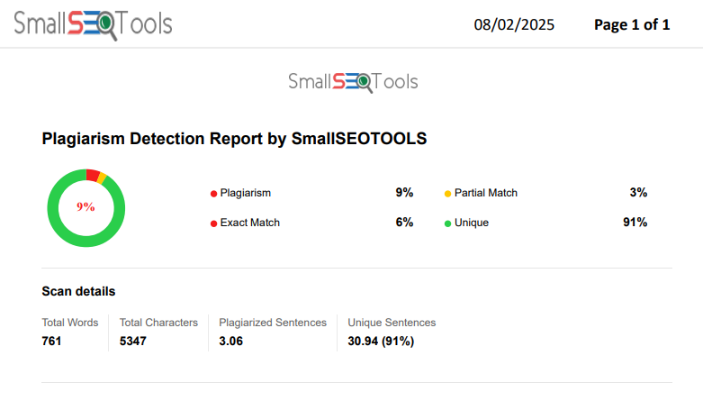
Date |  | 31/07/2025

