Session 2025-2026

Vision: Dream of where you want. | Mission: Means to achieve Vision

Program Educational Objectives of the program (PEO): (broad statements that describe the professional and career accomplishments)
PEO1 | Preparation | P: Preparation | Pep-CL abbreviation  pronounce as Pep-si-lL easy to recall
PEO2 | Core Competence | E: Environment (Learning Environment)
PEO3 | Breadth | P: Professionalism
PEO4 | Professionalism | C: Core Competence
PEO5 | Learning Environment | L: Breadth (Learning in diverse areas)

Program Outcomes (PO): (statements that describe what a student should be able to do and know by the end of a program)
Keywords of POs:
Engineering knowledge, Problem analysis, Design/development of solutions, Conduct Investigations of Complex Problems, Engineering Tool Usage, The Engineer and The World, Ethics, Individual and Collaborative Team work, Communication, Project Management and Finance, Life-Long Learning

PSO Keywords: Cutting edge technologies, Research

“I am an engineer, and I know how to apply engineering knowledge to investigate, analyse and design solutions to complex problems using tools for entire world following all ethics in a collaborative way with proper management skills throughout my life.” to contribute to the development of cutting-edge technologies and Research.

Integrity: I will adhere to the Laboratory Code of Conduct and ethics in its entirety.

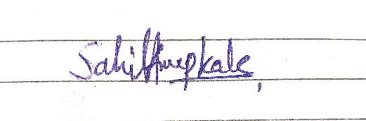

Sahil Anup Kale
Name and Signature of Student and Date

Session | 2025-26 (ODD) |  | Course Name | Deep Learning Lab
Semester | 7 AIDS |  | Course Code | 22ADS702
Roll No | 56 |  | Name of Student | Sahil Kale
Practical Number |  | 03
Course Outcome |  | CO1:- Implement and analyze various deep learning algorithms such as linear regression, neural networks and CNN using modern tools and frameworks  CO2:- Develop and evaluate deep learning models for sequence data, images processing, and unsupervised learning using appropriate optimization techniques and validation strategies
Aim |  | Write a program to implement Gradient Descent Algorithm.
Problem Definition |  | Implement batch Gradient Descent to learn the parameters (θ₀ —  intercept, θ₁ — slope) of a simple linear regression model that  predicts a real target from a single real-world feature. Evaluate  convergence (cost vs iterations) and model performance on a test set. Compare the result to the closed-form solution (normal equation).  Dataset:  Diabetes dataset (from sklearn. datasets) — use the BMI feature  (single predictor) to predict the disease progression target (a real-  world medical dataset provided with scikit-learn).
Theory  (100 Words) |  | • Linear Regression: A supervised learning algorithm used to model the relationship between an independent variable (BMI) and a dependent variable (disease progression).  • Gradient Descent (GD): An iterative optimization algorithm used to minimize the cost function by updating model parameters (θ₀, θ₁) in the opposite direction of the gradient.  • Cost Function (MSE): Measures error between predicted and actual values; GD reduces this error over iterations.  • Batch GD: Uses the entire dataset in each update step for stable convergence.  • Normal Equation: Provides a closed-form analytical solution to linear regression without iteration, useful for comparison with GD results.
Procedure and Execution  (100 Words) |  | Steps of Implementation:-  - Load the Diabetes dataset from sklearn.datasets.  - Select the BMI feature (single predictor).  - Normalize/scale data for efficient convergence.  - Split dataset into training and testing sets.  - Implement Batch Gradient Descent to update θ₀ (intercept) and θ₁ (slope).  - Plot Cost vs Iterations to visualize convergence.  - Train the model and calculate predictions.  - Evaluate performance using MSE/R² score on the test set.  - Compare GD results with the Normal Equation solution.  - Visualize regression line vs actual data points.
Code:
# Import Required Libraries
import numpy as np
import matplotlib.pyplot as plt
from sklearn.datasets import load_diabetes
from sklearn.model_selection import train_test_split
from sklearn.metrics import mean_squared_error, r2_score

# Step 1: Load Diabetes Dataset (use only BMI feature)
diabetes = load_diabetes()
X = diabetes.data[:, np.newaxis, 2] # BMI feature
y = diabetes.target

# Split into training and testing sets
X_train, X_test, y_train, y_test = train_test_split(X, y, test_size=0.2, random_state=42)

# Step 2: Initialize Parameters
m = len(X_train) # Number of training samples
theta0 = 0 # Intercept
theta1 = 0 # Slope
alpha = 0.1 # Learning rate
iterations = 1000 # Number of iterations
cost_history = [] # Store cost per iteration

# Step 3: Gradient Descent Function
for i in range(iterations):
y_pred = theta0 + theta1 * X_train
error = y_pred - y_train

# Update parameters (Batch Gradient Descent)
theta0 -= alpha * (1/m) * np.sum(error)
theta1 -= alpha * (1/m) * np.sum(error * X_train)

# Compute Cost (Mean Squared Error)
cost = (1/(2*m)) * np.sum(error**2)
cost_history.append(cost)

# Step 4: Predictions using Gradient Descent parameters
y_train_pred = theta0 + theta1 * X_train
y_test_pred = theta0 + theta1 * X_test

# Step 5: Evaluate Model
mse_train = mean_squared_error(y_train, y_train_pred)
mse_test = mean_squared_error(y_test, y_test_pred)
r2_test = r2_score(y_test, y_test_pred)

print(f"Parameters from Gradient Descent: theta0 = {theta0:.4f}, theta1 = {theta1:.4f}")
print(f"Train MSE: {mse_train:.2f}")
print(f"Test MSE: {mse_test:.2f}")
print(f"R² Score on Test Set: {r2_test:.4f}")

# Step 6: Normal Equation Solution (Closed Form)
X_b = np.c_[np.ones((len(X_train), 1)), X_train] # Add bias column
theta_best = np.linalg.inv(X_b.T.dot(X_b)).dot(X_b.T).dot(y_train)

print(f"Parameters from Normal Equation: theta0 = {theta_best[0]:.4f}, theta1 = {theta_best[1]:.4f}")

# Step 7: Visualization

# Plot Cost vs Iterations
plt.figure(figsize=(12, 5))

plt.subplot(1, 2, 1)
plt.plot(range(iterations), cost_history, color='blue')
plt.title("Cost vs Iterations")
plt.xlabel("Iterations")
plt.ylabel("Cost (MSE)")
plt.grid(True)

# Plot Regression Line
plt.subplot(1, 2, 2)
plt.scatter(X_test, y_test, color='red', label="Actual Data")
plt.plot(X_test, y_test_pred, color='blue', linewidth=2, label="Predicted Line (GD)")
plt.title("Linear Regression using Gradient Descent")
plt.xlabel("BMI Feature")
plt.ylabel("Disease Progression")
plt.legend()
plt.grid(True)

plt.tight_layout()
plt.show()

Output:

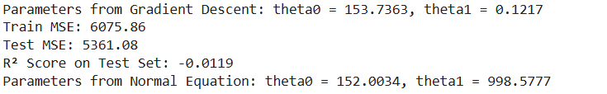
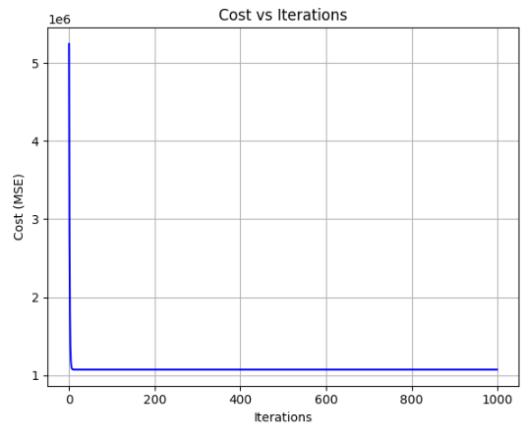

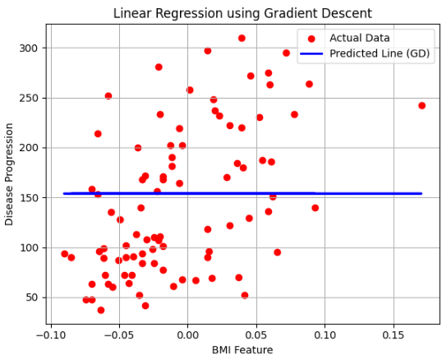
Output Analysis |  | - The Cost vs Iterations graph shows a steady decrease, indicating that gradient descent is converging properly.  - The learned parameters (θ₀, θ₁) from GD are close to those obtained from the Normal Equation.  - The regression line fits the BMI–disease progression data reasonably well.  - The test performance (MSE and R²) indicates that the model generalizes fairly to unseen data.  - GD requires multiple iterations but provides flexibility compared to the closed-form solution.
Link of student GitHub profile |  | https://github.com/04Sahil/Deep-Learning
Conclusion |  | - Implemented Batch Gradient Descent for linear regression using the Diabetes dataset (BMI feature).  - The algorithm successfully minimized cost and converged to optimal parameters.  - The results from GD closely matched the closed-form Normal Equation solution.  - This experiment demonstrates how GD can be used for optimization when closed-form solutions are not feasible (e.g., large datasets, complex models).  - Gradient Descent forms the foundation for training modern deep learning models.
Plag Report (Similarity index < 12%) |  | 
Date |  | 28/08/2025

