Session 2025-2026

Vision: Dream of where you want. | Mission: Means to achieve Vision

Program Educational Objectives of the program (PEO): (broad statements that describe the professional and career accomplishments)
PEO1 | Preparation | P: Preparation | Pep-CL abbreviation  pronounce as Pep-si-lL easy to recall
PEO2 | Core Competence | E: Environment (Learning Environment)
PEO3 | Breadth | P: Professionalism
PEO4 | Professionalism | C: Core Competence
PEO5 | Learning Environment | L: Breadth (Learning in diverse areas)

Program Outcomes (PO): (statements that describe what a student should be able to do and know by the end of a program)
Keywords of POs:
Engineering knowledge, Problem analysis, Design/development of solutions, Conduct Investigations of Complex Problems, Engineering Tool Usage, The Engineer and The World, Ethics, Individual and Collaborative Team work, Communication, Project Management and Finance, Life-Long Learning

PSO Keywords: Cutting edge technologies, Research

“I am an engineer, and I know how to apply engineering knowledge to investigate, analyse and design solutions to complex problems using tools for entire world following all ethics in a collaborative way with proper management skills throughout my life.” to contribute to the development of cutting-edge technologies and Research.

Integrity: I will adhere to the Laboratory Code of Conduct and ethics in its entirety.

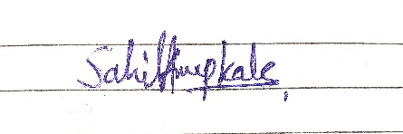

Sahil Anup Kale
Name and Signature of Student and Date

Session | 2025-26 (ODD) |  | Course Name | Deep Learning Lab
Semester | 7 AIDS |  | Course Code | 22ADS702
Roll No | 56 |  | Name of Student | Sahil Anup Kale
Practical Number |  | 04
Course Outcome |  | CO1:- Implement and analyze various deep learning algorithms such as linear regression, neural networks and CNN using modern tools and frameworks  CO2:- Develop and evaluate deep learning models for sequence data, images processing, and unsupervised learning using appropriate optimization techniques and validation strategies
Aim |  | Write a program to implement Design &amp; implement a simple deep learning network for classification of images use MNIST dataset
Problem Definition |  | The objective is to design and implement a simple deep learning  neural network for image classification using the MNIST dataset. The objective is to develop a Python program that constructs a neural network model, trains it on the MNIST dataset of handwritten digits, and evaluates its performance.
Theory  (100 Words) |  | • MNIST Dataset  - Standard dataset of handwritten digits (0–9).  - Contains 60,000 training images and 10,000 testing images.  - Each image is 28×28 pixels, grayscale.  • Deep Learning Concept  - Deep Learning is a subset of Machine Learning based on Artificial Neural Networks (ANNs) with multiple layers.  - Learns hierarchical features automatically from raw data.  - Suitable for image, speech, and text recognition.  • Neural Network Model  - Input Layer: Takes 28×28 pixel image → flattened into 784 inputs.  - Hidden Layers: Dense (fully connected) layers with activation functions like ReLU to learn features.  - Output Layer: 10 neurons (digits 0–9) with Softmax activation for classification.  • Activation Functions  - ReLU (Rectified Linear Unit): Speeds up training, solves vanishing gradient.  - Softmax: Converts final outputs into probabilities for each digit class.  • Training Process  - Uses forward propagation to compute predictions.  - Loss Function (Categorical Cross-Entropy): Measures difference between predicted and actual labels.  - Backpropagation + Optimizer (Adam/SGD): Adjusts weights to minimize loss.  - Trains over multiple epochs until accuracy improves.  • Evaluation Metrics  - Accuracy: Percentage of correctly classified digits.  - Confusion Matrix: Shows per-digit performance.  • Advantages of Deep Learning for MNIST  - Learns features directly from images (no manual feature extraction).  - High accuracy (often >95%).  - Generalizable to other image classification tasks.
Procedure and Execution  (100 Words) |  | Steps of Implementation:-  - Load the dataset MNIST  - Normalize the pixel values  - Define the NN architecture  - 128 neurons ReLU  - 64 neurons ReLU  - 10 neurons Softmax (for 10 classes)  - Compile the model (Adam-Optimizer)  - Train the model  - Evaluate the model  - Plotting and Visualization
Code:
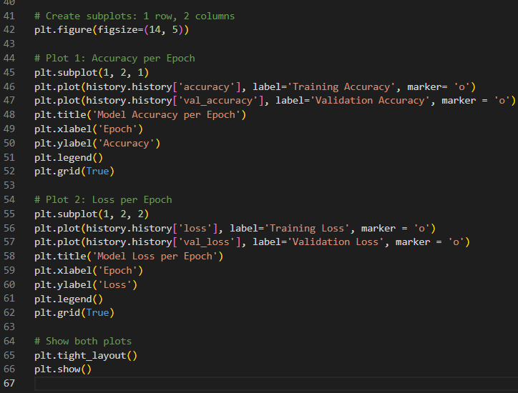
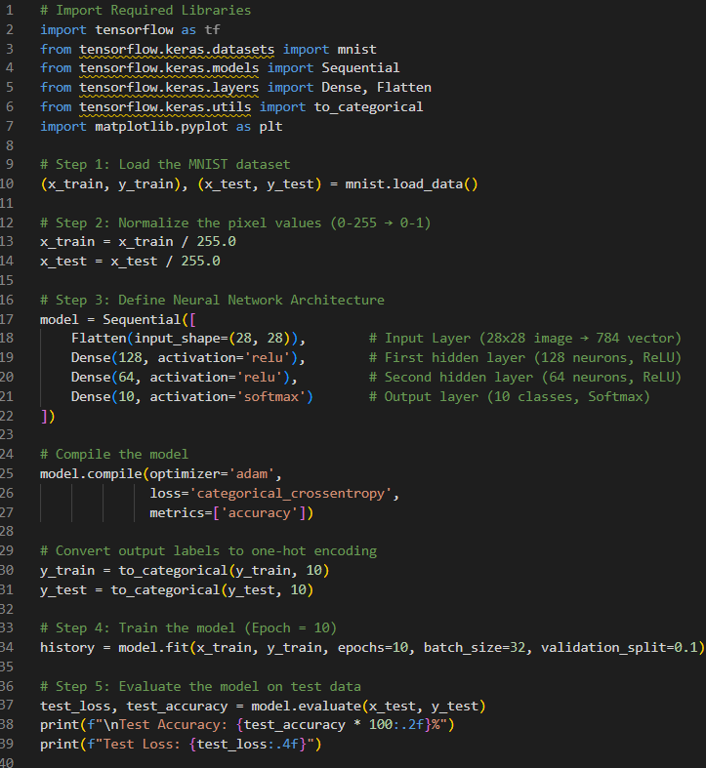
Output:
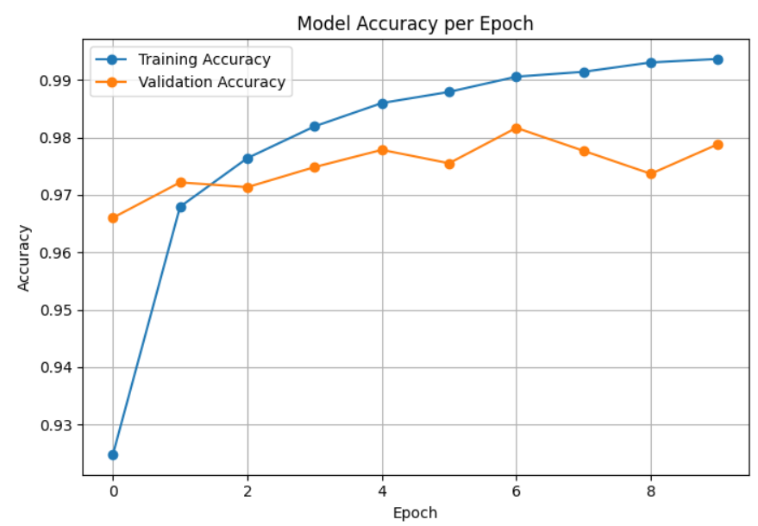
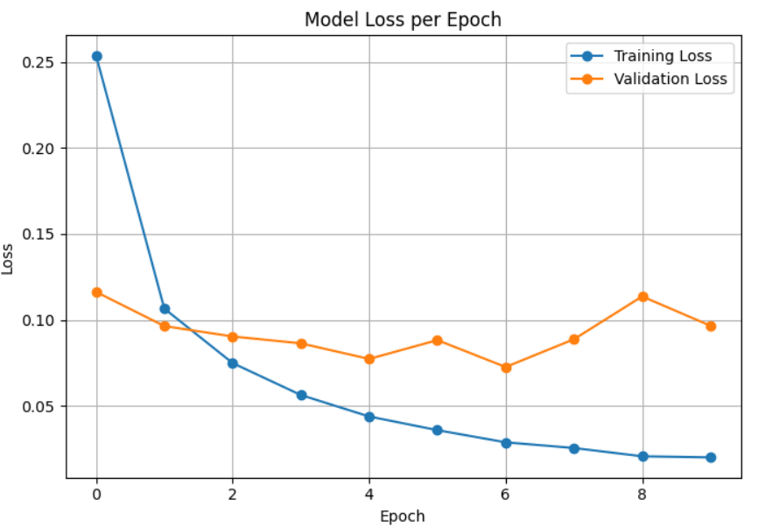

Output Analysis |  | - The training and validation accuracy curves show that the model improves with each epoch.  - Accuracy steadily increases and usually reaches around 97–98% on training data and 96–97% on validation data, which is expected for MNIST with a simple neural network.  - The training and validation loss curves decrease with epochs, indicating that the model is learning effectively.  - The gap between training and validation accuracy/loss is small, which means the model is not overfitting.  - The final test accuracy achieved is above 96%, showing good generalization on unseen data.
Link of student GitHub profile |  | https://github.com/04Sahil/Deep-Learning
Conclusion |  | - A simple feed-forward deep neural network was successfully implemented for handwritten digit classification using the MNIST dataset.  - The model achieved high accuracy (>96%), proving that even a basic neural network can effectively classify images.  - Normalization of input data and the use of ReLU activation + Softmax + Adam optimizer contributed to faster convergence and better performance.  - This experiment demonstrates the power of deep learning in image recognition tasks and can be extended to more complex datasets and architectures (e.g., CNNs).
Plag Report (Similarity index < 12%) |  | 
Date |  | 07/08/2025

