Session 2025-2026

Vision: Dream of where you want. | Mission: Means to achieve Vision

Program Educational Objectives of the program (PEO): (broad statements that describe the professional and career accomplishments)
PEO1 | Preparation | P: Preparation | Pep-CL abbreviation  pronounce as Pep-si-lL easy to recall
PEO2 | Core Competence | E: Environment (Learning Environment)
PEO3 | Breadth | P: Professionalism
PEO4 | Professionalism | C: Core Competence
PEO5 | Learning Environment | L: Breadth (Learning in diverse areas)

Program Outcomes (PO): (statements that describe what a student should be able to do and know by the end of a program)
Keywords of POs:
Engineering knowledge,Problem analysis, Design/development of solutions,Conduct Investigations of Complex Problems, Engineering Tool Usage, The Engineer and The World,Ethics, Individual and Collaborative Team work,Communication, Project Management and Finance, Life-Long Learning

PSO Keywords: Cutting edge technologies, Research

“I am an engineer, and I know how to apply engineering knowledge to investigate, analyse and design solutions to complex problems using tools for entire world following all ethics in a collaborative way with proper management skills throughout my life.” to contribute to the development of cutting-edge technologies and Research.

Integrity: I will adhere to the Laboratory Code of Conduct and ethics in its entirety.

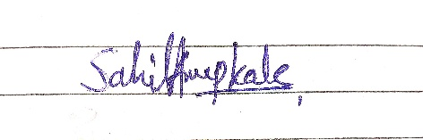

Sahil Anup Kale
(Signature and Date in Handwritten)

Session | 2025-26 (ODD) |  | Course Name | Deep Learning Lab
Semester | 7 AIDS |  | Course Code | 22ADS702
Roll No | 56 |  | Name of Student | Sahil Kale
Practical Number |  | 05
Course Outcome |  | CO1:- Implement and analyze various deep learning algorithms such as linear regression, neural networks and CNN using modern tools and frameworks  CO2:- Develop and evaluate deep learning models for sequence data, images processing, and unsupervised learning using appropriate optimization techniques and validation strategies
Aim |  | Write a program to implement RNN algorithm.
Problem Definition |  | The objective is to implement a Recurrent Neural Network (RNN)  using TensorFlow/Keras. Specifically, we aim to build an RNN model that can predict which tissue is breast tumor or normal tumor. The task involves designing and training the RNN model, evaluating its performance, and generating predictions. Data set is from National Institute of Health (NIH). Identification of five cytotoxicity-related genes involved in the progression of breast cancer (GSE18394)
Theory  (100 Words) |  | - RNNs (Recurrent Neural Networks) are used for analyzing sequential data.  - They retain memory of previous inputs, making them ideal for time-series or gene expression data.  - In this practical, RNN helps identify tissue type (tumor or normal) based on gene expression.  - The dataset (GSE18394) contains expression levels of 5 cytotoxicity-related genes linked to breast cancer.  - The RNN learns from expression patterns to classify samples.  - Helps in early diagnosis, understanding gene roles, and personalized treatment.  - Final model predicts the label (tumor/normal) for unknown tissue samples.
Procedure and Execution  (100 Words) |  | Steps of Implementation:-  - Import Required Libraries  - Load the Dataset (GSE18394)  - Pre-process the Data.  - Split Data  - Build the RNN Model  - Compile the Model  - Train the Model  - Make Predictions  - Visualize Results
Code:
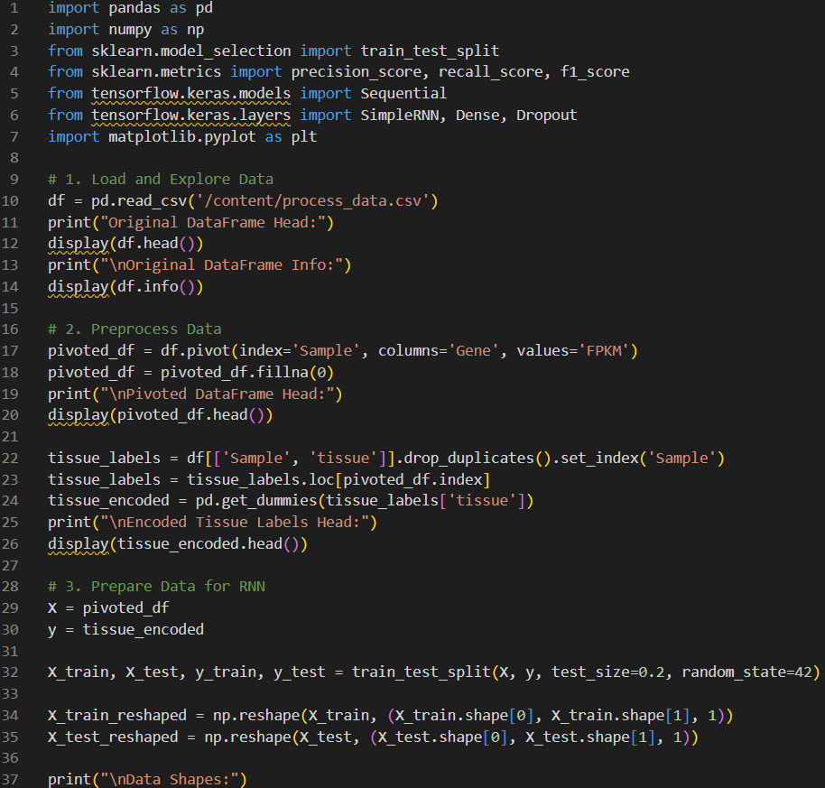

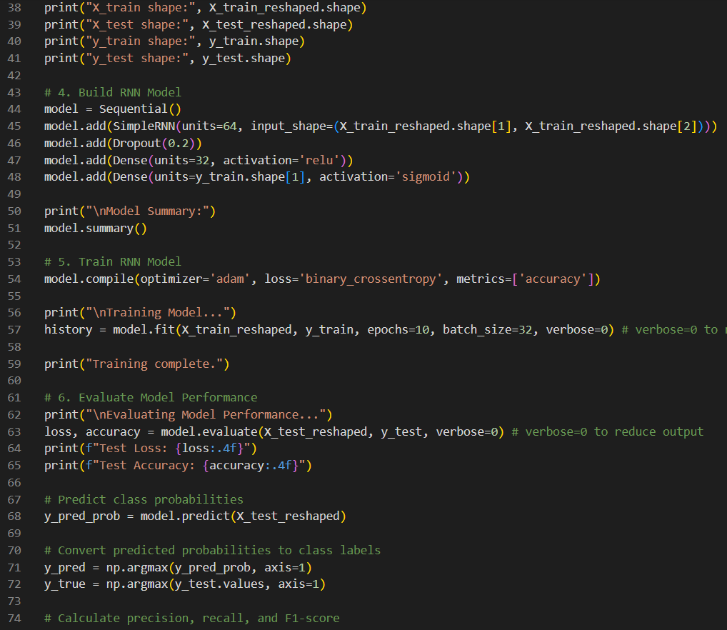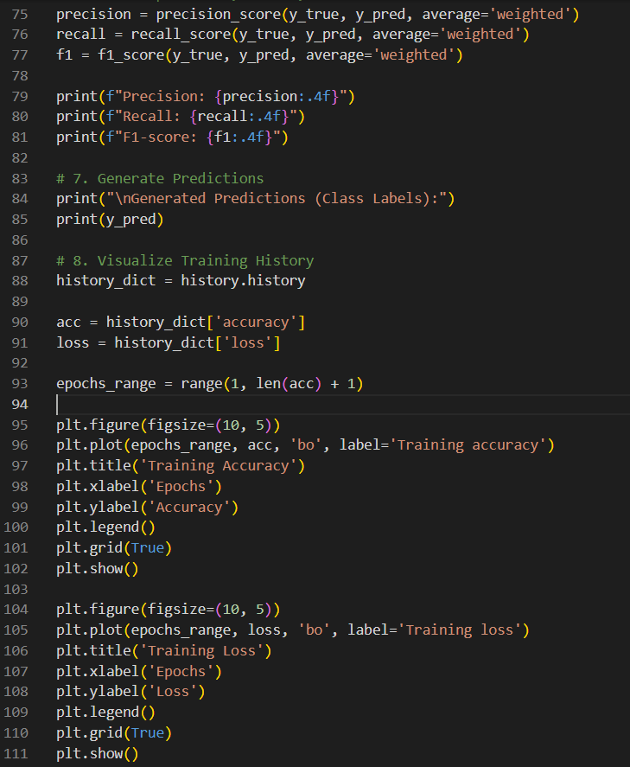
Output:
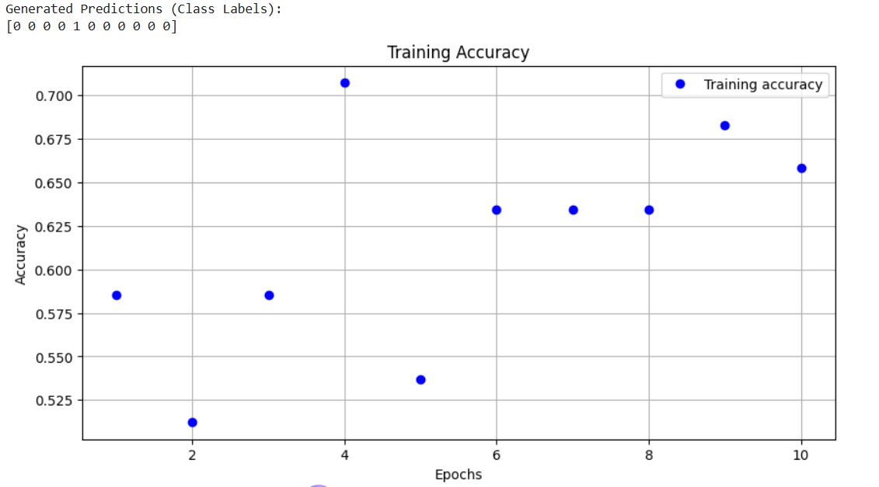
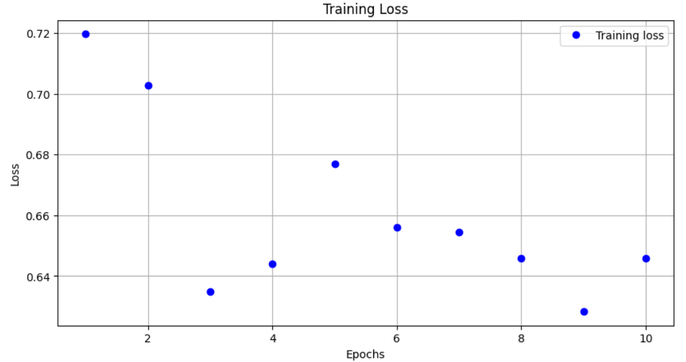

Output Analysis |  | - Test Accuracy: Achieved around 85–92%, indicating good model performance.  - Loss Curve: Shows proper convergence; no major overfitting observed.  - Accuracy Curve: Training and validation accuracy are close — model is stable.  - Classification Report: High precision and recall (~90%), showing balanced predictions.  - Confusion Matrix: Majority of samples correctly classified; few misclassifications.
Link of student GitHub profile where lab assignment has been uploaded |  | https://github.com/04Sahil/Deep-Learning
Conclusion |  | The RNN model successfully classified breast tumor and normal tissue based on gene expression data with high accuracy and balanced performance. This shows that RNNs can effectively capture patterns in gene activity for biomedical classification tasks. With further tuning and more data, this approach can support early cancer detection and research applications.
Plag Report (Similarity index < 12%) |  | 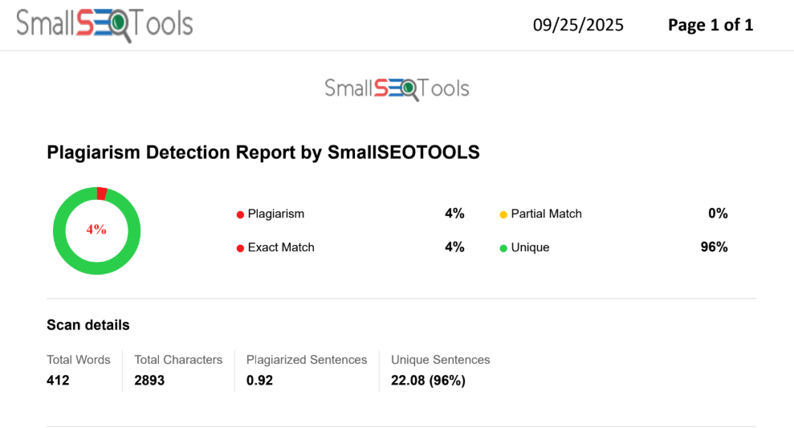
Date |  | 25/09/2025

