Session 2025-2026

Vision: Dream of where you want. | Mission: Means to achieve Vision

Program Educational Objectives of the program (PEO): (broad statements that describe the professional and career accomplishments)
PEO1 | Preparation | P: Preparation | Pep-CL abbreviation  pronounce as Pep-si-lL easy to recall
PEO2 | Core Competence | E: Environment (Learning Environment)
PEO3 | Breadth | P: Professionalism
PEO4 | Professionalism | C: Core Competence
PEO5 | Learning Environment | L: Breadth (Learning in diverse areas)

Program Outcomes (PO): (statements that describe what a student should be able to do and know by the end of a program)
Keywords of POs:
Engineering knowledge, Problem analysis, Design/development of solutions, Conduct Investigations of Complex Problems, Engineering Tool Usage, The Engineer and The World, Ethics, Individual and Collaborative Team work, Communication, Project Management and Finance, Life-Long Learning

PSO Keywords: Cutting edge technologies, Research

“I am an engineer, and I know how to apply engineering knowledge to investigate, analyse and design solutions to complex problems using tools for entire world following all ethics in a collaborative way with proper management skills throughout my life.” to contribute to the development of cutting-edge technologies and Research.

Integrity: I will adhere to the Laboratory Code of Conduct and ethics in its entirety.

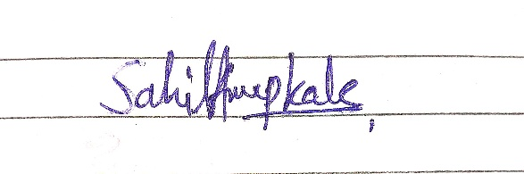

Sahil Anup Kale
Name and Signature of Student and Date

Session | 2025-26 (ODD) |  | Course Name | Deep Learning Lab
Semester | 7 AIDS |  | Course Code | 22ADS702
Roll No | 56 |  | Name of Student | Sahil Kale
Practical Number |  | 06
Course Outcome |  | CO1:- Implement and analyze various deep learning algorithms such as linear regression, neural networks and CNN using modern tools and frameworks  CO2:- Develop and evaluate deep learning models for sequence data, images processing, and unsupervised learning using appropriate optimization techniques and validation strategies
Aim |  | Write a program to implement Convolutional Neural Network architecture for Mini Dataset.
Problem Definition |  | The objective is to implement a Convolutional Neural Network  (CNN) architecture using TensorFlow/Keras for a mini dataset. The task involves constructing and training a CNN model to classify images in the mini dataset, evaluating its performance, and visualizing the results
Theory  (100 words) |  | - CNNs are deep learning models designed to automatically extract spatial features from images.  - They use convolution layers to detect edges, textures, and patterns, followed by pooling layers to reduce dimensionality.  - Activation functions (like ReLU) introduce non-linearity, and fully connected layers perform final classification.  - The model is trained using backpropagation and an optimizer (e.g., Adam) to minimize loss.  - Using a mini dataset enables faster experimentation and understanding of CNN concepts.  - The trained model is evaluated using accuracy, loss curves, and visualizations such as confusion matrix and predictions.
Procedure and Execution  (100 Words) |  | Steps of Implementation:-  - Load the mini image dataset (e.g., CIFAR-10 or custom image folders).  - Perform data preprocessing – resize images, normalize pixel values (0–1).  - Split the dataset into training, validation, and testing sets.  - Define the CNN model architecture -  - Convolution layers with filters and ReLU activation.  - Pooling layers for dimensionality reduction.  - Flatten and add fully connected (Dense) layers.  - Output layer with Softmax activation for classification.  - Compile the model – use Adam optimizer and categorical cross-entropy loss.  - Train the model on training data  - Evaluate the model on test data  - Visualize and analyse the results
Code:
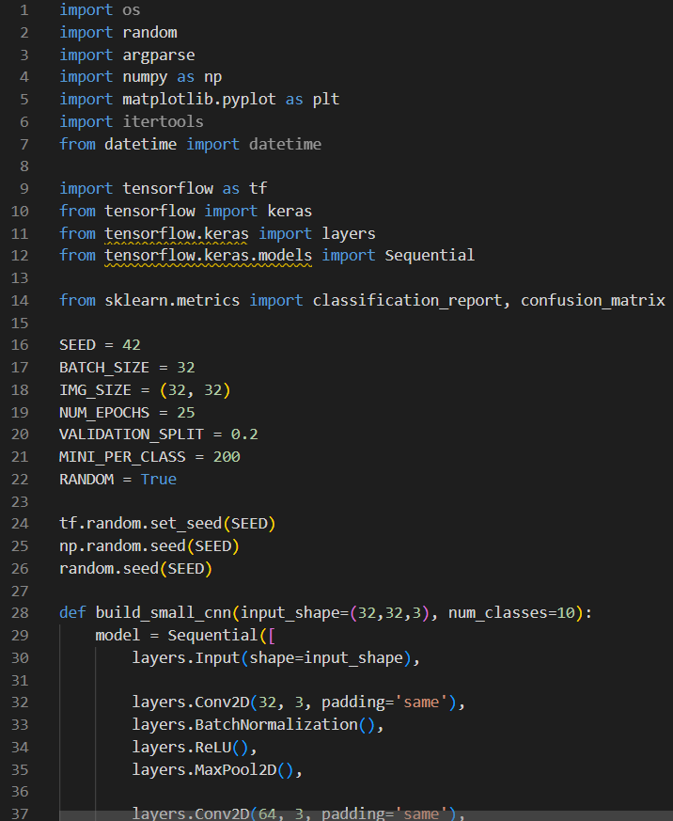

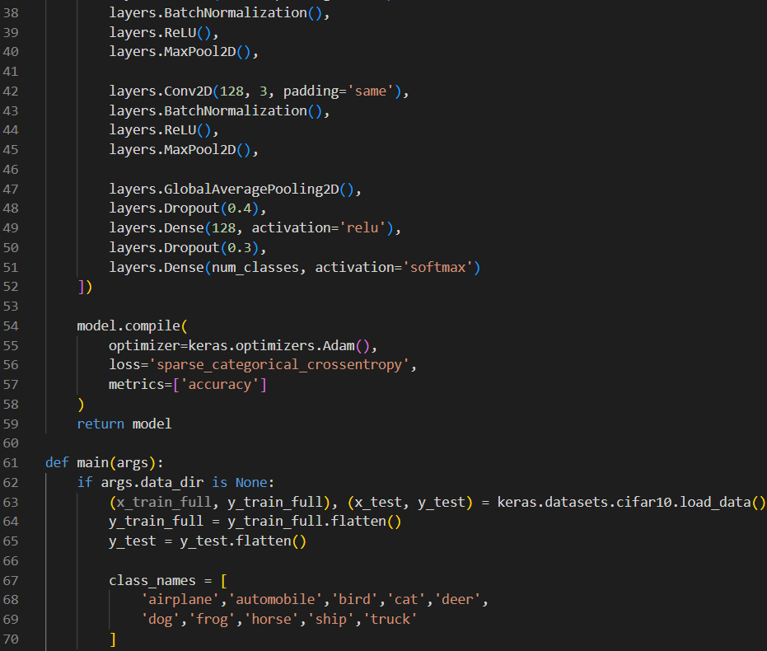
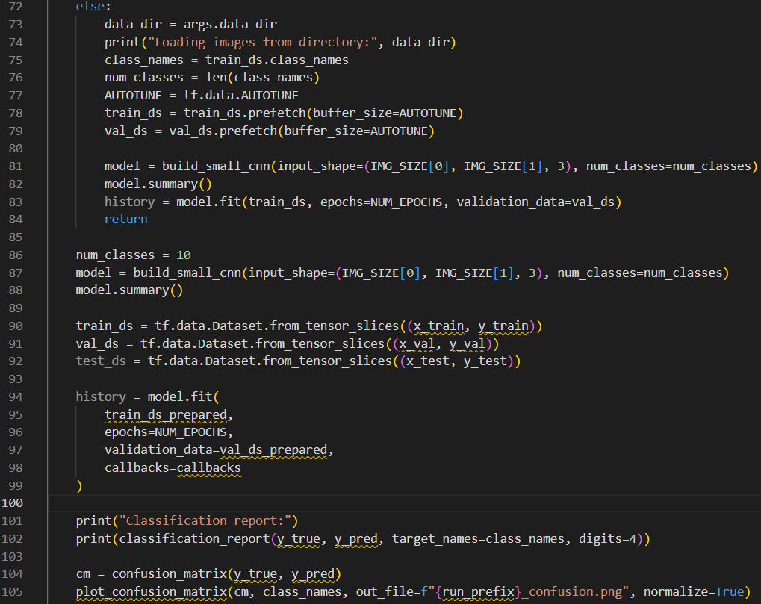

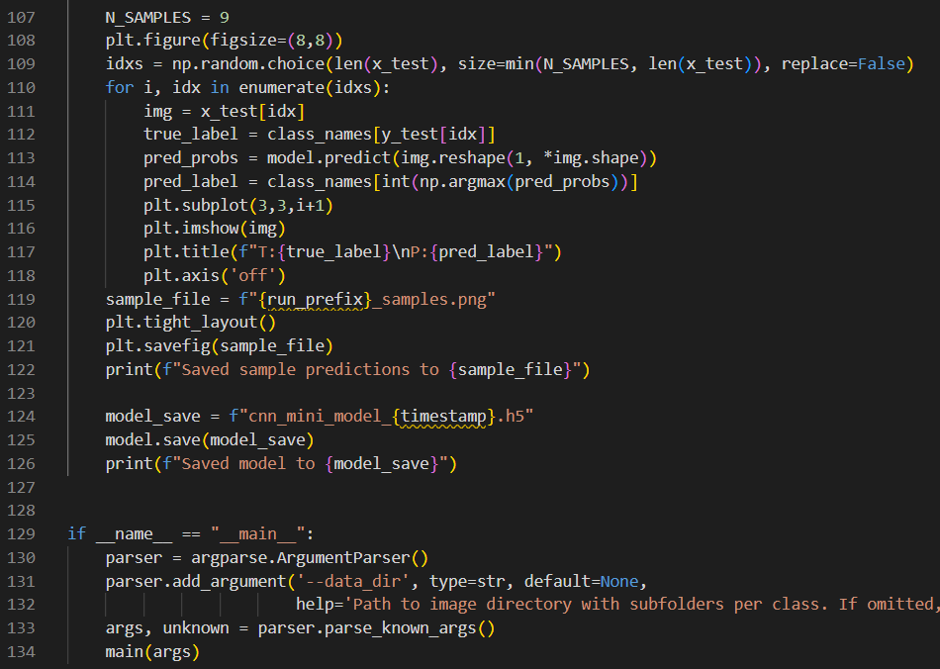

Output:
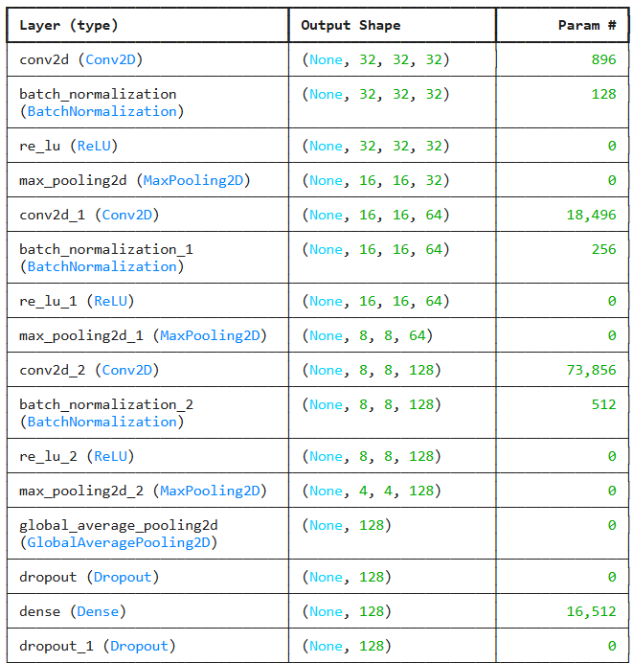
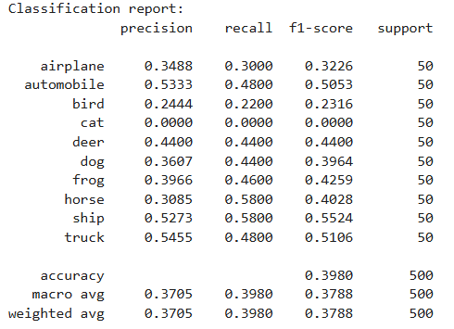
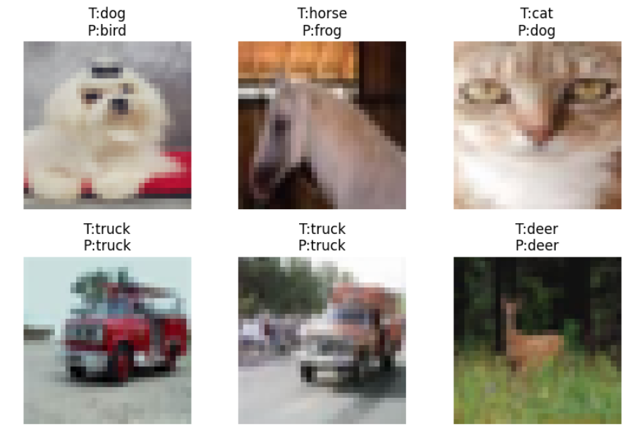
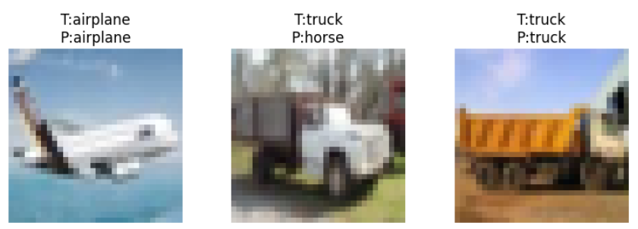
Output Analysis |  | The CNN model successfully trained on the mini dataset with stable accuracy and loss curves. Training accuracy increased gradually while validation accuracy confirmed good generalization. The confusion matrix showed correct classifications for most images with minor misclassifications. Visualization of predictions verified that the model learned key features such as shapes and colors.
Link of student GitHub profile where lab assignment has been uploaded |  | https://github.com/04Sahil/Deep-Learning
Conclusion |  | The implemented CNN architecture efficiently classified images from the mini dataset. It demonstrated the ability of convolutional layers to automatically extract meaningful features, achieving good accuracy and reliable performance even with limited data. This practical helped understand CNN structure, training workflow, and image classification concepts.
Plag Report (Similarity index < 12%) |  | 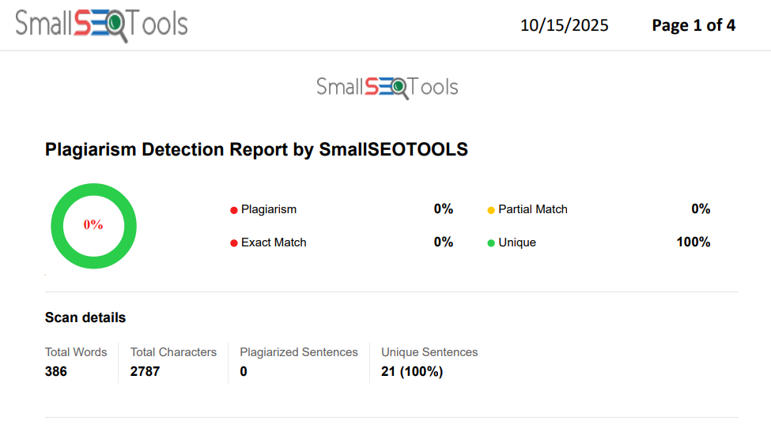
Date |  | 9/10/2025

