Session 2025-2026

Vision: Dream of where you want. | Mission: Means to achieve Vision

Program Educational Objectives of the program (PEO): (broad statements that describe the professional and career accomplishments)
PEO1 | Preparation | P: Preparation | Pep-CL abbreviation  pronounce as Pep-si-lL easy to recall
PEO2 | Core Competence | E: Environment (Learning Environment)
PEO3 | Breadth | P: Professionalism
PEO4 | Professionalism | C: Core Competence
PEO5 | Learning Environment | L: Breadth (Learning in diverse areas)

Program Outcomes (PO): (statements that describe what a student should be able to do and know by the end of a program)
Keywords of POs:
Engineering knowledge, Problem analysis, Design/development of solutions, Conduct Investigations of Complex Problems, Engineering Tool Usage, The Engineer and The World, Ethics, Individual and Collaborative Team work, Communication, Project Management and Finance, Life-Long Learning

PSO Keywords: Cutting edge technologies, Research

“I am an engineer, and I know how to apply engineering knowledge to investigate, analyse and design solutions to complex problems using tools for entire world following all ethics in a collaborative way with proper management skills throughout my life.” to contribute to the development of cutting-edge technologies and Research.

Integrity: I will adhere to the Laboratory Code of Conduct and ethics in its entirety.



Sahil Anup Kale
Name and Signature of Student and Date

Session | 2025-26 (ODD) |  | Course Name | Deep Learning Lab
Semester | 7 AIDS |  | Course Code | 22ADS702
Roll No | 56 |  | Name of Student | Sahil Kale
Practical Number |  | 07
Course Outcome |  | CO1:- Implement and analyze various deep learning algorithms such as linear regression, neural networks and CNN using modern tools and frameworks  CO2:- Develop and evaluate deep learning models for sequence data, images processing, and unsupervised learning using appropriate optimization techniques and validation strategies
Aim |  | Write a program to implement and study analysis of PCA.
Problem Definition |  | The objective is to implement Principal Component Analysis (PCA) in Python using the scikit-learn library, analyze its effectiveness in reducing the dimensionality of a dataset, and visualize.
Theory  (100 words) |  | Principal Component Analysis (PCA) is a dimensionality reduction technique that transforms a dataset of possibly correlated variables into a set of linearly uncorrelated variables called principal components. It finds the directions (principal components) in the data that capture the most variance. The first principal component captures the most variance, the second captures the second most, and so on. By keeping only the first few principal components, we can reduce the dimensionality of the data while retaining most of the original information, which can help with visualization and improve the performance of machine learning models.
Procedure and Execution  (100 Words) |  | Steps of Implementation:-  - Load Data  - Standardize Data  - Instantiate PCA  - Fit PCA  - Transform Data  - Analyze Results  - Visualize
Code:

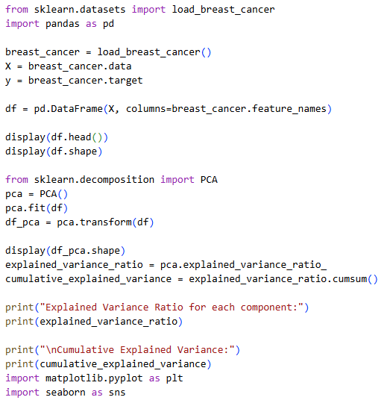
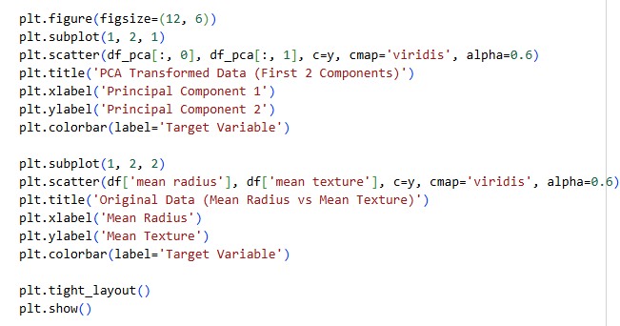

Output:

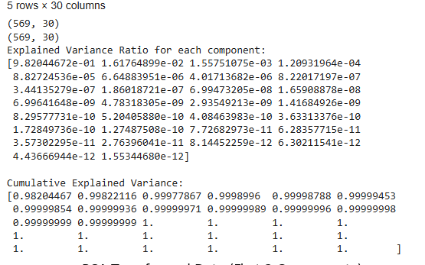
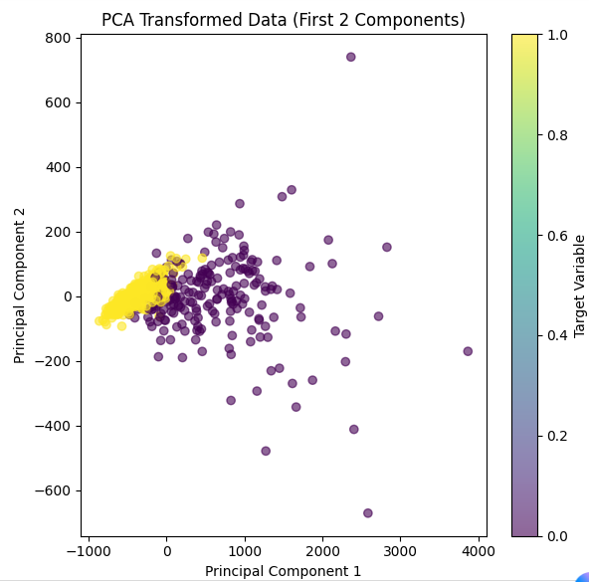

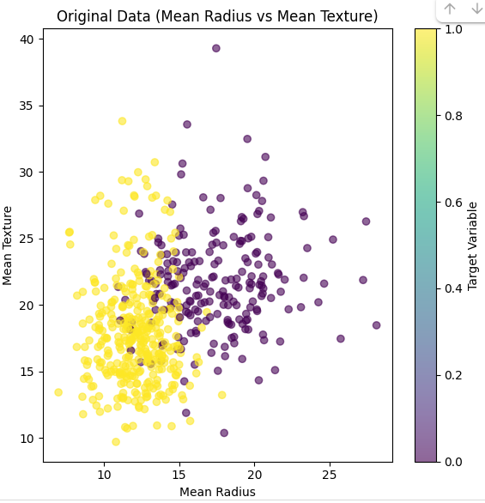

Output Analysis |  | - Data Loading: The breast cancer dataset was successfully loaded, containing 569 samples and 30 features. This high dimensionality makes it a good candidate for PCA.  - PCA Application: PCA was applied, initially retaining all 30 components. The shape of the transformed data is the same as the original, which is expected when not specifying the number of components.  - Effectiveness Analysis: The explained variance ratio shows that the first principal component captures a very large proportion of the variance (approximately 98.2%). The first two components together capture about 99.8% of the variance. Subsequent components contribute very little to the explained variance.  - Visualization: The scatter plot of the first two principal components shows a clear separation of the data points based on the target variable (malignant vs. benign). This separation is comparable to, or potentially better than, the separation seen when plotting two original features.
Link of student GitHub profile where lab assignment has been uploaded |  | https://github.com/04Sahil/Deep-Learning
Conclusion |  | The analysis demonstrates that PCA is highly effective in reducing the dimensionality of the breast cancer dataset. By using just the first two principal components, we can retain nearly all of the essential information (variance) in the data. This significant reduction from 30 features to 2 features simplifies the dataset considerably while preserving the ability to distinguish between the two classes. The visualization supports this conclusion, showing that the reduced data is still highly separable. Therefore, the 2-component PCA-transformed data is a suitable and more efficient representation for further analysis or machine learning tasks.
Plag Report (Similarity index < 12%) |  | 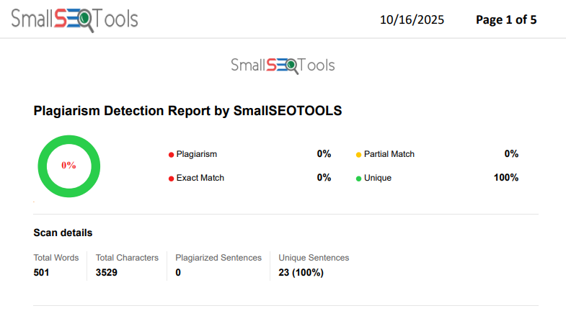
Date |  | 16/10/2025

