Session 2025-2026

Vision: Dream of where you want. | Mission: Means to achieve Vision

Program Educational Objectives of the program (PEO): (broad statements that describe the professional and career accomplishments)
PEO1 | Preparation | P: Preparation | Pep-CL abbreviation  pronounce as Pep-si-lL easy to recall
PEO2 | Core Competence | E: Environment (Learning Environment)
PEO3 | Breadth | P: Professionalism
PEO4 | Professionalism | C: Core Competence
PEO5 | Learning Environment | L: Breadth (Learning in diverse areas)

Program Outcomes (PO): (statements that describe what a student should be able to do and know by the end of a program)
Keywords of POs:
Engineering knowledge, Problem analysis, Design/development of solutions, Conduct Investigations of Complex Problems, Engineering Tool Usage, The Engineer and The World, Ethics, Individual and Collaborative Team work, Communication, Project Management and Finance, Life-Long Learning

PSO Keywords: Cutting edge technologies, Research

“I am an engineer, and I know how to apply engineering knowledge to investigate, analyse and design solutions to complex problems using tools for entire world following all ethics in a collaborative way with proper management skills throughout my life.” to contribute to the development of cutting-edge technologies and Research.

Integrity: I will adhere to the Laboratory Code of Conduct and ethics in its entirety.

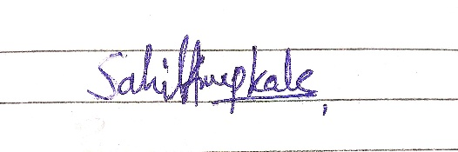

Sahil Anup Kale
Name and Signature of Student and Date

Session | 2025-26 (ODD) |  | Course Name | Deep Learning Lab
Semester | 7 AIDS |  | Course Code | 22ADS702
Roll No | 56 |  | Name of Student | Sahil Kale
Practical Number |  | 08
Course Outcome |  | CO1:- Implement and analyze various deep learning algorithms such as linear regression, neural networks and CNN using modern tools and frameworks  CO2:- Develop and evaluate deep learning models for sequence data, images processing, and unsupervised learning using appropriate optimization techniques and validation strategies
Aim |  | Implement autoencoders for dimensionality reduction or feature learning.
Problem Definition |  | The objective is to implement autoencoders for dimensionality  reduction or feature learning using Python for dataset such as a  collection of images or numerical features.
Theory  (100 words) |  | An autoencoder is a type of artificial neural network used for unsupervised learning of efficient data codings (representations) in an unsupervised manner. The goal of an autoencoder is to learn a representation (encoding) for a set of data, typically for dimensionality reduction, by training the network to ignore signal “noise”. Autoencoders work by compressing the input into a latent-space representation, and then reconstructing the output from this representation. The network is trained by minimizing the reconstruction error, which is the difference between the input and the reconstructed output. This forces the autoencoder to learn the most important features of the data in the latent space.
Procedure and Execution  (100 Words) |  | Steps of Implementation:-  - Load and preprocess the dataset (images or numerical data).  - Build the autoencoder model: - Define encoder layers to reduce dimensionality.  - Compile the model with a suitable loss function (e.g., mse or binary_crossentropy).  - Train the model using the dataset.  - Extract encoded features from the encoder for dimensionality reduction or feature learning.  - Evaluate reconstruction quality by comparing input and output
Code:
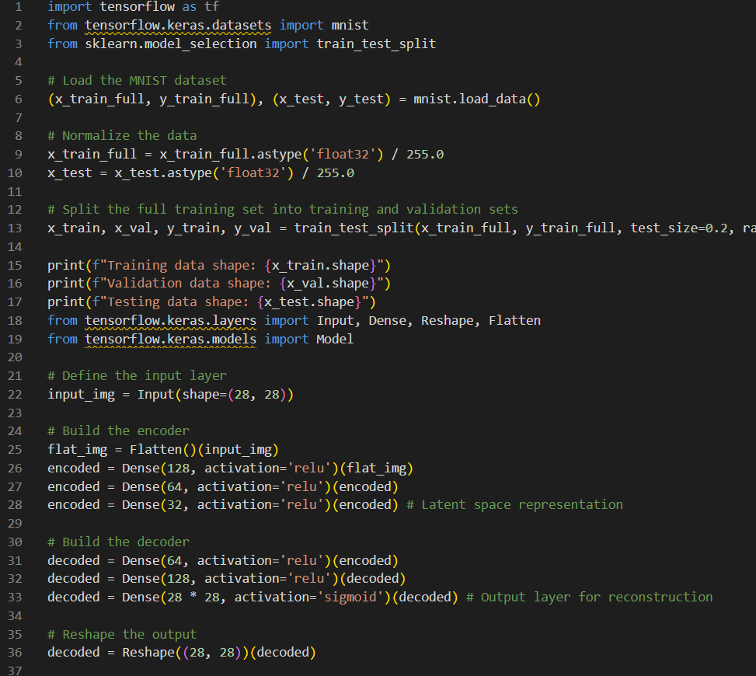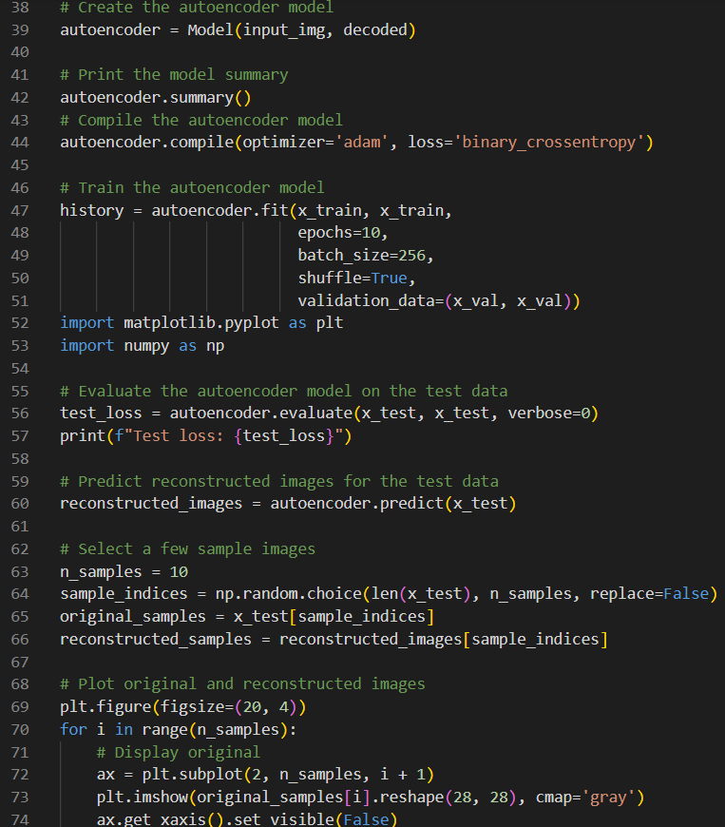
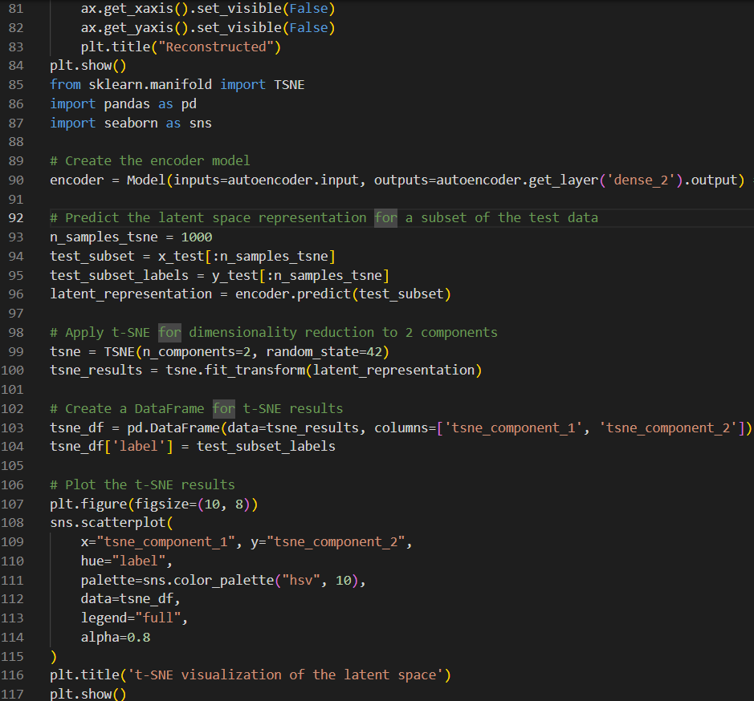

Output:
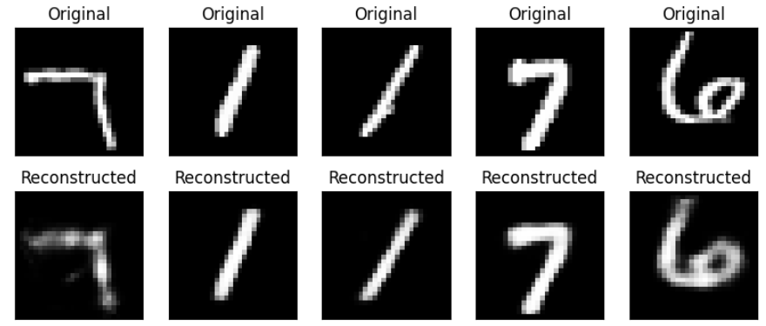

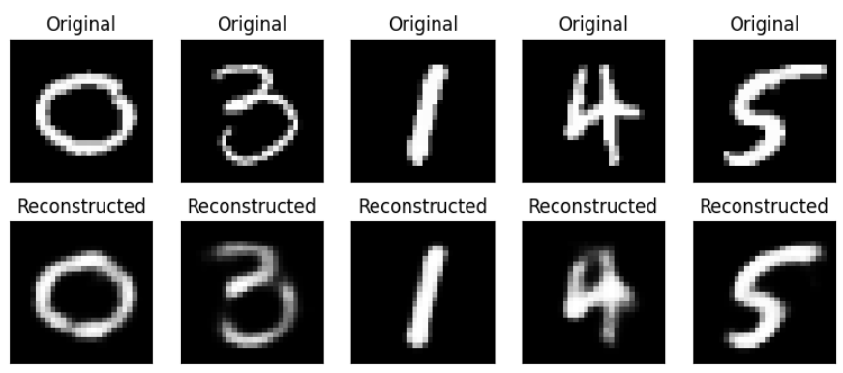
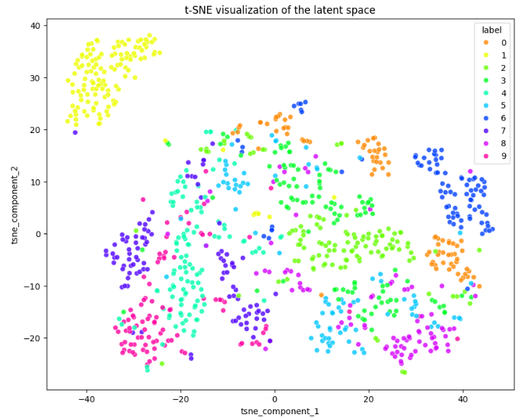

Output Analysis |  | - The MNIST dataset was successfully loaded, normalized to the range [0, 1], and split into training (48000 samples), validation (12000 samples), and testing (10000 samples) sets.  - An autoencoder model was built using TensorFlow/Keras, consisting of an encoder with Dense layers reducing the dimensionality to 32 in the latent space, and a decoder reconstructing the image with Dense layers and a final sigmoid activation.  - The autoencoder was compiled with the Adam optimizer and binary cross-entropy loss and trained for 10 epochs, showing a decrease in both training and validation loss.  - The autoencoder achieved a test loss of approximately 0.1018, indicating its ability to reconstruct test images.
Link of student GitHub profile where lab assignment has been uploaded |  | https://github.com/04Sahil/Deep-Learning
Conclusion |  | The learned latent space effectively captures discriminative features of the handwritten digits, making it suitable for tasks like classification or further analysis in a lower-dimensional space. Further experimentation could involve tuning the autoencoder's architecture (e.g., number of layers, units, activation functions) or training parameters (e.g., epochs, batch size, optimizer learning rate) to potentially improve reconstruction quality or the separability of classes in the latent space.
Plag Report (Similarity index < 12%) |  | 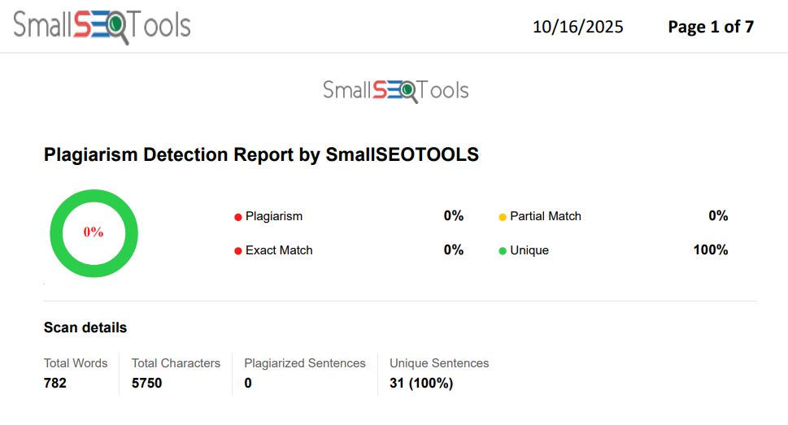
Date |  | 16/10/2025

