Compiler Design Lab
Lab 2

Name: Areen Chakraborty
Cse A Batch A2
220905496
Roll No. 53

Q1)

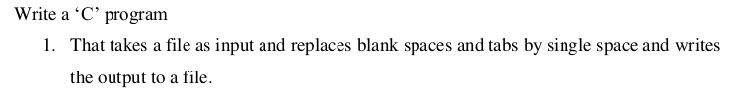
#include <stdio.h>
#include <stdlib.h>

void processFile(FILE* in, FILE* out) {
char ch, prevCh;

while ((ch = fgetc(in)) != EOF) {
if (ch == ' ' || ch == '\t') {
if (prevCh != ' ') {
fputc(' ', out);
}
} else {
fputc(ch, out);
}
prevCh = ch;
}
}

int main() {
FILE* in, *out;

in = fopen("q1in.c", "r");
if (in == NULL) {
printf("Cannot open file\n");
exit(1);
}

out = fopen("q1out.c", "w");

processFile(in, out);
}

Sample Input File
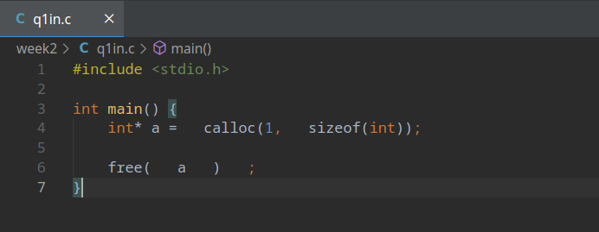

Sample Output File
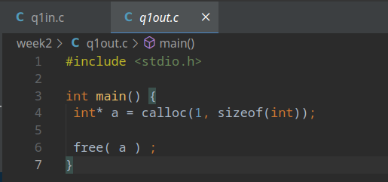

Q2)

#include <stdio.h>
#include <stdlib.h>

void discardPreprocessorDirectives(FILE* in, FILE* out) {
char line[1000];

while (fgets(line, sizeof(line), in)) {
if (line[0] != '#') {
fputs(line, out);
}
}
}

int main() {
FILE* in, *out;

in = fopen("q2in.c", "r");
if (in == NULL) {
perror("Cannot open file\n");
exit(1);
}

out = fopen("q2out.c", "w");

discardPreprocessorDirectives(in, out);
}

Sample Input File
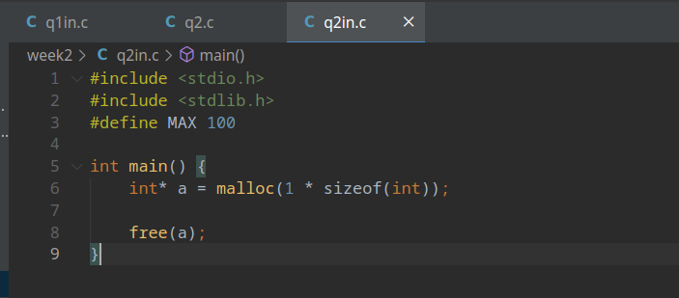

Sample Output File
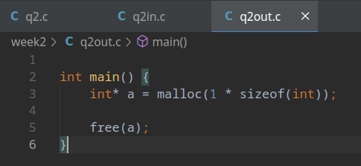

Q3)
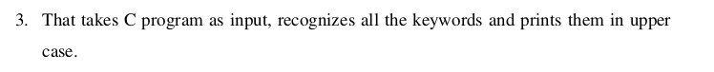
#include <stdio.h>
#include <stdlib.h>
#include <string.h>
#include <ctype.h>

#define NUM_KEYWORDS 32

char *keywords[NUM_KEYWORDS] = {
"auto", "break", "case", "char",
"const", "continue", "default", "do",
"double", "else", "enum", "extern",
"float", "for", "goto", "if",
"int", "long", "register", "return",
"short", "signed", "sizeof", "static",
"struct", "switch", "typedef", "union",
"unsigned", "void", "volatile", "while"
};

int isKeyword(char *word) {
for (int i = 0; i < NUM_KEYWORDS; i++) {
if (strcmp(keywords[i], word) == 0) {
return 1;
}
}
return 0;
}

void toUpperWord(char *word) {
for (int i = 0; word[i] != '\0'; i++) {
word[i] = toupper(word[i]);
}
}

void processFile(FILE* in) {
char c;
char word[500];
int i = 0;

while ((c = fgetc(in)) != EOF) {
if (isalpha(c) || c == '_') {
word[i++] = c;
} else {
if (i > 0) {
word[i] = '\0';

if (isKeyword(word)) {
toUpperWord(word);
}

printf("%s", word);
i = 0;
}
printf("%c", c);
}
}

if (i > 0) {
word[i] = '\0';

if (isKeyword(word)) {
toUpperWord(word);
}

printf("%s", word);
i = 0;
}
}

int main() {
FILE* in, *out;

in = fopen("q3in.c", "r");
if (in == NULL) {
printf("Cannot open file\n");
exit(1);
}

processFile(in);
}

Sample Input File

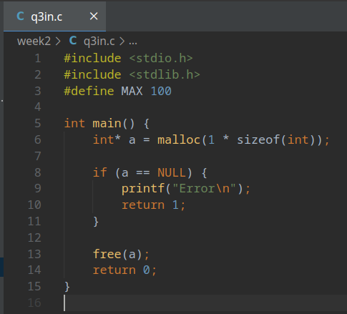

Sample Output

