**Name: Areen Chakraborty**

**220905496**

**CSE A Roll No. 53**

**Batch A2**

**Web Programming Lab – Week 4 Assignment**



Code:

def get_min(arr):

    min_val = arr[0]

    for num in arr:

        if num < min_val:

            min_val = num

    return min_val

arr = [3, 1, 4, 1, 5, 9, 2, 6, 5]

print("Minimum element:", get_min(arr))

Output:





Code:

def bubble_sort(arr):

    n = len(arr)

    for i in range(n):

        swapped = False

        for j in range(n - i - 1):

            if arr[j] > arr[j + 1]:

                arr[j], arr[j + 1] = arr[j + 1], arr[j]

                swapped = True

        if not swapped:

            break

arr = [64, 34, 25, 12, 22, 11, 90]

bubble_sort(arr)

print("Sorted array:", arr)

Output:





Code:

def matrix_multiply(A, B):

    rows_A, cols_A = len(A), len(A[0])

    rows_B, cols_B = len(B), len(B[0])

    if cols_A != rows_B:

        raise ValueError("Matrix dimensions do not match for multiplication")

    result = [[0] * cols_B for _ in range(rows_A)]

    for i in range(rows_A):

        for j in range(cols_B):

            for k in range(cols_A):

                result[i][j] += A[i][k] * B[k][j]

    return result

A = [[1, 2], [3, 4]]

B = [[5, 6], [7, 8]]

print("Matrix Multiplication Result:", matrix_multiply(A, B))

Output:





Code:

class ValidParentheses:

    def is_valid(self, s: str) -> bool:

        stack = []

        mapping = {')': '(', '}': '{', ']': '['}

        for char in s:

            if char in mapping:

                top_element = stack.pop() if stack else '#'

                if mapping[char] != top_element:

                    return False

            else:

                stack.append(char)

        return not stack

vp = ValidParentheses()

print(f'"()[]{{}}": {vp.is_valid("()[]{}")}')

print(f'"(]": {vp.is_valid("(]")}')

Output:

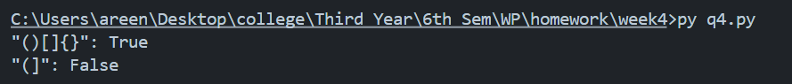



Code:

class ReverseString:

    def reverse_words(self, s: str) -> str:

        return ' '.join(s.split()[::-1])

rs = ReverseString()

print(rs.reverse_words("Hello World"))

Output:





Code:

import math

class Circle:

    def __init__(self, radius):

        self.radius = radius

    def area(self):

        return math.pi * self.radius ** 2

    def perimeter(self):

        return 2 * math.pi * self.radius

c = Circle(5)

print(f"Area: {c.area():.2f}")

print(f"Perimeter: {c.perimeter():.2f}")

Output:

