**Name: Areen Chakraborty**

**220905496**

**CSE A Roll No. 53**

**Batch A2**

**Web Programming Lab – Week 5 Assignment**

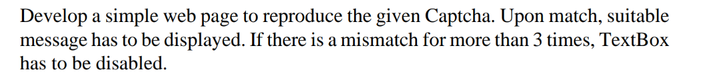

settings.py

INSTALLED_APPS = [

'django.contrib.admin',

'django.contrib.auth',

'django.contrib.contenttypes',

'django.contrib.sessions',

'django.contrib.messages',

'django.contrib.staticfiles',

'captcha_app',

]

urls.py

from django.contrib import admin

from django.urls import path

from captcha_app import views

urlpatterns = [

path('admin/', admin.site.urls),

path('', views.captcha_view, name='captcha'),

path('validate/', views.validate_captcha, name='validate_captcha'),

]

views.py

from django.shortcuts import render

from django.http import JsonResponse

import random

import string

# Generate random captcha

def generate_captcha():

return ''.join(random.choices(string.ascii_uppercase + string.digits, k=5))

def captcha_view(request):

captcha = generate_captcha()

request.session['captcha'] = captcha

return render(request, 'captcha.html', {'captcha': captcha})

def validate_captcha(request):

user_input = request.GET.get('captcha_input', '')

stored_captcha = request.session.get('captcha', '')

attempts = request.session.get('attempts', 0)

if user_input == stored_captcha:

request.session['attempts'] = 0

return JsonResponse({'status': 'success', 'message': 'Captcha matched!'})

attempts += 1

request.session['attempts'] = attempts

if attempts >= 3:

return JsonResponse({'status': 'error', 'message': 'Too many failed attempts. Input disabled!', 'disable': True})

return JsonResponse({'status': 'error', 'message': 'Captcha mismatch. Try again!'})

templates/captcha.html

<!DOCTYPE html>

<html>

<head>

<title>Captcha Verification</title>

<script src="https://code.jquery.com/jquery-3.6.0.min.js"></script>

<link rel="stylesheet" href="https://cdn.jsdelivr.net/npm/bootstrap@5.3.0/dist/css/bootstrap.min.css">

</head>

<body class="container mt-5">

<h3>Enter the Captcha</h3>

<div class="card p-3">

<p id="captcha" class="fw-bold text-primary">{{ captcha }}</p>

<input type="text" id="captcha_input" class="form-control" placeholder="Enter Captcha">

<button id="submit_btn" class="btn btn-primary mt-2">Submit</button>

<p id="message" class="mt-2"></p>

</div>

<script>

let attempts = 0;

$("#submit_btn").click(function () {

let inputVal = $("#captcha_input").val();

$.get("/validate/", { captcha_input: inputVal }, function (data) {

$("#message").text(data.message).removeClass().addClass(data.status === 'success' ? 'text-success' : 'text-danger');

if (data.disable) {

$("#captcha_input, #submit_btn").prop("disabled", true);

}

});

});

</script>

</body>

</html>

Output

