**Name: Areen Chakraborty**

**220905496**

**CSE A Roll No. 53**

**Batch A2**

**Web Programming Lab – Week 7 Assignment**

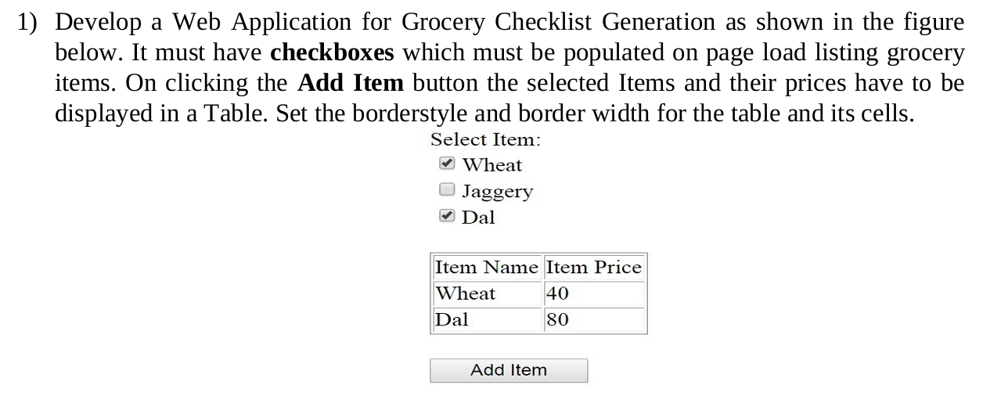

templates/grocery/index.html

<!DOCTYPE html>

<html>

<head>

<title>Grocery Checklist</title>

<style>

table {

border-collapse: collapse;

width: 50%;

margin-top: 20px;

}

th, td {

border: 1px solid black;

padding: 8px;

text-align: left;

}

th {

background-color: #f2f2f2;

}

.form-group {

margin: 20px 0;

}

.checkbox-list {

margin-bottom: 15px;

}

.checkbox-item {

margin: 5px 0;

}

.button {

padding: 10px 20px;

background-color: #4CAF50;

color: white;

border: none;

cursor: pointer;

}

.button:hover {

background-color: #45a049;

}

</style>

</head>

<body>

<h2>Select Item:</h2>

<form method="POST">

{% csrf_token %}

<div class="form-group">

<div class="checkbox-list">

{% for field in form %}

<div class="checkbox-item">

{{ field }}

{{ field.label_tag }}

</div>

{% endfor %}

</div>

<input type="submit" value="Add Item" class="button">

</div>

</form>

{% if selected_items %}

<table>

<thead>

<tr>

<th>Item Name</th>

<th>Item Price</th>

</tr>

</thead>

<tbody>

{% for item in selected_items %}

<tr>

<td>{{ item.name }}</td>

<td>{{ item.price }}</td>

</tr>

{% endfor %}

</tbody>

</table>

{% endif %}

</body>

</html>

Output

