Cline Manufacturing LLP

Limited Liability Partnership Agreement  
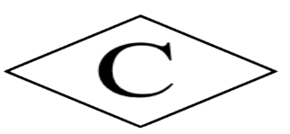

This Limited Liability Partnership Agreement ("Agreement") is entered into on [Date] by and between the partners of Cline Manufacturing LLP, a Limited Liability Partnership organized under the laws of the State of Colorado ("Partnership").

**1. Name and Formation**

The name of the Partnership shall be Cline Manufacturing LLP ("Partnership"). The Partnership is formed under the laws of the State of Colorado.

**2. Managing Director and Voting Rights**

Peter Cline shall serve as the Managing Director of the Partnership and shall maintain all voting rights. The Managing Director shall have the authority to make all decisions on behalf of the Partnership, subject to the terms of this Agreement.

**3. Ownership**

Ownership in the Partnership shall be determined by the fraction of the original money invested by each partner.

**4. Lockout Agreement**

There shall be an 8-year lockout agreement, during which partners shall not be entitled to withdraw their investments or receive any distributions from the Partnership. The lockout period shall commence upon the formation of the Partnership.

**5. Business Purpose**

The Partnership shall act as a subsidiary of Cline Capital for the purpose of acquiring American Gypsum LLC ("American Gypsum"). American Gypsum shall be solely owned by the Partnership.

**6. Retention of Earnings**

All earnings generated by American Gypsum shall be retained by the Partnership until the expiration of the lockout agreement.

**7. Amendment of Agreement**

This Agreement may only be amended by unanimous approval of the partners.

**8. Governing Law and Jurisdiction**

This Agreement shall be governed by and construed in accordance with the laws of the State of Colorado. Any disputes arising under or in connection with this Agreement shall be resolved in the courts of the State of Colorado.

**9. Head Office**

The head office of the Partnership shall be located in Gypsum Colorado where all company operations will me conducted.

In witness whereof, the undersigned partners have executed this Agreement as of the date first above written.

Signed: - 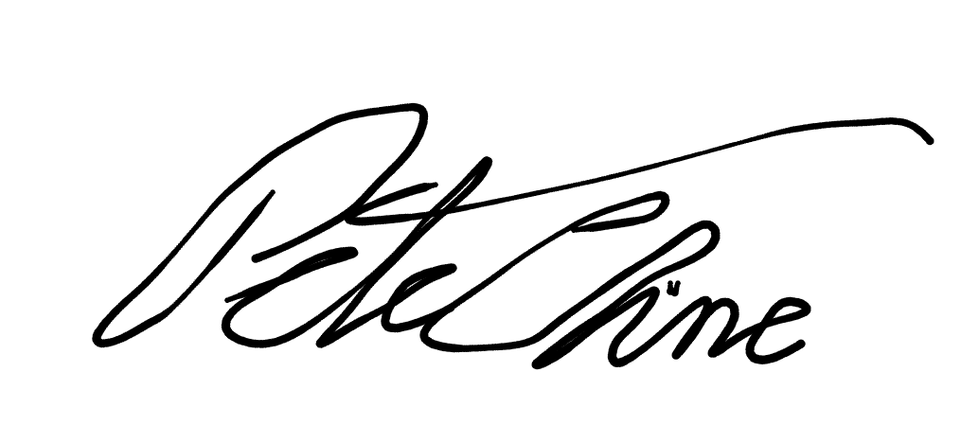 -

Signed: ____________________________

Date: ____________________________