**Tic Tac Toe**

**Algorithm:**

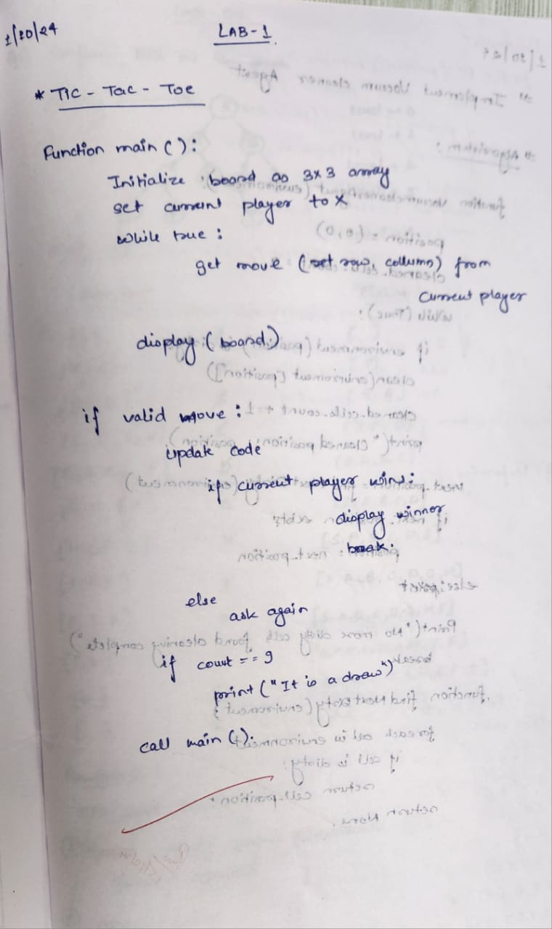

**State Space Tree:**

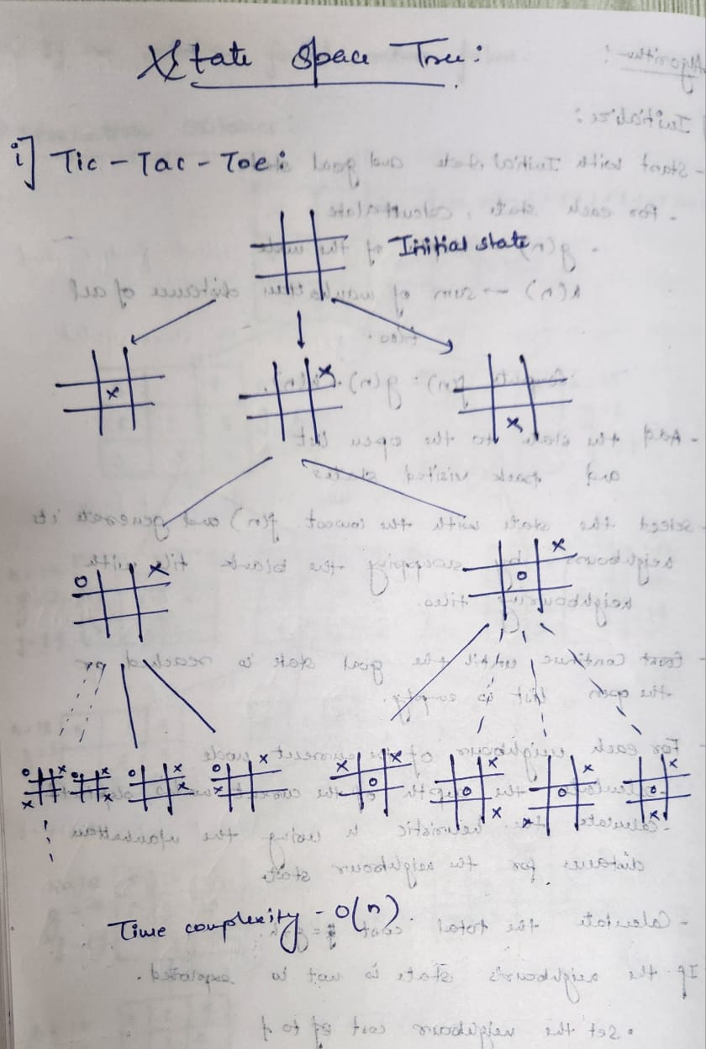

**Code:**

def checkpos(x, r, c):

if 0 <= r <= 2 and 0 <= c <= 2:

if x[r][c] != "X" and x[r][c] != "O":

return True

return False

def checkwinner(x):

for i in range(3):

j = 0

if x[i][j] == x[i][j+1] == x[i][j+2] != '-':

return True

elif x[j][i] == x[j+1][i] == x[j+2][i] != '-':

return True

elif(x[0][0] == x[1][1] == x[2][2] != '-' or x[0][2] == x[1][1] == x[2][0] != '-'):

return True

return False

def checkdraw(n):

if n == 9:

return True

return False

def display(x):

for i in range(3):

print(x[i])

def initialise():

x = []

for i in range(3):

l = []

for j in range(3):

l.append("-")

x.append(l)

return x

def main():

count = 0

gameover = False

x = initialise()

while count < 9:

while count%2 == 0:

print("Player X's turn: ")

r = int(input("Enter row: "))

c = int(input("Enter column: "))

if checkpos(x, r, c):

x[r][c] = 'X'

count += 1

display(x)

if checkwinner(x):

print("Player X won!")

gameover = True

break

else:

continue

if checkdraw(count):

print("It's a draw")

break

if gameover:

break

while count%2 == 1:

print("Player O's turn: ")

r = int(input("Enter row: "))

c = int(input("Enter column: "))

if checkpos(x,r,c):

x[r][c] = 'O'

display(x)

count += 1

if checkwinner(x):

print("Player O won!")

gameover = True

break

else:

continue

if checkdraw(count):

print("It's a draw")

break

if gameover:

break

main()

**Output:**

