**Vacuum Cleaner Agent**

**Algorithm:**

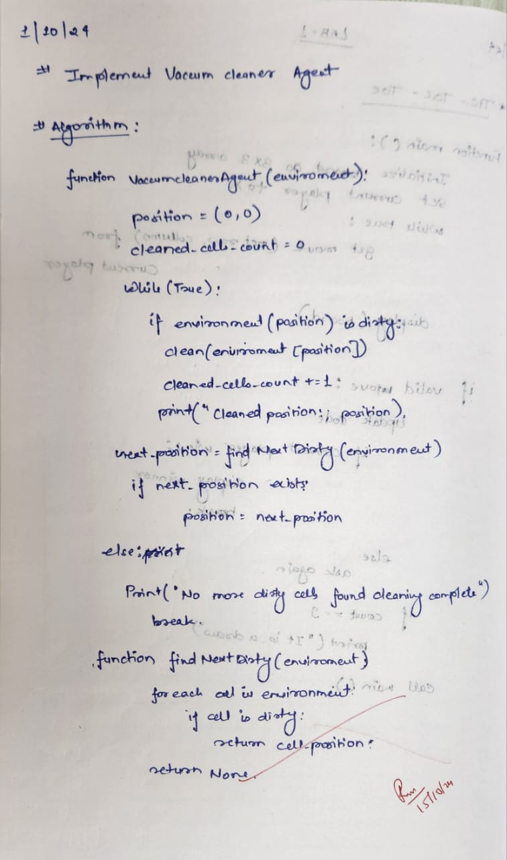

**State Space Tree:**

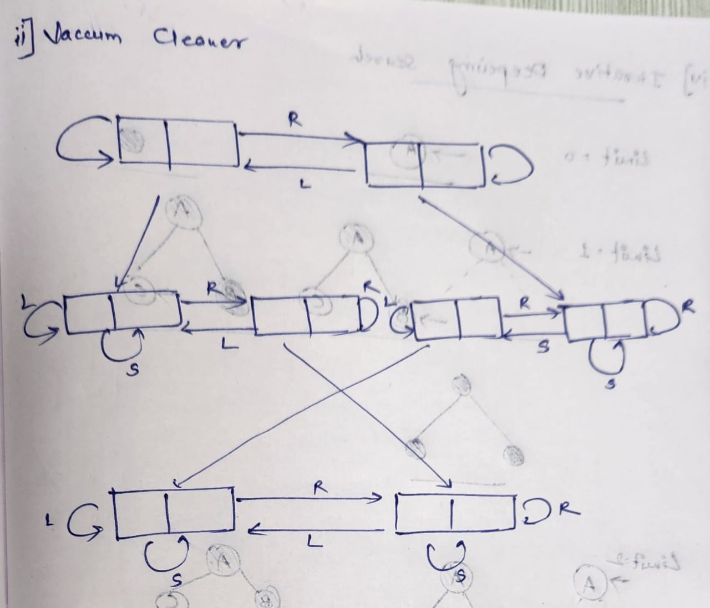

**Code:**

def vacuum_world():

goal_state = {'A': '0', 'B': '0'}

cost = 0

location_input = input("Enter Location of Vacuum: ")

status_input = input("Enter status of " + location_input + " (0 for Clean, 1 for Dirty): ")

status_input_complement = input("Enter status of the other room: ")

print("Initial Location Condition: " + str(goal_state))

if location_input == 'A':

print("Vacuum is placed in Location A")

if status_input == '1':

print("Location A is Dirty.")

goal_state['A'] = '0'

cost += 1

print("Cost for CLEANING A: " + str(cost))

print("Location A has been Cleaned.")

if status_input_complement == '1':

print("Location B is Dirty.")

print("Moving right to Location B.")

cost += 1

print("COST for moving RIGHT: " + str(cost))

goal_state['B'] = '0'

cost += 1

print("COST for SUCK: " + str(cost))

print("Location B has been Cleaned.")

else:

print("No action. Cost: " + str(cost))

print("Location B is already clean.")

else:

print("Location A is already clean.")

if status_input_complement == '1':

print("Location B is Dirty.")

print("Moving RIGHT to Location B.")

cost += 1

print("COST for moving RIGHT: " + str(cost))

goal_state['B'] = '0'

cost += 1

print("COST for SUCK: " + str(cost))

print("Location B has been Cleaned.")

else:

print("No action. Cost: " + str(cost))

print("Location B is already clean.")

else:

print("Vacuum is placed in Location B")

if status_input == '1':

print("Location B is Dirty.")

goal_state['B'] = '0'

cost += 1

print("COST for CLEANING B: " + str(cost))

print("Location B has been Cleaned.")

if status_input_complement == '1':

print("Location A is Dirty.")

print("Moving LEFT to Location A.")

cost += 1

print("COST for moving LEFT: " + str(cost))

goal_state['A'] = '0'

cost += 1

print("COST for SUCK: " + str(cost))

print("Location A has been Cleaned.")

else:

print("Location A is already clean.")

else:

print("Location B is already clean.")

if status_input_complement == '1':

print("Location A is Dirty.")

print("Moving LEFT to Location A.")

cost += 1

print("COST for moving LEFT: " + str(cost))

goal_state['A'] = '0'

cost += 1

print("COST for SUCK: " + str(cost))

print("Location A has been Cleaned.")

else:

print("No action. Cost: " + str(cost))

print("Location A is already clean.")

print("GOAL STATE: ")

print(goal_state)

print("Performance Measurement: " + str(cost))

vacuum_world()

**Output:**

