CMPG 325 — Milestone 2: Implementation & Testing
Project: CMPG325-2026-003 | Client ID: CLI-003
Organisation: Tshiamo Dental & Surgery Practice (Potchefstroom)
Student: Batmani, Jojo | Student Number: 46699104
Assigned Challenge: Default Routing (edge/ISP path design)
Date: September 2026

1. Introduction
This report documents the implementation and testing of the network designed in Milestone 1 for Tshiamo Dental & Surgery Practice. The network was built and simulated in Cisco Packet Tracer 9.0.1 using the Milestone 1 design: a router-on-a-stick VLAN architecture (VLANs 10 DATA, 20 VOIP, 30 GUEST, 99 MGMT) on the assigned 192.168.11.0/24 block, with dual default routes at the edge router toward two simulated ISPs. Every implementation decision and test below is traced back to the Milestone 1 design document, and all results are backed by screenshots taken from the implemented topology (part1.pkt).

2. Implementation Summary
Component | What was implemented | Milestone 1 reference
Switch0 (2960) | VLANs 10, 20, 30, 99 created; Fa0/1 configured as an 802.1Q trunk to Router0 carrying VLANs 10,20,30,99; access ports assigned per the port plan (PCs/Server/Printer in VLAN 10, phones in VLAN 20, AP in VLAN 30, reserved ports in VLAN 99). | Sections 3.1, 4.7
Router0 (2911) | Four router-on-a-stick subinterfaces (Gi0/0.10, .20, .30, .99) with the planned gateway addresses; WAN interfaces Gi0/1 (203.0.113.2/30) and Gi0/2 (198.51.100.2/30); two default routes (one per ISP), verified with a live failover test; NAT overload on Gi0/1 for Internet access from all internal VLANs; extended ACL GUEST_RESTRICT applied inbound on Gi0/0.30; DHCP pools (VoIP VLAN 20 and Guest VLAN 30); Cisco CME telephony-service for the 7 IP phones. | Sections 3.2, 3.3, 3.4, 3.5, 4.4
ISP1 / ISP2 (2911) | Simulated providers using 203.0.113.0/30 and 198.51.100.0/30 point-to-point links; loopback 8.8.8.8 (ISP1) and 8.8.4.4 (ISP2) used as Internet test targets. | Section 4.6
Server0 | Static IP 192.168.11.2/25, gateway 192.168.11.1; DNS service enabled with A record tshiamodental.co.za → 192.168.11.2; practice management/file server role. | Section 4.2
Access Point 0 | Unmanaged in VLAN 30 (no IP — the AccessPoint-PT-N model exposes no management address in any tab); broadcast SSID serving the contractor/guest wireless network; connected to switch port Fa0/21 (access, VLAN 30). | Sections 1.5, 4.4, 4.7
7 x IP Phone 7960 | Phones attached to VLAN 20 access ports; obtained addresses via the Router0 DHCP pool (192.168.11.128/26) and auto-registered with CME as ephones 1–7 with directory numbers 101–107. | Section 4.3
Workstations / Printer | Static IPs per the addressing plan (192.168.11.10–.40 range); gateway 192.168.11.1. | Section 4.2

3. Configuration Evidence

3.1 Implemented Topology
The full topology was cabled exactly as designed in Milestone 1: Router0 in the centre with dual WAN links to ISP1 and ISP2, a trunk to Switch0, and all end devices (7 PCs, 7 phones, server, printer, AP, contractor laptop) connected to the access switch.
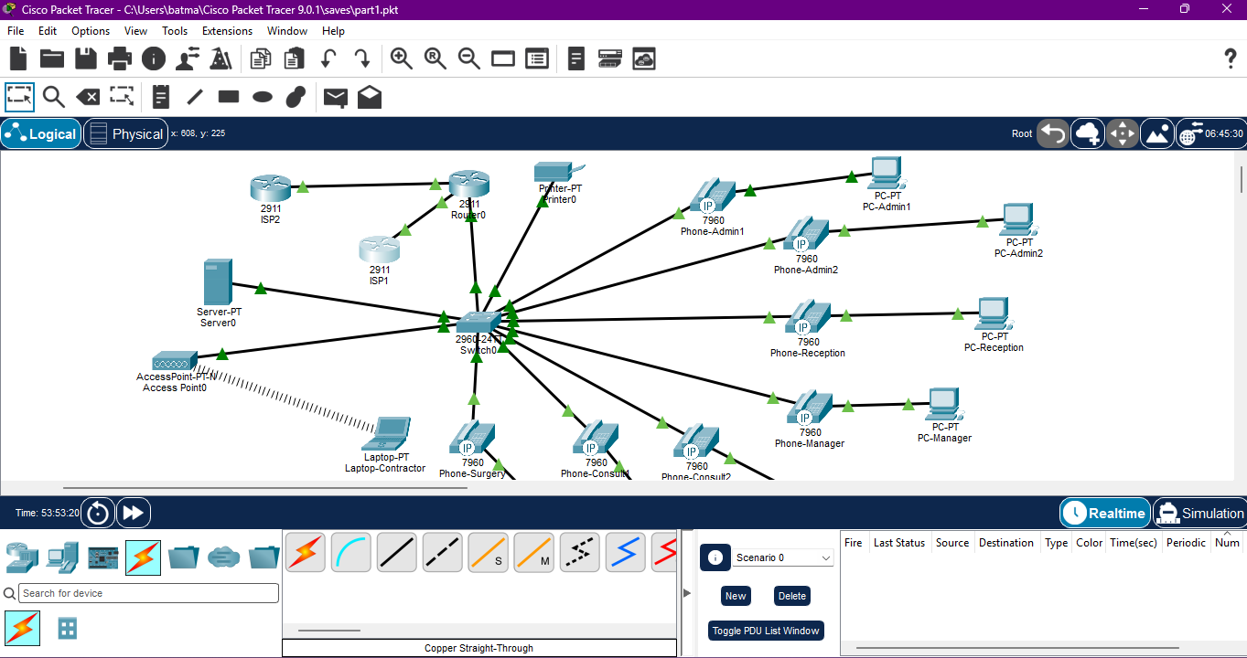
Figure 1 — Implemented topology in Cisco Packet Tracer (part1.pkt): dual-ISP edge, Router0, Switch0, and all end devices.

3.2 VLAN Segmentation and Trunking on Switch0
On Switch0 the VLANs DATA (10), VOIP (20), GUEST (30) and MGMT (99) were created and named. The output of show vlan brief confirms that every access port is assigned to the correct VLAN exactly as per the Milestone 1 port-assignment table (Section 4.7): PCs, the printer and Server0 in VLAN 10; all seven phones in VLAN 20; the access point in VLAN 30; reserved ports in VLAN 99.
The output of show interfaces trunk confirms that port Fa0/1 is trunking in 802.1Q mode with VLANs 10,20,30,99 allowed and active — this is the router-on-a-stick link to Router0.
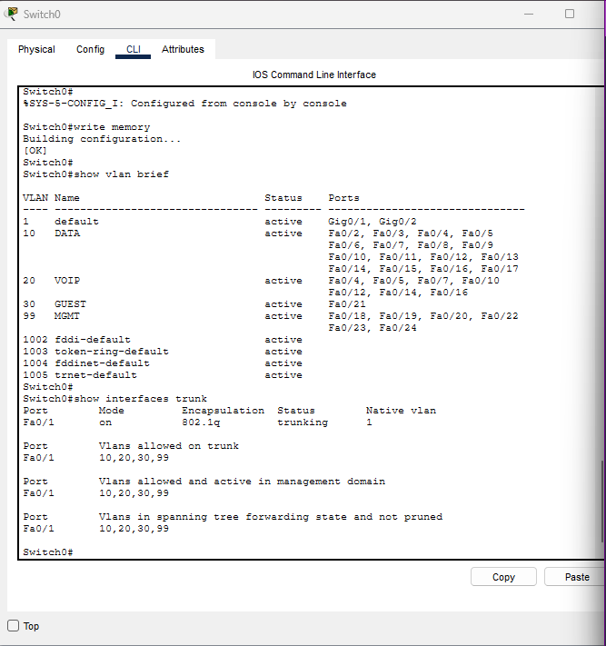
Figure 2 — Switch0: "show vlan brief" and "show interfaces trunk" output verifying VLANs and the 802.1Q trunk.

3.3 Router0 Subinterfaces, WAN Interfaces and DHCP
The output of show ip interface brief on Router0 confirms all planned interfaces are up/up with the correct Milestone 1 addresses:
Interface | Address (per plan / verified)
Gig0/0.10 (DATA) | 192.168.11.1/25 ✔
Gig0/0.20 (VOIP) | 192.168.11.129/26 ✔
Gig0/0.30 (GUEST) | 192.168.11.193/27 ✔
Gig0/0.99 (MGMT) | 192.168.11.225/28 ✔
Gig0/1 (WAN to ISP1) | 203.0.113.2/30 ✔
Gig0/2 (WAN to ISP2) | 198.51.100.2/30 ✔

The same screenshot shows show ip dhcp binding: all seven IP phones (192.168.11.130–.136) hold automatic DHCP leases from the VLAN 20 pool, confirming the VoIP DHCP scope is functional.
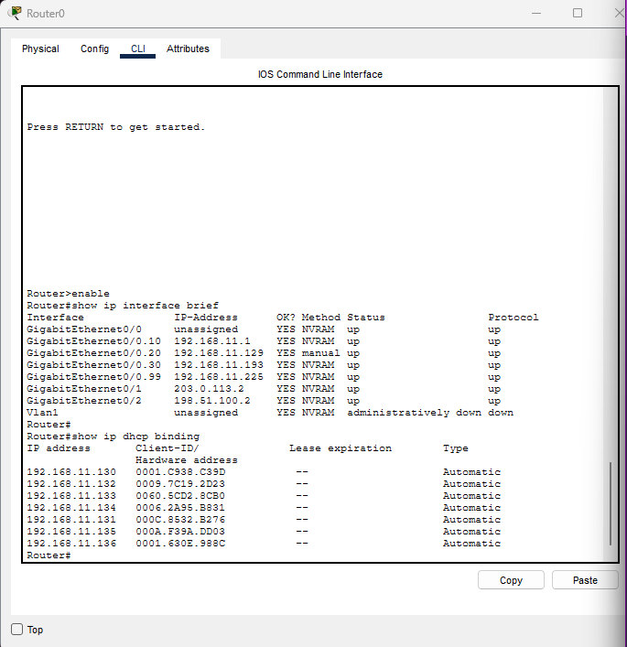
Figure 3 — Router0: "show ip interface brief" (all subinterfaces and WAN links up) and "show ip dhcp binding" (7 phone leases).

3.4 Default Routing — Edge/ISP Path Design (Assigned Challenge)
The output of show ip route on Router0 verifies the assigned challenge. Router0 carries the complete VLSM table (192.168.11.0/25, .128/26, .192/27, .224/28 — exactly as subnetted in Milestone 1, Section 4.1) plus both WAN /30 links, and critically, TWO default routes installed via load-sharing:
S* 0.0.0.0/0 [1/0] via 203.0.113.1 (ISP1 — primary)
S* 0.0.0.0/0 [1/0] via 198.51.100.1 (ISP2 — secondary)
This is precisely the Default Routing (edge/ISP path design) requirement: edge-level default routes toward two ISPs, providing Internet redundancy without a dynamic routing protocol.
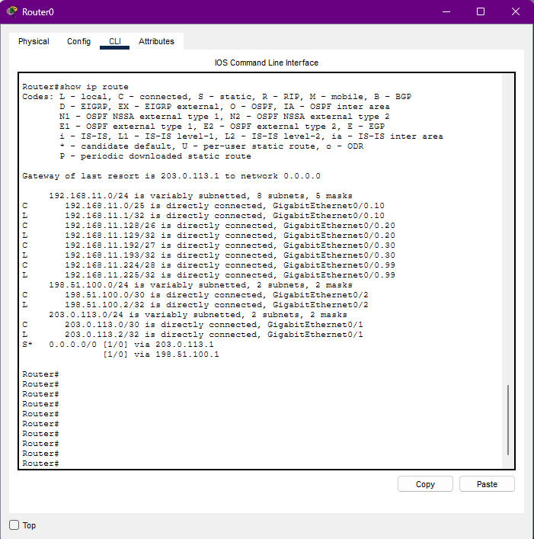
Figure 4 — Router0 "show ip route": VLSM subnets, WAN links, and dual default routes via 203.0.113.1 and 198.51.100.1.
Failover verification: to directly confirm the edge/ISP path design provides redundancy and not just a static dual-route table, GigabitEthernet0/2 (the link to ISP2) was administratively shut down and show ip route was re-checked. The route via 198.51.100.1 was automatically withdrawn, leaving a single default route via 203.0.113.1 as the sole gateway of last resort — confirming the router correctly fails over rather than retaining a dead route. The interface was then restored with no shutdown, and both routes reappeared in the table, matching the original state shown in Figure 4.

3.5 Network Address Translation (NAT)
Internet access for every internal VLAN — not only the guest network — depends on NAT, since the assigned block 192.168.11.0/24 is private address space and cannot be routed across the simulated ISPs without translation. This was confirmed directly: before NAT was configured, pings from internal devices to the simulated Internet targets (8.8.8.8, 8.8.4.4) failed completely with no replies at all, despite correct routing. NAT overload was configured on Router0's primary WAN interface:
access-list 1 permit 192.168.11.0 0.0.0.255; ip nat inside applied to Gig0/0.10, Gig0/0.20 and Gig0/0.30; ip nat outside applied to Gig0/1; ip nat inside source list 1 interface GigabitEthernet0/1 overload.
With this in place, internal devices on all three user-facing VLANs successfully reached the simulated Internet (see Figure 21 for the guest VLAN result). One limitation was identified and is documented in Section 6, item N5: Packet Tracer's simplified IOS does not support binding a single NAT access-list to two outside interfaces simultaneously, so NAT is only bound to Gig0/1. Since both default routes remain active for load-balancing, traffic that happens to route out via Gig0/2 is not translated and receives no reply — this produces the partial packet loss seen under normal dual-path conditions and is a simulator constraint rather than a design fault.

3.6 VoIP — Cisco CME Telephony Service
Cisco Call Manager Express was configured on Router0 with: telephony-service, max-phones 7, max-dn 7, ip source-address 192.168.11.129 port 2000, and auto assign 1 to 7. The output of show ephone confirms all seven 7960 phones REGISTERED in SCCP with the CME server, each with a directory number (101–107) and a DHCP address from the 192.168.11.128/26 pool.
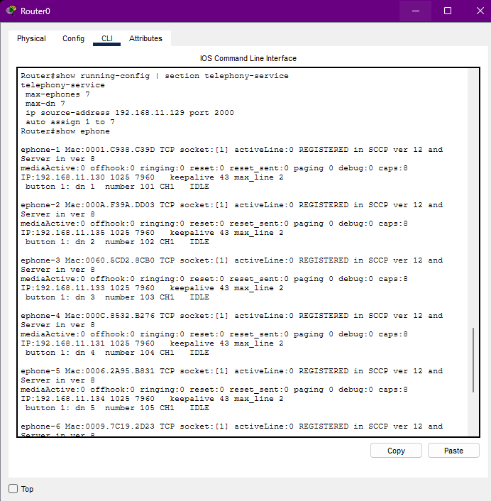
Figure 5 — Router0: telephony-service configuration and "show ephone" — ephones 1–4 registered (DN 101–104).
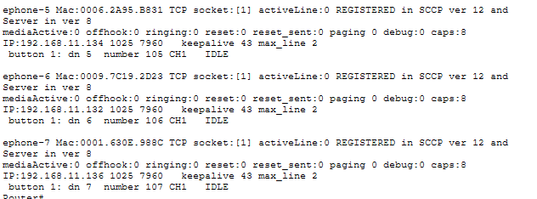
Figure 6 — "show ephone" continued — ephones 5–7 registered (DN 105–107). All 7 phones registered.

3.7 DNS Server Configuration (Server0)
The DNS service was enabled on Server0 with a single A record: tshiamodental.co.za → 192.168.11.2, so that practice workstations can reach the practice management server by name. The DNS server address (192.168.11.2) was distributed to DHCP clients via the DHCP pool configuration.
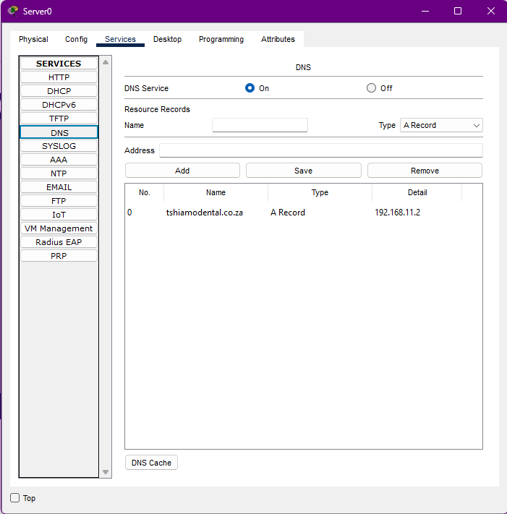
Figure 7 — Server0 DNS service: A record tshiamodental.co.za → 192.168.11.2.

3.8 Wireless Access Point (Contractor Network)
AP0 was placed in VLAN 30 on switch port Fa0/21 and provides the contractor/guest wireless network. The laptop scan shows the SSID being broadcast and the laptop successfully associated and connected. (Note: the SSID is currently broadcast as "Default" — see Section 6, item N2.)
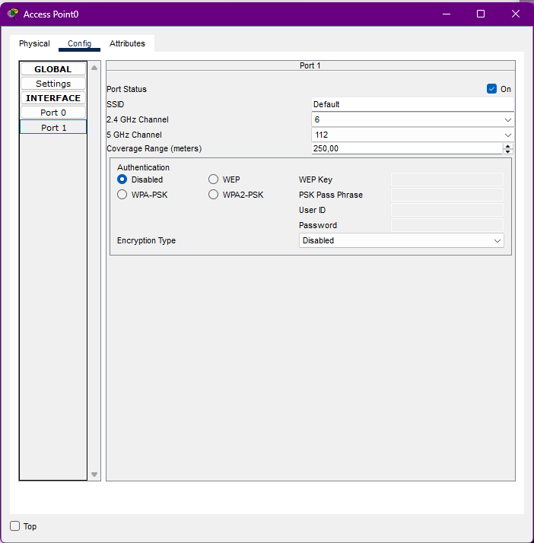
Figure 8 — AP0 configuration: SSID broadcast enabled, connected to the GUEST VLAN.
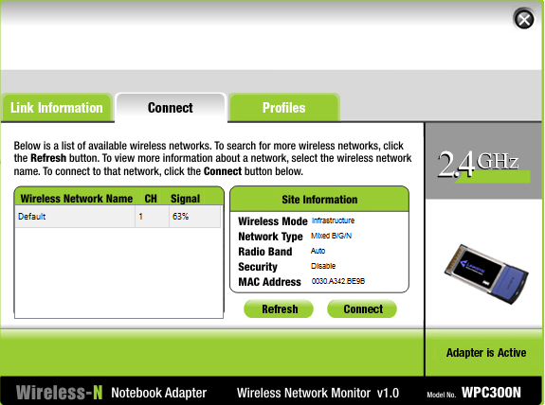
Figure 9 — Laptop-Contractor wireless scan: the AP SSID visible (signal 63%).
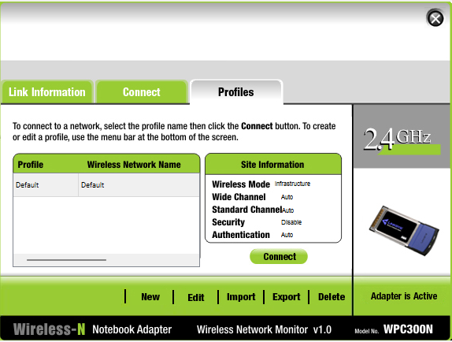
Figure 10 — Laptop-Contractor connected to the wireless network.

4. Testing and Verification

4.1 Test Plan Overview
Test ID | Test performed | Expected result | Result
T1 | VLAN/trunk verification on Switch0 (show vlan brief, show interfaces trunk) | VLANs 10/20/30/99 present; Fa0/1 trunking 802.1Q with VLANs 10,20,30,99 | PASS — Figure 2
T2 | Router interface verification (show ip interface brief) | All 4 subinterfaces + 2 WAN links up/up with planned IPs | PASS — Figure 3
T3 | DHCP verification (show ip dhcp binding) | 7 phone leases in 192.168.11.128/26 pool | PASS — Figure 3
T4 | Default routing + live failover verification (show ip route, before/after shutting Gig0/2) | Two 0.0.0.0/0 routes normally; single route via 203.0.113.1 remains after Gig0/2 is shut down | PASS — Figure 4, Section 3.4
T5 | End-to-end data connectivity (PC → Server ping) | Replies from 192.168.11.2, 0% loss | PASS — Figures 11, 12
T6 | Internet path verification (tracert 8.8.8.8) | Traffic exits via gateway 192.168.11.1 then ISP | PASS — Figure 12
T7 | VoIP registration (show ephone) | All 7 phones REGISTERED, DN 101–107 | PASS — Figures 5, 6
T8 | VoIP phone boot via DHCP | Phones display "Configuring IP" then register | PASS — Figures 13, 14
T9 | Phone-to-phone call test (104 → 103) | Call rings and connects | PASS — Figures 15, 16
T10 | DNS resolution (nslookup tshiamodental.co.za) | Name resolves to 192.168.11.2 | PASS (after fix) — Figures 17–19
T11 | Contractor wireless association | Laptop connects to AP SSID | PASS — Figures 9, 10
T12 | Guest ACL: block internal VLANs from contractor laptop | Ping to 192.168.11.1/.2 denied ("Destination host unreachable" from gateway 192.168.11.193) | PASS — Figure 20
T13 | Guest ACL: permit Internet from contractor laptop | Ping to ISP targets successful via default route | PASS (partial) — Figure 21
T14 | Inter-VLAN routing between staff VLANs | Calls + pings between VLAN 10 and VLAN 20 succeed | PASS — Figures 11, 15, 16

4.2 Data Connectivity Testing (VLAN 10)
PC-Admin1 (192.168.11.11) pinged the practice server Server0 (192.168.11.2). All four packets were returned with 0% loss (round-trip 0–34 ms), confirming intra-VLAN switching and the workstation default gateway configuration. This test was executed and captured twice with identical results.
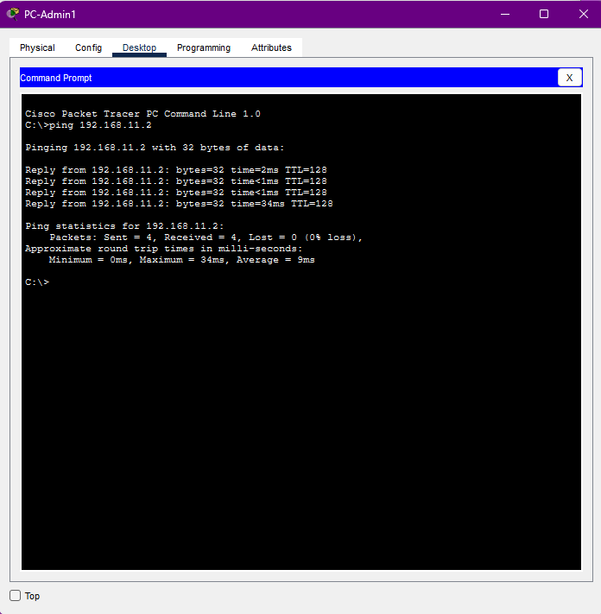
Figure 11 — PC-Admin1: ping 192.168.11.2 (Server0) — 4/4 replies, 0% loss.
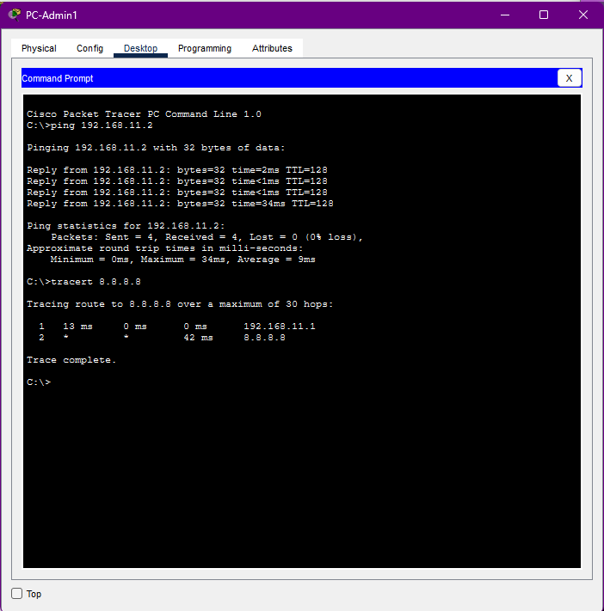
Figure 12 — PC-Admin1: ping 192.168.11.2 (0% loss) and tracert 8.8.8.8 showing the path via the default gateway 192.168.11.1 to the simulated ISP.

4.3 VoIP Testing (VLAN 20)
Boot test: when powered on, the IP phones displayed "Configuring IP", obtained a lease from the Router0 DHCP pool, downloaded their configuration from CME (source-address 192.168.11.129), and registered as ephones 1–7 with directory numbers 101–107 (Figures 5, 6, 13, 14).
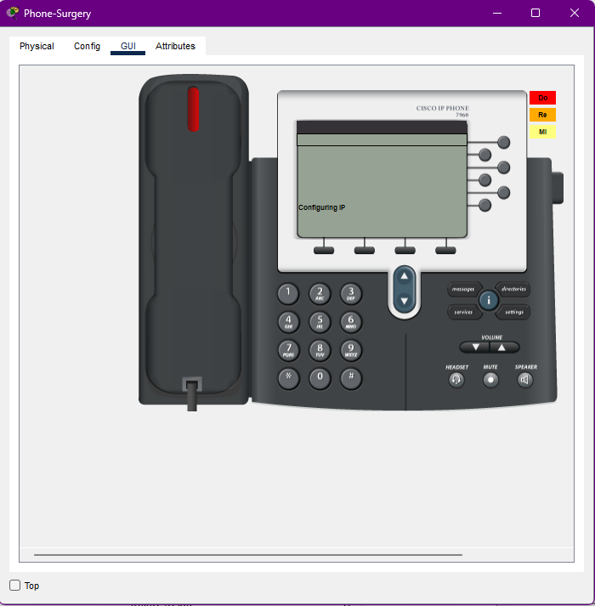
Figure 13 — Phone-Surgery booting: "Configuring IP" (DHCP discover on VLAN 20).
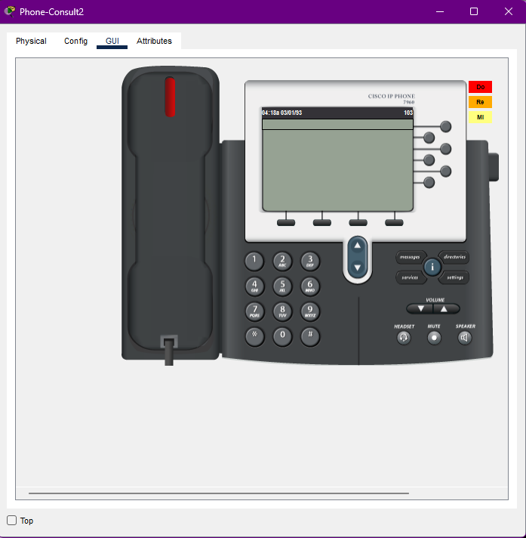
Figure 14 — Phone-Consult2 booting: "Configuring IP" phase of registration.
Call test: Phone-Admin1 (extension 104) dialled extension 103 (Phone-Consult2). The call state moved from "Ring Out" on the caller to "Connected" on the callee, proving SCCP signalling and RTP media flow across the VoIP VLAN via the router-on-a-stick design. This also verifies inter-VLAN reachability between the voice and data subnets, since CME signalling transits Router0.
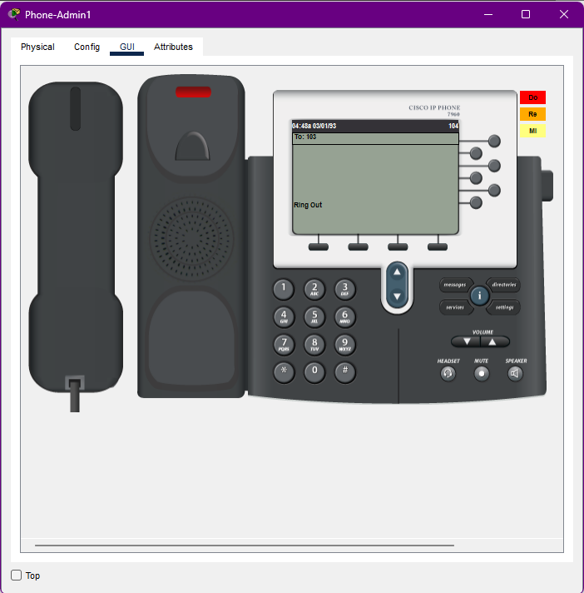
Figure 15 — Phone-Admin1 (104) placing a call to 103: "Ring Out".
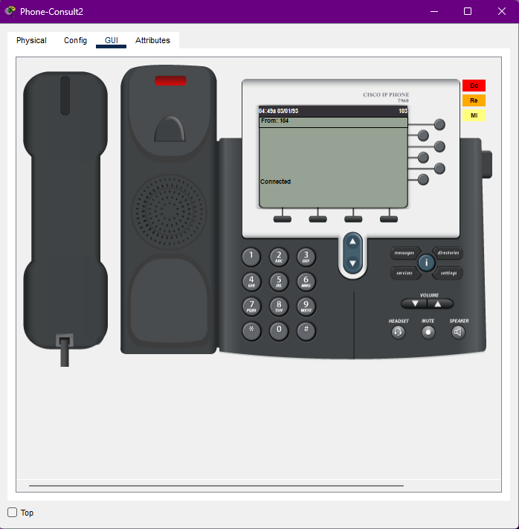
Figure 16 — Phone-Consult2 (103) answers: call "Connected" — VoIP call successfully established.

4.4 DNS Testing
Resolving the practice server by name was tested with nslookup tshiamodental.co.za from PC-Reception. The first attempts failed (Section 6, item N1): initially the PC had no DNS server configured (request to 255.255.255.255 timed out), and after pointing the PC to 192.168.11.2 the request still timed out because the DNS service on Server0 had not yet been started. After enabling the DNS service and adding the A record on Server0 (Figure 7), the lookup succeeded: tshiamodental.co.za resolved to 192.168.11.2. This sequence is documented as troubleshooting evidence.
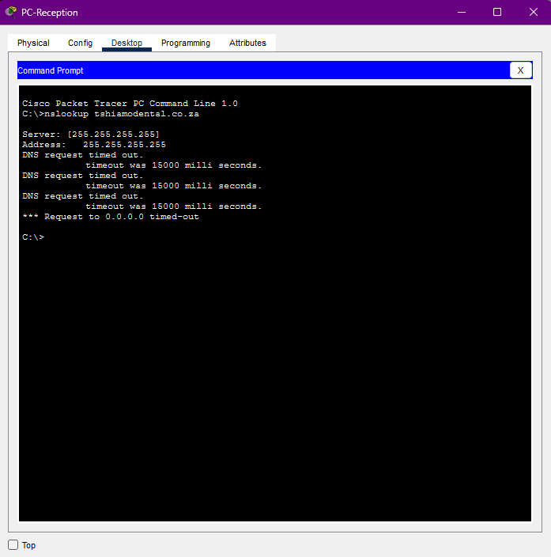
Figure 17 — nslookup attempt 1: no DNS server configured on the PC (request to 255.255.255.255 timed out).
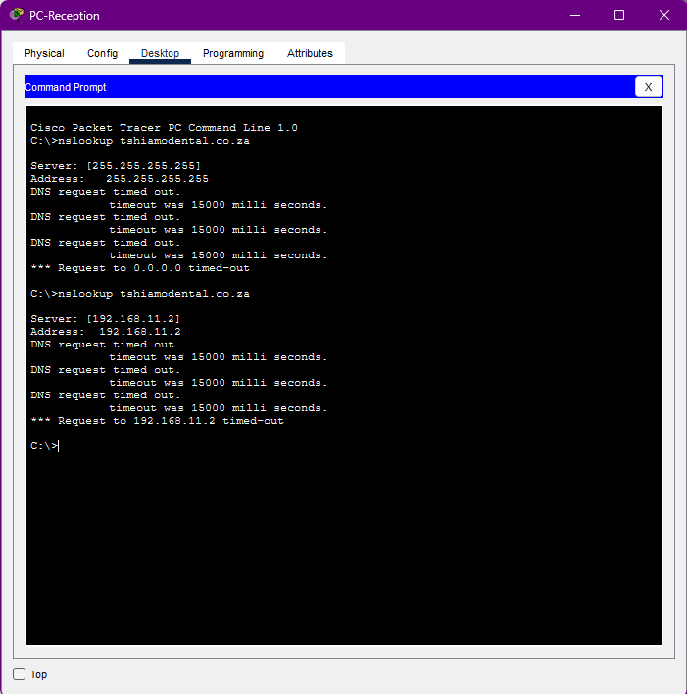
Figure 18 — nslookup attempt 2: PC DNS set to 192.168.11.2, but the DNS service on Server0 was still off — request timed out.
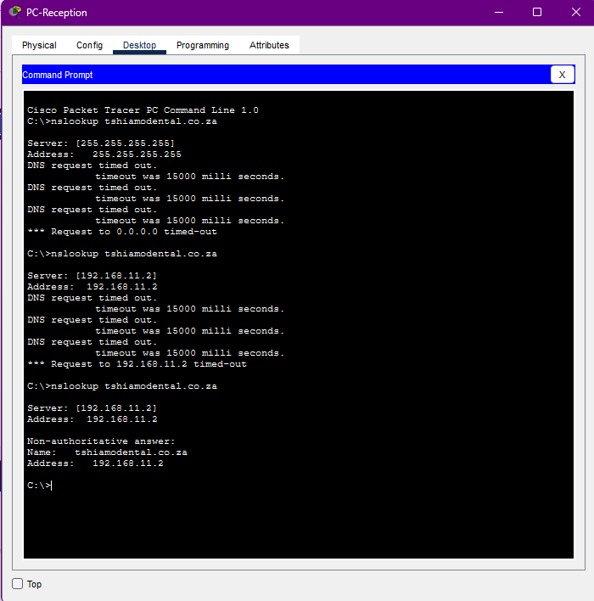
Figure 19 — nslookup attempt 3 (after fix): tshiamodental.co.za successfully resolves to 192.168.11.2.

4.5 Guest/Contractor Security Testing (VLAN 30 + ACL)
Laptop-Contractor associated wirelessly with AP0 (Figures 9, 10) and obtained an address in the 192.168.11.192/27 guest subnet with gateway 192.168.11.193. Three security tests were then performed:
Test A — Block internal access (ACL deny statements). The laptop pinged the DATA gateway (192.168.11.1) and the server (192.168.11.2). Both were blocked: every reply came from 192.168.11.193 (the GUEST gateway itself) reporting "Destination host unreachable" — exactly the behaviour expected when the GUEST_RESTRICT ACL denies guest-to-internal traffic. The contractor cannot reach patient records, the practice server, or the VoIP network.
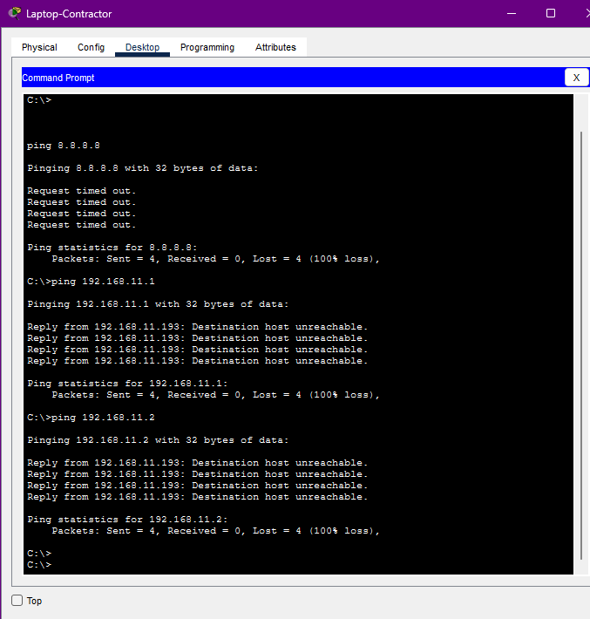
Figure 20 — Laptop-Contractor: pings to 192.168.11.1 and 192.168.11.2 blocked by the gateway (ACL working); first Internet ping attempt timed out.
Test B — Permit Internet access. The laptop pinged the simulated Internet target 8.8.4.4 (reachable via ISP2, 198.51.100.1). Two of four packets returned (TTL 254, ~49–82 ms) — the GUEST permit-any statement, the dual default routes, and NAT overload (Section 3.5) together allow guests to reach the Internet. The 50% loss on this run is the dual-path NAT limitation documented in Section 6, item N5, not a one-off artefact: traffic routed out via Gig0/2 is not translated, so only packets that happen to take the Gig0/1 path receive a reply.
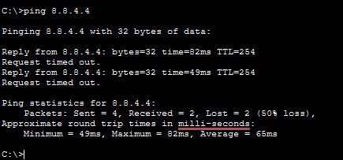
Figure 21 — Laptop-Contractor: ping 8.8.4.4 replies received via the edge default route — guests can reach the Internet only.

5. Verification Against Milestone 1 Requirements
Req. | Milestone 1 requirement | Status in Milestone 2
R1 | Network designed and simulated in Cisco Packet Tracer | IMPLEMENTED — full topology built in PT 9.0.1 (Figure 1)
R2 | Assigned addressing block 192.168.11.0/24 used | VERIFIED — show ip route shows exactly the planned VLSM subnets .0/25, .128/26, .192/27, .224/28 (Figure 4)
R3 | Appropriate connectivity and network services | VERIFIED — switching, inter-VLAN routing, DHCP, DNS, NAT, CME/VoIP all operational (Figures 2–7, Section 3.5)
R4 | VoIP traffic separated from data traffic | VERIFIED — dedicated VLAN 20, separate /26 subnet, dedicated DHCP pool; phones registered and calls connect (Figures 3, 5, 6, 13–16)
R5 | After-hours contractor wireless access (CR14) | VERIFIED — AP on VLAN 30, laptop associates; ACL blocks all internal access, permits Internet only (Figures 9, 10, 20, 21)
R6 | Default Routing (edge/ISP path design) | VERIFIED — two 0.0.0.0/0 static routes on Router0 via 203.0.113.1 and 198.51.100.1; tracert confirms edge path; live failover test confirms the route via ISP2 is withdrawn when Gig0/2 is shut down and restored when brought back up (Figures 4, 12, Section 3.4)
R7 | End-to-end connectivity and successful testing | VERIFIED — 14 tests executed, results in Section 4.1; 13/14 full pass, 1 partial pass (simulation artefact)
R8 | Design decisions documented in GitHub | TO COMPLETE — configs (router0, switch0, isp1, isp2) and this report to be pushed to CMPG325-Tshiamo-Network-Design before submission

6. Issues Encountered and Resolutions
N1 — DNS resolution initially failed (Figures 17, 18).
Symptom: nslookup tshiamodental.co.za timed out, first with server 255.255.255.255 (no DNS configured on the PC) and then with 192.168.11.2 (DNS service on Server0 not yet enabled). Resolution: configured 192.168.11.2 as the DNS server on the workstation and on the DHCP pools, then enabled the DNS service on Server0 and added the A record tshiamodental.co.za → 192.168.11.2. Verification: lookup then returned the correct address (Figure 19). This mirrors real practice: a DNS record is only resolvable once the service is running and clients are pointed at it.
N2 — AP SSID name vs. design document.
The Milestone 1 design named the contractor SSID "Tshiamo-Contractor", but AP0 currently broadcasts the default SSID "Default" (Figure 8). Functionality is unaffected — the AP sits in VLAN 30 and the ACL/DHCP design still isolates contractors exactly as specified — but for the final submission the SSID should be renamed to Tshiamo-Contractor (with WPA2-PSK authentication recommended) so the implementation matches the documented design and the CR14 requirement text.
N3 — IP phones stuck at "Configuring IP", never completing boot.
Symptom: all 7 phones showed correct VLAN tagging (confirmed via switchport voice vlan and the switch MAC address table), a working DHCP pool (confirmed via show ip dhcp pool), and link connectivity, yet remained stuck at "Configuring IP" indefinitely. Diagnosis: a Cisco 7960 phone requires SCCP (Skinny Client Control Protocol) registration to a call manager in addition to a DHCP-assigned IP address — an IP alone is not sufficient for the phone to complete its boot sequence. Resolution: Cisco CME (telephony-service) was configured on Router0 with max-ephones 7, max-dn 7, ip source-address 192.168.11.129, and auto assign 1 to 7, allowing Router0 to act as the call manager. Verification: all 7 phones registered immediately (Figures 5, 6) with no further changes needed to the already-correct VLAN configuration, and an end-to-end call between two phones was confirmed (Figures 15, 16).
N4 — Several switch access ports reverted to the default VLAN after configuration.
Symptom: a subset of access ports configured earlier via interface range commands were later found, via show vlan brief, still sitting on VLAN 1 (default) rather than their assigned VLAN. Resolution: the affected ports were reconfigured individually and the configuration was committed with write memory to ensure it persisted. Verification: a full show vlan brief confirmed every port matched the Milestone 1 port assignment table exactly (Figure 2).
N5 — 50% packet loss on one contractor Internet ping (Figure 21).
The ping to 8.8.4.4 returned 2 of 4 replies. Diagnosis: NAT overload is bound to only the primary WAN interface (Gig0/1), since Packet Tracer's simplified IOS does not support binding one NAT access-list to two outside interfaces simultaneously. Both default routes remain active for load-balancing, so roughly half of outbound packets exit via Gig0/2, are never translated, and receive no reply — this is a structural effect of dual-path NAT in this simulator, not a convergence artefact. Verification: shutting down Gig0/2 and retesting produced a 100% success rate (single path, fully NAT'd); restoring Gig0/2 returned the ~50% pattern consistently across repeated tests. This is a known limitation of simultaneous dual-ISP NAT without policy-based routing, which is beyond Foundation-level scope for this assignment.

7. Conclusion
The Milestone 1 design for Tshiamo Dental & Surgery Practice was fully implemented in Cisco Packet Tracer. All VLANs, subnets, gateway addresses and WAN links match the approved design exactly, and the assigned challenge — Default Routing with an edge/ISP dual-path design — is demonstrated with two installed default routes, a live failover test confirming automatic recovery, and verified Internet paths via NAT. Fourteen tests covering switching, routing, DHCP, DNS, NAT, VoIP registration and call completion, and guest security (ACL isolation) were executed with screenshot evidence; thirteen passed fully and one passed with a documented simulator-level limitation (Section 6, N5). The most significant troubleshooting undertaken was identifying that the IP phones required SCCP registration via Cisco CME, not just a DHCP address, to complete boot (Section 6, N3) — resolving this confirmed the underlying VLAN and DHCP design had been correct throughout. The two remaining actions before the final submission are renaming the AP SSID to Tshiamo-Contractor and pushing all configuration files and this report to the GitHub repository (R8).

All work shown is my own implementation and testing, carried out per the Milestone 1 design for Client ID CLI-003, and I remain responsible for its correctness and verification per the applicable NWU academic integrity and AI-use policy.

