**CHATBOT DEPLOYMENT WITH IBM CLOUD**

**WATSON ASSISTANT**

**PROJECT DEFINITION:**

Chatbot deployment with IBM Cloud Watson Assistant refers to the process of making a chatbot built using IBM Watson Assistant available for use in a live environment. IBM Cloud Watson Assistant is a platform that allows developers to create and train chatbots or virtual assistants for various applications, such as customer support, information retrieval, or task automation.

**PROJECT OBJECTIVES:**

The installation of Windows OS is generally a straightforward process, but like any software installation, it's not immune to errors. There are some of the potential errors that users may encounter during the installation of Windows OS.

The main objective is to ensure

Smooth Process

Minimize errors

Provide Clear Instructions

Offer Troubleshooting Guidance

Assist with Partitioning

Suggest Best Practices

**INNOVATION IDEAS:**

* 1. Disk-related errors:

Such as problems with partitioning, formatting, or selecting the correct disk for installation.

* 1. File copying errors:

Issues with copying files from the installation media to the hard drive during the installation process.

* 1. Hardware compatibility issues:

Problems arising due to incompatible or faulty hardware components.

* 1. Installation process interruption:

Unexpected interruptions during the installation, which can cause corruption or incomplete setup.

* 1. Driver issues:

Failure to install necessary drivers for components like graphics cards, network adapters, etc., causing functionality problems.

* 1. Activation errors:

Difficulties in activating Windows due to issues with product keys or activation servers.

* 1. User account creation issues:

Problems creating or setting up user accounts during the installation process.

* 1. Network configuration problems:

Difficulty in configuring network settings, causing connectivity issues post-installation.

**DESIGN**:

1. Development of the Chatbot:

Developers design and build the chatbot using the IBM Watson Assistant platform. This involves defining intents, entities, and dialog flows to enable the chatbot to understand user inputs and respond appropriately.

2. Training the Chatbot:

The chatbot is trained using sample conversations and data to improve its understanding of user queries and enhance its ability to provide accurate responses.

3. Integration with IBM Cloud:

Once the chatbot is developed and trained, it needs to be integrated with the IBM Cloud platform. This involves configuring the necessary settings, APIs, and connections to ensure seamless communication between the chatbot and other services on the IBM Cloud.

4. Deployment Configuration:

Developers configure deployment settings, such as deciding where the chatbot will be deployed, whether it will be embedded in a website, integrated with a mobile app, or used in a standalone environment.

5. Security and Access Control:

Implementing security measures to protect user data and ensure secure communication. Access control mechanisms are set up to manage who can interact with the chatbot and what actions they are allowed to perform.

6. Testing:

Thorough testing is conducted to identify and rectify any issues in the chatbot's behavior. This includes functional testing, user experience testing, and addressing any potential performance issues.

7. Scalability Considerations:

Assessing the scalability of the chatbot deployment to ensure it can handle varying levels of user interactions and requests. This may involve configuring resources on the IBM Cloud platform to accommodate increased traffic.

8. Monitoring and Analytics:

Implementing monitoring tools to track the chatbot's performance, detect errors, and gather analytics on user interactions. This data can be used to continuously improve the chatbot's capabilities.

9. Continuous Improvement:

Regularly updating and refining the chatbot based on user feedback, changing requirements, and evolving business needs. IBM Watson Assistant provides tools for ongoing training and improvement of the chatbot's language understanding.

**FLOW CHART:**

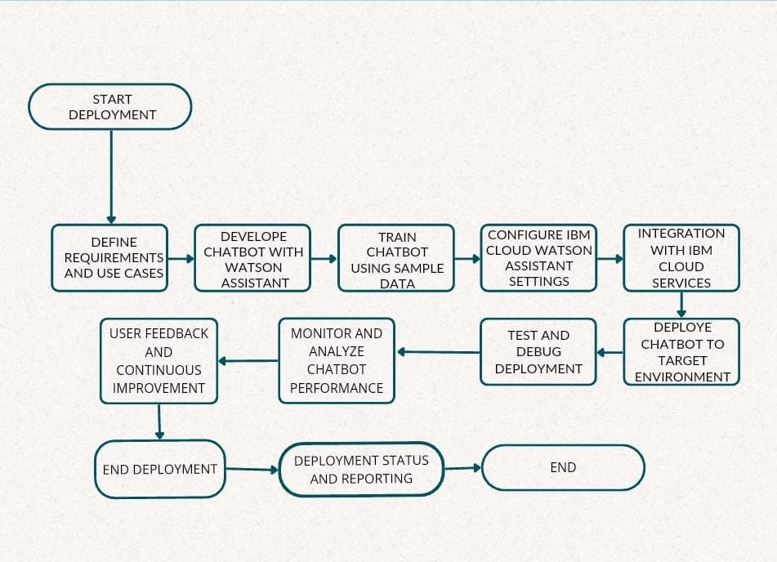

**BLOCK DIAGRAM**

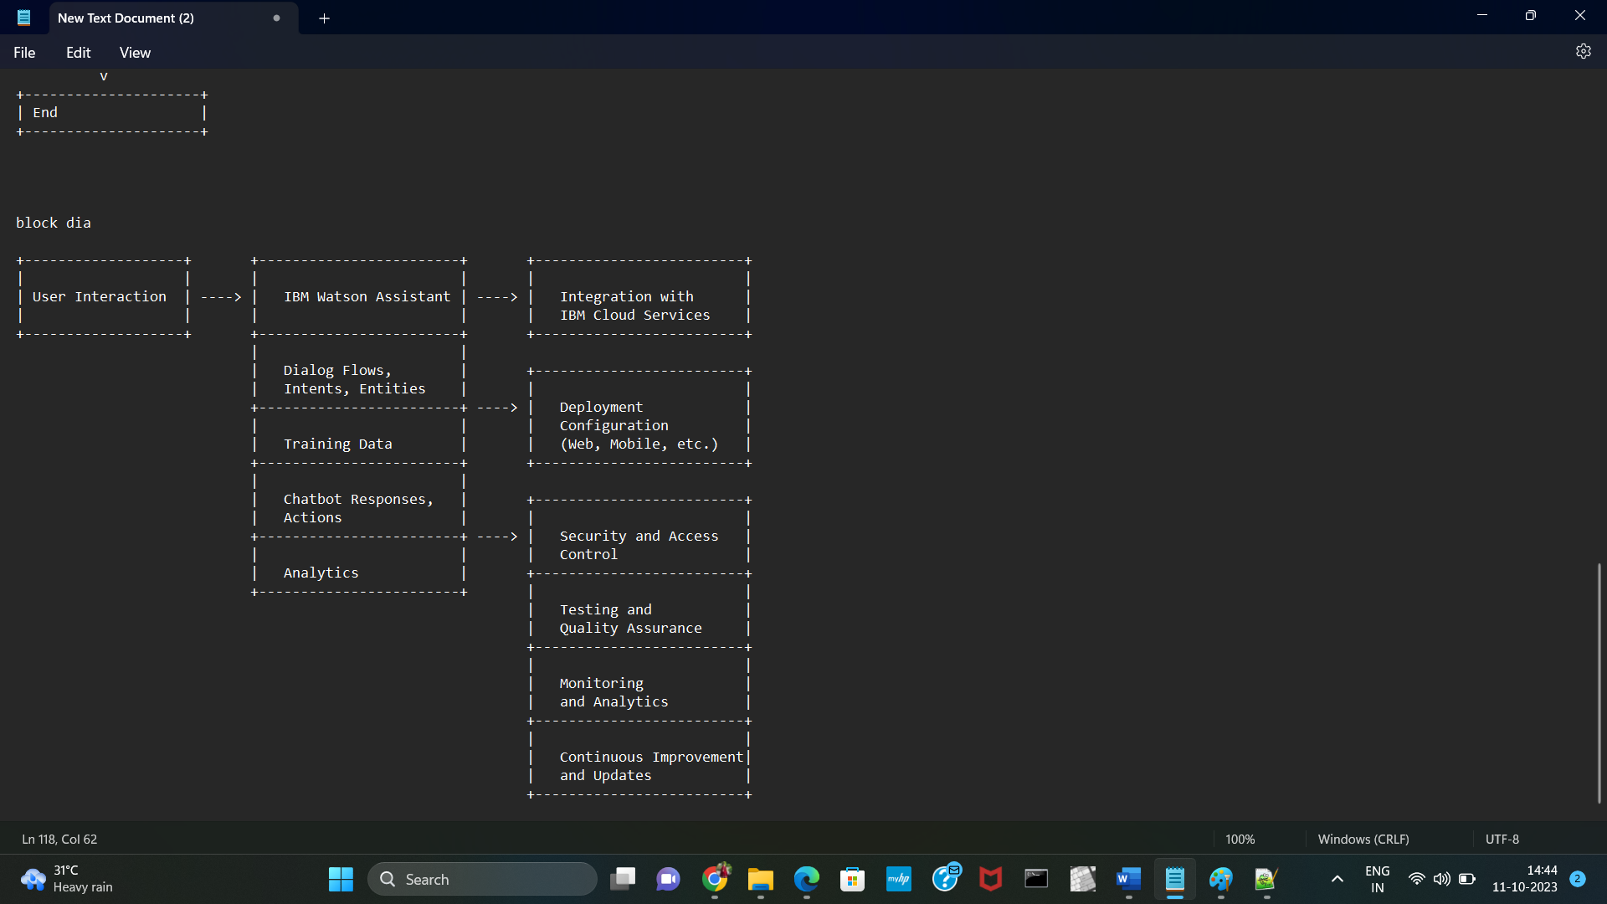

**CONCLUSION:**

By following these steps, We can successfully deploy a chatbot built with IBM Cloud Watson Assistant, providing an intelligent and interactive interface for users in various applications.